A2 Physiology Assessment

- British gymnast Beth Tweddle won the 2009 World Championship Floor Exercise title. Her routine involved a series of powerful tumbling sequences, balances and rotational movements, one of which is shown in Figure 1.
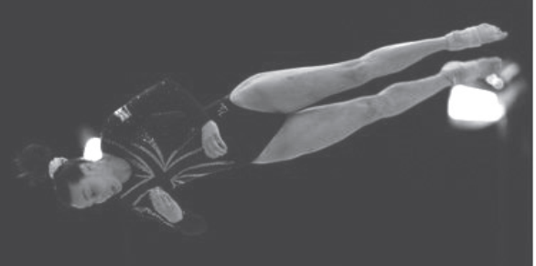
Explain how a gymnast can alter the speed of rotation during flight and outline how plyometrics can assist in their preparation to achieve maximum lift at take-off. (14 marks)
…………………………………………………………………………………………………………………………………………………………... …………………………………………………………………………………………………………………………………………………………...
…………………………………………………………………………………………………………………………………………………………...…………………………………………………………………………………………………………………………………………………………...
…………………………………………………………………………………………………………………………………………………………...…………………………………………………………………………………………………………………………………………………………... …………………………………………………………………………………………………………………………………………………………...
…………………………………………………………………………………………………………………………………………………………...…………………………………………………………………………………………………………………………………………………………...
…………………………………………………………………………………………………………………………………………………………...…………………………………………………………………………………………………………………………………………………………... …………………………………………………………………………………………………………………………………………………………...
…………………………………………………………………………………………………………………………………………………………...…………………………………………………………………………………………………………………………………………………………...
…………………………………………………………………………………………………………………………………………………………...…………………………………………………………………………………………………………………………………………………………... …………………………………………………………………………………………………………………………………………………………...
…………………………………………………………………………………………………………………………………………………………...…………………………………………………………………………………………………………………………………………………………...
…………………………………………………………………………………………………………………………………………………………...…………………………………………………………………………………………………………………………………………………………... …………………………………………………………………………………………………………………………………………………………...
…………………………………………………………………………………………………………………………………………………………...…………………………………………………………………………………………………………………………………………………………...
…………………………………………………………………………………………………………………………………………………………...

- At the 2008 Beijing Olympic Games, David Davies won the silver medal in the swimming 10 kilometre marathon event, in a time of 1 hour 51 minutes and 53.1 seconds. Explain how the majority of energy used during the race would be provided and outline the process of ‘glycogen loading’ that may be used by performers to improve performance in this type of event. (14 marks)

…………………………………………………………………………………………………………………………………………………………... …………………………………………………………………………………………………………………………………………………………...
…………………………………………………………………………………………………………………………………………………………...
…………………………………………………………………………………………………………………………………………………………...
…………………………………………………………………………………………………………………………………………………………...
…………………………………………………………………………………………………………………………………………………………...…………………………………………………………………………………………………………………………………………………………... …………………………………………………………………………………………………………………………………………………………...
…………………………………………………………………………………………………………………………………………………………...…………………………………………………………………………………………………………………………………………………………...…………………………………………………………………………………………………………………………………………………………... …………………………………………………………………………………………………………………………………………………………...
…………………………………………………………………………………………………………………………………………………………...…………………………………………………………………………………………………………………………………………………………... …………………………………………………………………………………………………………………………………………………………...
…………………………………………………………………………………………………………………………………………………………...…………………………………………………………………………………………………………………………………………………………...
…………………………………………………………………………………………………………………………………………………………...…………………………………………………………………………………………………………………………………………………………... …………………………………………………………………………………………………………………………………………………………...
…………………………………………………………………………………………………………………………………………………………...…………………………………………………………………………………………………………………………………………………………...
…………………………………………………………………………………………………………………………………………………………...

- The recovery process after training and between events during competition is vital to maximise performance.
The diagram illustrates the ‘excess post-exercise oxygen consumption’ (EPOC) of a performer following strenuous exercise.
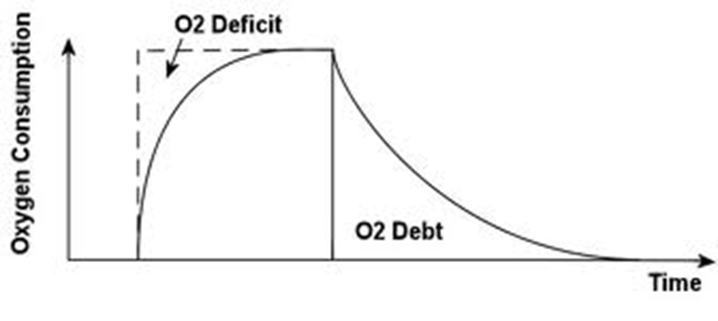
Outline the function and process of the fast component of the recovery process. (4 marks)
…………………………………………………………………………………………………………………………………………………………... …………………………………………………………………………………………………………………………………………………………...
…………………………………………………………………………………………………………………………………………………………...
…………………………………………………………………………………………………………………………………………………………...
…………………………………………………………………………………………………………………………………………………………...
…………………………………………………………………………………………………………………………………………………………...…………………………………………………………………………………………………………………………………………………………... …………………………………………………………………………………………………………………………………………………………...

- Describe the changes that occur in the body to make the aerobic energy systems more efficient following prolonged endurance training. (4 marks)
…………………………………………………………………………………………………………………………………………………………...…………………………………………………………………………………………………………………………………………………………... …………………………………………………………………………………………………………………………………………………………...
…………………………………………………………………………………………………………………………………………………………...…………………………………………………………………………………………………………………………………………………………...
…………………………………………………………………………………………………………………………………………………………...
…………………………………………………………………………………………………………………………………………………………...
…………………………………………………………………………………………………………………………………………………………...

- The Sliding Filament Hypothesis suggests muscular contraction occurs in the sarcomeres of the muscle fibres. Explain how actin and myosin filaments in the sarcomere bind together causing muscular contraction. (7 marks)
…………………………………………………………………………………………………………………………………………………………...
…………………………………………………………………………………………………………………………………………………………...…………………………………………………………………………………………………………………………………………………………... …………………………………………………………………………………………………………………………………………………………...
…………………………………………………………………………………………………………………………………………………………...…………………………………………………………………………………………………………………………………………………………...
…………………………………………………………………………………………………………………………………………………………....................................................................................................................................................................

- All gymnastic events require controlled powerful movements.
How can a performer vary the strength of muscular contractions to ensure that a skill is completed correctly? (4 marks)
…………………………………………………………………………………………………………………………………………………………...
…………………………………………………………………………………………………………………………………………………………...…………………………………………………………………………………………………………………………………………………………... …………………………………………………………………………………………………………………………………………………………...
…………………………………………………………………………………………………………………………………………………………...…………………………………………………………………………………………………………………………………………………………...
…………………………………………………………………………………………………………………………………………………………...................................................................................................................................................................

- Describe the physiological reasons why a performer may use anabolic steroids. (3 marks)
…………………………………………………………………………………………………………………………………………………………... …………………………………………………………………………………………………………………………………………………………... …………………………………………………………………………………………………………………………………………………………...
…………………………………………………………………………………………………………………………………………………………...…………………………………………………………………………………………………………………………………………………………...
…………………………………………………………………………………………………………………………………………………………...

- Explain how a swimmer would use ‘periodisation’ to prepare for competitions. (4 marks)
…………………………………………………………………………………………………………………………………………………………...…………………………………………………………………………………………………………………………………………………………... …………………………………………………………………………………………………………………………………………………………...
…………………………………………………………………………………………………………………………………………………………...…………………………………………………………………………………………………………………………………………………………...…………………………………………………………………………………………………………………………………………………………...
…………………………………………………………………………………………………………………………………………………………...…………………………………………………………………………………………………………………………………………………………...
…………………………………………………………………………………………………………………………………………………………...

- Elite athletes must develop and maintain extremely high levels of fitness to maximise their chances of winning. Elite athletes may use the results from lactate sampling and their respiratory exchange ratio (RER) to ensure their training is effective.
Explain the terms lactate sampling and respiratory exchange ratio. (4 marks)
…………………………………………………………………………………………………………………………………………………………...…………………………………………………………………………………………………………………………………………………………...…………………………………………………………………………………………………………………………………………………………...
…………………………………………………………………………………………………………………………………………………………...…………………………………………………………………………………………………………………………………………………………...…………………………………………………………………………………………………………………………………………………………...
…………………………………………………………………………………………………………………………………………………………...

- Explain how the use of an ice bath can help to reduce the ‘delayed onset of muscle soreness’ (DOMS). (4 marks)
…………………………………………………………………………………………………………………………………………………………...
…………………………………………………………………………………………………………………………………………………………...…………………………………………………………………………………………………………………………………………………………...…………………………………………………………………………………………………………………………………………………………...…………………………………………………………………………………………………………………………………………………………...…………………………………………………………………………………………………………………………………………………………...
…………………………………………………………………………………………………………………………………………………………...
…………………………………………………………………………………………………………………………………………………………...

- Using ‘Newton’s First and Second Laws of Motion’, explain how the swimmer dives off the starting blocks. (4 marks)
…………………………………………………………………………………………………………………………………………………………...…………………………………………………………………………………………………………………………………………………………...…………………………………………………………………………………………………………………………………………………………...…………………………………………………………………………………………………………………………………………………………...
…………………………………………………………………………………………………………………………………………………………...…………………………………………………………………………………………………………………………………………………………...…………………………………………………………………………………………………………………………………………………………...
…………………………………………………………………………………………………………………………………………………………...

End of Test
Result: / 66 marks
Grade:

