Arousal Crossword
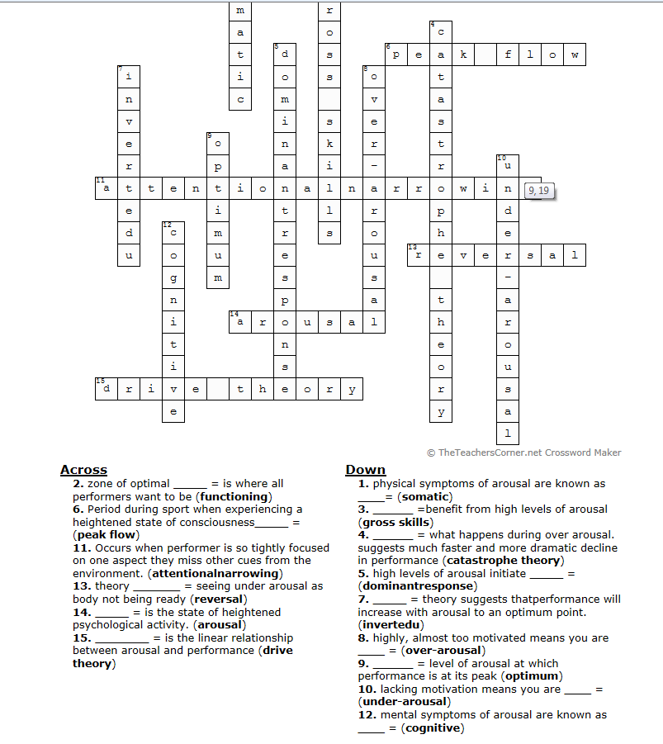
ANSWERS
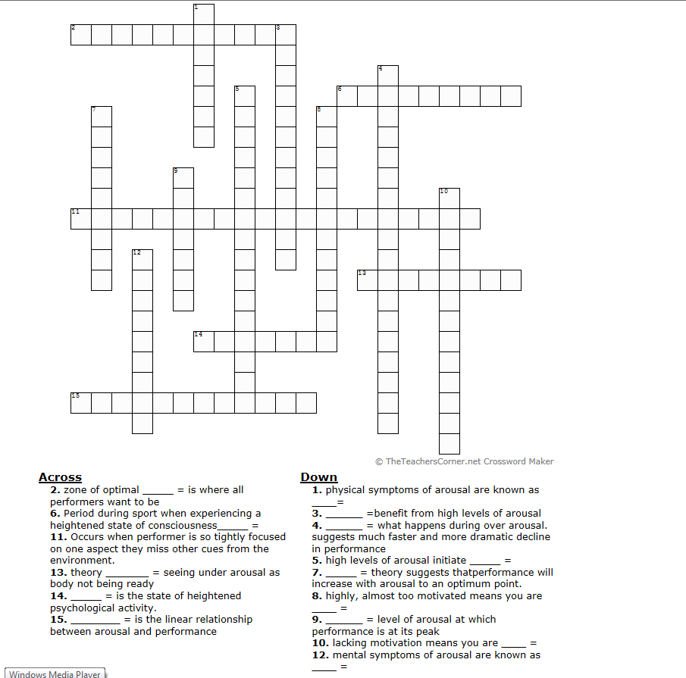
AROUSAL CROSSWORD
QUESTION SHEET

