AS PE Physiology Assessment
- In order to perform to their potential, long jumpers must use their muscles and bones efficiently.
Figure 1 shows a long jumper during the take-off phase of his jump.
Figure 1:
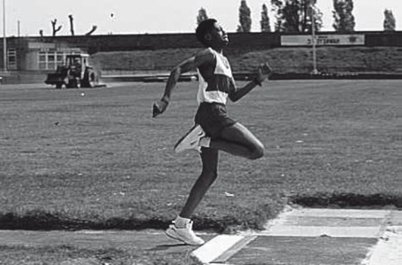
Using Figure 1, complete Table 1 to identify:
(i) the joint actions involved at the hip and ankle of the take-off leg as the performer leaves the board, (3 marks)
(ii) the names of the main agonists working at the knee and ankle. (3 marks)
Joint | - Joint action | - Main agonist
Hip
Knee
Ankle

- Name, sketch and label the lever system operating at the ankle of the take-off foot. (3 marks)

- What are the advantages and disadvantages of third class levers over the other types of lever systems? (2 marks)
……………………………………………………………………………………………………………………………………………………………………………………………………………………………………………………………………………………………………………………………………………………………………………………………………………………………………………………………………………………………………………………………………………………………………………………………………………………………………………………
- For effective performance, games players require oxygen to be delivered to the muscles and carbon dioxide to be removed. Explain how oxygen is taken up by haemoglobin from the lungs and released at the muscle site. (4 marks)
…………………………………………………………………………………………………………………………………………………………………………………………………………………………………………………………………………………………………………………………………………………………………………………………………………………………………………………………………………………………………………………………………………………………………………………………………………………………………………………………………………………………………………………………………………………………………………………………………………………………………………………………………………………………………………………………………………………………………………………………………………………………………………………………………………………………………………………………………………………………………………………………………………………………………………………………………………………………………………
- Explain why aerobic training improves the performer’s ability to transport oxygen. (2 marks)
……………………………………………………………………………………………………………………………………………………………………………………………………………………………………………………………………………………………………………………………………………………………………………………………………………………………………………………………………………………………………………………………………………………………………………………………………………………………………………………

- Figure 2 is a graph showing the typical readings of a spirometer.
Figure 2:
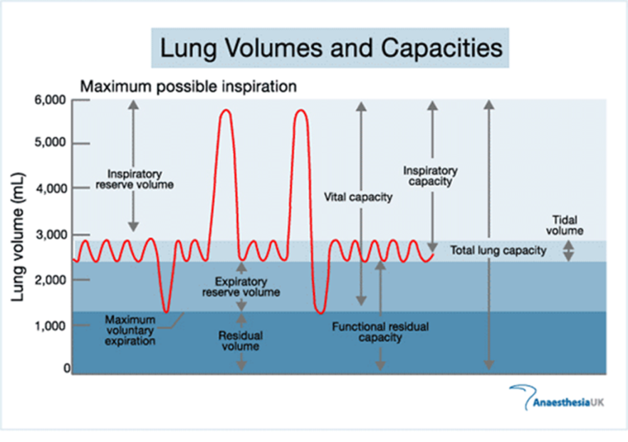
E
D
B
C
A
- Which lung volumes are represented by D and E? (2 marks)
……………………………………………………………………………………………………………………………………………………………………………………………………………………………………………………………………………………………………………………………………………………………………………………………………………………………………………………………………………………………………………………………………………………………………………………………………………………………………………………
- How would you expect volumes A, B and C to be affected during a game of rugby? (3 marks)
…………………………………………………………………………………………………………………………………………………………………………………………………………………………………………………………………………………………………………………………………………………………………………………………………………………………………………………………………………………………………………………………………………………………………………………………………………………………………………………………………………………………………………………………………………………………………………………………………………………

- Figure 3 shows the oxyhaemoglobin dissociation curve.
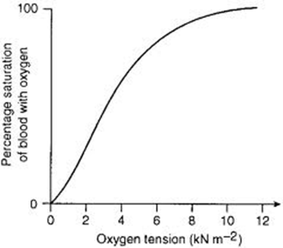
- Use Figure 3 to explain how oxygen is released by the blood and supplied to muscles. (2 marks)
……………………………………………………………………………………………………………………………………………………………………………………………………………………………………………………………………………………………………………………………………………………………………………………………………………………………………………………………………………………………………………………………………………………………………………………………………………………………………………………
- During exercise the curve shifts to the right. Explain the causes of this shift and the effect this has on oxygen delivery to the muscles. (4 marks)
……………………………………………………………………………………………………………………………………………………………………………………………………………………………………………………………………………………………………………………………………………………………………………………………………………………………………………………………………………………………………………………………………………………………………………………………………………………………………………………………………………………………………………………………………………………………………………………………………………………………………………………………………………………………………………………………………………………………………………………………………………………………………………………………………………………………………………………………………………

- Explain the variation in blood pressure and blood velocity shown in the graph below. (5 marks)
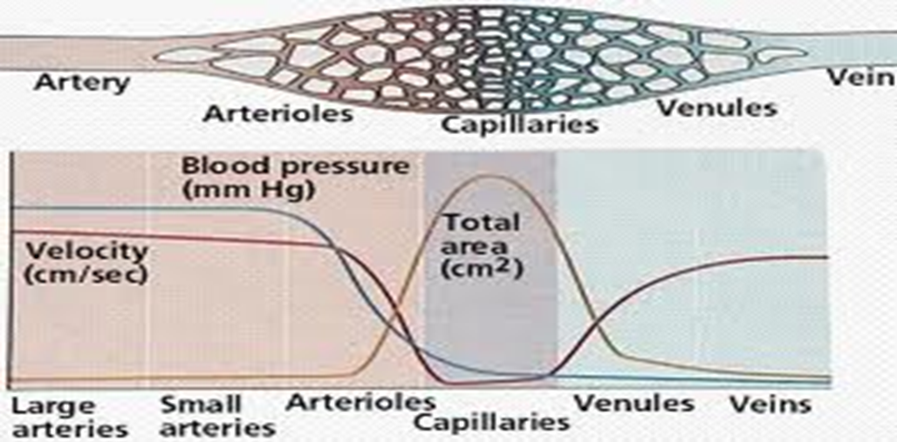…………………………………………………………………………………………………………………………………………………………………………………………………………………………………………………………………………………………………………………………………………………………………………………………………………………………………………………………………………………………………………………………………………………………………………………………………………………………………………………………………………………………………………………………………………………………………………………………………………………………………………………………………………………………………………………………………………………………………………………………………………………………………………………………………………………………………………………………………………………………………………………………………………………………………………………………………………………………………………

- State three characteristics or functions of arteries. (3 marks)
…………………………………………………………………………………………………………………………………………………………………………………………………………………………………………………………………………………………………………………………………………………………………………………………………………………………………………………………………………………………………………………………………………………………………………………………………………………………………………………………………………………………………………………………………………………………………………………………………………………

- Briefly explain the terms cardiac output and stroke volume, and the relationship between them. (3 marks)
…………………………………………………………………………………………………………………………………………………………………………………………………………………………………………………………………………………………………………………………………………………………………………………………………………………………………………………………………………………………………………………………………………………………………………………………………………………………………………………………………………………………………………………………………………………………………………………………………………………
- Describe how the sinoatrial node (SAN) and the atrioventricular node (AVN) control the increase in heart rate during exercise. (6 marks)
………………………………………………………………………………………………………………………………………………………………………………………………………………………………………………………………………………………………………………………………………………………………………………………………………………………………………………………………………………………………………………………………………………………………………………………………………………………………………………………………………………………………………………………………………………………………………………………………………………………………………………………………………………………………………………………………………………………………………………………………………………………………………………………………………………………………………………………………………………………………………………………………………………………………………………………………………………………………………………………………………………………………………………………………………………………………………………………………………
- Explain how and why the diet of a competitive weightlifter may need to differ from that of an untrained individual. (4 marks)
……………………………………………………………………………………………………………………………………………………………………………………………………………………………………………………………………………………………………………………………………………………………………………………………………………………………………………………………………………………………………………………………………………………………………………………………………………………………………………………………………………………………………………………………………………………………………………………………………………………………………………………………………………………………………………………………………………………………………………………………………………………………………………………………………………………………………………………………………………

- Why do people engaged in physical activity need to make sure that they eat foods containing sufficient iron and calcium? (4 marks)
……………………………………………………………………………………………………………………………………………………………………………………………………………………………………………………………………………………………………………………………………………………………………………………………………………………………………………………………………………………………………………………………………………………………………………………………………………………………………………………………………………………………………………………………………………………………………………………………………………………………………………………………………………………………………………………………………………………………………………………………………………………………………………………………………………………………………………………………………………
- Explain the difference between the terms health and fitness. (1 mark)
………………………………………………………………………………………………………………………………………………………………………………………………………………………………………………………………………………………………………………………………………………………………………………………………………………………………………………………………………………………
- A defender in a team game has to sprint for the ball, stop and then change direction to mark an attacker. The attacker moves towards goal and the defender has to stretch to win the ball.
Define three components of skill-related fitness that have been used in this period of play and state when they were used. (6 marks)
………………………………………………………………………………………………………………………………………………………………………………………………………………………………………………………………………………………………………………………………………………………………………………………………………………………………………………………………………………………………………………………………………………………………………………………………………………………………………………………………………………………………………………………………………………………………………………………………………………………………………………………………………………………………………………………………………………………………………………………………………………………………………………………………………………………………………………………………………………………………………………………………………………………………………………………………………………………………………………………………………………………………………………………………………………………………………………………………………

- State three lifestyle choices that can have an effect upon our health and fitness. (3 marks)
………………………………………………………………………………………………………………………………………………………………………………………………………………………………………………………………………………………………………………………………………………………………………………………………………………………………………………………………………………………………………………………………………………………………………………………………………………………………………………………………………………………………………………………………………………………………………………………………………………………………………………………………………………………………………………………………………………………………………………

End of Assessment
Total- /63
Grade:

