A2 Coursework – Athletics (100m sprint & Long Jump)

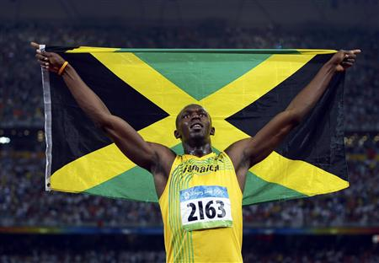
B2 100m 15-60m acceleration phase

Usain Bolt (pictured) is the fastest man over 100m in the world, he also holds the record for the 200m and is widely regarded as the greatest ever sprinter.
After the sprint start and first 15 metres Bolt will have reached approximately 70% of his maximum velocity and will still be accelerating during this, but at a reduced rate in comparison to the beginning of the race.
Legs:
Bolt’s rear leg drives off from the ground, achieving full extension with plantar flexion of the ankle aiding the drive of the toes off the track. He then pulls his leg through explosively, flexing at the knee to such a degree that the heel comes into close proximity with the underside of his buttocks, but not so close as to touch as this would slow the cycle of his leg. Bolt’s thighs and knee drive forwards and high, the lower leg is raised with it still in a state of complete flexion. As the knee is reaching the highest point of the drive his lower leg swings powerfully through, extending forwards of the knee but not achieving full extension until it is in contact with the track. The leg then drives down onto the track, the leg extending at the knee as it goes. The downwards leg drive is a clawing motion, the toe strike is directly below Bolt’s knee and his leg ‘claws’ back as if pulling the ground underneath and behind him, driving his body forward over it.
Bolt remains on the balls of his feet at all times, as this is the most mechanically efficient position to sprint in, with his feet pointing forward straight down the lane, ensuring that he drives his legs straight, maximising his efficiency and effective effort distribution. As it is a sprint, his leg action is as fast as possible with good stride length to allow Bolt to continually accelerate through this phase.
Arms:
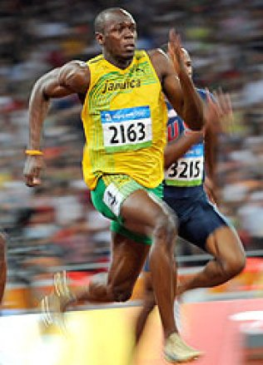
Bolt drives his arms smoothly but powerfully back and forth as fast as possible whilst still maintaining control, as this facilitates the rapid movement of his legs. The elbow drive commences just before rear leg drive and his elbows are kept at 90 degrees so that his hand doesn’t drop below the approximate level of a pocket. His hands are relaxed, with the fingers either straight or loosely curled but not bunched in fists as this is a waste of energy.
Body:
His general appearance is smooth and relaxed but driving as hard as possible with his elbows and legs. His body is tall with a slight forward lean to aid with acceleration, as his arms and legs are forced to speed up to counterbalance the lean. The angle of the lean is such that a straight line could be placed along Bolt’s head, neck, spine and the extended rear leg. The muscles of his face and neck are relaxed as are the shoulders which are held back and relaxed. The sprinter remains squarely in the middle of his lane at all times, with his eyes focused down the lane to the finish. At the end of this phase the Bolt will have reached 90-100% of his maximum velocity.

B1 100m 15-60m acceleration phase
After the sprint start and first 15 metres you will have reached approximately 70% of your maximum velocity and will still be accelerating, but at a reduced rate in comparison to the beginning of the race.
Legs:
My rear leg drives off from the ground, achieving full extension with plantar flexion of my ankle aiding the drive of my toes off the track. I then pull my leg through explosively, flexing at the knee to such a degree that the heel comes into close proximity with the underside of the buttocks, but not so close as to touch as this slows the cycle of the leg. I cannot do this as quickly or powerfully as Bolt, as he has more developed musculature and is a specialised sprinter, whereas I am a multi-eventer. My thighs and knee drive forwards and high, the lower leg is raised with it still in a state of complete flexion. As the knee is reaching the highest point of the drive the lower leg swings powerfully through, extending forwards of the knee but not achieving full extension until it is in contact with the track. The leg then drives down onto the track, the leg extending at the knee as it goes; Bolts leg has more force as it drives down to the track as he has longer levers, allowing greater momentum to be created. The downwards leg drive is a clawing motion, my toe strike is directly below my knee and my leg ‘claws’ back as if pulling the ground underneath and behind me, driving my body forward over it.
I remain on the balls of my feet at all times, they point forward straight down the lane, ensuring that my legs drive straight, maximising efficiency and effective effort distribution. As it is a sprint, my leg action is as fast as possible with good stride length to allow continual acceleration. My leg action is not as fast as Bolt’s and I also have shorter strides, which means I cannot accelerate as quickly as him.
Arms:
My arms are driven smoothly but not powerfully enough back and forth as fast as possible whilst still maintaining control, as this should facilitate the rapid movement of my legs, but my lack in power limits this, which is my major weakness. Bolt’s elbow drive commences just before his rear leg drive and his elbows are kept at 90 degrees so that his hand doesn’t drop below the approximate level of a pocket. My elbows can often extend beyond ninety degrees which means that I have to waste more energy driving them back through as they have further to travel back up. The hands should be relaxed, with the fingers either straight or loosely curled but not bunched in fists as this is a waste of energy, I have a tendency to bunch mine into fists, but Bolt keeps his in perfect form throughout his whole race.

Body:
The general appearance of the sprinter should be smooth and relaxed but driving as hard as possible with elbows and legs. I can, unlike Bolt, often appear to be too tense, which is affecting the range of movement at my joints and also wasting energy. Bolt’s body is tall with a slight forward lean to aid with acceleration as with mine also, as the body is forced to speed up to counterbalance the lean. The angle of the should be such that a straight line could be placed along the head, neck, spine and the extended rear leg, my head can often be in the incorrect place as I allow it to move, this can put the linear movement of my sprint off, making it less efficient. The muscles of the face and neck of Bolt are relaxed as are the shoulders which are held back and relaxed, but as I have mentioned, I often tense up. I remain squarely in the middle of the lane at all times, with tmy eyes focused down the lane to the finish, although if I know I am not accelerating fast enough, I can tend to see if I can see any competitors coming up next to me in my peripheral vision. At the end of this phase I will have reached 90-100% of my maximum velocity.

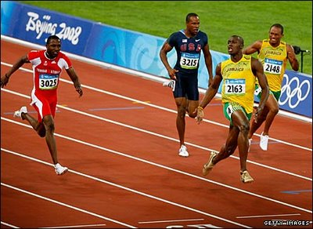
B2 Speed maintenance and dip finish
Usain Bolt (pictured) is the fastest man over 100m in the world, he also holds the record for the 200m and is widely regarded as the greatest ever sprinter. He often finishes far ahead of the field and so does not always dip, instead enjoying an early celebration…

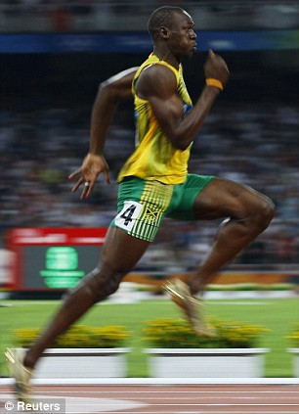
Bolt has his eyes focused at the end of the lane – ‘tunnel vision’ this is to make sure that he focuses on his race technique and not get distracted by his opponents – his head is in line with his spine, held high and square. His face is relaxed causing the ‘jelly jaw’ effect, there is no tension in his jaw and his chin is down and not out.
Bolt holds his shoulders down, relaxing his neck muscles as much as possible, giving the appearance of ‘long neck’, he makes sure his back is not hunched and that he remains relaxed; this is to ensure he has a full range of motion around his shoulders to make sure he gets the most driving force. He is square in the middle of his lane for the duration of the race, because weaving from side to side increases the distance covered in comparison to the other racers, which would put him at a disadvantage.
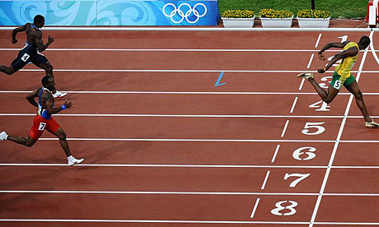
Smooth but fast forward and backward action of the arms, Bolt does not drive them across his body, but keeps them driving straight, brushing his vest with his elbows as they pass, as this is mechanically inefficient and as the . His elbows are held at 90 degrees at all times (angle between upper arm and lower arm). His hands are relaxed, fingers loosely curled or flat with his thumb uppermost.
Bolt uses high knee action called ‘prancing’ to lengthen his stride in the final stages of the race, covering more distance with fewer strides, this efficient as the sprinter is no longer accelerating by this stage so the aim is to try to maintain the highest speed possible through the line. Bolt’s leg action is fast and light as if running on hot surface, Bolt’s hips are tucked under and he uses slight forward rotation of the hip with forward leg drive to help extend the stride. This is seen in the photo of Bolt at the 2008 Beijing Olympics.
For the dip, Bolt leans forward quickly to have his chest cross the line as quickly as possible, as the torso must cross the line to stop the timer. To speed this motion he throws back his arms behind him, this causes forward motion and also brings the shoulders forward and down. As seen here:

B1 Speed maintenance and dip finish
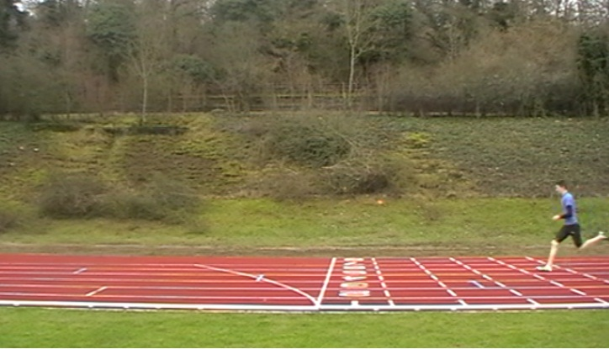
As I near the end of the race, I have my eyes focused at the end of the lane, this is known as ‘tunnel vision’. Sometimes however, particularly in big races, if any of my opponents enter my peripheral vision or even overtake me, then I can lose focus on the line and become preoccupied with my position in relation to them. My head is in line with my spine, held high and square. Bolt’s face is relaxed causing the ‘jelly jaw’ effect, there is no tension and his chin is down and not out. I tend to have a lot of tension in my face, a clenched
jaw, this can lead to tension in my neck which
affects my shoulders and their range of movement,
which in turn would shorten my strides because arm
movement dictates stride pattern.
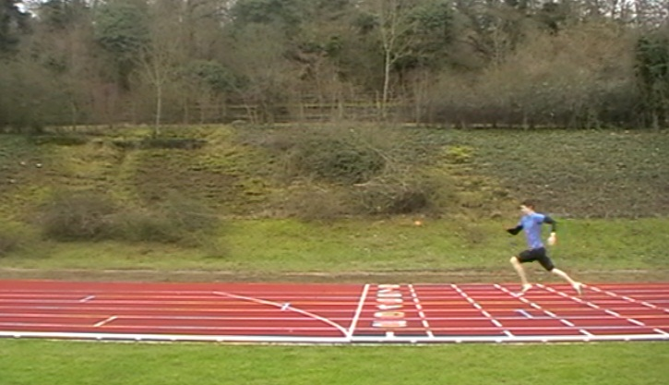
Bolt holds his shoulders down, relaxing his neck muscles as much as possible, giving the appearance of ‘long neck’. He makes sure his back is not hunched and that he remains relaxed and square in the middle of his lane all through the race. If I focus too much on my opponents it can cause me to tense up my shoulders and neck which limits the range of movements and speed of my arm drives, which directly affects my stride length and power, slowing my approach to the line.
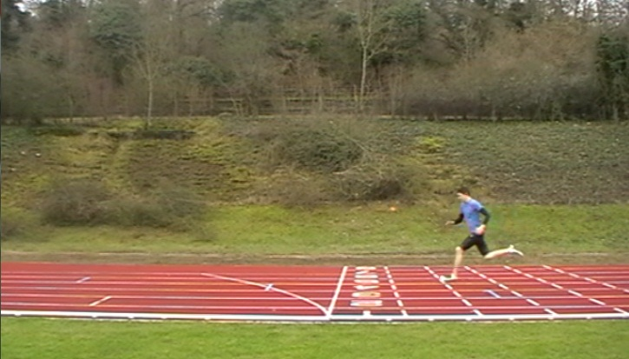
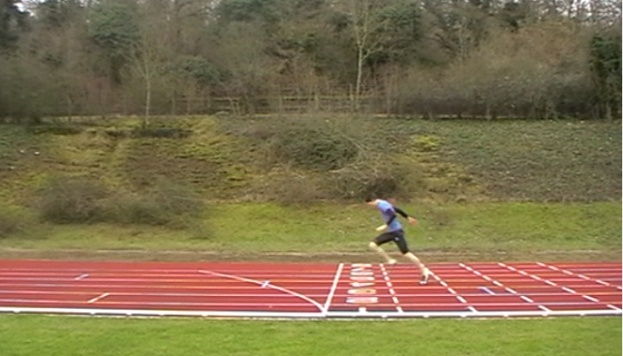
My arm actions are smooth, but not as fast Bolt’s due to my having less muscle mass and fewer fast twitch muscle fibres. Bolt does not drive his arms across his body, but keeps them driving straight, brushing his vest with his elbows as they pass. I often imitate this for the whole race, but if I have tired then I can slip into allowing my arms to come across my body, which wastes energy and slows the arms, which in turn slows my legs. My elbows are also held at 90 degrees (angle between upper arm and lower arm) throughout this phase. My hands are relaxed, fingers loosely curled or flat with my thumb uppermost much the same as Bolt, but again, if I am tiring then sometimes I can bunch them into fists, which is an unnecessary waste of energy as it does not benefit the arm drive in any way and so is using energy better used by the arms or legs.
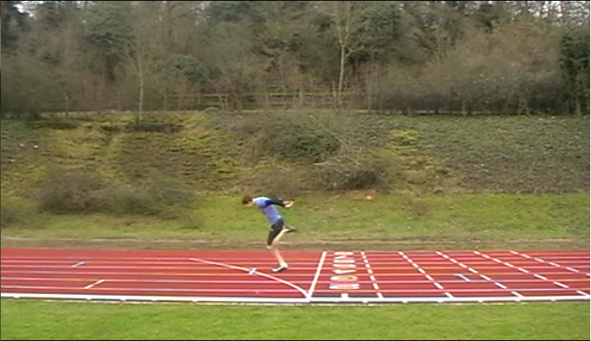
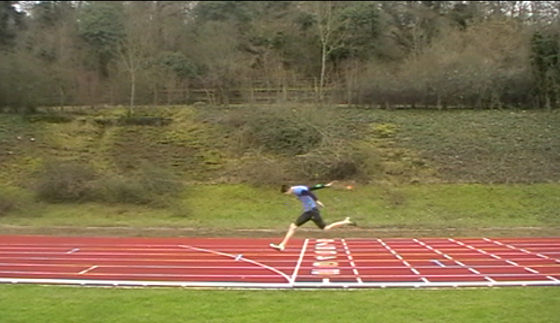
Like Bolt I also use high knee action called ‘prancing’ to lengthen my stride in the final stages of the race, covering more distance with fewer strides, my strides are not as long as Bolt though, as I have shorter legs and I cannot drive them with as much force. This technique is efficient as I am no longer accelerating by this stage so I aim to maintain the highest speed possible through the line. My leg action fast and light as if I were running on a hot surface, my hips are tucked under and I use slight forward rotation of my hips with forward leg drives to help extend my stride.
For the dip, I lean forward quickly to have my chest cross the line as quickly as possible, as the torso must cross the line to stop the timer. To speed this motion I throw back my arms behind me, this causes forward motion and also brings my shoulders forward and down. As seen in my photo sequence down the side of the page.

B2 - 100 metre Sprint Start/Drive Phase
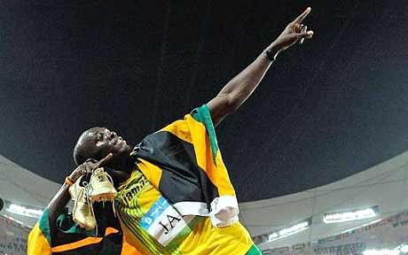
Elite/model performance.
Usain Bolt (pictured) is the fastest man over 100m in the world, he also holds the record for the 200m and is widely regarded as the greatest ever sprinter.
A quick reaction is essential, the quicker the start, the greater the advantage over the field.
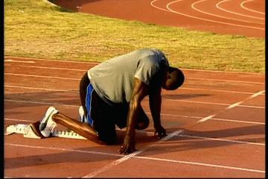
On your marks
When Bolt hears the initial command, "On your marks", he moves forward to his Blocks and adopts a position with his hands a little wider than shoulder width apart and just behind the starting line, with elbows straight, but not quite at full extension; so that he is in the correct position to assume the approximately forty five degree angle for the drive out of the blocks, but still has the capacity for a small spring from his arms to push him up. His hands form an arch using the fingers and thumb. The balls of his feet are in contact with the starting blocks and the knee of Bolt’s rear leg is in contact with the track. His head and neck are in line with his spine, with his face and neck relaxed. This body position provides the perfect platform from which to explosively drive from, without deviating from course, compensating for or wasting energy on any unwanted movements. He settles himself mentally and physically in preparation for the race, relaxed but completely focussed on the race; eyes focused on the track immediately in front of him.
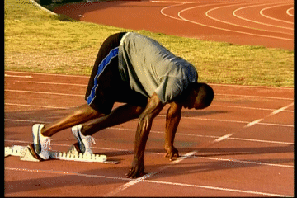
Set
On hearing the "Set" Bolt raises the knee of his rear leg off the ground to approximately one hundred and twenty degrees, thereby elevating his hips above his shoulders. This shifts his centre of gravity up and out, to give extra forward momentum when he drives out of the blocks. His head and neck are still in line with his spine, in preparation for his body to be at a forty five degree angle when he drives out of the blocks. By this point ‘tunnel vision’ should have set in; this is where Bolt will be looking straight down his lane to the finish.
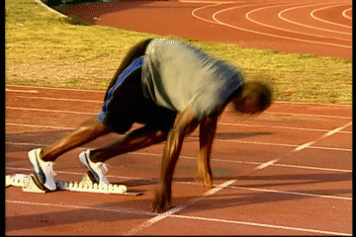
Firing of the gun
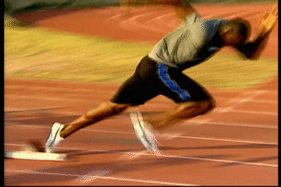
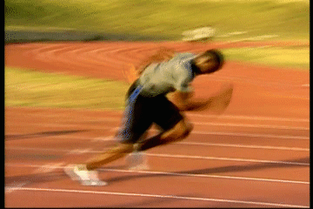
Then on the firing of the gun Bolt reacts by lifting his hands from the track, driving his arms vigorously and powerfully, achieving horizontal hyper extension; this driving of the arms dictates the speed power and length of his strides, and so is essential. He drives with both legs off the blocks bringing the rear leg through and into the first running strides, which are shorter and quicker than full race stride to optimise acceleration. It is important not to jump out of the blocks, but an explosive force is critical. His body is at approximately 45 degrees and his head is facing down at the track as he drives out of the blocks for the first 15-20m, this angle adds momentum to the start as it is necessary to accelerate so as not to fall forward and is also an optimal angle for putting explosive strength into the strides. He gradually rises towards an upright position during this phase. At no point do Bolt’s heels touch the track, he remains on the balls of his feet from the moment he settles into the blocks. The aim of his start is to leave the blocks balanced and with maximum velocity to permit Bolt to rapidly take up a mechanically efficient running position to optimise his race.
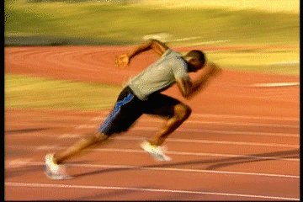
Result
If Bolt’s start is perfectly executed then he will have reached upright position having accelerated to near his top speed, in the minimal time, with maximal efficiency. He will be balanced and have good field position, allowing him to lengthen his strides, maintain his sprint through the finish line and win the race.

100 metre Sprint Start/Drive Phase- B1
My performance.
On your marks
Once, following the commands, I have settled myself into the blocks, I have the balls of my feet on the blocks, my rear knee in contact with the track, hands evenly positioned slightly wider than shoulder width. My shoulders are back and vertically above or slightly forward of my hands. My arms are straight but I do sometimes lock my elbows, which affects the amount of spring that I can achieve to drive my body from the blocks. I have my fingers and thumbs holding my palms off the track and bearing my weight. My head and neck are in line with my spine, sometimes however, I have my head positioned dropped too low; this means my angle of leaving the blocks can be too low, making it difficult to come up to full height quickly enough. I breathe gently, my face and neck relaxed; eyes focused on the track a meter or two in front of me. Unlike Bolt I can be anxious when I have set myself in the blocks, this can lead to over arousal, which causes problems with my performance throughout the race; I tense up my shoulders and neck, which reduces the efficiency and range of my arm drives, directly negatively effecting the speed and fluidity of my strides. It can also lead to learned helplessness, where I believe that failure is inevitable.
Set
On hearing the "Set" I elevate my hips to a position above my shoulders and shift my centre of gravity up and out, raising the knee of my rear leg off the ground to an angle of approximately one hundred and twenty degrees and the front leg to about ninety degrees; this will give extra forwards momentum in the drive phase (first 20 - 30m). Sometimes however, unlike Bolt, I can raise my hips too high, which also decreases the amount of explosive force I can generate from the blocks. My head and neck are still in line with my spine, in preparation for my body to be at a forty five degree angle when he drives out of the blocks, and I am looking one to two metres ahead.
Firing of the gun
Then on the firing of the gun I react. On the ‘B’ of the bang I exhale; lifting my hands from the track, driving them powerfully, achieving horizontal hyper extension and driving with both legs off the blocks bringing the rear leg through and into the first running strides, which are shorter and quicker than full race stride, sometimes I can make my first strides too long which also a fault that Bolt sometimes has, although he is able to rectify it. My reactions are slower than Bolts, and this can lead to poor field position coming out of the blocks. My body is at approximately 45 degrees and my head faces down at the track as I drive out of the blocks for the first 15-20m, gradually rising towards the upright running position. The aim of his start is to leave the blocks balanced and with maximum velocity to permit me to rapidly take up a mechanically efficient running position to optimise their race. I however, struggle to accelerate up to speed in the short time of the drive phase, I therefore have poor field position and am struggling to make up ground throughout the race; the lack of explosive power, the mass and strength of my fast twitch fibres not being great enough, is a major causal factor. Over arousal at this stage can affect my performance by making me false start because of over-anticipation of the gun. It could conversely make my reaction slower, as my over-arousal could be due to social inhibition theory, and I would become very aware of the crowd. If I suffered from somatic anxiety, I would be over-aware of my body’s physiological responses to a situation which I feel anxious. This would mean I would have lost selective attention, and so when the stimulus for me to start was initiated, it would have to wait due to the bottleneck theory; where I can only process a single stimulus at a time, and so I have to process other stimuli before I can react to the gun being fired.

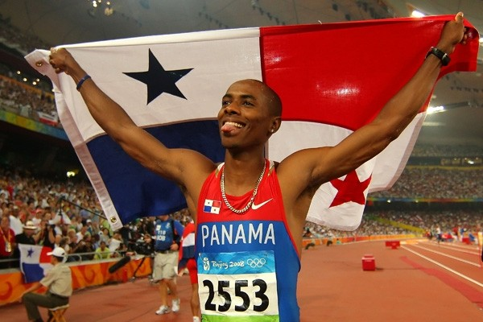
B2 Long jump flight and landing
Irving Saladino has won, among many accolades, Olympic gold in Beijing 2008 and gold in the 2007 World Championships. He is the first and only Panamanian Olympic gold medallist.
Legs: Hitch kick
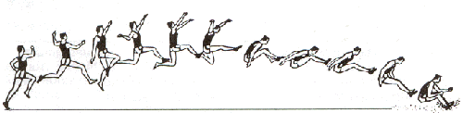
Following take off Saladino’s free leg is driven up powerfully to create upward momentum and extended out in front of his body. It is then swung back under and behind his body, folding as it comes through underneath to counter the rotation created by the second leg coming through. Saladino’s take-off leg then folds beneath the hips and comes forward and through whilst still bent. The take-off leg then continues forward, and extension of the knee straightens the whole leg for landing. The free leg completes its backward swing behind his hip and then folds up and cycles through and joins the forward leg parallel to the pit in preparation for landing. Just before impact, Irving snaps his legs back, his heels drive into the ground and act as an anchor, the snap back then pulling the body forward past the heels. Jumpers often fall to the side as it allows for greater distance to be achieved, as seen demonstrated by Saladino below.
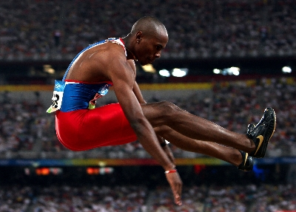
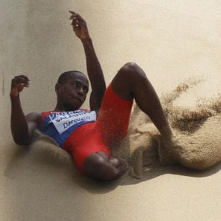
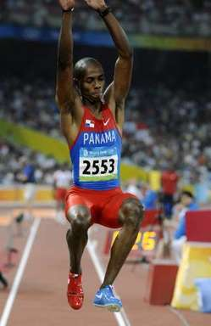

Arms: Hitch kick
The arm on the opposite side of Saladino’s take-off leg is driven up and away from the body at approximately forty-five degrees (taking ninety to be horizontally out in front) he then drives it in a forward circular motion completing a full rotation, to counter the forward rotation that will act upon the jumper in flight. His other arm also completes a forwards rotation; it begins after the first arm but comes round faster so that both of his arms arrive at forty-five degrees simultaneously. The two arms then swing backwards, following the same path as their last revolution but only just passing the trunk, which is leaning forwards, this ensures that the arms can gain enough force in their swing to pull the body past the feet upon landing. Upon impact both arms are simultaneously swung forwards powerfully to carry the body past the feet and achieve maximal distance.

B1 Long jump flight and landing
Legs: Hitch kick
Following take off my free leg is driven up powerfully to create upward momentum and extended out in front of the body, my leg drive is inferior to Saladino’s due to less muscle mass being at my disposal, and also a greater proportion of Saladino’s muscle fibres are fast twitch, in comparison to my own. It is then swung back under and behind the body, folding as it comes through underneath. The take-off then leg folds beneath the hips and comes forward and through whilst still bent. The take-off leg then continues forward, and extension of the knee straightens the whole leg for landing. The free leg completes its backward swing behind the hip and then folds up and cycles through and joins the forward leg parallel to the pit, sometimes however, my legs are not high enough, parallel to the ground, put angled down which reduces the distance I achieve and shortens the distance and angle that my legs have to drive into the ground. Just before impact, the legs are snapped back, the heels drive into the ground and act as an anchor, the snap back then pulling the body forward past the heels, but if my legs have dropped too low then my snap is not as effective as it needs to be. I will then fall to the side as it allows for greater distance to be achieved.
Sequence of the ‘hitch kick’ aerial style.

Arms: Hitch kick
My arm on the opposite side to my take-off leg is driven up and away from the body at approximately forty-five degrees (taking ninety to be horizontally out in front) it then drives in a forward circular motion completing a full rotation, to counter the forward rotation that will act upon me in flight, the rotation is affected by my lack of flexibility, this can destabilise my flight and lead to the landing being unstable and can lose distance. My other arm also completes a forwards rotation, again can be affected by my flexibility; it begins after the first arm but comes round faster so that the two arms arrive at forty-five degrees simultaneously. My two arms then swing backwards, following the same path as their last revolution but only just passing the trunk, which is leaning forwards. Upon impact both arms are simultaneously swung forwards powerfully to carry the body past the feet and achieve maximal distance, if I cannot swing my arms through in a powerful linear motion because of my flexibility then my body may not pass my feet which would cause me to fall back and lose a lot of distance. The distance I achieve is not as great as that achieved by Saladino; this is perhaps due to his ability to train far more frequently than I, which allows his body to be perfectly tuned for his event. He also has superior flexibility to allow easy fluid motion around his joints, which makes it much easier to put power into the movements required to achieve the greatest distance.

Long Jump run up B2
Dwight Phillips (born October 1, 1977 in Decatur, Georgia) is an American athlete and a four-time world outdoor champion in the long jump (’03, ’05, ’09, ’11). He has also competed in the 60 meters and 100 meters sprints.
Long jump run up
The objective of Dwight’s approach is to accelerate to a maximum controlled speed at take-off. The most important factor for the distance travelled by him is his velocity at take-off - both the speed and angle at which he leaves the ground. Elite jumpers usually leave the ground at an angle of twenty degrees or less. The greater the speed at take-off, the longer the trajectory of Dwight’s centre of mass will be, and so the greater the length of the jump.
The drive phase:
The first part of the run is the drive phase. Similar to the way that athletes are when they’re running a sprint Dwight leans into the start of his run to aid his acceleration, but in the drive phase of the long jump run up Dwight is pushing, picking up his foot and pushing back. When Dwight is driving, his head is down and driving his arms high to make sure that he reaches a high enough speed to counteract the forward lean, and stop him falling forwards. This is a highly effective way of achieving a high speed in as short a time as possible.
The transition phase:
In the transition phase, which is approximately two thirds of the way through the run-up, Dwight rises slowly from his low drive phase, into full sprinting stride, bringing his head up with each cycle, continuing to accelerate, standing tall and driving his legs powerfully and smoothly. He keeps his face neck and shoulders relatively relaxed, concentrating on sprinting to the board. Dwight does not drive his arms across his body, but keeps them driving straight, driving his arms smoothly but fast forward and backward action, brushing his vest with his elbows as they pass; this being the most mechanically efficient technique, giving maximum power output whilst wasting little or no energy. His elbows are held at 90 degrees at all times (angle between upper arm and lower arm). His hands are relaxed, fingers loosely curled or flat with his thumb uppermost.
The attack phase:
Dwight runs tall and ‘bouncily’ and is light and quick on his feet. He is not accelerating anymore, but maintaining his speed, this is called floating, and is an energy efficient technique, which allows Dwight to conserve energy and prepare to explode off the board. Phillips sinks his hips during his penultimate stride which is longer than those before and also the final stride, being up to 25 centimetres shorter than a normal running stride, this sinking allows a greater amount of upwards motion from the take-off and also stabilises him as much as possible.

B1
Long jump run up
The objective of the approach is to accelerate to a maximum controlled speed at take-off. The most important factor for the distance travelled by the performer is their velocity at take-off - both the speed and angle at which they leave the ground. Elite jumpers usually leave the ground at an angle of twenty degrees or less. The greater the speed at take-off, the longer the trajectory of the centre of mass will be, and so the greater the length of the jump.
The drive phase:
The first part of the run is the drive phase. Similarly to Dwight, I lean into the start of my run to aid acceleration, but not as low as the angle achieved when I use blocks in the sprint. When I am driving, I have my head down and I drive my arms high to make sure that I reach a high enough speed to counteract the forward lean, and stop myself falling forwards, the speed I achieve however, is not as great as Dwight’s which is quick enough to have seen him succeed in indoor sprinting. This is a highly effective way of achieving a high speed in as short a time as possible. I can allow the height of my arm drives to drop on my last jump which slows my acceleration, resulting in me not being at top speed when I arrive at the board, unlike Dwight who can maintain his full speed for every jump.
The transition phase:
In the transition phase, which is approximately two thirds of the way through my run-up, I rise slowly from my low drive phase, through into full sprinting stride, bringing my head up with each cycle, continuing to accelerate, standing tall and driving his legs powerfully and smoothly. Sometimes I rise too early in which removes the assistance of the lean and so I have to put in more effort to accelerate to my top speed. This causes fatigue in later jumps. I keep my face neck and shoulders relatively relaxed, concentrating on sprinting to the board. Except when I am fatigued, when the strain I put in can cause me to tense them up, wasting energy. I drive my arms smoothly but fast forwards and backwards, I do not drive my arms across my body, but keep them driving straight, brushing my vest with my elbows as they pass. Dwight’s elbows are held at 90 degrees at all times (angle between upper arm and lower arm). His hands are relaxed, fingers loosely curled or flat with his thumb uppermost. I, however, have a tendency to clench my fists and at the bottom of my arm drive, if I am fatigued, I can allow the angle between my upper and lower arm to increase. This lack in aerobic fitness is the major weakness in my run up, as, through slowing down and becoming fatigued as the competition goes on; all areas of my jump are affected.
The attack phase:
I run tall and ‘bouncily’ and am light and quick on my feet. I am not accelerating anymore, but maintaining my speed, this is called floating, and is an energy efficient technique, although mine is not as refined and perfected as Phillips’, as he has more time in which to train and has had longer to perfect it, mine still allows me to conserve energy and prepare to explode off the board. I sink my hips during my penultimate stride which is longer than those before and also the final stride, being up to 25 centimetres shorter than a normal running stride. Sometimes however, if the wind has altered during my run-up, I have to stretch to hit the board and so my last stride is not shorter, this limits the explosive strength I can put into my take-off. Poor anaerobic fitness affects this phase also, as if my aerobic fitness is limited then I cannot explode into the last section of the run up, due to fatigue.

B2 Long jump take-off
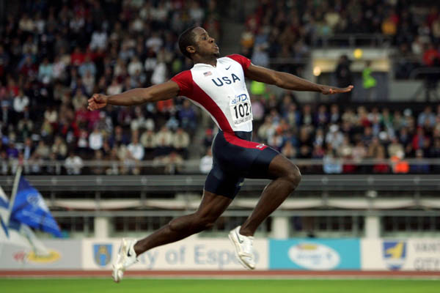
The preparation for the long jump take-off begins in the later phases of the approach run. Dwight prepares for take-off by sinking his hips and then raising them into the take-off phase. His next to last stride is longer than those before and the final stride being up to 25 centimetres shorter than a normal running stride; this ensures that Dwight does not stretch to the board so that maximal effort can be put into the explosive force off the board. Dwight’s hip sink and stride adjustment all happen in response to his postural adjustments. In preparation for the take-off he also prepares the take-off leg by pre-tensing the relevant musculature. At take-off Dwight ensures his hips are slightly forward of the shoulders.
When the take-off foot is placed on the board, it is slightly in advance of the jumper's hips and strikes the board on the mid line. This gives the best possible stability in flight which allows the
The final two foot contacts in Dwight’s take-off are flat, almost slapping. Dwight dorsiflexes his foot to create an angle of approximately 90° - this helps in ensuring that the whole of the base of the foot is presented to the take-off board and can be 'clawed backwards actively'. This is sometimes called the 'ankle sweep back', Where he drives his foot down into the board and forces it backwards. | 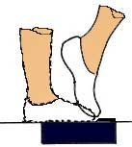
Dwight’s vertical impulse is achieved by the upward acceleration of the "free" limbs, the arms and the non-take-off leg, against the braced take off leg. These movements are characterised by short radius (blocked), and fast explosive actions.
Dwight’s head is carried in a normal position, in line with spine, and his eyes are focused forward and slightly up.

B1 Long jump take-off
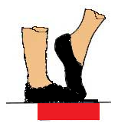
The preparation for the long jump take-off begins in the later phases of the approach run. Like Dwight I also prepare for take-off by sinking my hips and then raising them into the take-off phase, although I often do not sink them far enough, leading to less distance for my body to drive up whilst in contact with the ground, creating lift. My penultimate stride is longer than those before and the final stride being up to 25 centimetres shorter than a normal running stride, my chopped stride can often be too long, resulting in less force being driven through my plant foot, whereas Dwight’s are the perfect length every time, allowing him a perfect take-off. My hip sink and stride adjustment all happen in response to my postural adjustments in preparation for my take-off, to ensure I have the most stable platform to take off from. At take-off I too ensures my hips are slightly forward of my shoulders as much as possible, but if I have not hit my stride correctly, then sometimes they are behind.
When the take-off foot is placed on the board, it is slightly in advance of my hips and should strike the board on the mid line. Although often my foot is off to the left, which can cause unwanted rotation from take-off and into the air, unlike Dwight who hits the centre of the board consistently.
The final two foot contacts in my take-off are flat, almost slapping. I dorsiflex my take-off foot to create an angle of approximately 90° - this will help in ensuring that the whole of the base of my foot is presented to the take-off board and can be 'clawed backwards actively'. This is sometimes called the 'ankle sweep back'. I can sometimes have my foot at an angle greater than 90° which causes the ball of my foot only to hit the take-off board, giving a smaller base from which to sweep from. My sweep back is not as powerful as Dwight’s, which means the distance I can achieve is shorter.
The vertical impulse I achieve is created by the upward acceleration of the "free" limbs, the arms and the non-take-off leg, against the braced take off leg. These movements are characterised by short radius (blocked), fast explosive actions. These are not as explosive actions as Dwight’s, which is partly why his jump is greater than mine.
My head is carried in a normal position, in line with spine, and the eyes should be focused forward and slightly up. Sometimes if I have misjudged my run I look down for the board, to ensure I hit it, which can affect the height I can achieve as my body is then focused downwards, not up.

