A2 Coursework – Athletics (100m sprint & Long Jump)

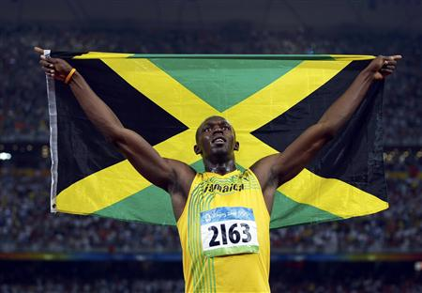
B2 100m 15-60m acceleration phase

Usain Bolt (pictured) is the fastest man over 100m in the world, he also holds the record for the 200m and is widely regarded as the greatest ever sprinter.
After the sprint start and first 15 metres Bolt will have reached approximately 70% of his maximum velocity and will still be accelerating during this, but at a reduced rate in comparison to the beginning of the race.
Legs:
Bolt’s rear leg drives off from the ground, achieving full extension with plantar flexion of the ankle aiding the drive of the toes off the track. He then pulls his leg through explosively, flexing at the knee to such a degree that the heel comes into close proximity with the underside of his buttocks, but not so close as to touch as this would slow the cycle of his leg. Bolt’s thighs and knee drive forwards and high, the lower leg is raised with it still in a state of complete flexion. As the knee is reaching the highest point of the drive his lower leg swings powerfully through, extending forwards of the knee but not achieving full extension until it is in contact with the track. The leg then drives down onto the track, the leg extending at the knee as it goes. The downwards leg drive is a clawing motion, the toe strike is directly below Bolt’s knee and his leg ‘claws’ back as if pulling the ground underneath and behind him, driving his body forward over it.
Bolt remains on the balls of his feet at all times, as this is the most mechanically efficient position to sprint in, with his feet pointing forward straight down the lane, ensuring that he drives his legs straight, maximising his efficiency and effective effort distribution. As it is a sprint, his leg action is as fast as possible with good stride length to allow Bolt to continually accelerate through this phase.
Arms:
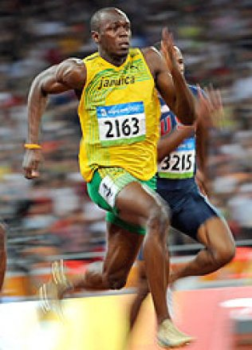
Bolt drives his arms smoothly but powerfully back and forth as fast as possible whilst still maintaining control, as this facilitates the rapid movement of his legs. The elbow drive commences just before rear leg drive and his elbows are kept at 90 degrees so that his hand doesn’t drop below the approximate level of a pocket. His hands are relaxed, with the fingers either straight or loosely curled but not bunched in fists as this is a waste of energy.
Body:
His general appearance is smooth and relaxed but driving as hard as possible with his elbows and legs. His body is tall with a slight forward lean to aid with acceleration, as his arms and legs are forced to speed up to counterbalance the lean. The angle of the lean is such that a straight line could be placed along Bolt’s head, neck, spine and the extended rear leg. The muscles of his face and neck are relaxed as are the shoulders which are held back and relaxed. The sprinter remains squarely in the middle of his lane at all times, with his eyes focused down the lane to the finish. At the end of this phase the Bolt will have reached 90-100% of his maximum velocity.

B1 100m 15-60m acceleration phase
After the sprint start and first 15 metres you will have reached approximately 70% of your maximum velocity and will still be accelerating, but at a reduced rate in comparison to the beginning of the race.
Legs:
My rear leg drives off from the ground, achieving full extension with plantar flexion of my ankle aiding the drive of my toes off the track. I then pull my leg through explosively, flexing at the knee to such a degree that the heel comes into close proximity with the underside of the buttocks, but not so close as to touch as this slows the cycle of the leg. I cannot do this as quickly or powerfully as Bolt, as he has more developed musculature and is a specialised sprinter, whereas I am a multi-eventer. My thighs and knee drive forwards and high, the lower leg is raised with it still in a state of complete flexion. As the knee is reaching the highest point of the drive the lower leg swings powerfully through, extending forwards of the knee but not achieving full extension until it is in contact with the track. The leg then drives down onto the track, the leg extending at the knee as it goes; Bolts leg has more force as it drives down to the track as he has longer levers, allowing greater momentum to be created. The downwards leg drive is a clawing motion, my toe strike is directly below my knee and my leg ‘claws’ back as if pulling the ground underneath and behind me, driving my body forward over it.
I remain on the balls of my feet at all times, they point forward straight down the lane, ensuring that my legs drive straight, maximising efficiency and effective effort distribution. As it is a sprint, my leg action is as fast as possible with good stride length to allow continual acceleration. My leg action is not as fast as Bolt’s and I also have shorter strides, which means I cannot accelerate as quickly as him.
Arms:
My arms are driven smoothly but not powerfully enough back and forth as fast as possible whilst still maintaining control, as this should facilitate the rapid movement of my legs, but my lack in power limits this, which is my major weakness. Bolt’s elbow drive commences just before his rear leg drive and his elbows are kept at 90 degrees so that his hand doesn’t drop below the approximate level of a pocket. My elbows can often extend beyond ninety degrees which means that I have to waste more energy driving them back through as they have further to travel back up. The hands should be relaxed, with the fingers either straight or loosely curled but not bunched in fists as this is a waste of energy, I have a tendency to bunch mine into fists, but Bolt keeps his in perfect form throughout his whole race.

Body:
The general appearance of the sprinter should be smooth and relaxed but driving as hard as possible with elbows and legs. I can, unlike Bolt, often appear to be too tense, which is affecting the range of movement at my joints and also wasting energy. Bolt’s body is tall with a slight forward lean to aid with acceleration as with mine also, as the body is forced to speed up to counterbalance the lean. The angle of the should be such that a straight line could be placed along the head, neck, spine and the extended rear leg, my head can often be in the incorrect place as I allow it to move, this can put the linear movement of my sprint off, making it less efficient. The muscles of the face and neck of Bolt are relaxed as are the shoulders which are held back and relaxed, but as I have mentioned, I often tense up. I remain squarely in the middle of the lane at all times, with tmy eyes focused down the lane to the finish, although if I know I am not accelerating fast enough, I can tend to see if I can see any competitors coming up next to me in my peripheral vision. At the end of this phase I will have reached 90-100% of my maximum velocity.

C1 100m, 15-60m acceleration phase
The main weakness in my 100m acceleration phase is power. Power in this instance is the maximum exertion of strength within a short burst movement. Power is repeatedly necessary throughout the 100m but it is even more crucial at this point in the race as acceleration is totally reliant on power.
The power is required to drive my trail leg off from the ground behind me and drive it through to a high knee position in front of me, it is then implied again as the leg is driven down to the ground and forces the ground past underneath me. Without this my leg movements can still be quick but they will be unable to propel me forwards to accelerate at a rate fast enough to remain at the front of the race. This will mean other competitors will accelerate past me, making me have to continually try to catch up. Focussing on catching up instead of on my personal race means that my technique will suffer, making it even less likely for me to be able to win the race, which will then result in anxiety at poor performance and could even lead to learned helplessness. This would mean that in future my acceleration phase will be even slower because I do not believe that I am able to accelerate fast enough to be in with a chance.
Power is essential for my arm drives as they need to drive forcefully and quickly back and forth from behind me, then forwards to a point where the hand is level with my head. This movement needs to be as powerful as possible as the force and speed of the arm drives dictates the speed and strength achievable by the legs, which is the most vital element of a sprint, especially in the acceleration phase, where the speed and power of the stride, not the length is the most important.
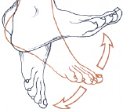
Powerful plantar flexion is also crucial because it drives the body forwards from the last point of contact on the track which aids the acceleration with the aid of a powerful contraction of the rest of the leg which is channelled down through it.
So my lack of power is the most detrimental weakness to my performance even though there are other contributing factors, and so must be addressed.

C2 100m, 15-60m acceleration phase
Weight Training
To improve my power in the acceleration phase of the 100m I am going to use weight training to build muscle mass and increase power in both my arms and legs.
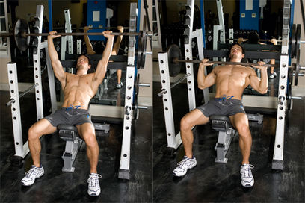
The exercises I will use are as follows:
- Incline Bench Press: Preparation, I will lie supine on an incline bench at approximately 30-40 degrees, this will engage my chest and shoulders. I will then plant my feet, grasp the bar with a grip slightly wider than shoulder width and dismount barbell from rack over my upper chest using wide oblique overhand grip.
Execution, Then I will slowly lower the barbell down to the top of my chest as far as possible without touching my body. I pause, and then slowly raise the bar back to the starting position. Ensuring I do not lock my elbows out, as this risks injury.
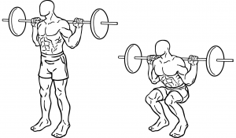
- Squats: Preparation, I Squat down to place my shoulders under the bar. I will then place my feet shoulder width apart directly under my shoulders. I extend my knees and hips until my legs are straight.
Execution, lower the bar by bending my knees forward slightly while allowing my hips to bend back behind, keeping my back straight and knees pointed same direction as feet. I then descend until my thighs are just past parallel to floor. I then lift the bar up by extending my knees and hips until my legs are fully straight.
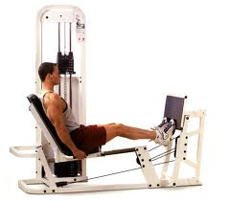
- Seated Calf Press: Preparation, I will sit on the seat and place the balls of my feet on platform. Grasp handles to sides and extend hips and knees. Place toes and balls of feet on lower portion of platform with heels and arches extending off.
Execution, I push the sled by extending my ankles as far as possible and straightening whole leg by extending my knees but not locking them. I return by bending ankles until calves are stretched.
- Dumbell Raises: Preparation, I select and position two dumbbells to my sides with palms facing inwards, arms straight.
Execution, With my elbows to my sides, I alternately raise one dumbbell and rotate my forearm until it is vertical and my palm faces my shoulder. I then rotate my forearms back and lower my arms back to the original position and then I repeat the motion with the opposite arm. I then continue to alternate between sides.
These exercises will increase the power in my arms, which will facilitate rapid leg movement. The increased power in my legs will increase my acceleration dramatically, allowing me so achieve my top speed ahead of my opponents, giving me excellent position from which to enter the speed maintenance phase able to cruise to the finish.

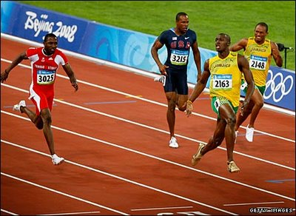
B2 Speed maintenance and dip finish
Usain Bolt (pictured) is the fastest man over 100m in the world, he also holds the record for the 200m and is widely regarded as the greatest ever sprinter. He often finishes far ahead of the field and so does not always dip, instead enjoying an early celebration…

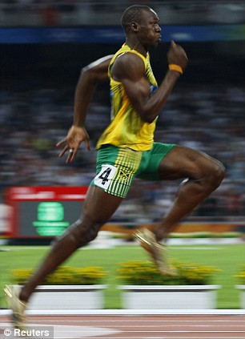
Bolt has his eyes focused at the end of the lane – ‘tunnel vision’ this is to make sure that he focuses on his race technique and not get distracted by his opponents – his head is in line with his spine, held high and square. His face is relaxed causing the ‘jelly jaw’ effect, there is no tension in his jaw and his chin is down and not out.
Bolt holds his shoulders down, relaxing his neck muscles as much as possible, giving the appearance of ‘long neck’, he makes sure his back is not hunched and that he remains relaxed; this is to ensure he has a full range of motion around his shoulders to make sure he gets the most driving force. He is square in the middle of his lane for the duration of the race, because weaving from side to side increases the distance covered in comparison to the other racers, which would put him at a disadvantage.
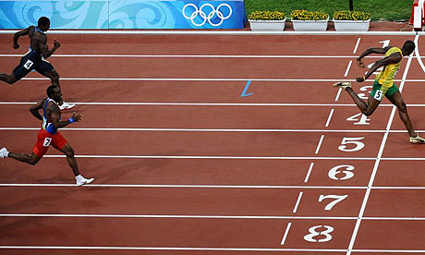
Smooth but fast forward and backward action of the arms, Bolt does not drive them across his body, but keeps them driving straight, brushing his vest with his elbows as they pass, as this is mechanically inefficient and as the . His elbows are held at 90 degrees at all times (angle between upper arm and lower arm). His hands are relaxed, fingers loosely curled or flat with his thumb uppermost.
Bolt uses high knee action called ‘prancing’ to lengthen his stride in the final stages of the race, covering more distance with fewer strides, this efficient as the sprinter is no longer accelerating by this stage so the aim is to try to maintain the highest speed possible through the line. Bolt’s leg action is fast and light as if running on hot surface, Bolt’s hips are tucked under and he uses slight forward rotation of the hip with forward leg drive to help extend the stride. This is seen in the photo of Bolt at the 2008 Beijing Olympics.
For the dip, Bolt leans forward quickly to have his chest cross the line as quickly as possible, as the torso must cross the line to stop the timer. To speed this motion he throws back his arms behind him, this causes forward motion and also brings the shoulders forward and down. As seen here:

B1 Speed maintenance and dip finish
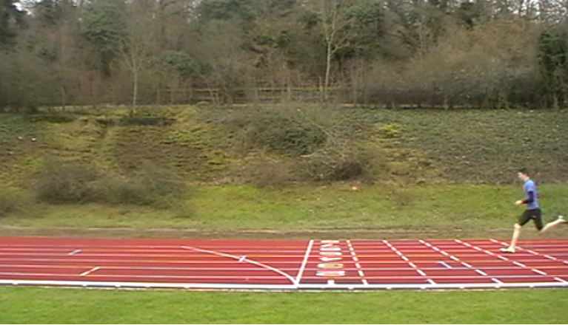
As I near the end of the race, I have my eyes focused at the end of the lane, this is known as ‘tunnel vision’. Sometimes however, particularly in big races, if any of my opponents enter my peripheral vision or even overtake me, then I can lose focus on the line and become preoccupied with my position in relation to them. My head is in line with my spine, held high and square. Bolt’s face is relaxed causing the ‘jelly jaw’ effect, there is no tension and his chin is down and not out. I tend to have a lot of tension in my face, a clenched
jaw, this can lead to tension in my neck which
affects my shoulders and their range of movement,
which in turn would shorten my strides because arm
movement dictates stride pattern.
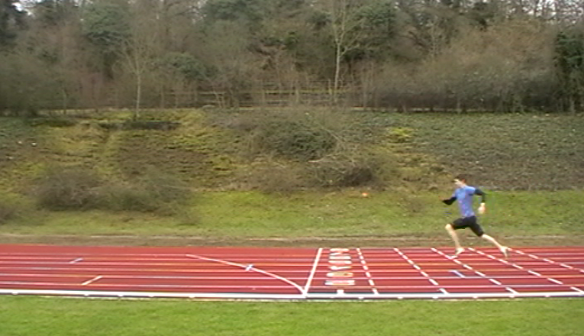
Bolt holds his shoulders down, relaxing his neck muscles as much as possible, giving the appearance of ‘long neck’. He makes sure his back is not hunched and that he remains relaxed and square in the middle of his lane all through the race. If I focus too much on my opponents it can cause me to tense up my shoulders and neck which limits the range of movements and speed of my arm drives, which directly affects my stride length and power, slowing my approach to the line.
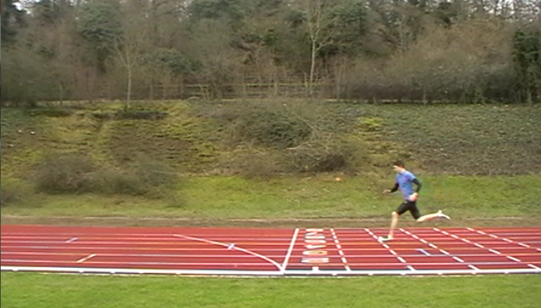
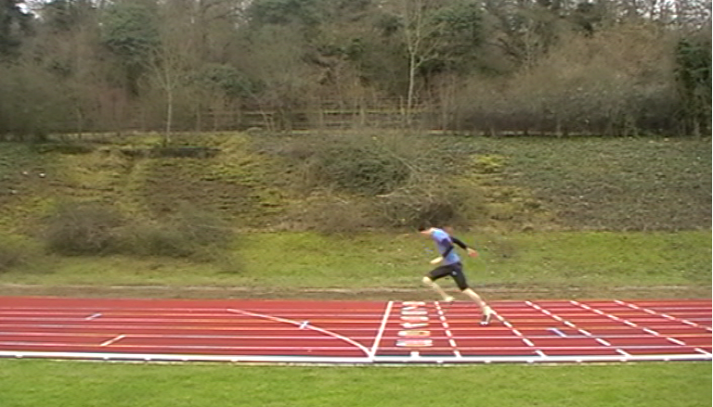
My arm actions are smooth, but not as fast Bolt’s due to my having less muscle mass and fewer fast twitch muscle fibres. Bolt does not drive his arms across his body, but keeps them driving straight, brushing his vest with his elbows as they pass. I often imitate this for the whole race, but if I have tired then I can slip into allowing my arms to come across my body, which wastes energy and slows the arms, which in turn slows my legs. My elbows are also held at 90 degrees (angle between upper arm and lower arm) throughout this phase. My hands are relaxed, fingers loosely curled or flat with my thumb uppermost much the same as Bolt, but again, if I am tiring then sometimes I can bunch them into fists, which is an unnecessary waste of energy as it does not benefit the arm drive in any way and so is using energy better used by the arms or legs.
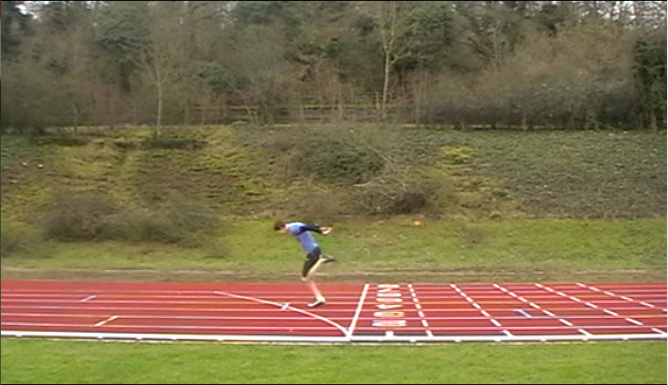
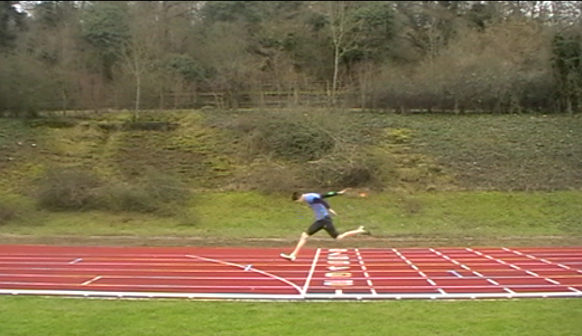
Like Bolt I also use high knee action called ‘prancing’ to lengthen my stride in the final stages of the race, covering more distance with fewer strides, my strides are not as long as Bolt though, as I have shorter legs and I cannot drive them with as much force. This technique is efficient as I am no longer accelerating by this stage so I aim to maintain the highest speed possible through the line. My leg action fast and light as if I were running on a hot surface, my hips are tucked under and I use slight forward rotation of my hips with forward leg drives to help extend my stride.
For the dip, I lean forward quickly to have my chest cross the line as quickly as possible, as the torso must cross the line to stop the timer. To speed this motion I throw back my arms behind me, this causes forward motion and also brings my shoulders forward and down. As seen in my photo sequence down the side of the page.

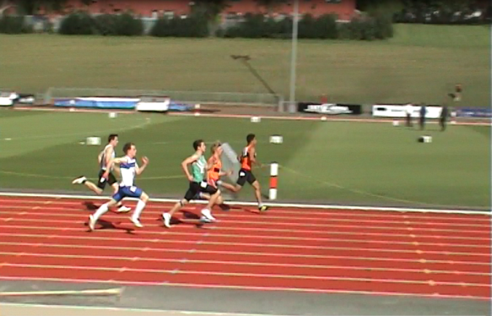
C1 Speed maintenance and dip finish, poor anaerobic fitness.
The major limiting factor on my performance is my anaerobic fitness levels, leading muscular fatigue which causes a breakdown in technique which inhibits my ability to sprint through the line.
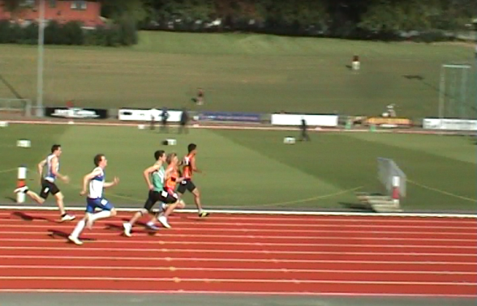
An increasingly acidic environment (acidosis) causes a breakdown in the chemical reactions that produce the muscle fibre contractions I need to continue sprinting, by denaturing the enzymes needed, such as ATPase. Acidosis is caused by the build-up of lactic acid and the release of hydrogen ions.
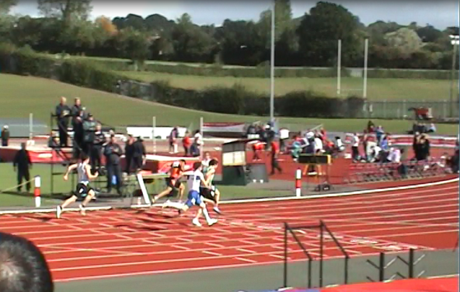
There is a change in the balance of the chemicals that propagate the action potential within the muscle fibre. This decreases the excitability of the muscle fibre and therefore reduces its ability to contract. This is has a massive effect on a sprint which requires all the muscles used to be contracting with the highest force the muscle can produce for the whole race. Any decrease in the output of the muscle fibres results in a decrease in speed which severely inhibits my ability to maintain my sprint through the line.
Another factor affecting my anaerobic fitness is my stores of phosphocreatine running out, this means that I cannot resynthesize ATP to continue to provide energy to continue sprinting at high speed. Although the aerobic and lactic acid systems are available, they cannot provide energy quickly enough to sustain ATP levels at the level of work in a 100m race.

C2 Interval Training

The Anaerobic (ATP-PC) Energy System
ATP-PC System - 'ATP-PC system' stands for 'Adenosine-Triphosphate - Phosphocreatine system'. This energy system is used as a rapid way to resynthesise ATP in the body, and lasts for approximately 10 seconds. It is only able to last for a short duration longer than that of normal ATP, as 1 PC molecule can reform only 1 molecule of ATP, once all the PC in the muscle cell is broken down, this energy system no longer functions, and the lactic acid system takes over. The ATP-PC system allows high intensity activity such as very explosive movements to last longer.
Adenosine Triphosphate (ATP) stores in the muscle last for approximately 2/3 seconds and the resynthesis of ATP from Phospho-Creatine (PC) will continue until PC stores are depleted, which takes approximately 4 to 5 seconds. In total this gives me around 5 to 7 seconds of ATP from these two combined
For me to develop this energy system, for specificity I will need sessions of 4 to 7 seconds at high intensity, working at near peak velocity. A training session would look something like this:
- 3 sets of 10 repetitions over a distance of 25/30m. There would be recovery of 30 seconds per repetition and 5 minutes rest per set.
- Using the I would then progress to doing 15 x 60m with 60 seconds recovery
- 20 x 20m shuttle runs with 45 seconds recovery
- This series of sprints can be easily altered to produce overload and the varying exercises help to prevent tedium. Listening to an iPod whilst training can also reduce tedium.

The Anaerobic Lactate (Glycolytic) System
Only used at the very end of the 100m, possibly for the last 10 or 15 metres.
Once the PC stores are depleted the body resorts to stored glucose for ATP. The breakdown of glucose or glycogen in anaerobic conditions results in the production of lactate and hydrogen ions. The accumulation of hydrogen ions is the limiting factor causing fatigue, as it causes an imbalance of the chemicals that propagate the nervous stimulus (the action potential) within the muscle fibre. This decreases the excitability of the muscle fibre and therefore reduces its ability to contract.
Sessions to develop this energy system:
- 5 to 8 x 300m fast - 45 seconds recovery - until pace significantly slows
- 150m intervals at cruising pace, this should be maintaining a speed of approximately 75% of my maximum- 20 seconds recovery - until pace significantly slows
- 8 x 300m - 3 minutes recovery (lactate recovery training)
Speed Endurance can be developed using a session such as this:
Speed Endurance
Intensity | 95-100%
Distance | 80-150m
No of Repetitions per Set | Up to 5
No of Sets | 3
Total distance covered per session | Up to 2250m

The effects of this training should be that as I near the end of the race I will be able to maintain my speed right through the line. The training will have increased the resynthesis of Adenosine triphosphate by increasing the saturation on Phosphocreatine so the Adenosine diphosphate will find it quicker, which will decrease the time taken to resynthesize the ATP, which will mean I will have more speed endurance and not tire as much at the end of the race. My body will also have become more efficient at removing lactic acid from my system from this repetitive high intensity training. These results will allow me to continue driving my knees high and extending my strides, and sprint through the line, maintaining or gaining position in the race.

B2 - 100 metre Sprint Start/Drive Phase
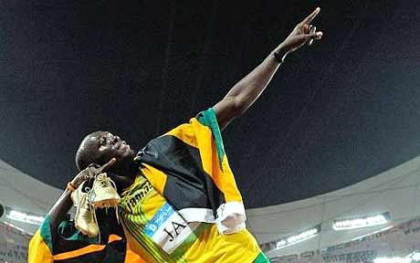
Elite/model performance.
Usain Bolt (pictured) is the fastest man over 100m in the world, he also holds the record for the 200m and is widely regarded as the greatest ever sprinter.
A quick reaction is essential, the quicker the start, the greater the advantage over the field.
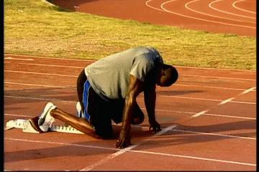
On your marks
When Bolt hears the initial command, "On your marks", he moves forward to his Blocks and adopts a position with his hands a little wider than shoulder width apart and just behind the starting line, with elbows straight, but not quite at full extension; so that he is in the correct position to assume the approximately forty five degree angle for the drive out of the blocks, but still has the capacity for a small spring from his arms to push him up. His hands form an arch using the fingers and thumb. The balls of his feet are in contact with the starting blocks and the knee of Bolt’s rear leg is in contact with the track. His head and neck are in line with his spine, with his face and neck relaxed. This body position provides the perfect platform from which to explosively drive from, without deviating from course, compensating for or wasting energy on any unwanted movements. He settles himself mentally and physically in preparation for the race, relaxed but completely focussed on the race; eyes focused on the track immediately in front of him.
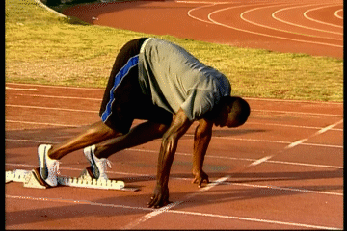
Set
On hearing the "Set" Bolt raises the knee of his rear leg off the ground to approximately one hundred and twenty degrees, thereby elevating his hips above his shoulders. This shifts his centre of gravity up and out, to give extra forward momentum when he drives out of the blocks. His head and neck are still in line with his spine, in preparation for his body to be at a forty five degree angle when he drives out of the blocks. By this point ‘tunnel vision’ should have set in; this is where Bolt will be looking straight down his lane to the finish.
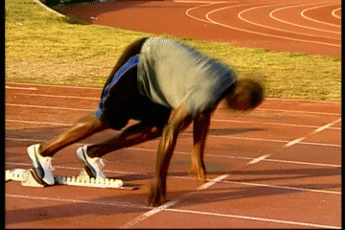
Firing of the gun
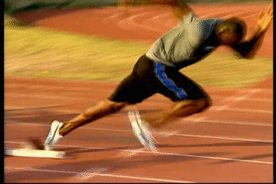
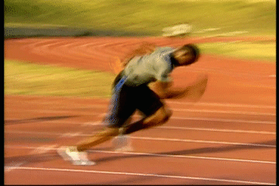
Then on the firing of the gun Bolt reacts by lifting his hands from the track, driving his arms vigorously and powerfully, achieving horizontal hyper extension; this driving of the arms dictates the speed power and length of his strides, and so is essential. He drives with both legs off the blocks bringing the rear leg through and into the first running strides, which are shorter and quicker than full race stride to optimise acceleration. It is important not to jump out of the blocks, but an explosive force is critical. His body is at approximately 45 degrees and his head is facing down at the track as he drives out of the blocks for the first 15-20m, this angle adds momentum to the start as it is necessary to accelerate so as not to fall forward and is also an optimal angle for putting explosive strength into the strides. He gradually rises towards an upright position during this phase. At no point do Bolt’s heels touch the track, he remains on the balls of his feet from the moment he settles into the blocks. The aim of his start is to leave the blocks balanced and with maximum velocity to permit Bolt to rapidly take up a mechanically efficient running position to optimise his race.
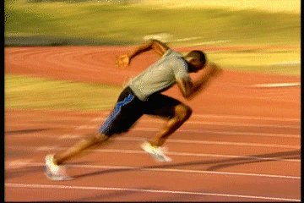
Result
If Bolt’s start is perfectly executed then he will have reached upright position having accelerated to near his top speed, in the minimal time, with maximal efficiency. He will be balanced and have good field position, allowing him to lengthen his strides, maintain his sprint through the finish line and win the race.

100 metre Sprint Start/Drive Phase- B1
My performance.
On your marks
Once, following the commands, I have settled myself into the blocks, I have the balls of my feet on the blocks, my rear knee in contact with the track, hands evenly positioned slightly wider than shoulder width. My shoulders are back and vertically above or slightly forward of my hands. My arms are straight but I do sometimes lock my elbows, which affects the amount of spring that I can achieve to drive my body from the blocks. I have my fingers and thumbs holding my palms off the track and bearing my weight. My head and neck are in line with my spine, sometimes however, I have my head positioned dropped too low; this means my angle of leaving the blocks can be too low, making it difficult to come up to full height quickly enough. I breathe gently, my face and neck relaxed; eyes focused on the track a meter or two in front of me. Unlike Bolt I can be anxious when I have set myself in the blocks, this can lead to over arousal, which causes problems with my performance throughout the race; I tense up my shoulders and neck, which reduces the efficiency and range of my arm drives, directly negatively effecting the speed and fluidity of my strides. It can also lead to learned helplessness, where I believe that failure is inevitable.
Set
On hearing the "Set" I elevate my hips to a position above my shoulders and shift my centre of gravity up and out, raising the knee of my rear leg off the ground to an angle of approximately one hundred and twenty degrees and the front leg to about ninety degrees; this will give extra forwards momentum in the drive phase (first 20 - 30m). Sometimes however, unlike Bolt, I can raise my hips too high, which also decreases the amount of explosive force I can generate from the blocks. My head and neck are still in line with my spine, in preparation for my body to be at a forty five degree angle when he drives out of the blocks, and I am looking one to two metres ahead.
Firing of the gun
Then on the firing of the gun I react. On the ‘B’ of the bang I exhale; lifting my hands from the track, driving them powerfully, achieving horizontal hyper extension and driving with both legs off the blocks bringing the rear leg through and into the first running strides, which are shorter and quicker than full race stride, sometimes I can make my first strides too long which also a fault that Bolt sometimes has, although he is able to rectify it. My reactions are slower than Bolts, and this can lead to poor field position coming out of the blocks. My body is at approximately 45 degrees and my head faces down at the track as I drive out of the blocks for the first 15-20m, gradually rising towards the upright running position. The aim of his start is to leave the blocks balanced and with maximum velocity to permit me to rapidly take up a mechanically efficient running position to optimise their race. I however, struggle to accelerate up to speed in the short time of the drive phase, I therefore have poor field position and am struggling to make up ground throughout the race; the lack of explosive power, the mass and strength of my fast twitch fibres not being great enough, is a major causal factor. Over arousal at this stage can affect my performance by making me false start because of over-anticipation of the gun. It could conversely make my reaction slower, as my over-arousal could be due to social inhibition theory, and I would become very aware of the crowd. If I suffered from somatic anxiety, I would be over-aware of my body’s physiological responses to a situation which I feel anxious. This would mean I would have lost selective attention, and so when the stimulus for me to start was initiated, it would have to wait due to the bottleneck theory; where I can only process a single stimulus at a time, and so I have to process other stimuli before I can react to the gun being fired.

C1 100m sprint start
My major weakness in the 100m start is over-arousal and anxiety. The detrimental effect of my arousal can be explained by the ‘inverted U theory’ 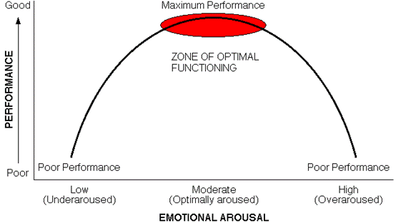
As seen above, performance is at its peak when my arousal levels are at their optimum, in the zone of optimal functioning. This is when I am aroused enough so as not to be under aroused which would cause my performance to be lack-lustre and sluggish, but not so high that I become over aroused and I make mistakes, such as ‘jumping the gun’ where in anticipation of the gun being fired, my over arousal causes me to start before I have received the stimulus to begin.
This over-arousal can also cause anxiety; this affects my performance because it causes me to tense up. This is detrimental to my performance in multiple ways; if I am tensed up then my shoulders cannot achieve horizontal hyperextension when I drive my arms out of the blocks. This decreases the power of my arm drives, which directly affects my leg drives as it prevents them from reaching optimum length as quickly as they should be able to; increasing the time it takes me to accelerate for the first fifteen to twenty metres. This immediately puts me at a disadvantage as I have to work even harder to try to get back into the race.
Somatic anxiety is a contributing factor to the decrease in my performance. When I have become over-aroused my body has many somatic responses, these include an increased heart rate and breathing rate, sweating, the need to urinate, the aforementioned increase in muscle tension and butterflies in my stomach. It is my awareness of these responses that increase my anxiety, and also my awareness of these responses that causes attentional narrowing which is where it takes me longer to process new stimuli such as the gun because of the attention to internal stimuli relating to my anxiety. This results in an increased reaction time, which puts me at a disadvantage to my opponents as I have begun sprinting after them, allowing them to have a lead from the off.
Catastrophe theory can also be applied to my start if my anxiety levels are high enough. Catastrophe is a development of the inverted U theory, where, instead of a steady fall off in performance following over arousal, there is a much faster and dramatic reduction in performance. This extreme decline is caused by high levels of both cognitive and somatic anxiety. This results in my performance being of far lower standard than it should be, and for the period of the 100m it would not be recoverable.
Evaluation apprehension contributes to my over-arousal as most of the competitions I race in have crowds among which are friends and my coaches, I therefore have the sense that my performance is being watched and evaluated which can cause problems if I already have uncertainties as to how I will perform as the evaluation of my performance I know is happening makes me want to excel and win. This places increased pressure on my performance, causing over arousal.
This is social inhibition (the detrimental effect of an audience on a performer’s performance) does not apply to the whole crowd though, as I perform better in front of a large crowd, this is social facilitation.

C2 100m Sprint start
To control anxiety and stress I shall implement a number of cognitive techniques:
Imagery: creating mental images to escape the immediate effects of anxiety.
One way of reducing stress is by changing the environment that is causing stress, but in the 100m it is not possible to do so. Imagery is a useful method of relaxing in such situations. Particular environments can be very relaxing, while others can be intensely stressful, an athletics arena for example. The principle behind the use of imagery in stress reduction is using my imagination to recreate a situation which in which I can relax, such as imagining myself at my training track where there is no pressure and it is strongly associated with positive emotions as training is a pleasurable activity. This dissipates the stress of the situation that I am in, enabling me to relax and focus on performing. I would do this in the time before we are called to our marks.
Visualisation: The process of creating a mental image of what you want to happen or feel (Mental rehearsal)
Visualisation is another form of mental rehearsal which uses visualisation to lock onto the ‘perfect performance’ as a way of focussing on controlling the performance. This reduces anxiety by diverting attention away from the cause of the anxiety and blocking out anxious thoughts.
In training, I would practice and watch the model performance of the sprint start so that I have the image and feel in my mind of the complete perfect performance. I can then ‘step into’ this and repeat it over and over in my head, mental rehearsal. This strengthens the pathways which will be utilised in the physical performance of the skill. So that when I got to the competition I would be able to visualise the performance and feel myself performing it giving me the confidence to go and do it, nullifying the effects of the anxiety or stress I may have been feeling.
Attentional control and cue utilisation: maintaining concentration on appropriate cues.
With this technique, when I had set myself in the blocks, I would block out all other stimuli and concentrate on the commands of the starter and then wait for the gun. This reduces anxiety because it blocks out the other competitors and crowd, who can cause social inhibition of my performance. It can also reduce my reaction time, which is a positive side effect.
Thought stopping: conditioning the mind to think of alternatives to the anxiety-causing negative thought.
This relaxation technique uses a simple physical or mental ‘action’, for example clenching a fist or imagining a picture as a means of switching your attention into a controlled mental state hence reducing cognitive anxiety. This can be used before the race, before I am called to my marks.
Self-talk: developing positive thoughts about one’s actions.
Breathing control: Using diaphragmatic breathing as a means of focusing on relaxation.
All of these techniques will create a state of mind in which I am not over aroused and anxious, but clear headed and able to concentrate on my race technique which allows me to increase the levels of my performance.

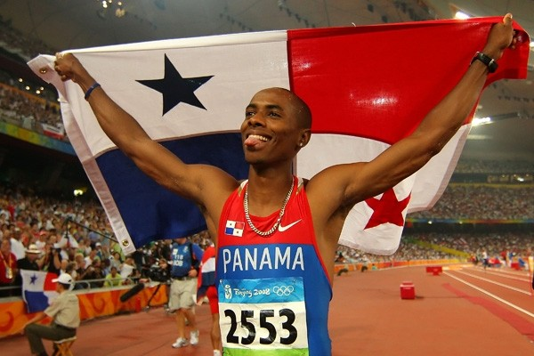
B2 Long jump flight and landing
Irving Saladino has won, among many accolades, Olympic gold in Beijing 2008 and gold in the 2007 World Championships. He is the first and only Panamanian Olympic gold medallist.
Legs: Hitch kick
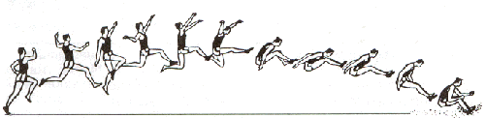
Following take off Saladino’s free leg is driven up powerfully to create upward momentum and extended out in front of his body. It is then swung back under and behind his body, folding as it comes through underneath to counter the rotation created by the second leg coming through. Saladino’s take-off leg then folds beneath the hips and comes forward and through whilst still bent. The take-off leg then continues forward, and extension of the knee straightens the whole leg for landing. The free leg completes its backward swing behind his hip and then folds up and cycles through and joins the forward leg parallel to the pit in preparation for landing. Just before impact, Irving snaps his legs back, his heels drive into the ground and act as an anchor, the snap back then pulling the body forward past the heels. Jumpers often fall to the side as it allows for greater distance to be achieved, as seen demonstrated by Saladino below.
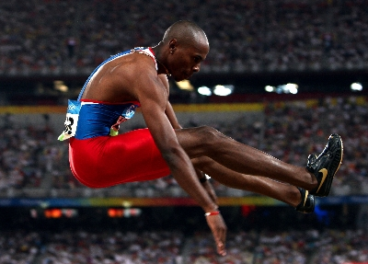
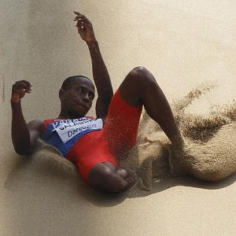
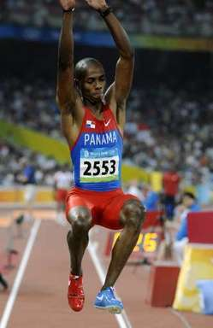

Arms: Hitch kick
The arm on the opposite side of Saladino’s take-off leg is driven up and away from the body at approximately forty-five degrees (taking ninety to be horizontally out in front) he then drives it in a forward circular motion completing a full rotation, to counter the forward rotation that will act upon the jumper in flight. His other arm also completes a forwards rotation; it begins after the first arm but comes round faster so that both of his arms arrive at forty-five degrees simultaneously. The two arms then swing backwards, following the same path as their last revolution but only just passing the trunk, which is leaning forwards, this ensures that the arms can gain enough force in their swing to pull the body past the feet upon landing. Upon impact both arms are simultaneously swung forwards powerfully to carry the body past the feet and achieve maximal distance.

B1 Long jump flight and landing
Legs: Hitch kick
Following take off my free leg is driven up powerfully to create upward momentum and extended out in front of the body, my leg drive is inferior to Saladino’s due to less muscle mass being at my disposal, and also a greater proportion of Saladino’s muscle fibres are fast twitch, in comparison to my own. It is then swung back under and behind the body, folding as it comes through underneath. The take-off then leg folds beneath the hips and comes forward and through whilst still bent. The take-off leg then continues forward, and extension of the knee straightens the whole leg for landing. The free leg completes its backward swing behind the hip and then folds up and cycles through and joins the forward leg parallel to the pit, sometimes however, my legs are not high enough, parallel to the ground, put angled down which reduces the distance I achieve and shortens the distance and angle that my legs have to drive into the ground. Just before impact, the legs are snapped back, the heels drive into the ground and act as an anchor, the snap back then pulling the body forward past the heels, but if my legs have dropped too low then my snap is not as effective as it needs to be. I will then fall to the side as it allows for greater distance to be achieved.
Sequence of the ‘hitch kick’ aerial style.

Arms: Hitch kick
My arm on the opposite side to my take-off leg is driven up and away from the body at approximately forty-five degrees (taking ninety to be horizontally out in front) it then drives in a forward circular motion completing a full rotation, to counter the forward rotation that will act upon me in flight, the rotation is affected by my lack of flexibility, this can destabilise my flight and lead to the landing being unstable and can lose distance. My other arm also completes a forwards rotation, again can be affected by my flexibility; it begins after the first arm but comes round faster so that the two arms arrive at forty-five degrees simultaneously. My two arms then swing backwards, following the same path as their last revolution but only just passing the trunk, which is leaning forwards. Upon impact both arms are simultaneously swung forwards powerfully to carry the body past the feet and achieve maximal distance, if I cannot swing my arms through in a powerful linear motion because of my flexibility then my body may not pass my feet which would cause me to fall back and lose a lot of distance. The distance I achieve is not as great as that achieved by Saladino; this is perhaps due to his ability to train far more frequently than I, which allows his body to be perfectly tuned for his event. He also has superior flexibility to allow easy fluid motion around his joints, which makes it much easier to put power into the movements required to achieve the greatest distance.

C1 Long jump flight and landing.
The main weakness affecting my long jump flight and landing performance is the limited range of movement around my joints, my flexibility.
My limited flexibility affects my performance because my technique relies on the cyclical motion of my arms and legs. If this motion is impeded, the forwards rotation acting upon me as I am in the air will rotate my body forwards and I will lose control and land leaning too far forwards which will decrease the length of my jump, as I will be unable to shoot my legs forwards to gain the distance I need to perform well. It could also result in injury as over-rotation could cause me to land on my front, shoulders or head, all of which could result in injury serious enough to prevent me from competing in the rest of the competition or the near future, such as a sprain, dislocation or concussion.
Inflexibility will also have a detrimental effect upon each phase of my long jump flight and landing as well as an overall effect.
After I have taken off, my free leg needs to drive powerfully up as high as possible to create lift, if however, due to a lack in range of motion it cannot drive up very high, the lift generated will be severely diminished and the decreased height achieve will drastically decrease the trajectory of my jump, severely diminishing the distance I can achieve.
The same also goes for my take-off leg, once it has driven off from the board it is needed to drive up and through in a similar way to the free leg, and then to extend up and out at right angles from the body and maintain this position to allow stable flight and a safe landing. Without the flexibility to pull the leg through under the body and out to a ninety degree angle from the body then the flight is destabilised and I would begin to fall to the left, my body leaning over to the side. This would lead to a landing which was too heavily on the left hand side, which would make it impossible for me to snap my legs back and pass the point at which my feet impacted. This will reduce the distance I have achieved by at least a leg length if not more.
If my arms are not flexible enough to cycle in a full circle around my shoulder, and my legs still follow the correct drive and shoot then I will over balance backwards which will result in my landing in a position as though I were lying down, with my back bearing some of the impact of the landing, this will drastically reduce the distance of my jump as by falling back I would lose at least a metre and a half, I being about 185cm tall or more.
All of these factors will lead to either a reduced performance or injury and so is the biggest weakness in my performance.

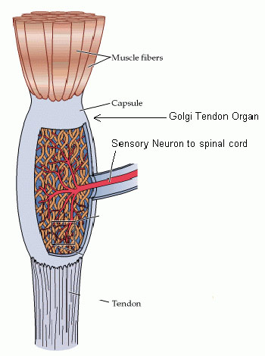
C2 Long jump flight and landing
Proprioceptive neuromuscular facilitation (PNF)
To combat my inflexibility I have decided to use PNF stretching. Proprioceptive neuromuscular facilitation uses alternating contraction and relaxation movements for flexibility. PNF stretching is one of the most effective forms of flexibility training for increasing the range of motion of a joint. PNF techniques can be both passive (no associated muscular contraction) and active (voluntary muscular contraction). While there are several variations of PNF stretching, they all have one thing in common: they facilitate or help the body’s muscular inhibition. This is the reason why PNF stretching is superior to other forms of flexibility training.
The PNF style I am going to use is the contract-relax, antagonist-contract (CRAC) technique, which uses isometric muscle contractions as its basis.
Isometric muscle contractions completed immediately before a passive stretch to help to achieve autogenic inhibition, where the muscles gradually relax. Muscle spindles are highly specialised receptors, located within muscle cells, which protect the muscle from injury. They sense how far and how fast a muscle is being stretched and, when activated, produce the stretch reflex. This reflex action (see image) causes the muscle to contract, preventing overstretching of the joint. For example if you are lying on your back performing a hamstring stretch, and take the stretch to the limit of your range of movement, your leg starts to jump and twitch. At this point the muscle spindles have been activated and are telling the muscle to contract to prevent any further stretching.
Also located within the muscle’s tendon is another sensor called the Golgi tendon organ (GTO). This organ senses how much tension there is being placed on the tendon. However, the GTO differs from the muscle spindle in that, when activated, it relaxes the muscle. Autogenic inhibition is reflex relaxation that occurs in the same muscle where the Golgi tendon organ is stimulated. Often the isometric contraction is referred to as ‘hold’ and the concentric muscle contraction is referred to as ‘contract’.
PNF stretching is not to be performed as a separate exercise session, I shall therefore do a thorough warm-up consisting of five to ten minutes of light aerobic exercise, for example a jog, and some dynamic stretching.
PNF stretching should be avoided immediately before, or on the morning of, a competition and I will leave forty-eight hours between each PNF session.
I will only perform one exercise per muscle group in a session, but I will do two to five sets of each exercise. Each set will consist of one stretch held for up to thirty seconds after the contracting phase.

Long Jump run up B2
Dwight Phillips (born October 1, 1977 in Decatur, Georgia) is an American athlete and a four-time world outdoor champion in the long jump (’03, ’05, ’09, ’11). He has also competed in the 60 meters and 100 meters sprints.
Long jump run up
The objective of Dwight’s approach is to accelerate to a maximum controlled speed at take-off. The most important factor for the distance travelled by him is his velocity at take-off - both the speed and angle at which he leaves the ground. Elite jumpers usually leave the ground at an angle of twenty degrees or less. The greater the speed at take-off, the longer the trajectory of Dwight’s centre of mass will be, and so the greater the length of the jump.
The drive phase:
The first part of the run is the drive phase. Similar to the way that athletes are when they’re running a sprint Dwight leans into the start of his run to aid his acceleration, but in the drive phase of the long jump run up Dwight is pushing, picking up his foot and pushing back. When Dwight is driving, his head is down and driving his arms high to make sure that he reaches a high enough speed to counteract the forward lean, and stop him falling forwards. This is a highly effective way of achieving a high speed in as short a time as possible.
The transition phase:
In the transition phase, which is approximately two thirds of the way through the run-up, Dwight rises slowly from his low drive phase, into full sprinting stride, bringing his head up with each cycle, continuing to accelerate, standing tall and driving his legs powerfully and smoothly. He keeps his face neck and shoulders relatively relaxed, concentrating on sprinting to the board. Dwight does not drive his arms across his body, but keeps them driving straight, driving his arms smoothly but fast forward and backward action, brushing his vest with his elbows as they pass; this being the most mechanically efficient technique, giving maximum power output whilst wasting little or no energy. His elbows are held at 90 degrees at all times (angle between upper arm and lower arm). His hands are relaxed, fingers loosely curled or flat with his thumb uppermost.
The attack phase:
Dwight runs tall and ‘bouncily’ and is light and quick on his feet. He is not accelerating anymore, but maintaining his speed, this is called floating, and is an energy efficient technique, which allows Dwight to conserve energy and prepare to explode off the board. Phillips sinks his hips during his penultimate stride which is longer than those before and also the final stride, being up to 25 centimetres shorter than a normal running stride, this sinking allows a greater amount of upwards motion from the take-off and also stabilises him as much as possible.

B1
Long jump run up
The objective of the approach is to accelerate to a maximum controlled speed at take-off. The most important factor for the distance travelled by the performer is their velocity at take-off - both the speed and angle at which they leave the ground. Elite jumpers usually leave the ground at an angle of twenty degrees or less. The greater the speed at take-off, the longer the trajectory of the centre of mass will be, and so the greater the length of the jump.
The drive phase:
The first part of the run is the drive phase. Similarly to Dwight, I lean into the start of my run to aid acceleration, but not as low as the angle achieved when I use blocks in the sprint. When I am driving, I have my head down and I drive my arms high to make sure that I reach a high enough speed to counteract the forward lean, and stop myself falling forwards, the speed I achieve however, is not as great as Dwight’s which is quick enough to have seen him succeed in indoor sprinting. This is a highly effective way of achieving a high speed in as short a time as possible. I can allow the height of my arm drives to drop on my last jump which slows my acceleration, resulting in me not being at top speed when I arrive at the board, unlike Dwight who can maintain his full speed for every jump.
The transition phase:
In the transition phase, which is approximately two thirds of the way through my run-up, I rise slowly from my low drive phase, through into full sprinting stride, bringing my head up with each cycle, continuing to accelerate, standing tall and driving his legs powerfully and smoothly. Sometimes I rise too early in which removes the assistance of the lean and so I have to put in more effort to accelerate to my top speed. This causes fatigue in later jumps. I keep my face neck and shoulders relatively relaxed, concentrating on sprinting to the board. Except when I am fatigued, when the strain I put in can cause me to tense them up, wasting energy. I drive my arms smoothly but fast forwards and backwards, I do not drive my arms across my body, but keep them driving straight, brushing my vest with my elbows as they pass. Dwight’s elbows are held at 90 degrees at all times (angle between upper arm and lower arm). His hands are relaxed, fingers loosely curled or flat with his thumb uppermost. I, however, have a tendency to clench my fists and at the bottom of my arm drive, if I am fatigued, I can allow the angle between my upper and lower arm to increase. This lack in aerobic fitness is the major weakness in my run up, as, through slowing down and becoming fatigued as the competition goes on; all areas of my jump are affected.
The attack phase:
I run tall and ‘bouncily’ and am light and quick on my feet. I am not accelerating anymore, but maintaining my speed, this is called floating, and is an energy efficient technique, although mine is not as refined and perfected as Phillips’, as he has more time in which to train and has had longer to perfect it, mine still allows me to conserve energy and prepare to explode off the board. I sink my hips during my penultimate stride which is longer than those before and also the final stride, being up to 25 centimetres shorter than a normal running stride. Sometimes however, if the wind has altered during my run-up, I have to stretch to hit the board and so my last stride is not shorter, this limits the explosive strength I can put into my take-off. Poor anaerobic fitness affects this phase also, as if my aerobic fitness is limited then I cannot explode into the last section of the run up, due to fatigue.

C1 Long Jump run up
In Long Jump competitions I have to jump usually five times in quite quick succession. The last two jumps in particular are in quick succession as only the top three or four jumpers get the extra two jumps. This means that my run up can be severely affected as the jumps progress due to a lack in aerobic fitness.
As the competition progresses, I will start to experience the effects of fatigue on my body. This will be because of a low level of oxygen consumption which is utilised in the muscles during exercise coupled with a low level of cardio-vascular endurance. This will have a detrimental effect on my performance and my ability to maintain a high speed run up each jump. The onset of fatigue means that I may become slower and feel more lethargic in my actions, unable to reach the speed required to get a good distance jump.
As the competition progresses I will have made multiple jumps, the last two of which will have been in much quicker succession. This will induce the onset of blood-lactate accumulation through the lactate threshold. During this attacking run up, the exercise will become more intense and so the muscular contractions will require more ATP, therefore, more ATP must be resynthesized to facilitate this. This leads to more glucose being broken down through glycolysis. By doing this more hydrogen is produced through the Krebs cycle, which is then released into the Electron Transport Chain. More oxygen is required to combine with the hydrogen. However, there is so much hydrogen that is released into the Electron Transport Chain that there is not enough oxygen present to bond with the hydrogen to create water. Instead, the hydrogen combines with pyruvate, which is present as a bi-product of glycolysis. These two combine to form lactic acid, which lowers the PH level in the blood and the muscles. This leads to fatigue, which means the glucose reserves become depleted. As fatigue kicks in it becomes harder to maintain the high intensity required for the sprint and so, the overall quality of the jump is affected. This means that where, for example, Dwight Phillips would be able to carry out and identical run up to his first and perform a perfect jump even when the aspects of fatigue are present, I will become slower in my technique and therefore lead to some side effects such as not having the required number of strides due to reduced stride length, resulting in not being on the board.
Another factor, in addition the idea of fatigue having a negative effect, is how heart rate intensities can affect my performance and my ability to carry out the required run up in competition.
As exercise goes on, blood viscosity increases because I start to perspire to maintain my core temperature which means there is less liquid in the blood. The increased viscosity makes it much harder for the blood to be pumped round the body, and returned through venous return to get the oxygen needed to the muscle site and remove the lactic acid which has been created. This means that the heart needs to pump harder and faster to maintain oxygen deliver levels required, and so as chemoreceptors detect that the acidity level in the blood has increased, a message is sent to the medulla oblongata and then down the sympathetic nervous system to the heart’s Sino Atrial Node which initiates the heartbeat, to increase in frequency, resulting in more oxygen being delivered to the muscles and facilitating carbon dioxide removal. This means that a lack of oxygen results in further fatigue and therefore makes sprinting down the run way even more difficult.
All of this has a detrimental effect on my performance. For example, when not fatigued, I am able to perform all the phases of the long jump without undue difficulty; such as the overall speed achieved during the run up. As fatigue increases however, I will reproduce this action with increasingly less effective results.

C2 Long Jump run-up
The main problem with my long jump run up was my inability to maintain the high speed required throughout my jumps. This is down to a lack in aerobic fitness. To combat this however, I do not wish to do too much distance running as I don’t want it to affect the muscle fibres in my legs, as I do not want any of my type II A muscle fibres transforming into type II B fibres. The corrective measure I have chosen, in view of these factors, is altitude training.
Altitude training enhances aerobic performance because the body is forced to adapt to lower levels of oxygen. It responds to this lack in oxygen in multiple ways. There is an increase in the number of red blood cells, and with this increased haemoglobin volume and concentration. There is increased capillarisation on the alveoli in the lungs, creating a larger surface area of capillaries, enabling a much faster rate of gaseous exchange through diffusion. As well as increasing the rate of oxygen transportation, the body is able to buffer lactate more effectively. These benefits continue for ten to fourteen days after the athlete returns to sea level.
Altitude Training schedule
There are three phases of training at altitude:
- Acclimatisation: Acclimatisation begins immediately on arrival at altitude. I will start with light training as my body will not be able to sustain any high effort exercise for any length of time, and I will allow lots of recovery time after exercise as my body will require more recovery time compared to at sea level as it takes in less oxygen. This phase will last for three to ten days.
- Primary training: Primary training is a progressive increase in intensity and frequency to allow the body to acclimatise and adapt to each increase. This increase in training will continue until it reaches the level of training which I was training at at sea level. This phase should last for one to three weeks, in which I will do repetitive sprints of the distance of 50m to increase my ability to run my run up at full pace each time in competition.
- Recovery: This phase can last for two to five days and is designed to prepare for the return to sea level and allow me to recover completely from the fatigue produced by high altitude training. The training volume and intensity is gradually reduced during this phase.
When returning to sea level, there are three stages of the effects upon my performance:
- Positive phase: During the first one to four days there is a visible increase in the capacity of the blood to carry oxygen.
- Progressive return to sea level: There is then a progressive return to sea level training volume and intensity, during which the probability of my having a good performance is reduced; this may be due to my altered fitness levels and loss of coordination whilst I was training at altitude. However, after several days of sea level training, there will be improvements in fitness and coordination.
- Finally, I will experience a fitness peak fifteen to twenty days after returning to sea level. The optimal time for me to compete is during this phase. A combination of positive factors, increased oxygen transport, improved economy and maintenance of breathing adaptations, explains the better performance during this third phase.
There are however many negatives involved in travelling to altitude to train; the reduced capacity to train whilst at altitude can detrimentally affect skill levels, which would have to be trained back up when I reached sea level. There is considerable cost and time involved if I were to travel to and from altitude to train, and there would be fatigue caused by the long distance travel too. There is also a risk of my getting altitude sickness and therefore being unable to train to any degree to make it worth it.
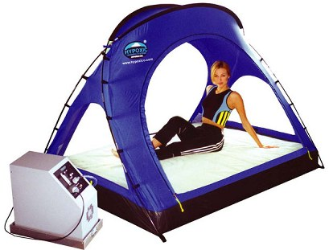
And so, to still gain the advantages of altitude training, but not experience the unwanted side effects, it would be most beneficial if, instead of going to altitude, I used a hypoxic tent which simulates altitude by reducing oxygen levels. This then would allow me to still be able to train at sea level, therefore not losing any skill or fitness levels. It is also becoming recognised that it is most beneficial to live and sleep at altitude but to train at sea level. This hypoxic tent allows me to effectively do this and so would be the most effective method of ‘altitude training’ for me to use.

B2 Long jump take-off
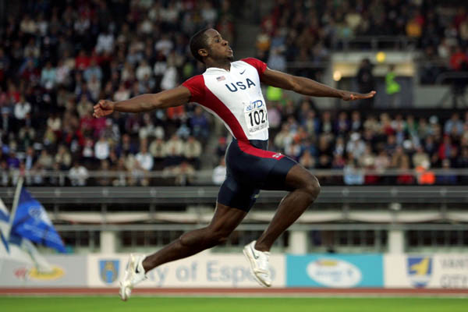
The preparation for the long jump take-off begins in the later phases of the approach run. Dwight prepares for take-off by sinking his hips and then raising them into the take-off phase. His next to last stride is longer than those before and the final stride being up to 25 centimetres shorter than a normal running stride; this ensures that Dwight does not stretch to the board so that maximal effort can be put into the explosive force off the board. Dwight’s hip sink and stride adjustment all happen in response to his postural adjustments. In preparation for the take-off he also prepares the take-off leg by pre-tensing the relevant musculature. At take-off Dwight ensures his hips are slightly forward of the shoulders.
When the take-off foot is placed on the board, it is slightly in advance of the jumper's hips and strikes the board on the mid line. This gives the best possible stability in flight which allows the
The final two foot contacts in Dwight’s take-off are flat, almost slapping. Dwight dorsiflexes his foot to create an angle of approximately 90° - this helps in ensuring that the whole of the base of the foot is presented to the take-off board and can be 'clawed backwards actively'. This is sometimes called the 'ankle sweep back', Where he drives his foot down into the board and forces it backwards. | 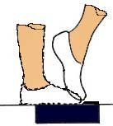
Dwight’s vertical impulse is achieved by the upward acceleration of the "free" limbs, the arms and the non-take-off leg, against the braced take off leg. These movements are characterised by short radius (blocked), and fast explosive actions.
Dwight’s head is carried in a normal position, in line with spine, and his eyes are focused forward and slightly up.

B1 Long jump take-off
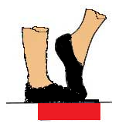
The preparation for the long jump take-off begins in the later phases of the approach run. Like Dwight I also prepare for take-off by sinking my hips and then raising them into the take-off phase, although I often do not sink them far enough, leading to less distance for my body to drive up whilst in contact with the ground, creating lift. My penultimate stride is longer than those before and the final stride being up to 25 centimetres shorter than a normal running stride, my chopped stride can often be too long, resulting in less force being driven through my plant foot, whereas Dwight’s are the perfect length every time, allowing him a perfect take-off. My hip sink and stride adjustment all happen in response to my postural adjustments in preparation for my take-off, to ensure I have the most stable platform to take off from. At take-off I too ensures my hips are slightly forward of my shoulders as much as possible, but if I have not hit my stride correctly, then sometimes they are behind.
When the take-off foot is placed on the board, it is slightly in advance of my hips and should strike the board on the mid line. Although often my foot is off to the left, which can cause unwanted rotation from take-off and into the air, unlike Dwight who hits the centre of the board consistently.
The final two foot contacts in my take-off are flat, almost slapping. I dorsiflex my take-off foot to create an angle of approximately 90° - this will help in ensuring that the whole of the base of my foot is presented to the take-off board and can be 'clawed backwards actively'. This is sometimes called the 'ankle sweep back'. I can sometimes have my foot at an angle greater than 90° which causes the ball of my foot only to hit the take-off board, giving a smaller base from which to sweep from. My sweep back is not as powerful as Dwight’s, which means the distance I can achieve is shorter.
The vertical impulse I achieve is created by the upward acceleration of the "free" limbs, the arms and the non-take-off leg, against the braced take off leg. These movements are characterised by short radius (blocked), fast explosive actions. These are not as explosive actions as Dwight’s, which is partly why his jump is greater than mine.
My head is carried in a normal position, in line with spine, and the eyes should be focused forward and slightly up. Sometimes if I have misjudged my run I look down for the board, to ensure I hit it, which can affect the height I can achieve as my body is then focused downwards, not up.

C1 Long jump take-off
Explosive strength
The weakness that most affects my long jump’s take off is my explosive strength. This is the limiting factor upon both the height and distance that I can achieve, the two factors that decide the trajectory of my jump. This will mean that my jump’s distance is reliant upon two factors which are let down by my lack in explosive strength.
Explosive strength is the rate at which force can be generated by the muscles and exerted. This means that my low levels of explosive strength make the movements required to lift me off the ground and propel me to a distance great enough for the long jump is not as effective as they are not powerful enough in the time I have to make them.
My take-off leg requires high levels of explosive strength to overcome gravity and propel me into the air and forward from the board. However, in the time it takes for my leg to eccentrically contract on hitting the board and then to concentrically contract with the required force in the short time my foot is in contact with the board it has not applied its full force, the contraction time being only 50-250 millisecondsᶧ. If my take off leg cannot provide enough explosive strength then I will not be able to create the lift needed for my momentum to carry me forwards and great distance. This results in me placing low in competitions and losing motivation to continue.
The same also goes for my take-off leg, once it has driven off from the board it is needed to drive up and through in a similar way to the free leg, and then to forcefully extend up and out at right angles from the body and maintain this position to allow stable flight and a safe landing. Without the explosive power to pull the leg through under the body and out fast and forcefully enough from the body, the flight becomes destabilised and I would begin to fall to the left, my body leaning over to the side. This would lead to a landing which was too heavily on the left hand side, which would make it impossible for me to snap my legs back and pass the point at which my feet impacted. This will reduce the distance I have achieved by at least a leg length if not more.
If my arms are not able to cycle in a full circle around my shoulder explosively, and my legs still follow the correct drive and shoot then I will over balance backwards which will result in my landing in a position as though I were lying down, with my back bearing some of the impact of the landing, this would put me at significant risk of injury. This will also drastically reduce the distance of my jump in falling back, as I would lose at least a metre and a half, I being about 185cm tall or more.
When my feet hit the ground, my lack in explosive strength in my arms means that I cannot swing them through explosively enough to generate the force necessary to drive my body past my feet and maximise the distance I achieve. This lack in explosive strength means that instead of my body passing my feet it will impact the sand behind them which limits the distance I can achieve. This will also increase the likelihood of me falling back and reducing the distance of my jump even further.
ᶧAagaard P, Simonsen E. Increased rate of force development and neural drive. ‘Journal of Applied Physiology’. 93: 1318-1326, 2002.

Long Jump Take Off – C2
To increase my explosive strength in the Long jump take-off I will use plyometric training. This works on the principal of eccentric contraction on the downwards phase and concentric contraction of muscles immediately after during the upwards phase. Plyometrics is a type of exercise training designed to produce fast, powerful movements, and improve the functions of the nervous system, generally for the purpose of improving performance in sports. Plyometric exercises may also be referred to as explosive exercises. Plyometric movements, in which a muscle is loaded and then contracted in rapid sequence, use the strength, elasticity and innervation of muscle and surrounding tissues. Plyometrics is used to increase the speed or force of muscular contractions, providing explosiveness for a variety of sport-specific activities, in this instance, the long jump take-off.
LEGS
Drop Jumping
This exercise involves dropping (not jumping) to the ground from a raised platform or box, and then immediately jumping up. The drop down gives the pre-stretch to the leg muscles (eccentric phase) and the vigorous drive upwards the secondary concentric contraction phase. The exercise is more effective the shorter the time the feet are in contact with the ground. The loading in this exercise is dictated by the height of the drop, which should be in the region of 0.7 to 1.10 meters. Drop jumping is a relatively high impact form of plyometric training and would normally be introduced after the athlete had become accustomed to lower impact alternatives, such as two-footed jumping on the spot. But as I have already become accustomed to these in my training, this level of plyometric training is applicable. This will increase the explosive strength in my legs required for a take-off of maximal lift and drive forward through the air.
Bounding and hurdling
Bounding is a form of plyometric training, where oversized strides are used in the running action and extra time is spent in the air. Two-legged bounds reduce the impact to be endured, but to increase the intensity one legged bounding, or hopping, can be used. Bounding upstairs is a useful way to work on both the vertical and horizontal aspects of the running action. Multiple jumps over a series of obstacles such as hurdles are valuable drills for sprinting.
Lower body plyometric exercises with intensity level:
- Standing based jumps performed on the spot (low intensity) - Tuck Jumps, Star Jumps
- Jumps from standing (low-medium intensity) - Standing long jump, Standing hop, Standing jump for height
- Multiple jumps from standing (medium intensity) - bounds, bunny hops, double footed jumps over low hurdle, double footed jumps up steps
- Depth jumping (high-very high intensity) - jumps down and up off box (40 to 100cm), bounding up hill, progression and overload can be obtained by increasing the height or adding a weight vest.
- Eccentric drop and hold drills (high-very high intensity) - hop and hold, bound/hop/bound/hop over 30 metres, stopping and holding on each landing before springing into the next move, drop and hold from a height greater than one metre.
Medicine Ball:
The medicine ball can also be used to condition the legs. The athlete lies face down on the floor, a partner or coach then rolls the medicine ball down the back of the thighs towards the feet, when the athlete feels the medicine ball about to reach their ankles they flick their lower leg sharply up, returning the medicine ball to the hands of the partner or coach. To allow progression and overload, the weight of the medicine ball used can be increased, and the frequency of flicks can also be raised.
ARMS
Press ups & Hand clap
Press-ups with a hand clap in between is an especially vigorous way to condition the arms and chest. The pre-stretch takes place as the hands arrive back on the ground and the chest sinks, and this is followed quickly by the explosive upwards action. As with many plyometric exercises, to get the best training effect keep the time in contact with the ground to a minimum. A weight disc or weight vest can be worn for progression and overload. This will increase the force with which I can use my arms to create lift, when I drive them upwards.
Running with wrist weights
Running with wrist weights conditions the muscles in the upper body to be able to move with large exertion and speed with resistance, building explosive power. When the weights are removed, the muscles will be able to propel the arms with greater speed and force, increasing levels of upward motion.
Medicine Ball:
Another means of increasing upper body strength and power is to lie on the ground facing upwards. A partner then drops a medicine ball down towards your chest; you then catch the ball and immediately throw it back. To allow progression and overload, the weight of the medicine ball used can be increased, and the frequency of drops and returns can also be raised.
Incline Push up depth jump
•The two mats are placed shoulder width apart
•Place the box to elevate the athlete's feet above their shoulders when in a press up position
Face the floor in a press up position with your feet on the box and your hands between the mats, push off from the ground and land with one hand on each mat. You then push off the mats with both hands and back to the starting position. Keep the hand contact time on the mats as short as possible.
How much
3 sets of 10 repetitions a set, 5 minute recovery between each set, Quality of the push ups is far more important than quantity.
All of these exercises will increase my explosive strength which will mean each of the separate parts of my take-off will be more powerful and therefore they will all collate to give a massive improvement to the distance I can achieve in my jump.

