A2 PE Coursework
Name: James Lavis
Date: June 2012
Sport: Football (Goalkeeper)

Contents:
P2 – Strategic skill one
P4 – Defensive skill one
P8 – Defensive skill two
P12 – Strategic skill two
P15 – Attacking skill one
P20 – Attacking skill two

Comparing an Elite performer
Strategic Skill 1– Organising Defence When Defending a Cross
I believe that Tim Howard is one of the premier league and worlds best goalkeepers, one of his great strengths is organising the defence to defend a cross.

Preparation phase

B2 - When an opposition player is out wide and looking to cross a ball into the 18 yard box, Tim Howard will be standing in the traditional position that the majority of goalkeepers use, in between the centre of the goal and the back post. He will be standing a few paces in front of the goal line so that he is ready to run forward and attack the ball. He will have his body facing towards the direction of the opposition player with the ball, whilst having his knees flexed slightly so that he is ready to run and is able to see both the attacking player with the ball and opposition players running in. He will try to ensure that his players have marked the opposition by giving them instructions and pointing to players who aren’t marked. These instructions would include “pick up the man inside” or “mark the space”. These shouts would be directed at an individual player so that they know Tim is talking to them. He would do this so that the players are focused on the jobs that they have to do in defending the goal.
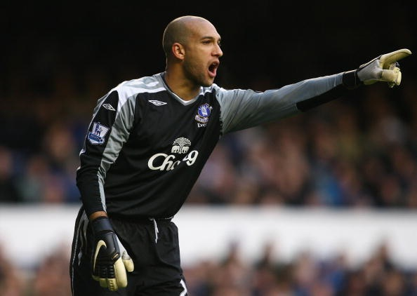
Tim Howard is very precise in his communication as he reacts quickly to the changing demands of a situation and is focused on the right cues, due to his experience he has gained from playing and training at a high level for many years.

B1 - I use the same technique as Tim, I stand in the same position as him in the goal but I do not stand out from the goal line as much as Tim, making the distance from the line of the ball further and reducing my chances of claiming the ball, as I don’t have huge confidence in myself to claim the ball. I tend to have my body closed and not facing towards the oncoming defenders and attackers. This is a huge weakness as I cannot see my defenders coming in and issue them instructions on players that may be unmarked. If I do issue instructions then they tend to be unclear sometimes and not as precise as Tim Howard’s as I can panic and don’t always use clear words. This is due to me being fairly inexperienced and every game I am gaining experience.

Execution phase

B2 - When the player plays the ball into the area, there are 2, maybe 3 main shouts that Tim Howard will use, these are all that are needed for a player to get in order for successful defence of the goal. These shouts are “away”, “keepers” or “time”. These 3 shouts are all a player needs as a cross is played in as it alerts them of the situation in hand. The shout “away” from Tim would alert his defence so they know that there is immediate danger and the ball needs to be cleared away from the goal; he would make the decision to make this call after a quick assessment of the situation, position of attackers and defenders and would draw on his past experiences. Tim Howard would use the shout “Keepers” to alert his defence that he is coming for the ball and that his teammates should leave the ball for Tim to come and collect, he would again make the decision to make this shout after assessing the situation. The shout “Time” alerts his teammates that the player nearest the ball has time to control the ball and play it simple to keep the ball and break, possibly on a counter attack. This shout generates a sense of calmness for the player who is controlling the ball as they know there is no immediate danger. Tim would again assess the situation; he would also draw on the experience he has gained and of knowledge of his teammate’s skills which he has gathered from training with them every day.

Once Tim has communicated with his defence, he is very unlikely to change his mind, he will always come for the ball if he has shouted ‘keepers’, even if its possibly the wrong shout he will come because his defence will have left the ball for him. This is because of his experience and his knowledge of the game and his teammates.

B1 - The three shouts which Tim uses are the ones which I use, whereas Tim will give a shout every time the ball comes in to the 18 yard box I can get caught up in thinking about my positioning or catching the ball and forget to give a shout, this can cause confusion between me and my other team mates within the 18 yard box as they won’t know whether to leave it for me to come and claim or whether to clear the ball away, this can also make my teammates anxious every time a ball comes into the box and possibly cause them to lose trust in me to be able to claim the ball. This is because I have not developed the experience or motor programme fully so I have to think slightly about what I am doing which takes my mind off giving a shout. Unlike Tim I don’t train everyday with my team mates we train twice a week so I don’t know my teammates abilities as well as he does with his team.

Recovery phase
B2 - Once the ball has been cleared or claimed by Tim, he will order instructions possibly ‘squeeze’ or ‘out’ to the defence to get out of the box and up the pitch so that there is no immediate pressure placed on himself and his defence and it could also catch opposition strikers out and they could be caught offside. He will also make sure his defence have picked men up, if his team do not have the ball in possession anymore, and that everyone is in the correct position.

B1 – I use the same calls as Tim Howard as well; I think I am better at this stage because there is nothing for me to think about ,apart from what my position is, physically and no imminent danger to my goal so I have got time to organise my defence before I get into the correct position.

Defending Skill 1 – Catching a cross
I will be comparing Joe Hart, the number one goalkeeper for England and Manchester City because I feel that he is one of the best at claiming crosses using the technique that he uses.

Preparation phase

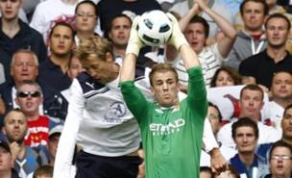
B2 - Joe Hart adopts the traditional technique which is used by goal keepers around the world, but adjusts it to suit himself and to suit his physical attributes and enhance his chances of claiming the ball. First of all, instead of standing in the centre of the goal he stands in between the centre and the back post of the goal, he does this as it easier for him to run forward to either claim the ball or cover his near post than to run backwards if the cross is longer. He will also stand 2 or 3 yards off the goal line, as this is the line which the ball tends to come across, it also makes a cross which is further out and normally harder to come for easier for him to come and claim or punch away. He will have his body at a 45° angle facing the corner of the 18 yard box, facing the way that the ball is coming from. He will be on the balls of his feet and with his knees flexed slightly so that he is ready to run out and jump to claim the ball. Having his body at this angle allows him to see the ball whilst being able to see opposition players making runs into the box so he can issue instructions to his defenders for them to pick the players up and mark them.

B1 – Like Joe I stand in the same position between the posts and like Joe I have my body at a 45º angle, as I like to give commands to my defence. But unlike Joe I don’t stand far enough out of my goal I only stand 1 or 2 yards out which I think is due to me not being as quick an agile as Joe so I feel as though if a shot or header was to be directed at the near post I wouldn’t be able to get there and save it quick enough. Like Joe I have my knees flexed slightly but as the game goes on I tend to not be on the balls of my feet, I think this is due to not having strong enough gastrocnemius muscles to hold my body up on the balls of my feet as the game progresses and I become more tired.

Execution phase

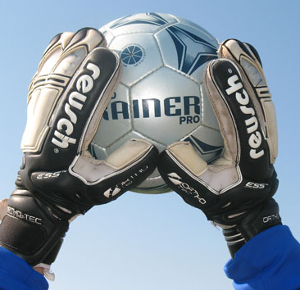
B2 - This stage begins when the ball is played into the box which is the moment when Joe will make his decision to either go and attack the ball to catch it or whether to give his defenders a shout for them to clear it. This decision will be made cognitively subject to the area within the 18 yard box that the ball is played into and the speed that the ball is travelling at. Muscular contractions in his quadriceps and hamstrings will occur as he begins to run towards the line at which the ball is travelling across at, so he is in the correct position to jump and claim the ball at its highest point reducing the chance of the opposition being able to get a head to the ball. Joe has powerful quadriceps and hamstrings as he is quite short for a goalkeeper yet can still claim crosses against tall players such as Peter Crouch (shown in the picture above). He will then use his powerful quadriceps and gastrocnemius to jump off the ground he will also bring either his left or right knee up in front of him to gain extra momentum and also to protect himself from players either jumping or running into him. He will extend his arms fully above his head, again to gain every bit of height advantage over the attacking players he can. He will aim to take the ball just above his head as this is the highest possible point he can catch the ball at. As Joe catches the ball he will have his hands in a ‘W’ shape with his thumbs behind the ball, this is to prevent the ball from slipping through his hands or the force of a hard cross forcing his hands apart. (As shown in the picture)

B1 – Unlike Joe who once has made his mind to either go and claim the ball or let his defenders clear it, I can be indecisive. This is due to my lack of experience and training. Joe has been playing a high level of football for many years and trains every day, whilst I have been restricted in the coaching and training that is available to me and the number of games which are available so I have not yet become experienced enough to decide on one choice and stick to that choice and not change my mind half way through coming out. I also focus on my positioning in relation to the balls trajectory too much and forget to give a shout sometimes; this is because I have not yet developed the motor programmes for the shout to come automatically without me thinking about it greatly. Whereas every catch Joe takes he will have his hands in the perfect ‘W’ position, I don’t always get my thumbs close enough and get my hands behind the ball enough, which sometimes results in my hands being forced apart, again this is from not having the motor programmes being fully developed.

Recovery phase

B2 – Once Joe has caught the ball he will bring his leg back into the original position using adduction. He will also bring the ball into his chest and wrap his arms around it quickly, securing it so that if any attacking players were to run into him the ball will not spill out and create an attacking chance for the opposing team. As he lands on the ground he have flexion of the knee joint to absorb the impact of landing on the ground, he will then distribute the ball to outfield players by either kicking or throwing the ball out.

B1 – At this stage I do the same movements as Joe apart from he will get the ball into his chest and wrap his arms around it to secure it, quicker than I will as he will have repeated this movement hundreds of times and will be in the autonomous stage of learning so won’t have to think about it, where as I will have to still think about the movement to initiate it as I am not yet in the autonomous stage of learning with this skill.

Defensive Skill 2 – Penalties- reaching the corners of the goal

Saving penalties is one of the hardest skills to do in goalkeeping. I am going to compare myself to Joe Hart as I believe he is one of the best goalkeepers at saving penalties which are put into the corner of goals.

Preparation Phase

B2- The first thing Joe will do is stand in the middle of the goal with flexion occurring at the knee joint to get his body into a position which he can spring off into the corners. Over the years which Joe has been a top level goalkeeper he has developed immense power in his quadriceps and hamstrings to gain the explosive power needed to spring off and reach the corners of the goal quickly. He has his knees flexed and up on the balls of his feet because it changes the body’s centre of gravity leaning forward over the transverse plane. He will be balanced and still with his eyes on the ball ready to spring off. This allows him to dive forwards as well as sideways; this narrows down the angle of the ball meaning if he gets a fingertip on the ball then it will go past the post rather than in the net. His feet will be shoulder width apart. He will have both his arms in front of him parallel to the ground with his hands slightly wider than the usual ‘W’ position, this is so he is ready to catch the ball if it is hit straight at him and also for when he dives into the corners he is ready to catch the ball rather than just knock it back out to the opposition players following it up.

Joe would also use some psychological techniques to try and gain a psychological advantage over the penalty taker. There are several techniques he uses, one is walking up to the penalty spot and standing right in front of the penalty taker as he is placing the ball on the spot, another is getting the ball in his hands and walking back to his line and then throwing the ball out but putting back spin on it so the penalty taker has to walk towards him to collect the ball meanwhile Joe will just be staring into his eyes. He will do this to cause anxiety within the player taking the penalty, this level of anxiety can increase nerves and could cause over arousal, increasing the chance of them missing the penalty.

B1 – Unlike Joe I do not have the training facilities to develop the levels of explosive power in the quadriceps and hamstrings. This means I am unable to reach into the corners of the goal and save the penalties, I am also unable to dive forwards with as much explosive power as Joe to narrow the angle this means if I was to get a slight fingertip on the ball then it may possibly go into the goal and not past the post. And unlike Joe I don’t have my hands out in front of me, I have my arms out above my head making myself look as big as possible which also makes the goal look smaller to the penalty taker. Like Joe I have my knees flexed but only slightly and I am up on the balls of my feet but unlike Joe I can become unbalanced which in turn can affect the amount of power I get when springing off to try and save the penalty.

Execution Phase

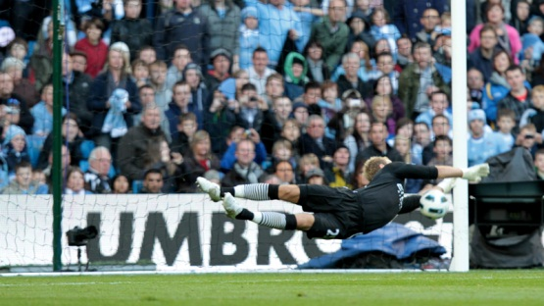
B2 - Like most of the goalkeepers in the professional game Joe will regularly wait for the penalty taker to hit the ball until he begins his movements in one direction or the other, but he will also use his past experiences of what a players body position is like when they are going to place the ball in a certain side of the goal. He will start his execution of the movement by leaning towards the direction the ball is traveling with the trailing leg beginning to leave the ground, for example if he is diving left then his right leg will leave the ground. As he has his knee joint already flexed then the body will wait until his hands are at a horizontal position to the ground, then the knee joint will start to rapidly explode and the quadriceps will contract rapidly causing Joe to gain huge levels of power and momentum towards the ball, allowing Joe to reach the ball at the correct point and hopefully save the penalty. His arms will be fully extended above his head allowing him maximum chance of saving the ball, his hands and arms won’t be any more than a balls width apart ensuring the ball is stopped if it hits his arms or hands powerfully. The biceps, triceps, deltoids and pectorals will contract isometrically to prevent the force of the ball pushing his hands and arms away and ensuring he gets a nice solid hand on the ball.

B1 – I have watched Joe save penalties and have tried to recreate his technique through vicarious learning. Like Joe I wait for the penalty taker to strike the ball, but unlike Joe I do not have the previous experiences to draw on as much as him of what a players body does when they are going to place the ball a certain side of the goal. I have good strength in my quadriceps but the speed of the contraction when my quadriceps are required to contract is not at the same level as Joes and can sometimes cause me to not get into the correct position to save the ball quickly enough if the ball has been hit with real power. Also the strength of my deltoids and pectorals isn’t very good which can lead to me not getting a strong enough hand on the ball, if the ball is hit hard enough it can force my hands backwards which can result in the ball not being deflected enough that it misses the goal.

Recovery Phase

B2 – During the recovery phase of a penalty save Joe’s feet will be the body part which hits the ground first, his body will land in order of feet to head. As he does this he will create amounts of momentum which Joe uses to roll onto his shoulder creating a rocking motion with this momentum and the fact his feet are on the ground he can spring back up using his quadriceps and save any rebounds. Joe has done this a number of times this season where he has saved a penalty and then because of the rocking motion he has been able to spring back up and save the rebound attempt.

B1 – Like Joe I use the momentum from the rocking motion to spring back up and attempt to save any rebound attempts, but due to the increased power in Joe’s quadriceps he is able to get up quicker, due to the lack of explosive power in my quadriceps I find it hard to spring up quickly enough. This season I have only been able to spring up and save rebounds on two occasions.

Strategic Skill 2 – Getting body in correct position when one on one with an attacker

I will be comparing Joe Hart of England and Manchester City. I am using Joe as I feel he is one of the best goal keepers in the world at getting his body in the correct position when one on one with an attacker.

Preparation Phase

B2 – Joe will never drop behind the 6 yard line, unless for a cross or corner, this is because it means he has less distance to cover when coming out to close an attacker down. When the attacker starts to move towards him he will begin to move out and close down the angle between the ball and the goal. He will have his body positioned along an imaginary line which comes out of the centre of the goal and through him to the ball (Shown in the picture). This is so there is not a big hole for him to place the ball in and easily score he will either have to hit a perfect shot into the corner or put it under Joe’s body which he is likely to save. He will have his body in a crouched position with his weight on the balls of his feet ready to move his body weight quickly. He will have the flexion action occurring at the knee joint so his quadriceps are almost parallel to the ground. He will have his feet slightly less than shoulder width apart, the gap between his legs will be small enough to stop the ball if the attacker decides to hit the ball between his legs. He will have his arms just out from the side of his body to make the goal look smaller to the attacker.

B1 – Like Joe I try to imagine the line from the centre of the goal to the ball and try to position myself on this line but sometimes when in a game situation I can lose my position in relation to the goal, this can lead to there being a big gap on one side of me and can allow strikers to just slot the ball into that gap. When I was younger and playing lower standard football I could get away with this as they didn’t pick up on this weakness but as I have started to play higher levels of football strikers have been very quick to pick up on this and try to get me out of position or can exploit the smallest of gaps to score. Like Joe I have my weight over the balls of my feet, but I tend to have my legs a bit too wide which has led to me letting goals in through my legs.

Execution Phase

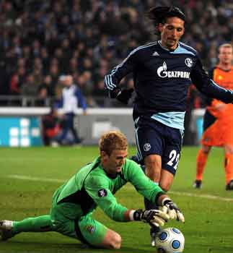
B2 – The execution phase begins as the attacker is about to shoot. Joe will still be in the crouched position and with his weight on the balls of his feet. It is best to stand up for as long as possible so he is able to dive in the right direction of the shot, if he dives early then the striker can just go around him or chip him. Joe will stand up for as long as possible as he has been conditioned to do so. Meaning he is able to move and manipulate his body. He will not anticipate what the striker is going to do as his reflexes are much faster and he can move quickly once he sees which way the ball has been hit. At the level at which Joe plays, players can easily do a fake shot, If he anticipates it or using his selective attention decides to dive where he thinks the player is going to shoot because of their body position or where they are looking, then he could be diving in the wrong direction. If Joe does this then he has committed himself to this dive and the player could easily take the ball around him he will stand up until the ball has been struck as a chance may arise for him to dive at the player’s feet and take the ball from him. Standing up until the player has struck the ball means he will always go the right way which hugely increases the chance of him getting a hand or fingertip on the ball and saving the shot even if they have faked a shot. If the player fakes a shot and Joe stays on his feet and is able to save it then the attacker won’t try it again due to the negative reinforcement they have been given.

B1 – Unlike Joe I anticipate what the striker is going to do and read his body language to select which side I am going to dive to, this leads to me committing myself to one side and then leaving an easy scoring opportunity for the striker. I do this because as I was growing up the standard of players I was playing against would not be able to do a fake shot or shoot in a different direction to what their body was angling up to so I could read their body position and where they were looking, this has conditioned me to always anticipate. But as I have started to play a higher standard I have found that players have seen me dive for a fake shot and then they have realised what I do and have changed their body angle or have done a fake shot making me dive and commit to one side giving them an easy goal scoring opportunity. I do this because I have a lack of confidence within myself in my ability to react quickly enough and save the shot.

Recovery Phase

B2 – Once Joe has dived and saved the ball he will use the momentum created from the dive to roll onto his shoulder and use this momentum to push himself up and get set to save any rebound attempts from the ball being pushed away by Joe. The whole time Joe is performing these movements he knows where he is in relation to the goal and the ball.

B1 – In the recovery phase I do the same movements as Joe. Although he will have more momentum due to the power and momentum created from his gastrocnemius and quadriceps to initiate the dive. Another difference is I can sometimes become confused where I am within relation to the goal and where the ball is. I think this is due to the information processing which goes on within my head, the way I process the situation which is in front of me and at the same time use the lines on the pitch to make sure I am in the correct position for example using the penalty spot as a reference to the centre of the goal.

Attacking Skill 1 – Kicking out of hands to create an attacking opportunity

I will be comparing Shay Given of Aston Villa and the Republic Of Ireland. He is one of the most experienced goalkeepers in world football. I feel that his kicking from his hands is near on perfect and he is very accurate in where he is kicking it.

Preparation Phase

B2 – Shay will begin by holding the ball in both hands with his palms facing each other. He will then transfer the ball into his left hand and hold the ball out in front of him with his left arm fully extended at about waist height, if he wants the ball to have a higher trajectory then he will hold the ball higher up and if he wants it to have a lower trajectory then he will hold it lower down. He will then angle his body towards where he wants the ball to go. Shay will then begin to bring his right leg backwards with slight flexion at the knee joint to create extra momentum through the ball. Plantar flexion will then occur at the ankle joint; making the foot pointed allowing a good strong contact on the ball. Once the leg has extended fully behind him and it is at a point where it can’t be extended any more then he will begin to swing his leg back round to the front of his body. His hips will also naturally rotate forwards he uses this to gain extra momentum and power through the kick. He will then drop the ball as the leg movement forward is initiated. As he drops the ball he will have his eyes fixed on a certain point on the ball, this ensures the best possible contact on the ball. This movement forward is initiated by the type 2a motor units within the quadriceps as it is a fast powerful movement.

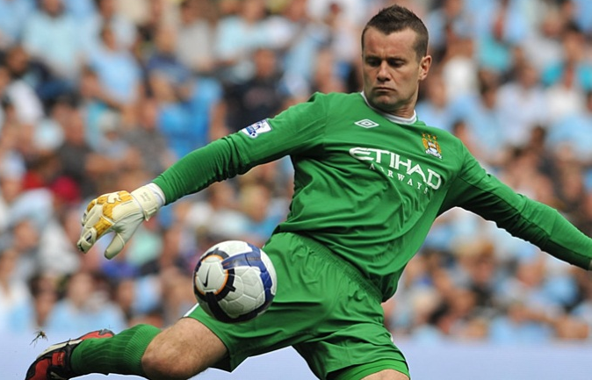
B1 – I use the same technique as Shay for kicking the ball. But a weakness within my kicking is that I drop the ball either too close to me resulting in the ball being kicked too high and not enough distance on it or too far away from me resulting in power and momentum being lost and the ball not travelling as far as it should do. This accurate type of kicking takes a lot of practice, Shay will train every day and will practice kicking every day where as I train twice a week and trying to fit kicking into a training session is difficult. I can also take my eye off the point of the ball I was focused on and change where I am looking resulting in the contact on the ball being weak and losing all power and momentum which has been gained. This can happen due to me looking at my target player or area of the pitch, I focus on this rather than the ball because I become fatigued and can forget to look at the ball.

Execution Phase

B2 – In the execution phase isotonic contraction begins to occur in various muscles in the leg, mainly the hamstrings and quadriceps. The flexion which is occurring at the knee joint turns into extension using the quadriceps and hamstrings which then causes the leg to move forwards. In this movement the agonist is the quadriceps and the antagonist is the hamstring. He will aim to kick the ball as the extension movement begins. This is because this is the point in the movement when the most power and momentum can be generated. He will still have plantar flexion occurring at the ankle and foot so he has a large surface area to make the best possible contact on the ball to gain the best possible distance and accuracy. Due to Shay’s huge experience he is able to kick the ball whilst being relaxed. When kicking out of your hands if you are rushing and tense then the contact on the ball can be weak. So being relaxed ensures he is able to get perfect contact on the ball and subsequently kick the ball accurately to where he wants it to go. But he is still able to kick the ball quickly even if players are still around him in close proximity.

B1 – I use the same technique that of Shay Given uses. Where I differ to Shay is the accuracy at which I hit the ball and how clean my contact on the ball is. I can sometimes rush my kicks as I am trying to start a counter attack quickly; this results in me dropping the ball either to close or too far away from my body. This results in me either getting under the ball too much and kicking the ball too high and not far enough or getting the slightest bit of contact on the ball and it not travelling far enough. My accuracy isn’t as good as Shay’s. This is due to the amount of training I receive compared to Shay. I train twice a week with the sessions lasting 2 hours, this short amount of training means dedicating time to practicing kicking within a game situation can be very hard to fit into this restricted training time. Shay will also dedicate his time to making himself as fit as possible he will work both the aerobic and anaerobic systems. This ensures in a hard game where he may have several saves to make in quick succession his concentration stays at a high level. Reduced concentration is an effect of fatigue. Due to my restricted training time it is hard for me to get the balance right between fitness and skill training. When I become fatigued my levels of concentration drop and I can forget to perform simple parts of the kicking. I can tend to forget to keep my eyes focused on the point on the ball to ensure the maximum contact; this is especially noticeable when I have had an intense period in a game. My kicking can become ineffective when my levels of fatigue increase due to the lack of power and accuracy.

Recovery Phase

B2 - The recovery phase is when the ball has been kicked. Once Shay has made contact with the ball he will move his right leg forward towards the direction he wants the ball to travel in to ensure the accuracy. His leg will continue to move forward until it is at a point where it cannot be raised any more. Once the leg starts to return to its original position the plantar flexion with cease and using dorsiflexion around the ankle joint it will return to its original position.

B1 – In this stage the same action occur when I kick the ball. The only difference is he is able to raise his leg higher due to increased flexibility in his hamstrings due to the amount of training and types of training he receives. This hinders me as I am not able to raise my leg higher to generate more power, resulting in my kicks not travelling as far as they should.

Attacking skill 2 – Throwing to create a counter attack

I will be comparing myself to Brad Friedel of Tottenham Hotspur and former USA number one. I am using Brad as I feel he is one of the best goalkeepers at throwing accurately and triggering a counter attack quickly.

Preparation Phase

B2 - At the beginning of his preparation phase he would have gathered the ball and would have it in his hands with both palms facing each other. He will then make his way to the edge of his area as he is doing so he will be looking for a player or an area around a player to throw the ball to or into. Brad will automatically look at the wide positions first as this is where the greatest chance of a counter attack is. He will always try and aim for an area in front of his player as this will allow them to run with the ball and the counter attack to progress at pace. The faster the ball is thrown out and the counter attack is started the more likely of catching the opposition out of position there is. He won’t run right up to the edge of the box, he will leave a couple of yards to ensure that his momentum doesn’t make him stray outside of his box when throwing it.

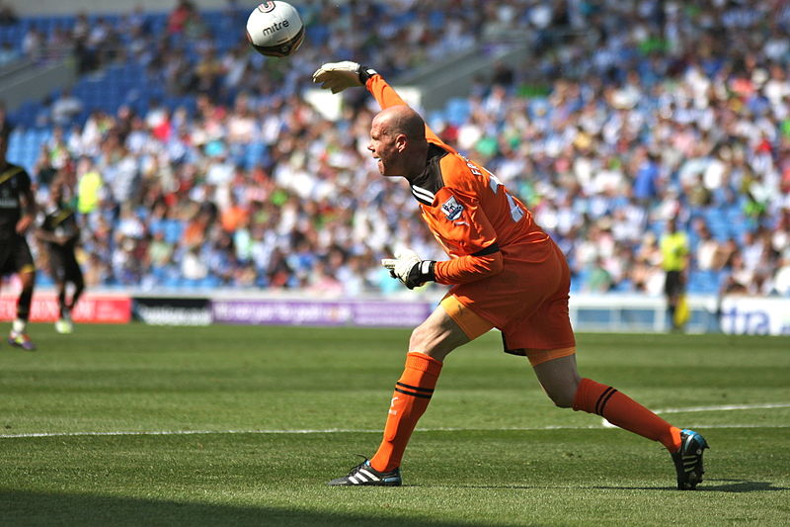
He would have the ball in his right hand as it is his strongest and most accurate, this is because it is his dominant arm meaning it is the strongest and can produce a powerful throw, which is key as opposition players will be trying to intercept it. If the throw is powerful they won’t have time to intercept it. He would have the ball resting on the inner forearm with his wrist being in the flexion position, this is to prevent the ball from falling out whilst he is preparing to throw it. He will then extend his arm behind him with extension occurring at the elbow joint. Brad is able to extend his arm fully behind himself as over many years he has been a professional footballer the training he has received has made his muscles very flexible. Brad has been known to do a lot of yoga over his years of playing professional football. Meaning that he is able to extend his arm further behind himself than a normal person meaning he can generate more power and accuracy.

B1 – Like Brad, once I have collected the ball I go to the edge of my area but still leave about 2 yards between me and the edge of the area. One difference is that once Brad has collected the ball due to his years of experience he will automatically look for a player out wide to throw the ball to and begin a counter attack. I don’t have the experience which Brad has and don’t always automatically look up for a player to throw it to. Another difference is that I haven’t had the years of top training which brad has received so I am unable to extend my arm fully behind me or as far behind me as he can. Subsequently I am unable to generate the same amount of power and accuracy due to the lack of flexibility of the shoulder joint.

Execution Phase
B2 – During the execution phase he would have his arm parallel to the side of his body; he will then bring his arm back behind himself beginning to make a circular motion, a movement similar to a cricket bowl. He will brush his ear with the inside of his bicep, this is to ensure his arm comes over straight, this ensures he gets the maximum accuracy when throwing. He might adapt this as the situation changes e.g. throwing the ball around an opponent who is in front of him. When his arm starts to pass through the frontal plane his wrist will cock back. His wrist will then flick forward helping to generate a small amount of extra power to get the required speed and distance. He will aim to release the ball at its highest point, if it is a throw requiring a lot of distance, then if he releases it at the highest it already has height to get over the players and travel the long distance due to it being the highest point. The main muscles which are used in this movement are the latissmus dorsi, pectorialis major and the deltoids. These are the muscles which are able to stretch to allow the arm to extend further behind the body. He will have his feet one foot in front of the other as this gives him maximum balance which also helps him to get the best accuracy. If his feet were next to each other the momentum he has generated will cause him to fall over resulting in a poor throw. He will also be able to drive his leg through from behind himself which will also create extra power and momentum through the transfer of his weight forward. He will also rotate his hips to generate a bit more power and due to the momentum his hips will naturally rotate.

B1 – I try to imitate the action which Brad uses. I always try and brush my ear with my bicep but due to my lack of flexibility within the latissmus dorsi, pectorialis major and the deltoids I am unable to stretch get my arm to brush my ear fully. I am also unable to generate the power like Brad can from these muscles as he has had many years of specialised training to make his muscles as efficient as possible. I am unable to create the accuracy that Brad creates; this is due to the technique which I use. I have never been coached on how to throw as it has never been an important part of my game at a junior level but now I am playing men’s football it is required more often as the game is quicker and more highly skilled. I have begun to use my body movements to create momentum so I have started to flick my wrist when throwing and rotating my hips. But when in a high pressure situation I can be focused on other parts of my performance which results in me not using the correct technique when throwing. This is due to me still being in the associative stage of the throwing movement. Unlike brad I only train twice a week and don’t always train with the outfield players. Brad trains every day with the same players so they will have set plays where the outfield players run wide straight away.

Recovery Phase
B2 – The recovery phase is when the ball has been released, his arm will continue to make the circular motion, and it will lose momentum as the arm comes down to the side of the body. Whist this movement is occurring the rotor cuff will stabilise the shoulder joint preventing it popping out as it is a ball and socket joint and can be very weak and vulnerable. It is important to keep these muscles and ligaments strong as it can cause serious injury if the joint pops out of place. The arm throwing the ball won’t stop suddenly as this will cause damage to the shoulder joint and muscles around it. His body will continue to rotate through. Once the body has stopped he will stand up and return to his normal standing position.

B1 – I also let my arm come down to my side and let my arm and body slow down naturally to prevent injury. Unlike brad my rotator cuffs are very weak due to me having dislocated both shoulders. I was unable to receive the right kind of physiotherapy which would be available to a top elite performer like Brad. This has resulted in me not being able to throw the ball with as much power as Brad does. The dislocation of my shoulder joint has meant that the muscles around my rotator cuff and shoulder joint have become very inflexible this has resulted in me not being able to extend my arm behind me fully and resulting in a reduction in power on my throw.

