A2 PE Coursework

**Name**: Will Hatlapa

**Date**: June 2012

**Sport**: Hockey (outfield)

**Contents**:

– Strategic skill one: Aerial lob

– Strategic skill two: Disguise pass

– Attacking skill one: Shot on goal

– Attacking skill two: Attacking short corner

– Defensive skill one: Channelling on the left side

– Defensive skill two: Defending a short corner

Comparing an Elite performer

**Strategic Skill 1– Aerial lob from right back to right wing:** This is an incredibly useful skill to perform; it offers height and variety to the game and can easily create goal-scoring chances if done correctly. It is also used to clear out from defence when under pressure.

Elite Performer: I have chosen to use Iain Lewers as my elite performer. He has recently moved from being an Ireland international to an England international, playing for both England and Great Britain. Iain often plays right back using the aerial to find players behind opponents or even to lead them into space. He executes this with precision and power.

**Preparation phase**

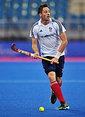

**B2 -** During the preparation phase of an aerial there are four main points Iain focuses on. These are; initial scan, getting into space, receiving the pass and scanning again for players and opponents. The first two are probably most crucial, they happen simultaneously; they are the initial scan for his players and the opponents and getting into space. Iain is at such a high level of ability that he’s able to get into space in plenty of time, this allows him enough time before the pass comes in to pre-scan, looking for team mates and approaching attackers. By doing this Iain creates enough space and time to perform the aerial without a large amount of pressure from opposing players. It also means Iain knows exactly where the aerial has to go, so when he comes to executing the skill no time is wasted decided where to position the pass. [http://pixel8photos.photoshelter.com/img/pixel.gif](http://pixel8photos.photoshelter.com/gallery-image/Visa-International-Invitational-Hockey-Tournament-02-05-12/G0000ijlU0WLwzgo/I0000oEzrcXoLvaQ/C0000RMJiy8UnG8A)

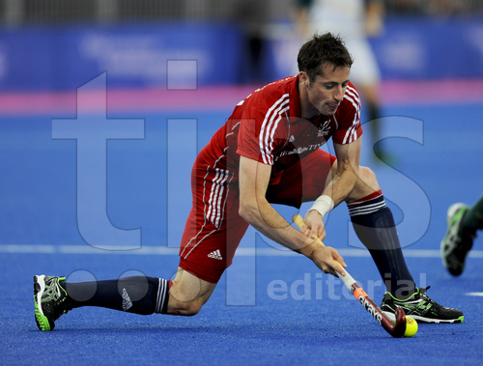**B1 –** A key point to prepare for the aerial is the pre-scan for opponents and more importantly teammates. When I perform the aerial, I often don’t create enough space/time to pre scan before I get the ball. For Iain pre scanning is second nature and a natural precaution before performing the skill. For me, I must concentrate on the environment around me much more due to less experience.   
This means I am not focusing on getting into space and scanning for teammates for the pass to go to. I cannot easily focus on three things at one time; instead I tend to focus on any approaching attackers and/or the ball carrier. This means I haven’t pre-scanned nor have I created enough space to play the aerial safely. Compared to Iain, controlling the ball once I received the pass is weak. Iain often takes one touch to control the pass and another to perform the skill. However when I receive the pass I frequently take two touches in order to control the ball, and another one to execute it. This again slows me down and gives the opposition more time to make a tackle.

**Execution phase**

**B2 –** Whilst Iain is executing the aerial his body position is crucial. Iain drops his right hand to the lower part of the grip. This enables the power he generates from his right arm to be transferred easily to the ball. Iain will have a low centre of gravity by bending his knees and having his legs shoulder-width apart. This will ensure he has a solid base for when he generates the necessary power; it also helps him maintain balance during and after the aerial has been performed. He must keep his balance in order to direct the ball in the correct position. Iain’s footwork may vary in different situations; he may have to perform the aerial on the move; then in this situation the ball and his feet will be moving forward, Iain will keep the ball out level with him at all times. The ball can’t be out in front otherwise power is lost when taking the aerial, nor can it be behind him, as he may lose sight of the ball and/or miss-time the pass. When the stick makes contact to the ball, there must be a smooth connection to prevent the ball bobbling over the stick or the pass to be in-accurate. The ball mustn’t leave contact with the stick throughout the final execution stage, if so the pass may be weak and/or the ball may bounce over the stick causing Iain to miss completely; if the ball remains on the stick more power can be generated. Iain tilts the stick ever so slightly back to ease the balls leverage upwards. As he does this he rotates his shoulders pushing up with his arms, driving the ball skyward. Iain uses core strength to rotate his body and provide the correct amount of power to successfully reach the target.

**B1** – During the execution phase I am weak at 3 aspects of the aerial. The first is my technique; when I do an aerial my action throughout is not fluid or smooth. I find it is quite “jolty”; what I mean by this is that I tend to rush the shot and push it as hard as possible in order to get the distance, whereas Iain is calm and controlled due to self-confidence. By doing this the ball is not in control and therefore tends to lose accuracy and power. Angling the stick appropriately is sometimes an issue; in some pressurised situations I mis-interpret the angle of the stick making the ball bobble, often to the opposing attacker. Iain is at such a high level and confidence that he knows exactly what angle he needs his stick to be in order to perform the skill. Another weaker aspect to my aerial is power and accuracy; when I play an aerial I don’t always put my right hand as low as I should, comparing that to Iain, who lowers his right hand to the correct position instinctively. This to me feels comfortable however without the correct stable and strong hand position I can’t elevate the pass with enough power. I have the accurate lower body position; my legs are slightly bent and planted firmly for a strong base that will provide some power. However I fail to get this position if I am forced to move to evade oncoming tackles compared to Iain, who gets into a suitable position where he would have to avoid an oncoming tackle. Once I have the ball I am able to maintain possession, however because I haven’t pre-scanned, I waste precious time by scanning for teammates whilst I have the ball. This means the attack is slowed down and the opposition defence can be organised.

[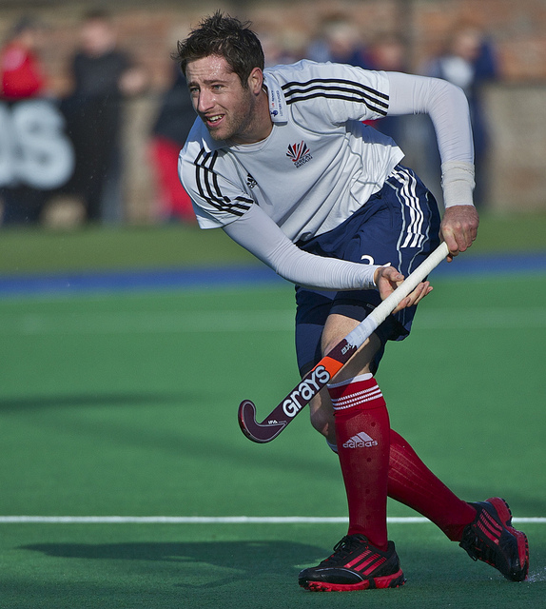](http://www.google.co.uk/url?sa=i&rct=j&q=iain+lewers+hockey&source=images&cd=&cad=rja&docid=5gXX98Ozf0eMBM&tbnid=e0wp4EVuMR0n3M:&ved=0CAUQjRw&url=http://www.flickr.com/photos/12608538@N03/6766933259/&ei=-VJUUe3-IKr20gXP8IGoDQ&bvm=bv.44442042,d.d2k&psig=AFQjCNHcx59hRNhZpAZhnX1wpIvKaOjSYg&ust=1364567105795141)**Recovery phase**

**B2 –** After Iain releases the ball into the air, the follow-through assists the direction of the ball and the power. For example, if Iain wanted the ball to go out straight in front of him, his follow-through/stick will stop out directly in front leaving the ball to fly straight. If he wanted to guide the ball leftward but deceive the opposition it was going straight, the stick rotation would carry on further round his body to provide the ball with that added momentum and direction.

**B1 –** My recovery phase is relatively strong. The follow through is directed exactly where I want it to; as with Iain’s follow through, depending on where we want the ball to go, we both swing accordingly. However recovering after a mis-hit is often a weakness. After making the mistake I am still in the recovery (follow-through) phase; this means I cannot react immediately due to single channel hypothesis. Iain has developed his reaction times to an adequate point where he can process information faster and therefore react quicker. High levels of experience also aid his reaction time. However fatigue may be a contributing factor. Another weakness is the fact that my feet are in a planted position, this means I will struggle to move quicker off the ball.

**Strategic skill 2 – Disguise pass from left back to centre mid-field:** This skill is often used to deceive the opposition into believing your pass is going to one player, when in fact it will go to another. This means the opposition will closely mark the wrong player and be off balance and out of position to defend against the actual pass.

[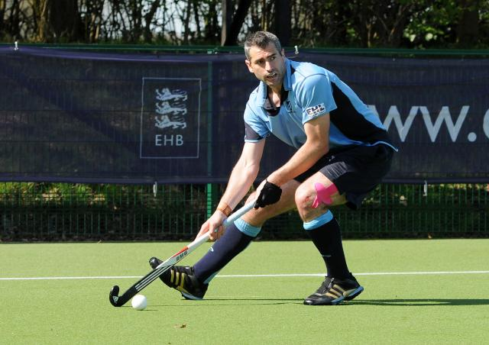](http://www.google.co.uk/url?sa=i&rct=j&q=richard+mantell+pass&source=images&cd=&cad=rja&docid=By4Y6zvA6xrOHM&tbnid=6-8HXYETz6KjAM:&ved=0CAUQjRw&url=http://www.pushhockey.co.uk/content/images/2011/richard-mantell-1&ei=M6ZmUc3oAoeThgfzmoHICQ&psig=AFQjCNG89mOIX5D8hcpi9Y7Lo8C1VZytjA&ust=1365768084235601)Elite performer: I am going to use Richard Mantell as my perfect model. Richard plays for both Reading HC and Great Britain, playing at the highest levels of hockey. He distributes the ball with such power and accuracy and is experienced enough to alter a pass if necessary.

**Preparation phase**

**B2 –** The disguise pass is a skill used to deceive opponents in such a way that a better attacking opportunity is made for the performers team. The pass makes the opponents believe the ball is going one way, when in fact it is going a different direction entirely.Richard will frequently use this deceptive pass as it will create space and chances for his fellow teammates. During the preparation phase, Richard will pre-scan the pitch for teammates and of course any challengers. This enables him to know where the pass must go before he even makes it. This also gives the impression to spectators that he has more time on the ball; this is commonly associated with a high level of experience. Within the preparation phase Richard will also move to space or a position he can perform the skill. This requires intrinsic knowledge and experience; Richard will realise the opportunity before he is in possession, giving him space and time to control the ball when the pass comes in. This means he won’t have to rush the skill, which in turn improves the accuracy of the pass.

**B1 –** When I perform this skill I do pre-scan however I do not scan instinctively or as frequently. I feel this is due to a lack in concentration and experience. I am concerned about the challengers around me and the pass coming in rather than my teammates in attack or midfield. Getting into a suitable position is also where I need to improve; often due to fatigue I don’t get into a decent position with enough space to perform the skill.

**Execution phase**

[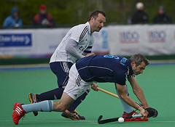](http://www.google.co.uk/url?sa=i&rct=j&q=richard+mantell+pass&source=images&cd=&cad=rja&docid=BsO2TEESN4zHEM&tbnid=UfbZfv878KOGEM:&ved=0CAUQjRw&url=http://www.flickr.com/photos/12608538@N03/sets/72157629829597125/&ei=mKdmUbHcHcWwhAfC5IG4CQ&psig=AFQjCNG89mOIX5D8hcpi9Y7Lo8C1VZytjA&ust=1365768084235601)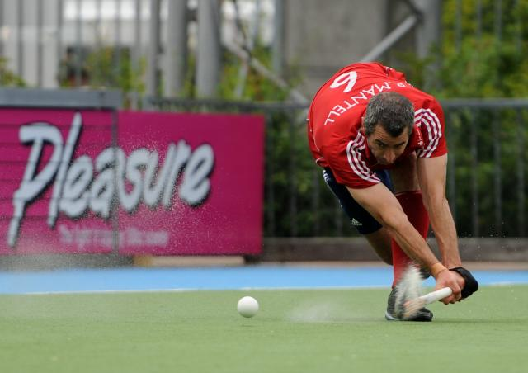**B2 –** Richard executes this skill with power and accuracy. Richard can play the pass by positioning his body in the opposite direction to where he intends to hit it, depending on which direction it is going. For example; he’s passing to the centre midfield but disguising it to look like he’s passing down the wing. Richard will have his body facing front-on, directing down the line as if he was passing that way. He will also use eye contact; by looking down the line he will deceive any approaching attackers. Richard will have a low body position, with slightly bent knees providing a strong base for extra power. He will point his left foot down the line and have his back foot behind him at a right angle; this is the traditional position for a slap hit. This will help disguise what he actually wants to achieve. In the traditional slap hit Richard will have the ball in line with his front foot or just behind. He does this so he can hit the ball cleanly and with enough power. However doing the disguise pass, Richard will have the ball slightly further back, almost between the two legs but still at a sticks reach away. Keeping his head still to avoid miss hitting the ball, Richard will draw back his stick as usual for the onset of power. However, because Richard carefully placed the ball further behind him than usual, he will strike the ball earlier with the stick. This will direct the ball out towards the middle of the pitch, avoiding the opponent in front, with disguise and power. The ball will ever so slightly be dragged along the stick for a short period of time, giving it more momentum and direction.

**B1 –** Whilst I perform this skill I lose both power and accuracy. I position my body correctly, by facing the direction I am dummying. When I do this I do deceive the opponent most of the time, even if fatigued I get my body in the correct position to disguise the pass. However, I feel I don’t get in the correct position to strike the ball, whereas Richard knows instinctively where his body needs to be to strike the ball. Making eye-contact is also not a problem nor is it a problem for Richard, he is at such a high level that he doesn’t need to keep his head down looking at the ball; instead he can maintain eye contact with his opponent. Time and again fatigue gets the better of me and makes getting in a low body position very obstinate. I am too tired to maintain that all important self-discipline when getting into the correct body position. Richard is at a level of fitness that could easily see him through a game without feeling fatigued; therefore meaning he gets into a low position with ease. When it comes to actually performing the slap I have the ball in the correct spot between my legs, but cannot get enough power behind the shot. The same goes for accuracy. I believe the accuracy of my shot is down to the movement of my head. I know definitely when I execute the skill I don’t keep my head still; in Richards case he keeps his head perfectly still and level to perform the slap accurately. This, toward the later stages of a match, could be due to fatigue or monotony where focus and determination are lost. Regarding power; I know I have the correct power to perform a normal slap even when fatigued, as I am confident in my technique. Nevertheless, performing the disguise slap proves less powerful and therefore more overt to my opponents. I get the impression this is mainly due to lack of practice and experience with this skill but also higher levels of anxiety levels. Also my technique with a disguise pass is obviously altered to a regular slap and therefore not as strong, deterring the amount of power produced. Compared to Richard; who has practiced this skill a number of times and also used it in game situations, he has built up enough experience of what he should and shouldn’t do, his technique is now perfected. I physically don’t have that time or the facilities to practice the skill as often as Richard. I feel however the main issue with this skill would be lack of confidence and over arousal caused from the pressure of the moment.

**Recovery Phase**

[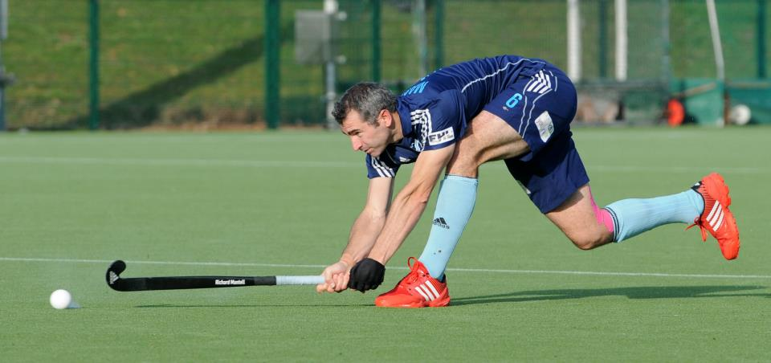](http://www.google.co.uk/url?sa=i&rct=j&q=richard+mantell+reading+2012&source=images&cd=&cad=rja&docid=7q8844GIW4EJRM&tbnid=MIN7V0PO-zDyKM:&ved=0CAUQjRw&url=http://thetopofthed.com/2012/03/28/england-hockey-league-end-of-season-play-offs-part-1/&ei=5rBmUcKdNtGBhAf2s4DoBQ&psig=AFQjCNFGW_q_X3ztafNd6F9EJsd6_GGmiQ&ust=1365770318533133)**B2 –** The recovery phase simply involves backswing/follow through and quick footwork to recover and set for a return pass or correction. Richard, when following through the shot, will flick his wrists right at the end of contact with the ball. This will give it that added power needed to reach his target. This flick motion that Richard uses is a quick and snappy finish to the hit and is used to also assist him due to the odd angle at which his arms are stretched. The follow through will finish with his stick out toward the direction of the ball or even further round depending on the force he put in. His shoulders will rotate with the stick to add momentum and maintain balance. Richard quickly goes from a follow through position to a front on, prepared position. By using quick, agile feet he will finish the skill and come from a low position to an upright position, ready to receive a pass or correct his. He will be on his toes, prepared for the next sequence of play.

**B1 –** During the follow through in my recovery phase, I am rarely able to flick my wrists enough, as opposed to Richard who finishes his slap with a strong flick of the wrists. This is because I am already at full stretch when I am in contact with the ball, meaning when the drag/push is complete my arms are already in the follow-through phase. This means power and accuracy are both deducted, making my disguise pass a weak part of my game. This is down to poor technique and practice of the skill. Richard will not struggle with this aspect, as he is physically very large and his stretch is far greater than mine. However I am quick to respond to the pass; I recover quickly and am ready to expect an interception or even a return pass.

**Attacking skill 1 – Shot at goal from top of the D:** One of the first skills learnt and one of the only skills every team hopes to use the most. Shooting is a common skill to know, but involves power, accuracy and being in the right place at the right time.

Elite performer: I will be using Rob Moore as my perfect model for shooting at goal. He is a capable attacker with a great hitting technique and countless attempts on goal, not to mention some amazing goals too.

**Preparation phase**

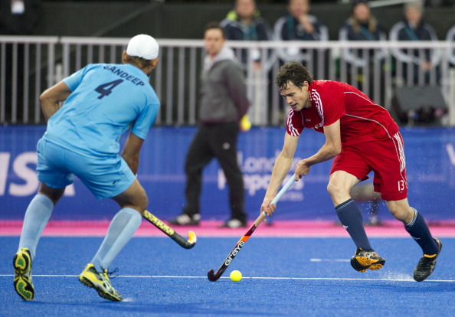**B2 –** Rob will more often than not be on the move as he enters the circle. In preparation, Rob will scan for space, opponents and of course the ball. Rob communicates with his fellow attackers; calls for the ball go back and forth when building an attack. Rob will enter the circle and call for the pass; by this time Rob has found a space, by posting up and is ready to strike. Once the pass is received he will have very little time before the space/gap is closed by the defenders and/or a tackle is made. Firstly Rob will control the ball and get it into the best position for a strike to be made. Rob will have his left shoulder pointing in the direction of the goal, doing this will aid his accuracy keeping the ball on target. Rob will have his head still, down over the ball; he does this to prevent mis-hitting the ball. Next in his preparation he will step into the hit. This means he will plant his left foot just in front of the ball, giving a stable base for a powerful hit. His feet will be roughly shoulder width apart, depending on the length of his stride and at what pace he is moving into the circle. Rob will slide his right hand up from the bottom of the grip, to join the left hand at the top before striking the ball; this is the traditional hand position when striking the ball and is taught globally this way. Rob will keep low with his knees bent and his weight evenly distributed on the balls of his feet; his weight will usually be centred in the preparation phase. Doing this will increase stability and power in the shot, meaning he is harder to knock off the ball and harder for the shot to be saved! Lastly, Rob will draw back his stick in a flat backswing, cocking his wrists as he does; his flat, stretched backswing (to avoid be penalised for dangerous play) will provide power to his shot. Cocking the wrists will give the backswing extra height without exceeding his shoulders height.

**B1 -** For me, scanning in the shooting area is an instinctive part of my shot and therefore is a stronger part to this skill. I recognise where I need to hit the ball and where I am in relation to defenders and fellow teammates. However, situations can quickly change in the circle so I should be aware and scan more frequently. This may lead to slowed decision making and/or reactions, compared to Rob who would not be fazed by changing situations in the D. He is at a level where he can react instinctively to most situations. As far as communication is concerned it is a sound part of the skill, I feel natural and confident when demanding a pass for a shot. Acquiring space in or just outside the circle is a definite weakness. My posting-up is weak; a post-up is a quick movement to 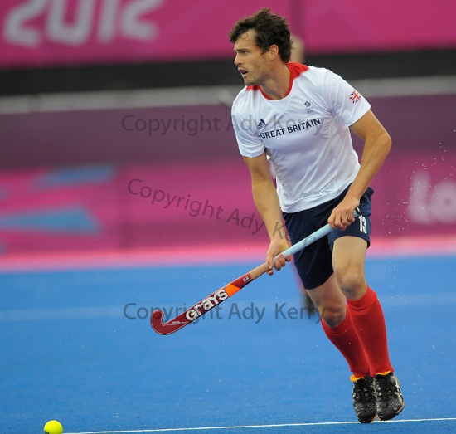evade any opponents you may have marking you. If an opponent is tightly marking behind you, you must make a sudden acceleration of pace away from the defender and toward the ball. The space you created is added time for you to control the ball without the hassle of a defender. My post-up is weak because I have a lack of power in the muscle groups used. Fatigue may also contribute to the lack of momentum in the post up. Rob will be at a level of fitness where fatigue doesn’t affect him so easily. Also his training and conditioning will be intense and well structured. He has the right facilities and time to train properly to gain strength where it is needed. This lack of speed in my post up will mean the whole skill is slowed down; because the defender will still be closely marking me, I may need to take an extra touch to control the pass and beat the defender, resulting in a slower attack.

**Execution phase**

**B2 –** In the course of the execution phase, Rob will attempt to strike the ball cleanly and accurately with enough power to challenge the keeper. Firstly Rob will centre his weight between the feet for balance and a robust foundation for his strike. He will do this by keeping his knees bent and his feet shoulder width apart. Rob, keeping his head over the ball, will straighten his left arm to almost full stretch and tuck his right elbow into his side: This is to generate the initial power behind the ball. As Rob strikes the ball he transfers his weight onto his front leg and hip; in turn dipping his front shoulder. Through the contact of the ball Rob will turn his shoulder for added power. Because Rob is doing this on the move, he crosses his right foot behind the left in order to get his body in the correct position. Lastly, Rob strikes the ball squarely on the lower half of the ball to provide power and accuracy. If he hit it too low the ball will fly up and potentially become a dangerous ball, if it’s hit on the top half the ball will bobble forward with very little power and even less accuracy.

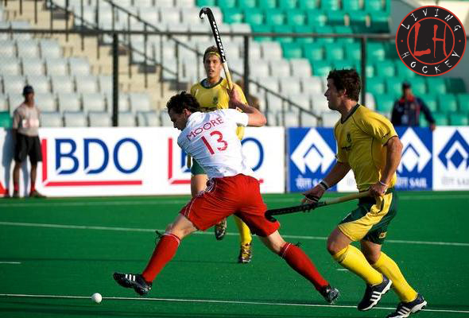**B1 –** During the execution phase of my shot I distribute my weight evenly, but shooting on the move can often result in me directing my body wayward of the goal. I regularly get too upright as I am running and therefore don’t have a strong foundation to the shot. This may be due to being on the move or even fatigue in the muscles that may prevent me getting into the correct position. Compared to Rob, he gets into a correct body position instinctively due to vast experience and the development of motor programmes. Although I am confident with my technique when hitting, I feel that I don’t generate enough power behind the shot to challenge the keeper. My arm is bent with my other elbow tucked in, yet on some occasions there isn’t enough momentum behind the hit. Fatigue may be a large part of this. As lactic acid builds in the muscles, hitting the ball powerfully may be harder. Rob will find it easier to generate power even in the later stages of them game; fatigue would not affect Rob so quickly due to constant specific training.

**Recovery phase**

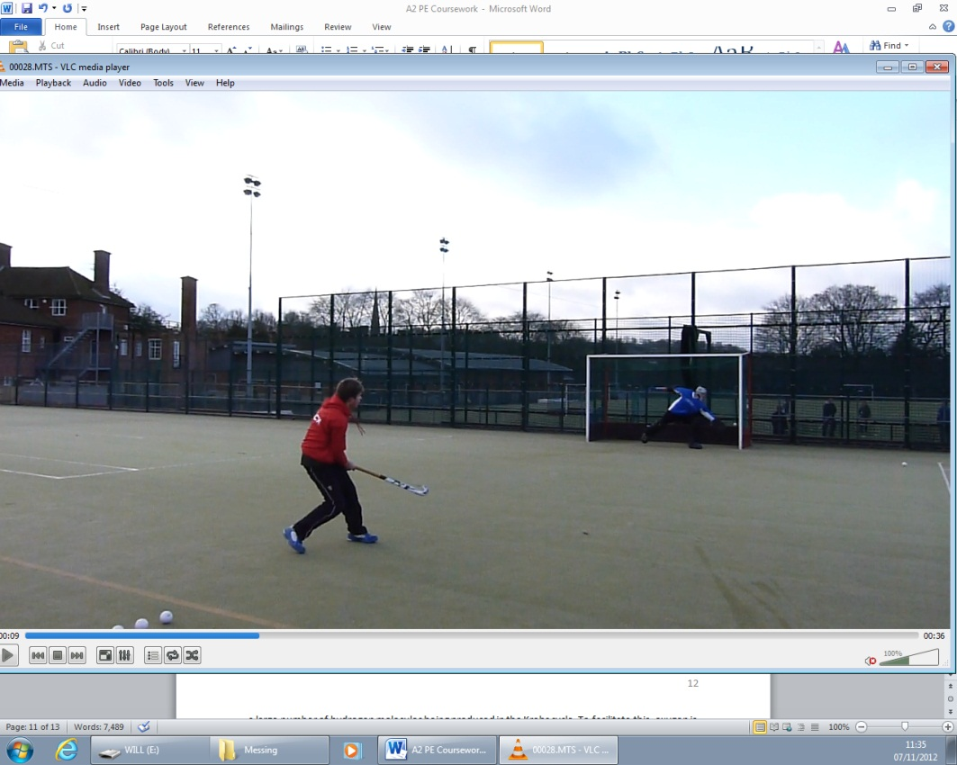**B2 –** In the recovery phase Rob will transfer his weight fluidly through his front leg with both his knees remaining relaxed and bent. In order to maintain accuracy throughout the shot, Rob will keep his head still and over the ball to avoid mis-hitting. His stick will swing through, finishing pointing at his target. He will then quickly return to the recovery position to receive a deflection/interception, by bringing his stick back closer to him in an upright location. Rob will be on his toes for the remaining few seconds in order to react to deflections or even a goal celebration!

[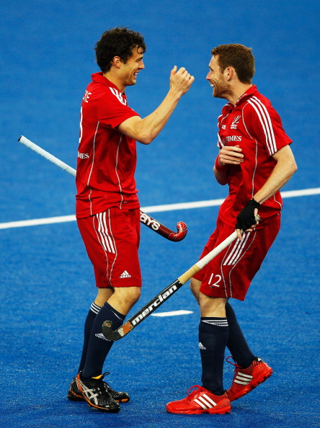](http://www.google.co.uk/url?sa=i&rct=j&q=Rob+moore+hockey&source=images&cd=&cad=rja&docid=KsP_Xr5eWD8y_M&tbnid=ajl0n2di6faRMM:&ved=0CAUQjRw&url=http://image.sportskeeda.com/visa-international-invitational-hockey-tournament-locog-test-event-for-london-2012-day-two/&ei=wXp-UZLZDISN7QbkpYHYDA&psig=AFQjCNGoqcBVOHGANagFHEZipm8GlmCnSw&ust=1367329694063077)

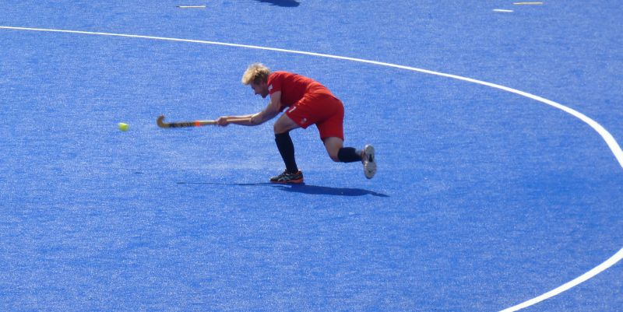**Attacking Skill 2 – attacking short corner, drag flick:** One of the top things a team aim to achieve in a match, other than scoring, is a short corner. It is a perfect goal scoring opportunity and a chance for the team to show off many routines and skills.

Elite Performer: I am going to use Ashley Jackson as my short corner perfect model. He is an excellent striker with a wide range of goal scoring ideas and excellent execution.

**Preparation phase**

**B2 -** Ashley will communicate with his fellow team members to decide upon one practiced routine they will all help perform. As a team they decide, and taking the shot may involve more than three people. One of the key influential factors that make Ashley one of the best short corner strikers is his vast experience. Ashley habitually has eye contact with the goalkeeper; this is to see where the goalkeeper might lead or to make the keeper second guess where he might direct the shot. Timing is crucial for Ashley; he must prepare his run up to pin-point accuracy in order to get maximum striking efficiency. He needs to arrive at the ball as it comes in to the stopper. Performing the drag flick, Ashley will get low to the ground with relaxed knees and shoulders; this will provide him with the power he needs to perform the flick. The bent knees will once again provide a low body position and in this case the momentum needed to flick. The loose shoulders are to relax before he uses them for extreme rotation as he flicks the ball. This rotation provides direction for the ball and power behind it. Lastly in the preparation phase, Ashley shall keep constant eye contact with the injector in order to know exactly when the ball is being pushed out and therefore when he must start his run up.

**B1 –** I have had little experience taking short corners myself; I normally inject or trap. However, in my time playing hockey I have been the initial striker a few times. This shortage of experience is a key factor to the lack of ability when short corner taking. Ashley Jackson has had countless practice time and performance time and therefore building up his experience and skill level. My timing coming up to the ball isn’t perfect; I often miss time it and get to the ball too late, meaning defenders are already too close. Compared to Ashley, with the use of constant high level coach attention and enough time to practice, he has developed a successful run up with accurate timing. I communicate well with my teammates, gathering and giving the right information to perform this skill. However, confidence to execute the skill is absent; this anxiety means I am not thinking clearly on what I must do, but rather on what I might accidently do. Opposed to Ashley, I have very little time and not the same level of coaching in order to devise practiced short corner routines.

**Execution phase**

**B2 –** Again timing is crucial; Ashley will time his run to start as the ball is half way from the injector to the trapper. He knows to do this instinctively, from the vast experience he has collected. As he does this he will alter his grip at the last minute, not giving away anything to inspecting defenders. He will have the traditional hand grip when holding a stick but with his left hand rotated round to the left, almost to the underside of the grip. He will lower his right hand to the end of the grip for added support and power. His left hand supplies the elevation to the ball and of course the added power. Ashley will drag the ball into the circle, keeping his hands low and parallel to the floor. This “drag” builds up momentum behind the ball and also provides disguise for the direction; as that is only revealed at the last second of ball/stick contact. Ashley uses the four step approach; leading with his right foot, then his left foot into the circle, right foot then crosses behind the front foot (left) for added power, and then finally plants his left foot forward to stabilise. The first right step he takes goes as far past the ball as comfortably possible to enlarge the dragging space to build up momentum and power. Ashley makes sure his upper body remains parallel to the floor to enable easier rotation from right to left, during execution. As he drags the ball from behind his back foot he uses his right hand to guide the stick/ball forward, whilst his left hand pulls backward for elevation and momentum. Ashley keeps in contact with the ball for as long as possible in order to build momentum and provide the opportunity to alter the direction if necessary. As this happens his upper body rotates almost 90 degrees, to give the last thrust of power and direction.

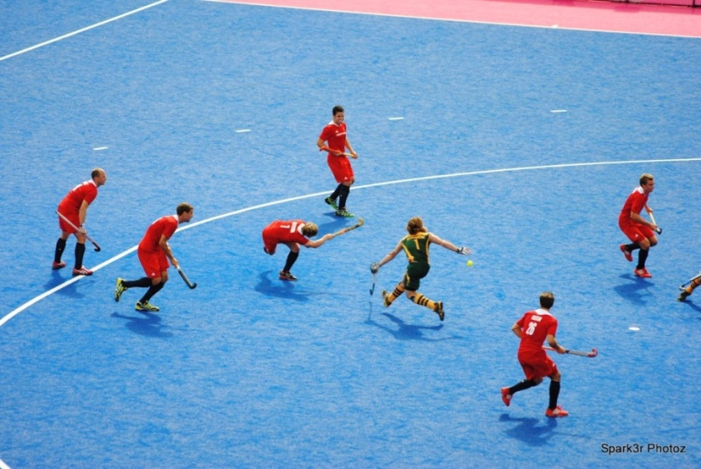**B1 –** My timing here is sufficient; I manage to time my run up with the injection well. However I find the four step approach difficult and have not yet found a more comfortable alternative. This means I can often mis-time the run up. Ashley Jackson has such a high level of skill and has dedicated coaches to develop his technique .Taking the drag flick, I commonly find myself missing the allocated target and also not executing with enough power. This may be due to a number of different reasons. One, is my hand positioning; I do not rotate my left hand to underneath my grip, nor do I have a low right hand. This however is not the case with Ashley; his technique involves having a higher right hand than usual. But due to his higher level of ability and strength he can generate power easier and more efficiently than me. I find it more comfortable to have a higher right hand and keep the left hand in the traditional grip. This mistake leads to obviously lack of power and also that much needed elevation from the left hand. Another reason I fail time and again when getting power behind the flick, is my lower body position. I commonly find myself not getting low enough to the ground due to a lack of flexibility and fatigue; it prevents me from applying full strength and rotation to my shot. The last reason for generating little power is my poor overall technique and lack of experience performing the skill; obviously compared to Ashley, his technique is analysed and developed by himself and qualified coaches. Another weakness is the actual drag; I tend to rush the action, when in fact it should be a slow too fast, fluid motion. My rushed, jolty drag often results in missing the shot entirely or weakening the flick. Jackson’s drag action is smooth and not rushed. My upper body rotation isn’t effective, I have a slow angular velocity; nevertheless my movement is restricted to a 90 degree rotation due to my more upright position. If I were lower to the ground I could rotate more easily to a 180 degree and therefore add power.

**Recovery phase**

**B2 –** Ashley will recover by finishing his rotation facing his goal, so in theory he does a 180 degree rotation. This provides his flick with extreme power. After he releases the ball, his right leg shall swing out and forward, pulling his left leg around anti-clockwise and thus providing the lower body rotation. By this point Ashley will be a couple of yards away from the P-spot; this means he will quickly need to return to a position he can receive a deflection, rebound and/or take another strike at goal.

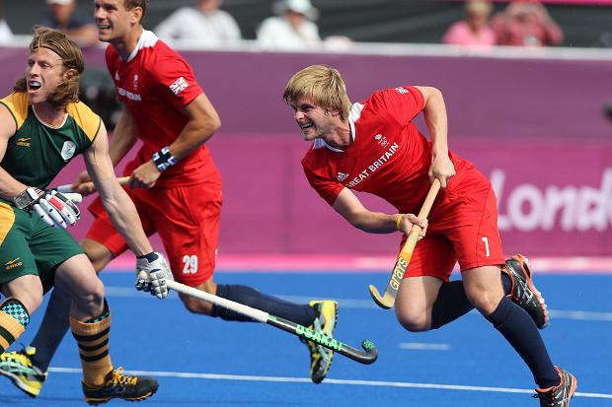**B1 –** In my recovery phase I don’t quite rotate as fully as I should. This again is probably due to the more upright position I have adopted; thus, not providing me with enough power to score a goal. I feel this is commonly due to fatigue, but as I have recently established my drag flick technique hinders my overall performance of the skill. Jackson has a high level of fitness and so, doesn’t fatigue as quickly as I do; therefore getting into the correct low body position.

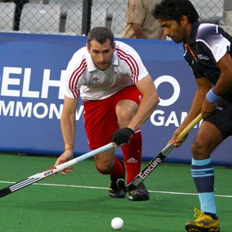**Defensive skill 1 – defending/channelling on the left side:** Often both left midfield and left forward overlap and interchange with one another during an attack; the ball may start in the centre and be distributed wide to the left mid. This means Richard must be aware of the attack in front of him but also organising the defence behind him.

Elite performer – Richard Mantell: Rich Mantell is a strong and experienced defender, one I inspire to be like. Richard has enough experience to be able to concentrate on the tackle, whilst still communicating with his teammates.

[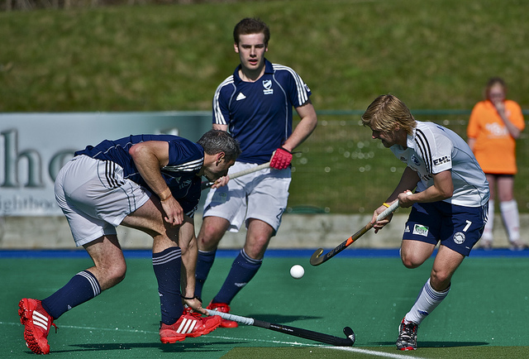](http://www.google.co.uk/url?sa=i&rct=j&q=richard+mantell+reading+2012&source=images&cd=&cad=rja&docid=nLF-zpF10NWi3M&tbnid=BZ1BfQQxESFQ8M:&ved=0CAUQjRw&url=http://www.flickr.com/photos/12608538@N03/7038178063/&ei=fq9mUcHFGMmYhQe1wIHwAg&psig=AFQjCNFGW_q_X3ztafNd6F9EJsd6_GGmiQ&ust=1365770318533133)**B2 –** Once Richard has become aware the attack is coming down the left wing, his right side, his first thought is slow the attack down. Richard slows his opponent down to give the rest of his defence time to set and form defensive positions; either marking players or helping with the tackle. In order to slow down the attack Richard will use the skill “channelling”; this is where an attacker is channelled away from the D and into a less dangerous area, where opportunities to score or make a pass are slight. In this case Richard will get his feet round, pointing out toward the side line; this enables his body to face outwards, away from the centre of the pitch, showing the attacker the line. This gives the attacker only two options; either to carry on down the line, where they are isolated and in a weaker position to attack or to “roll out” and give a pass back to a teammate to reset the attack. In both cases Richard would achieve his goal, to slow down the attack. When channelling Richard will be in a low body position; this will permit fast, agile movements and offer a more stable, balanced body position. This would make it harder for the attacker to beat Richard, as he is now harder to push through and he can easily adjust to any twists and turns the attacker makes to outdo him. With the intention of slowing the attacker down Richard must also keep the attackers head up; by jockeying and jabbing, Richard will make the attacker look up, loose control and second guess his movements. This will either result in an easy tackle or a turn-over of procession. Once Richards’s teammates have organised the defence and other attackers are marked Richard will communicate with the defence to find out if a tackle should be made. Often this decision would be made instinctively; Richard is at such a high level of experience that he realises when to make a tackle and when not to. However, remaining in that strong low body position, Richard will gain the attackers attention and pressurise him to look up and therefore make a mistake. This would lead to a turnover of play. As soon as Richard has made the tackle or procession has been turned over he must distribute the ball and/or eliminate any opposition.

**B1** - During an attack communication with the other defenders is often not done; this is mainly due to a lack of confidence. I have only recently become a defender and also only recently joined this particular team. I do not have the confidence yet to talk/order the defence when defending an attack. This means any changes in the attack would not always be noticed by the other defenders and therefore become a successful attack. As opposed to Richard who knows exactly what needs to be said and done. Experience is also a key factor to a lack of communication; as I previously stated, I have recently become a defender and do not know if my teammates are in the correct position for this particular attack and so I wouldn’t ask them to move. Also due to a lack of experience I will concentrate mainly on what I am doing and what the attacker in front of me is doing rather than what other players around me should do. My channelling skills are adequate with the stick; on the other hand my footwork and body position is not. I understand I should channel the attacker away from the circle and out towards the side line however; due to my lack of experience I often make the mistake of being in the wrong body position. I am to flat/face on, this enables the attacker to put me off balance and beat me, moving to a more effective position. Fatigue and lack of power and speed also contribute to me making errors when channelling or tracking back. I feel definitely the speed of my footwork is too slow; because the attacker is running front-on and I am moving backwards or sideways I struggle to keep up with the attacker. Frequently I stay in an upright position; instead I should have a low body position. By having an upright body I cannot move or shadow the attacker’s manoeuvers; this means I will be off balance and slow at recovering procession if and when the attacker outdoes me. Also being upright does not offer me a stable position to make a strong tackle.

**Defensive skill 2 – defending a short corner, running one:**  The short corner or penalty corner is awarded when an offense has been made by a defender in the circle. It may be a deliberate offense with the intentions of slowing or stopping play, or an offense forced to be made by the attackers. For example passing the ball onto a defenders foot inside the circle; this would award the penalty corner and a better shooting opportunity.

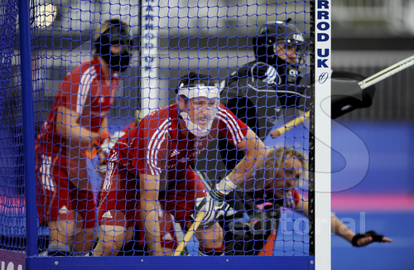Elite performer - Iain Lewers: Iain Lewers often defends short corners, mainly due to playing in defence. I am using him because he has great confidence in defence in outfield and during set plays; he provides a good “perfect model” to analyse.

**B2 –** When defending a short corner Iain and his four other teammates must make a decision on how to best defend the goal. They will have a number of set routines that they will be able to execute due to constant analytic videos on opposition gone through with coaches and teammates. Studying the oppositions body language and previous tactics the defenders can interpret what the attackers may do and respond accordingly. Iain often runs out one; this simply means Iain will run out to what he and his teammates believe is the initial striker. Iain will be poised behind the goal line watching every movement or signal the attackers make. He also keeps an eye on the injector to know when to run out. However this information is normally passed on by the goalkeeper. In order to gain more momentum and speed coming out of the goal, Iain will use a teammate’s foot as a make-shift starting block and the outside post to push off. This added momentum will enable Iain to reach the initial striker quicker and there he is more likely to block the shot or put enough pressure on the striker that a mistake is made. As Iain runs out he keeps his stick in an upright position out in front of him. Iain will try to align his stick directly in line with the strikers shot, increasing the chance of a deflection and saving a goal. Iain will keep the stick in that position because in the modern short corner the ball is very rarely hit along the floor; it tends to be flicked. He covers his feet and lower legs to prevent another corner being awarded if hit. Iain’s speed, knowledge and experience of the situation are three main factors that make Iain so good at defending short corners. His speed helps him because it enables him to get to the striker quicker, meaning the attackers have less time to think and therefore perform the corner routine. His knowledge and experience of the situation allows him to recall on past experiences when defending against the same team in order to know what they are likely to do. It also allows Iain to react better to a situation if it goes wrong; for example mis-interpreting the initial striker, Iain can react and get into an effective position to defend the corner.

**B1** – My communication with the four other defenders is adequate; I know to a certain extend what is required and together we decide who should defend what. We do not have the same resources as the top players; for example the analytical videos and teams of coaches to help analyse the oppositions strategies. I am often chosen to run one, as Iain does. I can predict potentially the initial hitter just by the line-up of the attack at the top of the circle and communicate this to my teammates. I know from experience when I should run out without looking too much toward the injector. I find getting to the initial striker is a weak point. I feel I am not as fast getting out from inside the goal and therefore not putting enough pressure on the striker. This may be due to fatigue and/or lack of power in the muscle group associated with this. It may also be the lack of propulsion I get from my initial starting point. I don’t use another teammate to ‘push’ off nor do I use the post as effectively as I perhaps should. Regarding my stick position; I am fairly confident at that however, when defending a short corner late into the game fatigue restricts my stick position. Due to fatigue my actions are slower which prevents me from getting my stick upright and in line with the shot quickly, whilst running out. Knowledge and experience in this situation are scarce too; if the opposition’s routine is changed, I cannot react quick enough to defend the new routine. Also confidence in these situations is a key part to defending a short corner. I have not yet developed enough confidence to defend a short corner effectively. Running toward a speeding ball at pace is not something any player aims to do; however in this situation it is necessary. For me to be more efficient when defending a short, I must build enough confidence to execute the defensive skill.

