A2 Coursework - Judo
Jodie Thacker

Candidate Number: 7466

Contents:

O- Goshi
Power & plyometrics
Lack of Aerobic fitness & continuous training
Muscular Strength & weight Training
Flexibility & PNF
Confidence & increasing self-efficacy
Anxiety & methods of controlling anxiety.

Morote Seoi Nage
Kami- shiho Gatame
Kesa – Gatame
Uchi Mata
O Soto Gari

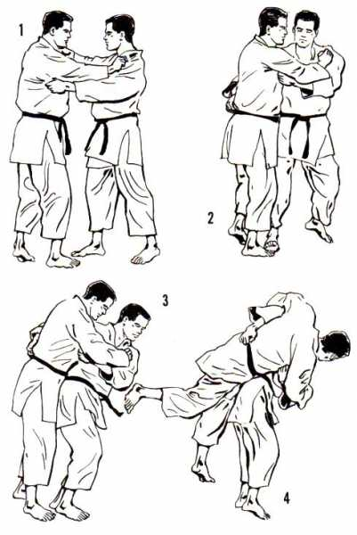
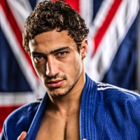
B2 Throwing technique: O-Goshi
Ashley McKenzie competes in the -60kg category and is said to be ‘one of the most talented young judoka’ according the British Judo Association. He has shown this by winning the 2010 u23 European Championships and also winning the Poland World Cup and GB World Cup in 2011. Furthermore he competed at the 2012 London Olympics.

The London judoka is capable of beating anyone on his day and holds victories over Olympic silver medallist and seven-time European medallist Ludwig Paischer of Austria as well as former world and European champion Georgii Zantaraia from Ukraine.
Preparation:
O-Goshi is classed as a major hip throw and is therefore classed as koshi-waza (hip technique). Also it is an extremely basic throw that is considered to be of orange belt standard in the British Judo Association’s grading syllabus. Therefore this throw is not often used in competition as it can be easily overcome. However an elite performer such as Ashley will use this simple throw especially if he is shorter than his opponent, as this will give him an advantage as he will have a lower centre of gravity. This is essential in throwing, and Ashley achieves this by keeping his belt lower than Uke’s (opponent) belt when going into the squat position.
In addition when fighting in a judo competition your choice of throw is dependent on the positioning of your opponent, although Ashley moves his opponent into the desired position by establishing a good grip. In competition establishing grip is a vital part of producing the perfect throw that will result in being awarded ippon (one full point). Ashley scores a full point by executing O Goshi skilfully resulting in Uke thrown on the back with considerable force or speed. The first stage of any judo throw or the kumi kata involves Ashley deciding on a preferred grip and stance, however if his opponent is facing him, and has gripped the lapel or is establishing their grip whilst pushing Ashley backwards this would be the perfect opportunity to use O Goshi. If the opponent has gripped his sleeve this gives Ashley the opportunity to slip his hand underneath the opponents and around the waist, this is essential as this technique requires Ashley to change his lapel grip, so that his right hand is gripping around Uke’s waist. He can then set up the throw by keeping his right arm free, and griping Uke’s right sleeve with his left hand. Controlling the sleeve is essential as he can now dominate the competition, as gaining this control allows him to move his opponent into the desirable position; in order to produce enough momentum for them be placed in an unbalanced position.
Execution:
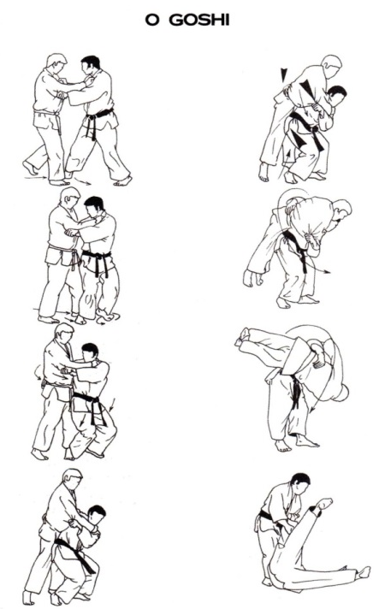
Once Ashley has established a firm grip on Uke’s sleeve he then steps backwards forcefully pulling their right sleeve towards his body by flexing his arm rapidly. The force he applies with both his movement backwards and the rapid flexion results in making Uke unbalanced and it brings Uke onto their toes allowing him to get close towards the body I which he pins himself against. The act of unbalancing Uke in this way completes the next stage of throwing which is known as Kuzushi – this is where Ashley brings Uke into a position where their centre of mass is not directly between both feet allowing him to throw them over. Whilst moving Uke towards himself, Ashley steps forward and across their body using his right foot and then place his arm around Uke's waist by forcing his right arm between Uke’s left arm. By griping along the belt line this allows him to pull the opponent closer towards his body, which is important for remaining in control of the throw and therefore limiting an counter attacks. Ashley does this extremely well closing all gaps between their bodies making it harder for Uke to produce any counter attacks as they have no room to move around the body.
He then pins his body to Uke’s and turns in quickly by bringing his second leg or non-dominant leg behind him, also he pushes both hips past Uke's and therefore resulting in him being in front of Uke's body. By making sure that his feet are facing in a forwards direction, with knees slightly bent in a squat like position allows him to use his hips as pivot in which to lift Uke. Lifting Uke from this position means that the exertion of force comes from muscles acting together generating force from the waist and abdominals. Also by doing this he is then placing his hips in a lower position than an opponent's centre of gravity, which is crucial to produce momentum to lift the opponent also this prevents any back injury. Once this movement is completed Ashley is in the Throwing Preparation Tsukuri phase as he has moved into the correct position to complete the throw.
Furthermore, when positioning his feet, he will make sure that they land close together and between Uke’s feet in order to gain maximum force power when straightening his legs. This straightening of legs, allows him to lift Uke off the ground. Once they are off the ground he twists his body towards the left also making sure he is continuing to pull on the right sleeve and turning his head in the direction of the throw. All of these final steps allow him to throw Uke onto their back landing just in front of his feet. This therefore is the throws execution as Ashley completes the throw using generated momentum and power produced from the standing position.
Recovery:
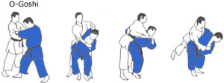
In the completion of the throw or nage concentrates on Ashley guiding Uke to the floor, therefore in this phase Ashley will be thinking about throwing his opponent as close to his feet as possible as he will be able to quickly apply an appropriate hold down if Ippon is not scored. He then will have a number of options to choose when applying the hold down; however the preferred and easiest hold down to apply is Kesa Gatame. The choice of this hold down would be determined either by Uke – who has not responded quickly enough to the throw and has therefore not rolled onto their stomach to prevent a hold down. Uke’s position with their back or side on the floor gives Ashley the advantage and he does well to respond quickly dropping to his knees and pinning Uke down. Furthermore, if Ashley has thrown the opponent and keeps his grip on the sleeve this can therefore make the response quicker. Also he could use an arm lock such as Juji Gatame from this position as he already has grip of the arm. All of these stages would be performed in a matter of seconds with the application of force and speed to ensure that ippon is scored. All stages are therefore performed in quick succession in a flow like sequence, as the gripping, pulling backwards are executed together, the rotation of the hips by stepping across Uke with the right foot is also coupled with the gripping around the waist as well as turning into the squat position and finally the lift and rotation are performed together.
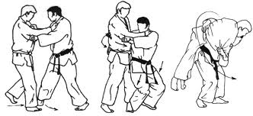
B1 O-Goshi
B1 Preparation:
Judo is dependent on the positioning of your opponent and Ashley does well to use his grip to manipulate the Uke’s movements. I also try to move my opponent into the desired position alike Ashley by establishing a good grip. However I find establishing the perfect grip for this throw difficult as it requires you grip the right sleeve high enough to have full control of it. This is something Ashley does extremely well in comparison as he finds it easy to grip the sleeve at the right height also applying speed and forcefully pulling Uke forwards to create the momentum for the throw. Furthermore my gripping position is weaker as in the competitive situation I find it hard to apply the right amount of speed and grip the sleeve in a high position as I am normally too focused on the execution and throwing Uke as quickly as possible that this causes my grip to become sloppy. Additionally Ashley’s gripping technique and rapid application will all have be progressed through his vigorous training routine which will involves grip fighting – learning how to grip successfully and to use blocking techniques in order to avoid unwanted grips that allows him to control Uke’s movements. Whereas I lack the constant grip training that would enable me to grip the sleeve successful without my grip being blocked or removed by Uke. This training will be beneficial during the competition, as grip fighting is a crucial element and Ashley does well to avoid Uke from gripping his sleeve or lapel by using these blocking techniques.
Ashley sets up his grip this by keeping his right arm free, and griping Uke’s right sleeve with his left hand. For his grip to remain on the sleeve Ashley must have good strength in his left arm in order to retain his grip whist Uke is pulling on his sleeve to remove it, this therefore means that his left arm is equally as strong as his dominant right arm, however when fighting my left arm is much weaker than Ashley’s as it is my non dominant arm, so I find it hard to grip tight enough for Uke not to remove my grip from their sleeve. Therefore being unable to retaining the grip can be considered as a weakness and this is due to the fact that I my left arm lack the same muscular strength in the biceps that are required when gripping as tightly as possible. Although taking into consideration his regular training it is not surprising that I don’t know have the same amount of muscular strength in my arms, and furthermore males also have more muscle mass than females therefore my grip will always be weaker when compared to an elite male performer.
B1 Execution:
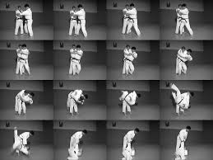
Also I am relatively weak in applying the right amount of force and speed needed when executing this through in a competitive situation as I cannot flex my biceps rapidly unlike Ashley therefore affecting my ability to make Uke unbalanced. However I prefer to use Uke’s disadvantage – if Uke is trying to counter attack my grip they are likely to get closer towards my body therefore allowing me to quickly turn into their body with little movement of my arms apart from the change of grip from lapel to waist. Uke’s movement towards me means that they are more likely to be learning forward trying to remove my grip therefore it is easier to break their balance using their own weight and gravity to throw them.
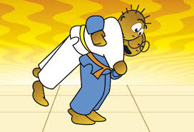
Alike Ashley I would choose to apply this throw in a competitive situation if I was shorter than my opponent as this would give me the advantage as I would be able to produce a lower centre of gravity which is needed to successfully complete this throw. Again like Ashley I try to keep my belt lower than my opponents, however I bend my knees slightly more than I need to in order to produce more power in my legs, although being slightly lower in position sometimes leads to me be more unbalanced therefore it can reduce power exertion from my legs and ultimately this unbalanced position cause both Uke and me to fall to the ground resulting in no Ippon scored. Also I am relatively weak at producing enough power from my legs and especially from the hamstrings as I have not trained specifically in for this muscle group and have focused largely on training in general fitness whereas Ashley will have specifically trained each muscle group in order to be at peak strength.
In addition, I am weak at setting up my foot placements in the correct area to ensure that I can produce maximum power when I lift Uke. Ashley will step across the body with his right foot making sure that his feet are facing in a forward direction and have landed in between Uke’s legs whereas when I turn into the throw my feet do land in a forward facing direction but are not always in between Uke’s feet therefore I cannot produce maximum power and momentum when straightening my legs in order to throw Uke. Also whilst stepping across occasionally I step too far which causes me to lean forward therefore creating an unbalanced position. He closes all gaps between their bodies whereas in competition I find it hard to close all gaps as I concentrate more on turning into Uke’s body at speed rather than making sure that all of my body is in the correct position. In competition I get distracted by trying to apply a throw at speed rather than making sure that I can create maximum power, therefore this weakness could be developed by practicing more tachi waza (standing techniques) in completive situations.
When completing the throw I straighten my legs, as they are already slightly bent, this action lifts Uke of the ground and is performed whilst twisting the body towards the left. However I also have to continuing pulling on the right sleeve whilst turning my head in the direction of the throw. However I do not always apply my full strength when pulling the sleeve as I normally rely on my hips that are acting as a pivot to throw Uke, although everybody develops their own style of judo and it varies between gender, age and body type therefore this needs to be taken into consideration when exploring my weaknesses.
B1 Recovery:
Having thrown Uke onto the ground Ashley throws the opponent as close to his feet as possible making it easier to quickly apply a hold down, however once I have executed O Goshi my opponent does not always land closely at my feet this may be due to errors in the execution, especially in the feet placement stage or the straightening of legs as in competition I tend to focus on the speed of performance which may lead me to execute an extremely sloppy throw causing my opponent to land further away from my feet than I would like them too.
In addition, I sometimes lack the speed in which to execute the throw perfectly which therefore lead to the ideal flow like sequence to become disjointed – this is mainly because you cannot also anticipate what your opponent is going to do therefore is can sometimes become difficult to complete all stages of the execution with force and speed as the opponents movements when trying to execute O Goshi may lead you to decide that it would not be the best throw to achieve Ippon.

B2 Throwing technique: Morote Seoi Nage
Gemma has displayed using Morote Seoi Nage also known as Seoi Nage when competing in the Judo World Championships held in Paris, 2011. Gemma Howell fought Morgane Ribout (FRA)
http://www.youtube.com/watch?v=CrRoJuFV3dE
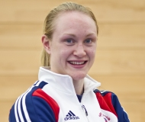
Gemma Howell competes in the -63kg weight category and has achieved bronze medals in the Junior World and European Championship in 2008 at the age of 16. Also she has achieved 7th place in the 2010 World Championship.

Preparation:
Morote Seoi Nage also known as Seoi Nage, is a shoulder throw that involves gripping Uke’s judogi (judo suit) with his two hands rather than the grip of Ippon Seoi Nage in which only one hand grips the sleeve whist the other is placed under Uke’s armpit on the same arm. This throw is also considered as on the highest scoring throws even though it is considered to be of orange belt standard in the British Judo Association’s grading syllabus. This throw is often demonstrated in competition using variations such as the standard and most effective position executing it standing whilst other judoka’s demonstrate Seoi Nage in the drop position. Moreover this throw is particularly successful when you are shorter than your opponent as this allows you to create a low centre of gravity quickly without having to squat down too far placing you in an unbalanced position.
Additionally, you can apply Seoi Nage in most situations, as you can easily move your opponent into the correct position to complete the throw. Gemma chooses to apply this throw both when she is being dominated by her opponent Ribout who forcefully pushes her backwards which creates space between both competitors creating the perfect opportunity for Gemma to rotate her body and drop down onto her knees to execute a drop Seoi Nage. Also Gemma’s choice to apply drop seoi nage stems from her opponent’s position, as Ribout pushes her backwards therefore creating a forward moving momentum, which leads her to become more unbalanced as Gemma resists. Thus making it easy to throw Ribout over as she is already unbalanced, which means all Gemma does is use this to her advantage to drop down onto her knees using her opponent’s momentum to throw her over. Furthermore the preparation phase for Seoi Nage is particularly similar to that of O Goshi as a well-established grip will allow Gemma to move her opponent into the desired position, if the opponent has not aided Gemma by forcing her backwards to create space for the execution of the throw.
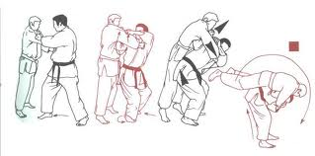
Gemma’s preparation for this throw can be seen a number of times within the fight between herself and Ribout. Gemma unsuccessfully throws with Morote Seoi Nage several times and this is purely due to either the grip she establishes or the position and action of her opponent. Firstly at 37 seconds into the video Gemma chooses to apply Seoi Nage, she does establish her grip immediately planting her left hand onto the sleeve and her right hand high on the lapel, however you can see that her opponent uses grip fighting to try and remove Gemma’s grip off of the lapel in order to obtain her own grip. This leads to Gemma changing her grip moving her right hand higher upon the lapel which causes it to be placed around the head; the space created between their bodies resulting from this action allows Ribout to grip around Gemma’s waist. Hence why Gemma cannot complete the throw as Ribout’s grip limits the space for rotation leading Gemma to rotate half way into the body an then dropping down onto her knees without pulling on the arm, therefore resulting in Ribout falling on top if Gemma in order to fight with Ne Waza.
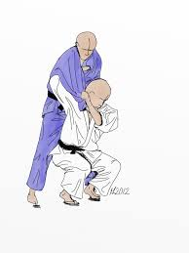
Establishing a perfect grip is vital, as this control of the body can eliminate Uke from trying to use grip fighting to remove your control over the sleeve. As you can see Gemma immediately applies her grip and you can see in the video at one minute in, where both competitors grip each other immediately in order to try and dominate the competition. Gemma grips Uke’s right arm with her left hand therefore gaining control of the sleeve which is vital, as controlling the sleeve will also aid the completion of the throw; as a strong pull on the sleeve hand guides the opponent onto their back. As Gemma gains control of the sleeve she pulls the arm forcefully downwards by flexing her arm at the elbow; by completing this action quickly using both speed and force, the opponents body is also pulled forwards which allows Gemma to plant her right foot forwards and quickly rotate her body, dropping to her knees strongly pulling on Uke’s sleeve to rotate them onto their back. However even though the grip has been successfully established, Uke seems to anticipate the movements, when Gemma drops to her knees she has unbalanced Uke enough therefore she does not get thrown onto her back straight away which you would expect. Thus Uke falls of the side of the body rather than been rotated straight over Gemma’s body as she was not in a very unbalanced position and did not have sufficient forwards momentum to fly straight over the top of Gemma.
Execution:
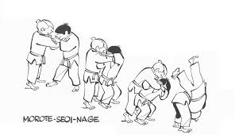
As soon as Gemma establishes her grip; with her left hand gripping Uke’s sleeve and her right hand placed high on the lapel, she will then rapidly decide whether to execute Seoi Nage either in the drop or standing position. Despite this, the set up for the throw is exactly the same for both variations of seoi nage; firstly Gemma takes a cross step leading with her right leg once she has established a right handed grip, then she places her foot in-between Uke’s legs as this ensures that she creates the perfect position in which Uke’s feet and Gemma’s planted foot that is now set forward creates an equilateral triangle. Most Judoka’s will know about the equilateral triangle that they must create as this helps to ensure that there is the correct amount of space between Uke’s body and her body. Moreover the triangle helps to gauge how close Gemma should pin herself to Uke in order to produce maximum force and speed when rotating her body into the throw. Also creating this space between herself and the opposition allows Gemma to rotate her body and drop onto her knees or take up the squat position to complete the throw either in the drop or standing position.
If Gemma was to complete Seoi Nage in the standing position whilst taking the diagonal step towards Uke Gemma will be in a squatted position creating by bending her knees. By being in the squatted position her hips are placed below her opponents belt line; creating this stature helps Gemma keep a low centre of gravity as stepping in low also helps Gemma to throw in one fluid motion and help her maintain stability whilst straightening her legs to throw Uke over. At the same time as planting her foot forwards and maintaining a low centre of gravity. Gemma will break Uke’s balance to the front by pulling strongly upwards and forwards using her arms to place Uke in an unbalanced position. Breaking Uke’s balance in this way is also referred to as Kuzushi (the action of pushing or pulling whilst entering a throw). So to apply Kuzushi, Gemma pulls her opponent upwards and towards her body lifting Uke with both hands, whilst taking a small step back in order to raise Uke up onto their toes, therefore pulling them off balance.
As well as positioning the foot into the triangle, keeping a low centre of gravity and applying Kuzushi, Gemma produces all off these movements in a fluid sequence, as she continues to pull her opponent forward whilst using her planted foot as a pivot to rotate the body bringing the other foot level with the opponent’s foot. Producing this movement leaves Gemma and Uke facing in the same direction which is extremely important as Gemma can now use her hips as a pivot to throw Uke over. Furthermore, as she rotates her body into Uke she slides her right arm that is gripping the lapel across Uke’s chest leaving the elbow positioned underneath their right armpit, however if she has a left handed grip then the left arm that is gripping the lapel will also slide across the chest and end up under Uke’s left armpit. When sliding this arm across the body Gemma therefore gains control of both Uke’s arms disabling any opportunity for the opponent to produce a counter attack. Making sure the elbow is under the armpit rather than pushed up into the air allows Gemma more control of Uke’s body and at this stage of the execution she pins herself against her opponents body as this closes all gaps between the competitors and allows her to forcefully pull the opponent over her body by pulling the sleeve hand forcefully to throw them over her shoulder.
To complete the throw all Gemma does is straighten her legs at the knees, as she previously set up this position by stepping into the throw with bent knees in a semi squatted position. By straightening the legs Gemma uses her hips as a pivot to throw Uke over; this also stresses the importance of the hip placement when turning into Uke. If the hips are not placed below Uke’s belt line then Gemma cannot exert maximum force when throwing her opponent as she has not achieved a low centre of gravity or bent her knees enough to achieve a squatted position, this therefore would give Gemma less force to throw the opponent over as there would only be a small movement from lifting the knees. However this normally causes Tori (the thrower) to bend their body forward which generates no force therefore the large movement from straightening the legs is needed in order to complete the throw. Additionally, the last phase of this throw is much alike that of O Goshi, as Gemma positions her feet close together and between Uke’s feet when turning into the throw allowing her to gain maximum force power when straightening her legs to lift Uke off the ground and onto her back. Gemma then twists her body towards the left whilst bending forward pulling on the sleeve arm to pull the opponent onto her back and then she then lifts them over her right shoulder and throws them onto their back. By twisting her body, moving her head in the direction she is throwing and dropping the upper body to turn the shoulders in the same direction she pulls Uke over her shoulder and onto their back to score Ippon. Also pulling strongly on the sleeve in this stage helps her to guide the opponent over with control.
Similarly; Gemma displayed Seoi Nage in the drop position. This is very much the same execution as the gripping, the first foot placement into the triangle and the application of Kuzushi are the same for both variations of Seoi Nage. However once having placed the right foot into the equilateral triangle and entering this whilst applying lots of Kuzushi, Gemma then pulls the opponent forward and onto her right shoulder if a right handed grip has been set up. She does this by pulling on both the sleeve and lapel grip to force Uke forwards also breaking his balance even further forward. Gemma then drops her right leg that has been previously planted also spinning on her right foot to turn her body so that it is facing the same direction as Uke. Spinning on her right foot whilst dropping the hip allows Gemma to place her left foot and drop down onto her left knee as well, making sure that both legs are now in between Uke’s legs. As both knees are now on the floor Gemma again slides her right arm that is gripping the lapel over Uke’s chest pushing the elbow underneath their armpit, she then pulls Uke's right arm down and locks it against her body closing all gaps between her and her opponent. At the same time as closing all gaps between their bodies, Gemma lifts Uke up with both hands and rotates her body pulling strongly on the sleeve arm to rotate Uke onto their back. The movement of Gemma’s body is also the same for both variations as she will still turn to the left to face the direction in which she is throwing her opponent despite being on her knees this is still an important factor into rotating Uke onto their back.
Recovery:
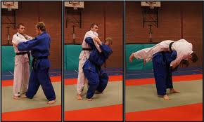
The recovery phase of Seoi Nage is also very similar to the recovery phase of O Goshi. Gemma also will try to throw her opponent as close to her feet as possible especially when executing Seoi Nage in the standing position as the opponent can fall off the side of the body rather than being rotated over the right shoulder if Gemma does not apply the right application of force to the sleeve arm to rotate Uke over and onto their back. Therefore throwing close towards the feet in the standing position or the body in the drop position is vital as this allows Gemma to easily hold down her opponent or fight with Ne waza if necessary. Moreover, keeping the grip established upon the opponent allows Gemma to respond quicker and easily slip into a suitable hold down with the grip she has already established. If she has thrown Uke onto their side but still has grip of their sleeve arm then the most effective hold down would be Juji – Gatame which is an very effective arm lock as it disables Uke’s sleeve hand by Gemma applying pressure to their elbow by pulling the arm backwards causing discomfort to Uke, usually resulting in Uke tapping out of the hold because of the discomfort applied therefore Gemma can score by Waza Ari.
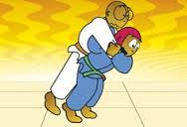
In addition the last stage of throwing is known as Kime whereby Tori (the thrower) follows through to finish the throw. The follow through involves Gemma to determining how hard she would like to throw the opponent and the direction in which the opponent is thrown and where they land. Ultimately to follow through with this throw Gemma must maintain momentum through all stages of the throwing process as most actions are executed together rather than individually creating a fluid sequence of movements. However, if Gemma performed action individually it would take far too much time allowing the opponent to attack therefore performing the throw at speed is also an important factor in the recovery phase. In the throwing phase (Kake) Gemma completes Seoi Nage by generating momentum and energy to throw from the standing position and stopping actions in this phase means that Gemma loses control of Uke’s body reducing the chances of throwing them onto their back to score Ippon, thus Gemma performs actions simultaneously at speed to ensure that Ippon is scored.

B1 Morote Seoi Nage
B1 Preparation:
Firstly, if Gemma has a considerable weight advantage over Uke then this gives her a greater advantage when in both the preparation and execution stage, as her weight advantage will allow her to freely move Uke around in order to plant the correct grip, and furthermore using her weight advantage to pull Uke over. However if she or I was to be of smaller weight than our opponents then this can be a difficult throw to execute because of the lack of strength and weight I would have to either squat down and pick up the opponent or to drop down onto my knees and pull them over my shoulder. Therefore giving me a disadvantage as I cannot pick up my opponent if they are significantly heavier or stronger than myself therefore upper body weight training would help to improve this. Whereas Gemma’s training routine would include weight training therefore she would be more able and confident to pick her opponent up in order to throw them over the shoulder. I also find it difficult in execute these stages as I become tired not only because I lack strength and it is harder to lift my opponent up but because I lack aerobic fitness whereas Gemma would not fatigue easily because of her extensive training.
Moreover, the decision to apply Seoi Nage is normally very easy for performers as there is a great range of ways they can manipulate their opponent in order to apply the throw. Gemma usually applies this when she is facing her opponent; although she uses it when being dominated by her opponent especially if they are forcefully pushing her backwards. I do prefer this method too. Especially when dropping down onto my knees to execute drop Seoi Nage however it can be difficult to execute as I cannot drop down onto my knees or turn into their body quick enough to execute the throw as quickly as Gemma does, meaning that the opponent would be forcefully pushing me back and therefore apply Kusuzhi to prepare for their upcoming throw. However I do prefer this method as I do not fatigue quickly when performing this in the drop position. Also if too much space is created between myself and the opponent it makes in increasingly difficult to produce enough momentum for the throw.
Furthermore, the combination of movement and a well - established grip all contribute to the Kumi Kata stage in which Gemma decides on a preferred grip and stance in order to produce Seoi Nage; also choosing to do this is essential before a throw can be successfully executed, and for the throw to move into the next stage of Kuzushi. However, this throw becomes unsuccessful when under pressure and I often face being countered as I do not apply my grip quick enough or I do not plant my right hand high enough on the lapel to control the movement of my opponent therefore producing a major disadvantage whereas Gemma adapts to the situation by moving her right hand higher on the lapel and almost so her grip is around the back of the head this gives her more control and enables her to manipulate the opponent. By not adapting to the situation rapidly this can cause my opponent to produce a counter throw as they already have a well-established grip and are facing me therefore giving them the opportunity to perform a backwards throw or turn around to produce a forward facing throw if they move quick enough.
In competition, Gemma grips her opponent’s right arm with her left hand therefore gaining control of the sleeve which is vital as this will aid the completion of the throw. However when I establish this grip I tend to grip the arm higher than normal as I grip above the elbow allowing me more control. Although, this can make the completion of the throw harder when turning into the body therefore I can create my own disadvantages by placing my grip on the sleeve in the incorrect area. Once the hand is placed upon the sleeve Gemma pulls the arm forcefully downwards by flexing her arm at the elbow; by completing this action quickly using both speed and force, the opponent’s body is also pulled forwards off balancing her opponent. Completing this action is easy if your opponent does not counter your movement however I can struggle with pulling the arm strongly enough to off balance my opponent therefore putting me into a weaker position. Strength training may help to me increase my upper body strength enough to make sure I can off balance Uke using a combination of strength and speed.
B1 Execution:
The execution of this throw involves the same set up for both the standing and drop Seoi Nage. Alike Uchi mata and O Goshi this throw requires Gemma to create the perfect position with her planted foot at the top of the ‘equilateral triangle’ as this allows the correct amount of space in order to produce the throw. However in competition it is not always that easy to get into the correct position especially when you are facing your opponent, as this means speed is a vital factor. This becomes a disadvantage as I cannot produce enough speed for the throw to be successful whereas Gemma generation of speed always occurs at this stage as she will not be overthinking the grip and foot placement, unlike myself as I do not want to step in too deeply. Although this does tend to happen when stepping into the triangle, so if I do step too deeply I reduce my rotation, angle and space I have to turn around and either drop onto my knees or produce the throw in the standing position; whereas Gemma creates the correct amount of space allowing her to create maximum force when in the throwing phase. Also to produce the correct position which completes the Tsukuri stage of the throw includes Gemma creating a squatted position by bending her knees so that her hips are placed below her opponents belt line; creating this helps to maintain stability whilst straightening her legs to throw Uke over. However when I go into the squat position I do not always align my hips below the belt line as I am too concerned about completing the throw using speed and force meaning that I place more importance on using force to throw my opponent over rather than correctly aligning my hips. Furthermore, I can never position my elbow underneath their right armpit as I find this extremely uncomfortable as I have not practiced this enough to be used to the movement. Therefore I do not gain control of both arms unlike Gemma who manages to create this position with speed. As well as this, generally my grip upon the lapel and the sleeve are not placed high enough meaning that I do not have ultimate control over the opponent’s body whereas Gemma’s grip is always placed high on the lapel and sleeve which makes sure that she can control Uke’s body.
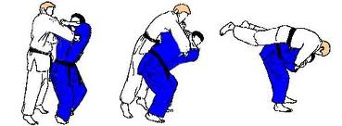
When executing Seoi Nage in the drop position, Gemma drops down onto both knees making sure that she lands straight in between Uke’s feet. I find that this can be difficult when in competition, especially if my opponent is resisting. Also if I have not correctly placed my grip with my dominant hand on the lapel and the other hand high on the sleeve then it is difficult to pull the opponent over my shoulder as I do not have full control of their arms. This therefore makes it difficult to execute drop seoi nage also hindering the control of Uke’s fall as I cannot slide my arm that is gripping the lapel over Uke’s chest pushing the elbow underneath their armpit – because this position cannot be achieved the throw can be easily countered. However, Gemma always makes sure that her grip is planted high enough on the lapel to ensure she has full control when guiding Uke over her shoulder and this is achieved by sliding her arm that is gripping the lapel over Uke’s chest pushing the elbow underneath their armpit.

B1 Recovery:
In the recovery phase, Gemma throws her opponent as close to her feet as possible especially when executing Seoi Nage in the standing position. However once I have executed the throw my opponent does not always land closely at my feet. This is a result of errors in execution but also lack of control when guiding Uke to the floor when rotating them onto their back. I try to guide them over too quickly and therefore am not in full control of their movement or move too slowly which causes them to fall off the side of my body and therefore not landing onto their back in order for me to score Ippon. Whereas Gemma does not make the same mistakes as I do in the execution phase and can therefore throw Uke correctly onto their back using both force and speed to achieve this.
Also in the last stage of throwing (Kime) Gemma will follow through therefore controlling the opponent over her shoulder. This means that Gemma must show control and ultimately follow through with this throw by maintaining momentum through all stages of the throwing process as most actions are executed together rather than individually creating a fluid sequence of movements. Nevertheless in a competitive situation not all off my throws remain fluid as maintaining momentum throughout all stages can be difficult especially when the opponent is trying their best to counter my movements. Also I do tend to perform some actions individually, especially if I feel this can help me to produce the perfect throw in the recovery phase. For example I tend to separate my movement into Kuzushi and my foot placement even though it would be much better in a fluid movement. I feel I get the correct foot placement by taking my time to plant it rather than rushing to put all movements together, although this does not always work to produce the perfect throw it does help me to get every aspect of movement right and also helps me amend my performance in future competitions.
Furthermore, when in the recovery phase Gemma holds her grip upon her opponent which allows her to respond quicker and easily slip into a suitable hold down with the grip she has already established. Although I find keeping hold of the grip can be difficult especially when Uke falls onto their side and has therefore broken my grip unless I respond quick enough to the change in situation.

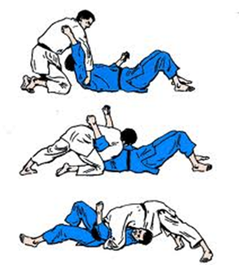
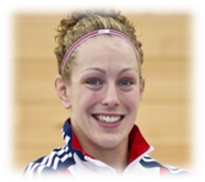
B2 Holding Techniques - Kamishiho Gatame
Sally Conway competes in the -70kg weight category and is one of country's most physical judoka according to the British Judo Association. Sally has a number of achievements including winning the Olympic test event silver in 2011. She is also three-time World Cup winner and finished fifth-place at the World Championships and IJF Grand Slam's in Moscow and Paris.
Preparation:
Kamishiho Gatame is one of the seven mat holds (Osaekomi-waza) and is referred to as an upper four quarter hold down; which is considered to be of yellow belt standard according to the British Judo Association. However when this hold down is performed properly it can be very effective. This hold down is effective as it enables Sally to gain full control of Uke’s upper body therefore allowing her to hold them down for the full 25 seconds, which results in scoring Ippon. This hold down should end up with Sally lying onto top of Uke’s Upper body with her hands gripping the sides of the belt and her chin placed upon the chest in order to hold Uke down successfully.
This hold down can also be used in a number of ways, firstly to follow from a throw but it can also be used to counter a hold down from your opponent. When choosing to perform the throw Sally will be looking for cues from the environment. Firstly looking at cues from Uke to throw them over into into Kamishiho Gatame as most straight over throws naturally lead to this hold down Sally has a number of throws to choose from in order to follow up with this hold down. Throws such as Ippon Seoi Nage are a more popular combination that leads into Kamishiho Gatame, as Uke lands in the perfect position for Sally to quickly drop down onto her knees and hold them down using this technique, if Uke is not quick enough to respond to the throw and turn over onto their stomach. Using this pinning technique is dependent on Uke’s response but ultimately Sally’s reaction to Uke movements in which she would have trained extensively to quicken her reaction time. Additionally once Sally has thrown, However Uke has landed on their side then she would choose to apply this hold down in the competitive situation. When Uke is lead on their side Sally drops down onto her knees directly behind Uke’s head, so she can lay her upper body over Uke’s and grip onto the side of their belt whilst apply pressure to Uke in order to hold them down.
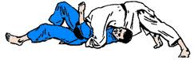
Sally would choose to apply this hold down especially if the opponent is currently dominating the competition by holding her down using this technique. Sally can use the disadvantage of being pinned down with Kamishiho Gatame to her advantage as the opponent has already set up the grip for her. Therefore all Sally needs to do is tip them off balance and onto their back still retaining their current grip. Sally can escape Kamishiho Gatame by using the strength in her legs to counter the hold down. Even though Sally’s upper body is immobilised by the hold she still has her legs to manipulate the position of her opponent, by using her legs and twisting her body Sally can escape the grip however it is important that she creates an element of surprise. Sally creates the element of surprise by firstly rocking her body to one side by pushing up with her legs and twisting her body in the desired direction – the direction in which she first twists is decided by the opponent as they will apply pressure to Sally’s head whilst in the hold resulting in her placing her head on one side of her body. The first rock therefore will go against the direction of her head and then she quickly switches direction and rocks the other way (in the direction her head is tilted) as she will not be able to move it whilst the opponent is applying pressure. Furthermore, by presenting the 2nd stimulus of changing the direction, she quickly gains advantage as this was presented in quick succession to the 1st stimulus therefore confusing the opponent as they are still trying to adapt their hold down to the first stimulus (the initial rocking of the body). Therefore by switching direction quickly Sally rolls the opponent over and onto their back still keeping the same grip that Uke had set up previously set up therefore she holds them down using Kamishiho Gatame.
Execution:
In the Kami-shiho-gatame Sally lies with her upper body covering Uke from above their head using both her arms and body to pin Uke down. Sally kneels just above Uke’s head, laying her upper body over Uke’s. Once in position she slides both her arms underneath Uke’s shoulders and grips the belt. By taking a strong grip of the Uke’s belt Sally can control both sides of Uke’s body minimalizing their escape and ultimately this helps to keep Uke flat on their back resulting in Sally scoring Ippon. After gripping the belt Sally will lock her arms tightly against Uke’s body in order to keep Uke’s arms immobilized otherwise they may try to escape the hold down by pushing their hands upwards and twisting the body to turn Sally over. However if Uke is twisting their body and struggling out of the hold down Sally tends to pull the grip in even tighter whilst forcing her full body weight onto their upper body also angling her head downwards creating a tighter hold in which this makes the hold difficult to escape from. If Sally does not place both arms underneath Uke’s then this leaves both their arms free, allowing them to raise them which would aid their escape from the hold down. Therefore she makes sure that both arms are underneath Uke instead of over the top as this creates a powerful position and gives her ultimate control of the hold down.
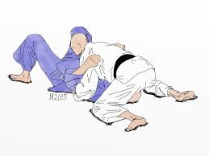
Also she will make sure that she has good chest contact with Uke’s upper body. Sally assures that she has full control of the upper body by placing her chin on Uke’s chest. This also allows her to know whether she is leaning over the body far enough to control in fully. If her chin is not on Uke’s chest then her hold down can be countered, therefore she makes sure she creates good chest contact. Sally knows when she is not preforming the hold down correctly when she does not have this contact therefore this stage can also help her amend her performance and therefore gain full control of the body. Once the grip has been established Sally pulls the belt towards her body in order to tighten the hold down and ensure that Uke cannot escape from the hold. This results in Uke’s head being under her armpit as she has lent over the body keeping the chin on their chest.

Recovery:
Furthermore in the recovery stage, Sally will make sure that she is causing Uke discomfort by pressing her stomach against Uke’s face whilst pinning their arms down. Causing this discomfort therefore makes it harder for Uke to escape the hold down because of the pressure that Sally is applying. Also Uke’s head will have tilted to one side because of the pressure applied and the direction of Uke’s head tilted to one side pre warns Sally to which side Uke may try and escape from. As Uke tends to bridge and twist their body in the direction of the head as Sally is pushing down on the head with her stomach making it uncomfortable to move the head in the other direction, this allows Sally to quickly counter any attempt of an escape.
In addition, she will ensure that she has full control of the upper body by pushing her stomach and hips to the floor and spreads both legs out straight with the feet wide apart. However if she does not feel this is a strong enough hold to maintain for 25 seconds then she may go up onto her toes, pushing off the mat. This action allows her to maintain full control of Uke especially if they are trying to escape from the hold down. In addition this hold down can also be performed with the knees bent close to Uke head; she may choose to perform Kamishiho Gatame in this way, as in the competitive situation she will want to minimise the chances of escape. This is the most common leg variation used in competition as it gives Sally ultimate control as this position also helps pull the grip on the belt in tighter to prevent an escape. Also she will vary her leg positions depending on cues that Uke is displaying.
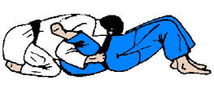
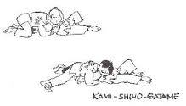

B1 Kamishiho Gatame
B1 Preparation:
If I have thrown Uke with a straight over throw such as Ippon Seoi Nage, but instead of landing on their back they have landed on their side then I would choose to apply Kamishiho Gatame only when I still have my grip on their sleeve. However if I have not thrown Uke close enough to my feet then it makes it extremely hard to quickly drop onto my knees and apply the hold down rapidly. Whereas Sally’s execution of the throw is more likely to be perfect resulting in Uke landing close to her feet therefore allowing her to use her quick reaction time to her advantage.
Sally can escape the hold down of Kamishiho Gatame by using an escape bridging technique to turn her opponent over into the same hold down, therefore she uses her weakness of being held down to her advantage especially if the opponent has not properly applied the hold down. However this technique can be extremely hard to execute as the direction of your head already gives the opponent a clue to which direction you will try to escape from. In this situation I sometimes try to move my head in the other direction, but this is only possible if the opponent has not applied the right pressure onto my head. However this hold down is also difficult to escape from due to the pressure applied by the opponent, and furthermore the escape requires me to use my muscular strength in my leg to push off the floor which can be difficult when Uke is controlling the sides of my body and pulling me in tightly. Sally finds it easy to use all of her strength against her opponent as she would have specifically trained for each major muscular group in the body allowing her to push her body up applying both power and speed to quickly twist and rock her opponent over. I find it difficult to produce this action quickly applying the right amount of speed in order to turn my opponent over into Kamishio Gatame as a result of lacking lower body power and strength.
B1 Execution:
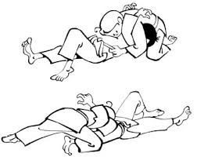
Sally kneels just above Uke’s head, laying her upper body over Uke’s however the positioning of yourself highly depends on where your opponent has landed and what actions they are taking to either escape your hold down or to pin you down. This therefore this can cause your body position to be incorrect compared to the desired position explained in the execution phase. If Sally responds quicker than her opponent this gives her the advantage to use ne – waza (groundwork) which is her strongest area in competition. Sally’s rapid reactions to Uke once they have been throw allows her to drop down quickly into Kamishiho Gatame kneeling just above the head – her quick reaction aids her bodily position and gives her more time to manipulate Uke’s body to her advantage however when getting into this position my reactions are not always fast enough and I cannot get the correct position and apply the grip resulting in Uke possibly turning over onto their stomach.
Alike Sally I grip Uke belt at the side in order to gain control of their body making it harder for Uke to bridge out of the hold down, however placing my grip upon their belt can sometimes be a struggle especially if Uke is trying to escape my grip, although even if my grip is not the strongest it could be I normally resolve this by locking my arms tightly against the side of Uke body and pulling my grip in tightly towards myself. Also if Uke is twisting their body and struggling out of the hold down Sally forces her full body weight onto their upper body also angling her head downwards. I tend to reposition my grip and make sure my arms are underneath Uke shoulders in order to create the strongest position possible before thinking about applying more body weight onto my opponent. Thinking about the position of my legs and the weight I am applying is more of a secondary thought as I mainly focus on trying to control Uke body using my upper body strength therefore forgetting what role my legs play in the positioning of the hold down. Moreover, having good chest contact is key when executing this pinning technique however sometimes I do not lean over Uke body far enough therefore making it easier from them to escape the hold down.
B1 Recovery:
During the recovery stage, causing discomfort to Uke is key. This is achieved by pressing the stomach against the side of Uke’s face however I do not always cause the most discomfort possible when pressing down this is because I do not lean my body far enough over Uke’s upper body. This means that I do not apply enough pressure for Uke to become uncomfortable, but Sally makes sure she does this by leaning her body weight onto Uke. Moreover not applying enough pressure potentially makes it easier for Uke to escape from the hold down. If my bodily position is incorrect leading to me not applying enough pressure to Uke’s face then Uke does have the opportunity to escape the hold down and to possibly bridge in either direction as they will have space to move their head. As a result of me not applying enough pressure to the face in order to keep it in one direction it does not allow me to use this cue if Uke does decide to bridge into an escape therefore I would need to be prepared for them bridging in either direction.
When positioning my legs I prefer to push my hips to the floor and spread both legs out straight with the feet wide apart however in the competitive situation I may not have enough time to quickly maintain this position. Although Sally makes sure that she does push her hips to the floor and spreads both legs out so that she can gain full control of the opponent’s upper body whereas I lose control of their body because I do not always maintain this position. In this case I would perform the hold down with my knees bent close to Uke head as this takes a lot less time to fall into the hold own and control Uke’s upper body, but Sally would always maintain the correct position whilst raising up onto her toes causing her to have more control of the body. I also find lifting up onto the toes uncomfortable and therefore tend not to do this as I do not feel like I have full control of Uke, so practice in this area would be beneficial.
Also, trying to get the leg position correct and performing this quickly can be difficult, sometimes leading to the wrong bodily position as I become too focused on my grip trying to keep hold of Uke whilst they will be escaping therefore the leg position is sometimes a more secondary thought. Whereas Sally will always consciously thinking about her position and at which position she will have an advantage over Uke and can therefore apply this hold down successfully.
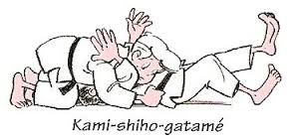

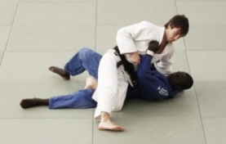
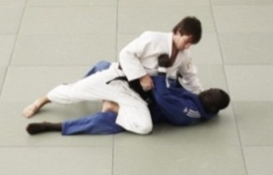
B2 Holding Techniques – Kesa Gatame:
Escape Into Kesa Gatame
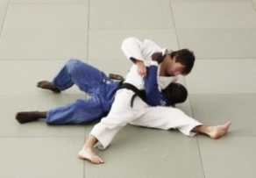
Elite Performer Sally Conway – featured also for the hold down Kami-Shiho-Gatame above.
Preparation:
Kesa Gatame is also one of the seven mat holds (Osaekomi-waza), and is also known as a scarf hold, as it requires Tori (thrower) to take full control of the head and ultimately the entire body. If Sally applies this hold down perfectly then she will secure the head and neck by wrapping her arm around Uke and holding as firmly as possible. As she has hold of the head and neck this is where the term scarf hold comes from.
In the preparation stage of this hold down Sally would have already thrown her opponent on to the mat, once the throw has taken place and Uke has fallen onto their back then Sally would score Ippon. However in the event that Uke’s reaction time is quicker than and they have turned over then sally would quickly use Ne Waza (groundwork) to turn her opponent over and hold them down with Kesa Gatame as most throws naturally lead into this hold down.This makes it easy for Sally to apply the hold as it is the easiest to fall into when in a competitive situation and she would choose to apply this as it is likely that Uke’s grip once she has thrown will still be on gripping her lapel therefore she can easily slip into this hold down if Uke does not respond quick enough and turn over into a defensive position.
Furthermore if either her or the opponent have been unsuccessful in an attacking throw and have both fallen onto the mat, Sally would also try to apply this hold down, as in this situation Sally would fight with Newaza typically using this in a situation where Uke has rolled up into the ball and is fighting defensively. If this has occurred, then Sally would try to turnover Uke into the hold Kesa Gatame, by using the pull through. The pull through involves Sally being positioned at the side of Uke where she then forcefully pushes her right arm underneath Uke stomach and gripping around both their arms on the inside whereas left arm grips around the front of the opponents arms, so that the left arm is placed underneath their neck. Once the grip is securely in place she pulls strongly on the the opponents arms sweeping them towards her body, then pulling as tightly as possible to her body she pushes Uke over using her chest allowing her to turn them over onto their back. Once the turnover is complete Sally can apply Kesa Gatame as Uke will be lying on their back. She does this by keeping her left hand that has is placed on their right sleeve and was holding onto the far arm underneath the neck during the pull through, whilst letting go of her right handed grip that was placed under their stomach. Sally then wraps her right arm around Uke’s head by placing the arm under the head and squeezing tight. With her left arm she pulls their right arm around her stomach and pins it into her body whilst leaning all her weight onto her opponent, therefore applying Kesa Gatame.
Also Sally would apply Kesa Gatame when she is in a weak position – if Sally is trapped between Uke’s legs and Uke is lying on their back then it is highly likely that the opponent will try and apply a strangle. This therefore puts Sally in a weak position but she can overcome this be escaping from between the opponents legs. Sally does this by stepping over Uke thigh and moving her body to the side and from this position Sally can apply Kesa-Gatame as she has escaped her legs and can therefore set up the upper body position from here.
Execution:
To execute the hold down Sally will sit closely beside Uke, facing away from them with her back to the opponent. She then closes all gaps between both their bodies which will enable her to distribute her weight evenly onto the opponent; this should prevent Uke from escaping the hold using a bridging technique. Also Sally will wrap her right arm around their neck and under their head; this allows her to gain maximal control of the opponent body and makes it extremely hard for the opponent to bridge out of the hold down, especially as Sally will be applying as much force and weight onto the opponent body in order for it to be uncomfortable for Uke. She creates this uncomfortable position my holding Uke head and neck as tightly as she can. She will then grip their jacket on the lapel, again allowing maximal control of their upper body, so they cannot bridge out of her hold down. By wrapping her arm around the head Sally is pinning Uke’s upper body as if she is hugging her opponent.
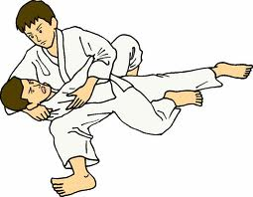
Sally also tucks Uke's free arm tightly underneath her left arm by pulling it around her waist, and pinning it tightly into her body, locking it into her side therefore disabling movement. This means that Uke cannot use there arm to escape from the hold down, also pinning the arm tightly into the body contributes to making the position as uncomfortable for Uke as possible. Also using her left arm she then makes sure that she grips the arm at the elbow taking full control of their upper arm. However when pinning the arm around her waist Sally also makes sure she pulls the arm tightly underneath her armpit allowing her to control the hand as well. This is all beneficial is creating an uncomfortable position as well as allowing Sally to have maximal control of her opponent. Furthermore, this technique relies on good control using a grip of Uke's sleeve, head and neck in order to hold them down for 20 seconds to gain Ippon.
Recovery:
Sally concentrates on her body alignment when pinning Uke down as she tries to achieve maximum stability by spreading her legs out and making sure that she is forming the shape of the letter T with her legs. Also aligning the body in this way spreads her weight evenly preventing escapes and therefore allowing Sally maximum control of her opponent thus enabling her to pin them down for the full 25 seconds and achieving ippon. This position is extremely important when executing Kesa Gatame, as keeping the right leg extended in the forward facing direction will counteract Uke’s escape if they bridge in that direction. The extension of the leg facing forward helps Sally to maintain balance when using this pinning technique. Also Sally makes sure that her left foot is not positioned too far behind her. If her foot is flexed too far backwards this gives Uke the opportunity to wrap their legs around Sally’s allowing them to counteract the hold down. In addition the left leg should be flexed at the knee, however if the knee is flexed too far inwards and not positioned properly this gives Uke the opportunity to bridge out of the hold down as the leg positions mean that Sally will be leaning too far into Uke, pushing them in their desired direction in order to produce the escape. Therefore Sally’s execution of the hold down by gripping the opponent in the correct place and aligning the legs in a T shape allows her to hold the opponent and not push them backwards allowing them to escape.
In the recovery of this hold down Sally lowers the position of her head, by keeping her head downwards, and focusing on looking down at the mat means that Sally is in the correct position to apply the most downwards force when leaning on Uke. As well as moving the head position, Sally will lean her body into the opponent’s body by focusing her weight on the weakest part of their body – in this position this would be on the ribs. Focusing her weight here instead of on the sternum – strongest part of their body in this position therefore creates an uncomfortable position for Uke. Moreover the recovery phase is all about reacting to the opponents movements, if Uke is pushing their head forwards in an attempt to sit up and escape the hold Sally pushes her head downwards forcing Uke back into the mat using both her head movements and the upper body control that she has gained in the execution stage. However if Uke is trying to force Sally’s head forward creating a weak position she will lean further back to ensure that she is not pulled forwards and off the opponent as this falling momentum will cause her hand to let go of Uke’s arm as she will break the fall forwards by bringing her hand out and onto the mat so she does not go head first therefore releasing Uke’s arm, which allows them to escape and roll out of the hold down.
B1 Kesa- Gatame
B1 Preparation:
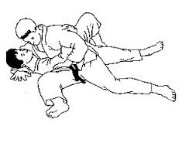
As most throws naturally lead into Kesa Gatame this makes it extremely easy to make a quick decision when in a competitive situation. Alike Sally I would choose to apply this hold down if I have thrown my opponent and their grip is still on my lapel and also if I haven’t lost my grip on their sleeve, however in a competitive situation my grip on the opponent may be compromised depending on both the execution of the throw and speed in which I perform the desired throw. Sometimes after having thrown my opponent my grip may slip off the sleeve making is harder for me to get into the perfect position to perform Kesa Gatame. However Sally doesn’t lose her grip because she has practiced getting into this hold down multiple times meaning that she gains more experience through repetition of this hold down, therefore I would need to undertake much more practice in order to stop realising my grip on the sleeve. Furthermore once having thrown Uke my responses become a lot slower therefore giving Uke the opportunity to roll over into a defensive position in which I would have to use either another hold down or turn my opponent over into Kesa Gatame. But Sally’s reaction time is much faster than mine because she would have specifically trained to improve her reaction time in order to quickly apply this hold down. So when I have not reacted quick enough to go straight into applying the hold down, and Uke is in a defensive position whereby they have rolled up into the ball, I would take this opportunity to turn over Uke into Kesa Gatame by using the same technique described in the preparation phase but this becomes increasingly hard to apply when in a weaker position.
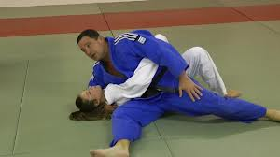
In addition I am relatively weaker in strength, particularly in my upper body compared to Sally. However because she has regular weight training that enables her to gain strength, whereas I do not undertake any type of weight training to improve my upper body strength. This strength is importance as it helps when holding Uke’s head and sleeve tightly whilst apply weight to the opponent. Ultimately she can rely on her strength when turning the opponent over into a hold down whereas when I execute Kesa Gatame from the weaker position I find it hard to escape from between the legs. This is partly because I do not have the strength to push Uke’s thigh down to the floor when they are holding my legs in by wrapping their legs around mine, therefore meaning that I cannot escape the potential strangle as I cannot get to the side of the opponents body.
B1 Execution:
Sally sits closely beside Uke closing all gaps between both their bodies; in contrast in the competitive situation I find it difficult to react quickly to my opponent on the ground therefore when executing the hold I do not get close enough to their body as I am more focused on performing the skill quickly. This can therefore cause a gap to form between us making it easier for Uke to tip me off balance and escape the hold down. I could resolve this issue when wrapping my right arm around the neck tightly and pulling Uke towards my body, this would limit Uke’s chance of escape. This increased space can therefore cause a disadvantage in my hold down as I am not holding them as tightly as possible, I do not create an uncomfortable position allowing Uke to escape or bridge out of the hold down easily as thy have space between our bodies in which to twist their body away from me causing the hold down to become broken. Whereas Sally does not have any space between herself and the opponent during the hold down therefore maintaining control over the opponents body meaning that they cannot escape the hold down.
Additionally, Sally creates the perfect hold down by using her grip to gain control of her opponent. When gripping Uke’s closest arm she pins it around her waist and grips tightly with her left arm at the elbow with their hand underneath their armpit, whereas when I execute the throw I do grip the arm and hold it tightly around my waist however I sometimes do not place their hand underneath my armpit therefore I don’t not gain full control of the upper body and disable their arm movement which means I tend to lean into their body more to hold them down, which does create a more uncomfortable position, However Uke’s change of escaping the hold down is increased as they can use their arm to help them escape the hold down.
B1 Recovery:
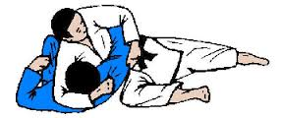
When pinning Uke down I spread my legs out in order to try and produce the right bodily alignment, however the alignment of my legs is not always in the shape of the letter T therefore I never achieve the maximum stability or control whilst holding Uke down. As my legs are not always in the correct alignment this puts me into an unbalanced position making it extremely easy for Uke to either rock me off balance. Therefore I would need to improve flexibility at the hips so that I can produce this T shape in order to hold Uke down, whereas Sally finds it easy to produce this T position because of increased flexibility. Also, I am in a weak position where Uke can swing his leg up and around my neck to force my back onto the mat or they can also escape using the bridging technique as my weight is not evenly spread across their body. Furthermore the positioning of my right foot is usually correct as I always try to make sure that it is facing in the forwards directing – I do this when gripping my opponent’s lapel after having wrapped my right arm around their neck and under their head. However I occasionally position my left leg too close to my opponents feet therefore meaning that it is too far back in the T shape position, meaning that my opponent has more opportunity to escape their throw as they can capture my leg pulling it towards them forcing me to be unbalanced allowing them to roll me over their body and escape the hold down.
When Sally performs this hold down she distributes her weight evenly and leans into Uke’s body making sure her body is also leant forwards to prevent an escape, however when positioning my body the distribution of my weight is not always even and I tend to learn backwards into Uke body more than I should do therefore pushing them rather than holding them down and forcing my weight onto their upper body. This creates a weak position and Uke has the opportunity to sit up and therefore counteract the hold down which also gives them the advantage of possibly putting me into a different hold down.
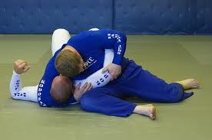

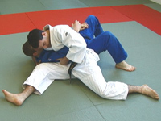

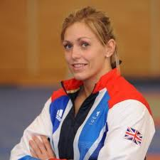
B2 Other Techniques – Uchi Mata
Gemma demonstrated this technique perfectly when defeating Ruika Sato (JPN) in the last 12 seconds of the contest by achieving ippon by Uchi Mata, therefore winning the Dusseldorf Grand Prix.
http://www.youtube.com/watch?v=Xj46-H8icfU – 10m 20s in Gemma is awarded Ippon by Uchi Mata in the last 12 seconds of the contest.

Gemma Gibbons competes in the -78kg category and is a seven-time World Cup medallist, who also won a silver medal at the London Olympics 2012. She has also achieved bronze medals at the World University Games and the u23 European Championship.

Preparation:
Uchi Mata is a foot technique or ashi waza and it is considered to be of green belt standard in the British Judo Association’s grading syllabus. Despite this the throw is considered to be one of the highest scoring techniques used in competition. Gemma also used this throw consistently in competitions; however the most famous use of the throw includes winning the final of the Düsseldorf Grand Prix against Sato (JPN), also throwing Ramirez (POL) with a left Uchi Mata for ippon in the London 2012 Olympics.
In the preparation phase of Uchi Mata Gemma must firstly establish her grip as this a vital for producing the perfect throw that will result in being awarded ippon. As you can see from the video of Gemma executing Uchi Mata her grip is totally dependent upon what the opponent had already set up – as you can see Sato is running straight into the throw, and not thinking about setting up an opportunity to throw herself (this is also suggested by the commentator). Sato then becomes increasingly frustrated which leads into running straight into the throw, giving Gemma an advantage and the opportunity to apply Uchi Mata. The reason why this would have been chosen would firstly result from Sato running into Gemma’s body as she is now facing Sato this gives her the opportunity to establish her grip and move Sato’s around to place her into the correct position to produce Uchi Mata, also Sato has chosen what throw Gemma will apply as the grip can be established quickly when the opponent is aggressively moving towards you. Additionally, if this throw is executed correctly it can easily achieve ippon as the opponent should land on their back if the perfect amount of force, speed and control is applied.
Moreover, Gemma takes advantage of Sato’s frustration by keeping calm and letting Sato come flying towards her as this ultimately makes it easier to turn into the body rapidly as she would already be in an unbalanced position. As you can see from the video when Sato runs at Gemma with both of them gripping up in contact, Gemma immediately establishes grip with her left hand gripping the lapel around the back of the head and the right hand controlling the sleeve giving her domination over her opponent as controlling the lapel allows her to freely move Sato around. However pausing the footage at 10m 21 you can see that Sato has not established any grip on Gemma and is focusing on grip fighting using both hands to free her from Gemma’s strongly established left handed grip upon her lapel. Sato is unsuccessful in pushing Gemma’s grip away. Also when forming the grip, Gemma’s hand is high on both the lapel and sleeve in order to make the throw successful and allow her more control when throwing Sato in mid - air to complete the throw.
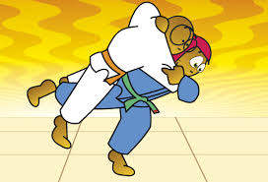
Furthermore, Gemma’s changes her grip just before throwing Sato over. Her left hand grip slips off the lapel ending up further down onto the back giving her more control of the throw. Sato then resists this lower grip by planting her grip at Gemma’s side. However this creates a bigger space for Gemma to reach over the shoulder gripping the upper back where it is impossible for Sato to remove her grip. As well as modifying her left hand her right hand moves up the sleeve ready to turn the opponent over by twisting her body and sweeping the leg up catching the inner thigh. When modifying her grip Gemma will make sure that just before she executes the throw by lifting Uke into the air that her elbow is bent into their armpit ready for when Gemma will need to pull on the lapel to turn Uke over in mid -air.
Additionally the preparation phase mainly involves setting up the grip ready for the throw, however watching the video of Gemma’s performance shows that she was previously unsuccessful in completing the throw Uchi Mata. At 9 minutes 31 seconds Gemma sets up her grip quickly however because she had gripped around the waist this restricts her movement if she was to turn into the body also reducing the sweeping action of the leg. Also because her grip is not correct Sato resists Gemma’s attempt of Uchi Mata by gripping her lapel and locking her arm straight so Gemma cannot face her and sweep the leg up even though Gemma does place her leg the resistance from Sato leads them to become stuck in that set position.
However, the reason she applies this throw successfully the last time is because Sato is facing her therefore giving Gemma the opportunity set up her grip perfectly, with her right hand on sleeve and left hand on lapel. Also as you can see Gemma does not want Sato to second guess her choice of throw as she could then be countered causing her to be throw or held down. Thus before Gemma commits to the throw she throws her left leg forwards twice as if she is going to throw her backwards. Throwing her leg forward before turning into the throw shows that Gemma is making the decision whether to use a backwards throw or to turn into Uke’s body a produce a forward facing throw. Ultimately I feel this decision to use Uchi Mata is dependent on Sato’s response to Gemma’s action of moving her leg forward as she changes her stance bringing one leg forward as well as her grip going around Gemma’s waist, opening up her body for Gemma to turn in.
Execution:
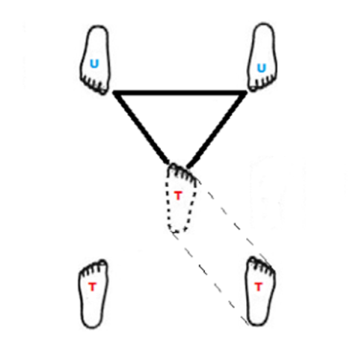
Once Gemma establishes her grip on Uke’s sleeve and at the top of Uke’s lapel ( her hand is just behind the head) she then takes a small cross step leading with her left leg if she has set up a left handed grip or leading with her right leg if a right handed grip has been established. Gemma will naturally be stronger on one side of the body, however which grip she applies completely depends on the positioning of the opponent and the grip they have on Gemma. She would have trained for the throw off both sides of the body and therefore whichever side she decides to throw off each throw will be strong and she will be able to generate the amount of speed and force required for Uke to land on their back therefore resulting in the score of ippon. In the case of the Dusseldorf Grand Prix final against Sato (JPN) the successful Uchi Mata is produced using a left handed grip with her right hand placed high upon the sleeve and her left hand around the back of the head and gripping the lapel, this grip is perfectly set for the execution of Uchi Mata as she has a high grip on the sleeve allowing more control of the movement and she is also facing her opponent Sato.
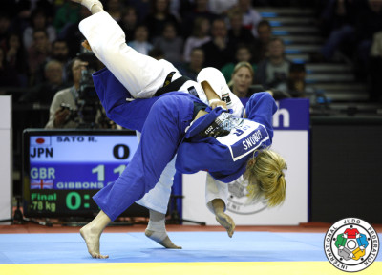
When taking the small cross step towards Uke; Gemma places her foot in-between Uke’s legs making sure that she creates the perfect position, in which Uke’s feet and Gemma’s planted foot that is now set forward creates an equilateral triangle. Also she will turn her foot around so it is facing in the forward direction. This is also executed at the same time as bringing the leg around ready for the sweeping action. This triangle helps to gauge how close Gemma should pin herself to Uke in order to produce maximum force and speed when rotating her body into the throw. If Gemma steps in too deep this will reduce the speed and the space in which she has to rotate her body, also being too close to Uke’s body can cause the hip to get caught therefore reducing rotation at the hips and the space in which she has to sweep her leg back into Uke’s inner thigh, as the being too close means Gemma will create a shorter lever which makes catching their inner thigh in the sweeping stage incredibly difficult and therefore Gemma would be unable to complete the throw.
Moreover, you can see Gemma plant her foot into the triangle at 10m 25 seconds as she takes the small cross step and quickly rotates her hips bringing her other foot sweeping round ending parallel and in a forward facing direction. The foot placement is therefore the most important factor to produce the correct position before turning into the throw and as you can see from the video Gemma also shifts her weight onto her stepping foot which allows her to use this as a pivot when turning into the throw.
Also whilst taking this step towards Uke, Gemma also applies lots of Kuzushi (the action of pushing or pulling whilst entering a throw) in this case Gemma is pulling her opponent towards her in order to close the big gaps between their bodies and also by pulling upwards with the sleeve hand which causes Uke to raise up onto their toes creating an unbalanced position. Making Uke unbalanced is key when executing this throw as this eliminates any possibility of them producing a counter throw which in this case Gemma would try to avoid being counter by Uchi Mata sukashi. Also at 10m 26 seconds into the video link provided you can see Gemma has applied kuzushi by pulling upwards with both the sleeve and lapel grip as Sato becomes raised onto her toes and nearly off the floor as Gemma has pulled her onto the hip even before sweeping the leg straight back into Uke’s inner thigh. You can also see that she has applied kuzushi in the picture above as both Sato and Gemma are raised onto their toe which creates the ultimate unbalanced position.
Once Gemma has applied kuzushi, her left arm that has a grip on the lapel around the back of the head is bent at the elbow and tucked in by Uke’s armpit, resulting in the forearm resting on their side whereas the with the other arm she pulls upwards and outwards. However, if the elbow was not tucked in and it is lifted whilst turning into the throw then Gemma cannot pull with both hands when trying to drive Uke over and onto the mat. She then rotates her body into and under Uke’s body using the planted foot as a pivot to bring the other foot parallel; so both feet are facing in a forward direction (the direction Uke is facing). Also by sliding the other leg in between Uke’s this acts as a support when rotating the opponent onto their back, also when turning into the throw she keeps a low centre of gravity by planting her hips below the belt line of Uke which allows her to lift Uke up and maintain good stability when in the throwing phase. By creating this low centre of gravity Gemma can easily get Uke up onto the hip to complete the throw.
Whilst Gemma stretches and raises her planted leg upwards she sweeps her leg straight back in one swift motion, until her leg becomes raised higher than the hip. This therefore causes Gemma to catch one of Uke’s legs at the inner thigh and raises it into the air causing an even more unbalanced position that enables her to pull the opponent onto her upper thigh, then continuing to turn her body and head in the direction in which she wants to throw, in this case she turns to the right as she has a left handed grip. Turning in the desired direction ensures that she produces enough force and strength for Uke to flick over the hip and onto their back. Also when turning Gemma does not rely on just raising her leg high enough for Uke to fall over because they are unbalanced, she makes sure that she moves in a circular motion to face the desired direction whilst pulling strongly on both the lapel and the sleeve to turn Uke over in mid- air by twisting her body. Moreover when moving in the circle motion Gemma also follows the movement of the opponent with her pivot leg to ensure that Uke cannot step out of the throw or produce any counters. The movements and the force applied to the opponent ultimately flick them off the leg and onto their back resulting in Gemma scoring Ippon.
In competition with Sato you can see at 10m 26 seconds that Gemma as completely committed to the throw as her head is facing downwards towards the mat and her body is leant forwards ready to turn in the circular motion. As Gemma turns her head and body, you can see Sato flicks off her hip and lands on her back with Gemma also falling onto her to ensure that if she does not score ippon she can hold Sato down.
Recovery:
Immediately after completing all movements Gemma ensures that just before Uke falls off the hip that her body is aligned correctly as this will ensure that she creates maximum force and speed for Uke to fall quickly off the hip and onto their back. The bodily alignment that Gemma wants and does achieve is her head facing forward and looking down to the mat also with her body lent forwards ready to twist and pull Uke over her hip. Furthermore Gemma rises up onto her toes when throwing Uke. By raising up onto her toes with her body leant forward she creates a completely unbalanced position for both herself and Uke this therefore makes Gemma certain that Uke will fall to the ground rather than produce a counter throw.
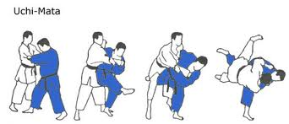
Also the reason why Gemma decides to create an unbalanced position for herself by raising up onto her toes is because she needs to correct her execution of the throw; by leaning forward and raising up onto the toes Gemma corrects previous movements in the execution phase. Even though Gemma has achieved a strong cross step into the throw and has therefore planted the foot correctly into the triangle, she is still deeper than she would have liked due to the position of Sato when establishing a grip. Gemma does well to recover as she still catches the inner thigh when sweeping her leg up high because Uke is in an unbalanced position leaning forwards, however Gemma does not quite sweep her leg up high enough so that it is higher than her hip therefore causing difficulties with completing the throw. This leads to Gemma’s recovery, and you can see from the video that she raises up onto her toes, her stance completely changes when Sato does not get thrown over, she adapts her body position so that she can get her leg up higher that her hip and the easiest way to achieve this is by leaning forwards as this acts as a counterbalance, lowering the upper body allows the leg to sweep up even higher taking Uke off the floor and as a result the throw can be completed.
In addition, the action Gemma wants to achieve when in the recovery phase should mimic that of when she completes a front roll or a break fall; in which she will roll over using either her right or left shoulder depending on which direction she is throwing. The actual roll will not take place but the body position when executing this should be displayed when she is rotating Uke onto their back. Gemma completes this as she leans her body forwards and rotates her body and head whilst moving forwards and facing the direction in which she wants to throw Uke. By completing this Gemma’s shoulder should be positioned either facing down towards her left foot if she has established a right handed grip or her left shoulder will be down towards her right foot, this position helps to amend the execution of the throw also.
After completing the execution of the throw Uke should have already been thrown and have landed onto their back just in front of Gemma’s legs. In this case the execution is good and Gemma does manage to recover which leads to Sato being thrown straight onto her back, but if she would had landed on her side Gemma would have dropped straight down onto Uke to either hold her down or if her reactions are not as quick as Uke then resort to Ne Waza (groundwork). However you can see from the video provided that in recovery of the throw Gemma throws Sato straight over onto to her back and she lands close towards her feet which aids Gemma’s reactions to drop down onto Sato to assure that she does score ippon.
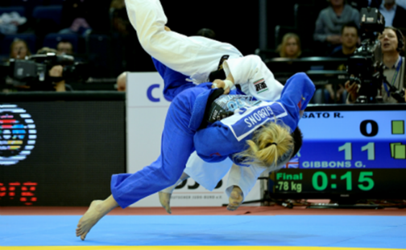

B1 Uchi Mata
B1 Preparation:
When in the preparation phase of Uchi Mata it is incredibly important to establish your grip immediately when the opportunity arises; however Gemma’s grip on Sato was completely dependent upon what grip Sato has upon her judogi (judo suit). When in this situation where my opponent establishes their grip first I tend to get distracted by this and therefore resort to grip fighting in order to remove the unwanted grip so that I then can take advantage whilst the opponent does not have a grip to set one up myself. However by only concentrating on removing the grip of my judogi this leads me to miss other cues such as my opponent’s foot placement or bodily stance therefore I miss vital clues into what throw they are preparing for, giving me less of an opportunity to produce a counter attack because I am so focused on removing the grip. Whereas Gemma manipulates this to her advantage using Sato’s established grip and working on moving her into a position in which she can throw rather than spending what little time she had left in the competition to grip fight.
Gemma also takes advantage of Sato’s frustration by keeping calm and letting Sato come flying towards her which means that Gemma must react quickly in order to turn into the body and sweep the leg up. However when my opponent is frustrated and flying towards me I struggle to quickly apply my grip and turn into the body. This is mainly due to my slow reaction time and lack of experience compared to Gemma who extensive training programme would factor in work on reaction times. If I was to practice extensively reacting to this kind of movement then this would improve my reaction time and ultimately give me advantage alike Gemma as she would have extensively practiced applying this top scoring technique at speed in a pressurised position.
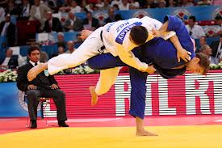
Gemma changes her grip just before throwing Sato over, moving her left hand into a stronger position lower down the back to help her control of Sato. However when I execute Uchi Mata I rarely change my grip just before throwing as I feel as if I cannot amend my performance this late into the preparation phase which therefore results in a sloppy throw as I do not move my grip up higher on both the sleeve and lapel hand thus losing that extra control of the opponent and meaning that I cannot follow though completely. Also when positioning my arms before executing the throw the elbow must be tucked into the opponent’s armpit in order to give you maximum control and space to rapidly extend the arm when throwing Uke over. However I find tucking this arm right in difficult and extremely uncomfortable so I therefore tend not to worry about what position, whereas Gemma always correctly places her arm in this position or will amend her performance in later stages to complete this so that she does have control. As a result of not positiong the arm in the correct place I do not have the maximum amount of control to allow me to vary the speed in which Uke is thrown over. So I feel more training into the preparation phase of this throw would make this position a lot less uncomfortable and help me to produce the perfect Uchi Mata performed at speed rather than slowly and very poorly.

B1 Execution:
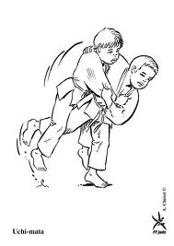
Usually in competition if I can I would set up a right handed grip purely because this is the stronger side of my body and I would prefer to throw on that side. Therefore I would use my right hand to grip behind Uke’s head on the lapel and my left hand would be gripping the sleeve in a high position. Alike Gemma I train to throw off both sides of the body therefore if I could not use a right handed grip because my opponent was blocking like Sato then I would set up a left handed grip like Gemma as Sato has left this side unprotected. Although I would find scoring ippon hard if I had a left handed grip as I would not be able to produce maximum force as my left side is a lot weaker meaning a cannot pull down hard enough on the sleeve for Uke to fall onto the back. Although Gemma’s left side could be weaker too, but because she has no other options she trys the throw anyway, whereas I would not even consider using a left handed throw because I do not feel confident enough to execute it safely. Therefore more training on throwing left handed grip would help to strengthen my left side and to become more confident in trying to execute a throw on the weaker side.
Gemma places her leading foot in between Uke’s legs when taking a small cross step. Generally the leading foot must make an equilateral triangle using both Uke’s feet and the leading foot as the top of the triangle, however I find that it is extremely easy to step in too deep into the triangle therefore reducing my rotation, angle and space I have to sweep my leg up high to catch Uke’s inner thigh. This foot placement is always my weakest area when setting up to do this throw, especially in a competition where all actions need to be performed together and in a matter of seconds therefore I tend to step in too deep with ‘the triangle’ which most judo players refer to causing the action of my sweeping leg to be reduced. Also stepping into the triangle too deep means that my body is also too close to Uke further reducing the space in which I have to rotate my body into the throw, as well as having less space for the sweeping action of the leg.
Gemma applies lots of kuzushi whilst taking the cross step in, this action is also extremely important as this makes Uke unbalanced. Gemma pulls on her opponent strongly, pulling them upwards causing them to rise up onto their toes whereas I find it difficult to pull my opponent upwards whilst turning into the throw as I can never quite pull the opponent up strongly enough for them to be in a completely unbalanced position, as Gemma demonstrates with Sato almost lifted off the floor at this point. This therefore makes the opponent harder to throw when I sweep my leg straight back to catch Uke’s inner thigh.
When I rotate into the throw I too use my planted foot as a pivot bringing the other foot parallel, however when turning into their body I do not always keep a low stance with my hips below Uke’s belt line therefore I cannot maintain maximum stability when executing this throw which makes it harder to maintain balance when sweeping one foot up to complete the throw. When Gemma rotates her body into Uke’s she always keeps a low stature. Also when Gemma sweeps her planted foot straight back she makes sure that she raises it higher than her hips in order to catch Uke’s inner thigh to lift them off the ground, although when I am executing this movement I do not always raise my leg up high enough and keep it straight whilst lifting it up, this makes completing the throw difficult as it is hard to catch Uke’s inner thigh high enough for me to rotate them off of my hip. This leads me to re aligning my body and moving in a circular motion to throw Uke over rather than sweeping them off the ground and using my upper body strength to pull them to the ground whilst rotating my body when they are in mid- air.
Gemma completely commits to the throw by leaning forward ready to rotate her opponent over her thigh; she also turns in the direction in which she would like to throw her opponent. If I was to complete the throw in competition I would try to make sure that I was leant forward but I usually tend to only focus on turning my body towards and down towards my left foot if I was throwing right handed, this shows ultimate commitment to the throw. Although I sometimes find it difficult to completely commit to the throw as I feel that when the opponent has been swept into the air the most important thing is to keep that rotation going rather than leaning forward as this creates an unbalanced position where I could fall as well as Uke.Therefore judoka’s who have been taught differently would view this as being un committed.
B1 Recovery:
In the recovery phase of Uchi Mata, I struggle to create the perfect body alignment in which my body is leant forward in an unbalanced position. Whereas Gemma changes her body position as a corrective measure for not lifting the leg up high enough for Uke to be thrown over, so by leaning her upper body forwards it ensures that Uke will be thrown over. Also when I do not sweep the leg up high enough I try to use my body position to throw Uke over, however when I am completing the throw I find it difficult to lean my upper body forwards, because I am not used to completing this throw in an unbalanced position and therefore my throw becomes extremely sloppy if I adopt this position. More training in this area would correct this. Also I find holding this position hard and would therefore avoid leaning too far forward, instead if I am finding it difficult to throw Uke I would not lean forward but would use my support leg to move round in a circle still keeping Uke’s leg up high; this motion allows Uke to fall off the side of the body.
Also if I have not swept Uke’s leg up high so that my leg is higher than my hip causing Uke to be raised into the air then I too would think about changing my body position by raising up onto my toes, although I prefer not to execute the throw in this way as I lose an element of control when pulling Uke over as I feel that being more unbalanced reduces the amount of force I can apply. Gemma will always execute this by lifting her leg up high so that it is in line with her hip because it unbalances Uke more than herself, and this is because she has more experience in executing this throw therefore specific training on this throw would be beneficial to my execution. Also being on my toes means the whole throw is sped up as Uke falls of the thigh quicker as they are closer to the floor, this is perfect for Gemma as the generates speed will be beneficial in the rotation phase. However I find it uncomfortable to perform the throw at this speed as I am not used to preforming it that quickly. Therefore I forget vital elements such as pulling on the sleeve and tend to rely more on Uke just falling rather than how my movements will get them to fall to the ground. Again this can be improved by experience as Gemma’s training would help her to gain experience and familiarise herself with more difficult throws, whereas I would just avoid difficult throws.
Moreover, I do not lean my body forwards enough and rise up onto my toes creating this unbalanced position. Therefore I cannot generate maximum force or speed when throwing Uke over my thigh which can sometimes lead to Uke landing on their side rather than their back; resulting in ippon not being scored therefore I would need to make sure that I throw Uke close towards my feet giving me the chance to drop down onto my knees and fight with Ne-Waza (groundwork) if it is necessary as Gemma does this as well to ensure she does score a point.
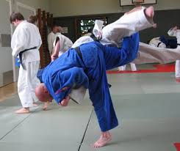

B2 Other Techniques – O Soto Gari
Michael Horley competes in the -90kg category and some of his best results include gaining a gold medal in the English open (2011) and silver medals in both the Slovenian and Spanish European cup in 2011.

Michael Horley has demonstrated O Soto Gari in various competitions including his first contest against Joshua Plant in the English Open, throwing him within 29 seconds of the competition. Furthermore Michael dominated Glenn Bolleboom with O Soto Gari throwing him within 30 seconds with this major outer reaping throw.

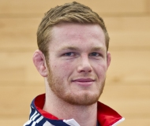

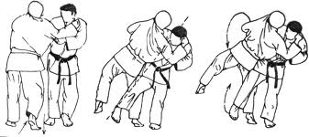
Preparation:
O Soto Gari (large outer reap) is classed as a foot technique or Ashi Waza, this throw is also categorised under orange belt in the grading syllabus produced by the British Judo Association. Moreover O Soto Gari is one of four basic throws to the back that can be very effective in competition if all four stages of the throw are executed correctly. Michael firstly needs to set up a stance and Grip (Kumi Kata) in order for the throw to be successfully executed. Deciding on a preferred grip and stance is essential as establishing a good grip and removing his opponents grip upon his judogi can be what helps Michael to win the match against Joshua Plant in the English Open 2011. Michael chooses to apply O Soto Gari because it is the most versatile throw as it can be applied when the opponent is either standing in the natural position with feet shoulder width apart, when they are moving backwards, forwards or to the side.
Michael shows application of this throw when he is being pushed backwards by his opponent. As the opponent forces Michael backwards their right leg remains set forwards giving Michael the perfect opportunity to sweep his right leg to the side and throw Uke over. When Bolleboom forces Michael backwards this also creates the space in which he needs to swing his leg out and behind Uke’s therefore Uke creates the opportunity whereby all Michael needs to do is reacts rapidly to his opponents reactions to use them to his own advantage, which is exactly what he achieves when throwing Bolleboom over with a quick and swift O Soto Gari.
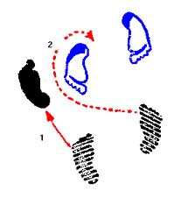
Moreover, if Michael was to move his opponent into the desired position he usually establishes a right handed grip in order to easily pull Uke off balance. Michael uses his right hand (or tsurite lifting hand) to grasp hold of Uke’s left lapel, whereas the left hand (or hiki –te pulling hand) grasps Uke’s right sleeve just below the elbow; this grip on the sleeve allows Michael to control the arm and direct Uke into the correct position to execute O Soto Gari. Additionally, Michael’s stance and grip is referred to as a traditional judo grip during Kumi-Kata as he establishes a right handed grip whilst facing his opponent therefore both competitors are standing with their feet shoulder width apart. However Michael steps his right foot slightly forward so that it is level with Uke’s foot, ready for the next stage of the throwing technique – which is kuzushi where Michael breaks Uke’s balance allowing his to throw Uke over onto their back. Michael applies Kuzushi whilst moving the opponent into position as executing this together quickens the speed of the execution. By stepping the supporting leg forwards and to the side of Uke this helps to breaks their balance in a sideward and backwards direction. He also makes sure that he maintains the same upper body contact keeping a firm grip of Uke with arms bent at the elbow allowing him to get closer towards Uke’s body to complete the throw. As well as pulling the sleeve arm downwards, he pulls it in front of his chest. Ultimately by pulling the sleeve arm into his chest Michael creates space in which he can step on the outside of Uke’s without getting caught by their arm.
Whilst pulling the sleeve arm downwards and across into his chest he simultaneously pulls the lapel upwards this causes Uke to become unbalanced in an off centred position leaning backwards and onto the right leg therefore Michael uses his grip upon Uke to unbalance the opponent in the direction in which he would like to throw. Michael makes Uke off balanced to the rear as this is a backwards facing throw, and therefore once the execution is complete Uke should land on their back if the right amount of force and control is applied. Also Michael makes these movements over exaggerated and big in order to create space to execute the throw and to assure that Uke is completely off balance and therefore cannot produce any counter attacks.
Execution:
When applying kuzushi the forearm that Michael grips on the opponent’s lapel is in contact with Uke’s chest – the importance of this contact can be seen when trying to apply Kuzushi as attacking the chest area as well as sweeping the leg is vital. As well as the arm having good chest contact, Michael also unbalances Uke by using the planted grip to lift Uke upwards. Therefore moving this arm in an upwards motion allows him to gain control over the head which therefore controls their whole upper body allowing them to become unbalanced. This action includes using both grips on the lapel and sleeve together to continue to unbalance Uke backwards, pushing Uke to the rear. Also as Michael steps to one side of Uke in the next stage of the throw, he can unbalance them even more as he will pull them in a sideward and backward direction whilst maintaining the right level of upper body contact which will allow him to use his grip in order to unbalance Uke in the direction of the throw. Michael could also pull Uke’s sleeve strongly towards him first to bring the desired foot forward and them complete this stage as he can get closer to the foot quickly.
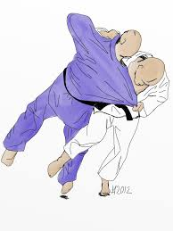
Within the kuzushi stage, Michael unbalances his opponent, by manipulating Uke’s position so that their centre of mass is not directly between both feet. He will be facing his opponent, however his stance will not be directly in front of Uke like other throws require. The best position would be slightly offset to the opponent’s stance as this will allow him a bigger amount of space to move his hips into the throw and swing his right leg outward allowing for one fluid movement rather than disjointed actions that can allow Uke to counter the throw. Therefore Michael steps his supporting left leg to the side of Uke’s right leg by moving diagonally across moving his hips into the throw first rather than the shoulders. Being slightly offset to the opponent also allows Michael to achieve the correct bodily position and reap Uke’s leg up higher when completing the throw. By moving the hips into the throw first Michael can place his supporting leg allowing him to move into the tsukuri stage whereby he has achieved the correct position ready to throw Uke over using maximum power and momentum generated throughout earlier stages. Also his body should be tightly pinned to Uke therefore when stepping out he can tilt Uke’s centre of gravity to one side, and the other leg lifts, shifting his body weight to the leg that he intends to reap. At this moment Michael is ready to swing his reaping leg around Uke .
Furthermore, when the supporting leg has been placed, Michael steps his right leg behind Uke’s calf ready to reap the leg upwards. By stepping behind Uke’s leg with a straight leg, and toes pointed allows Michael to reap the leg by sweeping his leg backwards and through the gap between Uke’s feet keeping contact with their leg throughout. Also swinging his leg back strongly whilst using the collar hand to move Uke’s head in a backwards direction to keep them unbalanced. When Michael reaps the leg his head moves in a downwards direction as he alters his bodily position whilst sweeping Uke’s leg to ensure that there is enough momentum to throw Uke over and guide them onto their back in order to score ippon and win the competition.
Recovery:
In recovery of O Soto Gari, Michael needs to use the generated momentum from the execution phase in order to guide Uke over onto the mats with control. The most important phases of this throw include both kuzushi and tsukuri as the unbalancing of the opponent and the correct position is important in generating the momentum for the final stages. However in the recovery stage or kake Michael must make sure that he points his toes to achieve the maximum reaping power when pulling the opponents leg backwards and it also helps to create the correct leg action when strongly reaping the leg backwards. Also when reaping the leg Michael will lift his leg up as high as possible without affecting his balance and power generated in early stages of the throw. Making contact with Uke’s leg and pulling it backwards using his leg so that it is positioned up high generates more power to throw the opponent over, and also makes them even more unbalanced as the opponent has to shift all their weight onto the remaining leg to try and stay upright. After completing all movements Michael ensures that just before Uke falls that his body is aligned correctly ensures that he creates maximum force and speed for Uke to fall quickly onto their back.
Moreover, Michael will change the direction of his head movement so that it is level with the angle in which he has reaped the leg backwards in order to maintain his own balanced throughout the final stages of O Soto Gari. Before these stages Michael’s head would be directed in a downwards direction. To complete the throw Michael must guide Uke to the floor with control in order to gain score by ippon this is known as the nage, and also includes throwing Uke as close to the feet as possible in case Uke does not land on their back, Michael can hold them down to score. Ultimately the follow through must maintain momentum through all stages of the throwing process as most actions are executed together rather than individually creating a fluid sequence of movements allowing for Michael to throw Uke backwards.

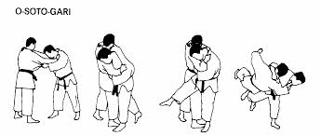

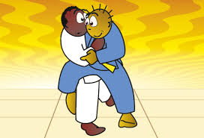
B1 Other Techniques – O Soto Gari
B1 Preparation:
Establishing the perfect stance and grip for this throw is extremely important as this can affect later stages whilst executing O Soto Gari. Michael establishes a right handed grip with his right hand placed high upon the collar and his left hand placed above the elbow on Uke’s sleeve but setting his grip up high upon the judogi allows him more control when moving into the kuzushi stage. However when I establish my grip I do not place it high enough on the sleeve therefore I do not have full control when I am at the stage of throwing Uke, by doing this I give myself a disadvantage as I cannot pull Uke into the throw as my grip will be too far down on the sleeve and therefore any strength that is applied will not be at its maximum. Also by not placing my hand high enough on the collar means the execution of the throw becomes poor as I cannot forcefully push Uke over using the sleeve whilst reaping the leg in the execution phase whereas Michael maintains a high grip upon both the sleeve and the collar in order to produce maximum force to push Uke over as well as this a high grip can aid the unbalancing of Uke during the Kuzushi stage.
Producing the perfect stance for this throw can be difficult in a competitive situation as your opponent will be doing everything they can to remove your grip, however this can be advantageous as it gives Michael a chance to place his right foot forwards ready to move into the correct position for the throw. When placing this foot I sometimes step in too deep therefore giving me less space to place my supporting left leg to the side of Uke’s body and to move my hips into the correct place ready to sweep the foot. Whereas Michael’s stance allows him the right amount of space in order to move diagonally across Uke’s body to complete the throw. Also maintaining upper body contact whilst unbalancing the opponent can be difficult as if I have not placed my feet correctly it becomes harder to unbalance Uke sideward and backwards, therefore affecting upper body contact as I would need to use my upper body strength more than my weight to push the opponent away from my body this can therefore lead to me fatiguing quickly. By pushing Uke away from my body affects my who stance as I am not close enough to sweep the leg.
Additionally, shifting Uke’s weight is key and Michael achieves this by pulling the sleeve arm downwards and across into his chest whilst simultaneously pulling the lapel upwards this causes Uke to become unbalanced and there weight is shifted onto the one leg. Also Michael makes these movements over exaggerated and big in order to create space to execute the throw, whereas when I complete these actions I cannot unbalance Uke enough because I do not apply the right amount of force when pulling the sleeve across my body, therefore affecting the whole kuzushi stage meaning that I would need to do more upper body strength training to improve the force applied in this stage. Also I need to improve on making these movements over exaggerated and bigger in order to control Uke’s body fully.
B1 Execution:
Having good chest contact throughout the stages of kuzushi is vital and Michael does this by placing his forearm against his opponents lapel so he can later use this grip to help push over whilst sweeping the leg. However when I perform this throw I do not always place my forearm against the lapel as I am too worried about sweeping the leg up high enough to throw Uke over rather than using force for my upper body to aid me in the throw. As my right arm becomes stretched instead of placed upon the lapel this gives me a disadvantage as I cannot pin my body as close to Uke therefore making it harder to position myself in order to reap the foot – having a big gap between us also gives Uke more time to counter the throw.
Michael’s stance is not straight on but just to the side of Uke allowing him more space to sweep the leg and unbalance the opponent in a sideward and backwards direction whereas I find positioning myself for this throw can be difficult in the competitive situation as I look for the right opportunity to use this throw rather than manipulate my opponent into it. Therefore my positioning is sometimes straight on rather than offset to my opponent this means that the throws direction is affected as it starts to push Uke straight backwards. Also my wrong positioning can affect my ability to apply kuzushi with the tsurite.
Moreover, as I do not have the correct stance I do not have the right amount of space to move my hips into the throw and this is a result of planting my supporting left leg too shallow meaning I cannot move my hips into the throw first so I tend to lead with my shoulders which is not advisable because I will become unbalanced and give Uke the chance to throw me over. Also because I do not have the correct stance, this affects my reaping action of pulling the leg up high in order to throw Uke onto their back. During the throwing phase where Michael steps behind Uke’s leg with pointed toes and sweeps his leg backwards maintaining contact with Uke’s leg to throw the opponent over, I do not always point my toes in this stage and rely heavily on keeping a straight leg when sweeping Uke’s leg upwards this therefore affects the momentum of the throw and relies on more strength to be used when pushing Uke over rather than my weight as an advantage.
B1 Recovery:
Firstly, in recovery of O Soto Gari I find it hard to maintain the generated momentum from the kuzushi and tsukuri stages of the throw as it can be difficult to unbalance the opponent and sweep their leg whilst maintaining my own balance. Whereas Michael is able to maintain his balance throughout using his position to keep his momentum for the final stages of the throw, however as I tend to become unbalanced in these stages the recovery is usually affected as I cannot achieve maximum reaping power as a result of being to unbalanced myself.
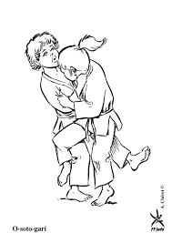
Furthermore, being unbalanced within the final stages of the throw means that I do not point my toes which also affects my body position whilst completing the reaping stage of the throw, this could ultimately cause Uke to fall on their side rather than on their back. However having more experience with using this throw in competition Michael will always make sure that he is positioned correctly in order to score ippon, whereas I can become too focused on the just throwing the opponent rather than amending my position so that the throw is executed perfectly. As well as this, being in an unbalanced position affects my body alignment through the reaping stage as I will be too unbalanced and position further forward than I would like in order to complete the throw therefore whilst making contact with Uke’s leg I do not lift it high enough in the air to generate maximum power when throwing Uke over. Although I cannot complete this successfully, Michael displays that it can easily be done when the execution stages are set up perfectly. Therefore more training on the execution stages would be beneficial before moving onto the recovery of this throw. Also not sweeping the leg high enough does not make Uke shift their weight onto their remaining leg therefore I would need to throw Uke over using more strength both from the leg sweeping and by pushing on Uke’s lapel and sleeve whilst they are falling backwards. By using my strength instead of my body position and weight to complete this backwards facing throw means that I need to complete more training on this throw and possibly improve my strength as well in order to makes sure that Uke is thrown onto their back.
When completing O Soto Gari, Michael throws as close to his feet as possible in order to quickly hold the opponent down if the throw has not been executed correctly and Uke has not fallen onto their back. Ultimately the follow through must maintain momentum through all stages as this creates a fluid sequence of movements rather than staggered individual movements. However this is not always easy to achieve if Uke is resisting or Kuzushi has not been applied affectively therefore I do not always maintain my momentum through all stages of the throw but I can sometimes amend my performance in the recovery stage by holding Uke down if the throw has not been successful in getting Uke to land on their back.

