Lack of Strength
Downhill Biking – cornering
C1 Cornering – Lack of strength
The movements required for muscling a downhill bike around and the physicality of the tracks requires high amounts of strength. Both the arms and legs take a huge pounding when riding downhill, as continuous force is placed upon them, and the arms and legs must cushion harsh bumps and drops in order to keep the bike in control. These continuous vibrations and pumping actions can lead to arm pump. This is where the muscle's in the arms are pumped full of blood to the point where the muscle swells and becomes too large for the muscle membrane. This can be extremely painful and has a negative effect on a rider’s ability to ride both fast and smoothly, as just hanging on to the bars becomes difficult. Therefore it is clear that good physical strength will enable a rider to deal with rough tracks and allow them to ride at their peak performance for the majority of a downhill track. It is my lack of strength that equates to me experiencing arm pump and muscular fatigue in my legs, therefore reducing my performance and losing me time.

Strength is an important aspect of cornering. When cornering at high speed a rider will experience a significant G force and the bike will feel like it wants to lean over more, which would result in a crash. In this situation the rider must rely on their strength to uphold the bike in a stable position and stop it from over tilting. Doing this requires muscular strength in all of the major muscle groups, including arms, legs and core. This is because the whole body must work together in order to keep a stable and strong position. Weakness in the core for example may result in the core tilting toward the ground, further tilting the bike over. Strength is also important in the preparation and recovery stages of a corner. Often the run in to a corner can be very technical or rough. In these situations the rider must be able to hold their line in to a corner in order to ride it with speed. This means they can’t allow themselves to be thrown around and must rely on their strength to hold their position.

Skeletal muscle is made of bundles of muscle fibres. These fibres are bound together by connective tissue and contain blood vessels and nerves. Within these fibres the main process of muscular contraction takes place, called the sliding filament theory. Myofibrils within the muscle fibres contain sarcomeres. Each sarcomere is divided by the next one by the Z line. These sarcomeres contain two protein filaments, the actin filaments and the myosin filaments. The sarcomeres shorten due to the myosin filaments pulling the actin filaments inwards. The process of muscular contraction starts when a nerve impulse is sent to the sarcoplasmic reticulum; this initiates the release of calcium ions (Ca+).

In the presence of high concentrations of Ca+, the Ca+ binds to Troponin, changing its shape and so moving Tropomyosin from the active site of the Actin. The Myosin filaments can now attach to the Actin, forming a cross-bridge.

The breakdown of ATP releases energy which enables the Myosin to pull the Actin filaments inwards and so shortening the muscle. This occurs along the entire length of every myofibril in the muscle cell.

The Myosin detaches from the Actin and the cross-bridge is broken when an ATP molecule binds to the Myosin head. When the ATP is then broken down the Myosin head can again attach to an Actin binding site further along the Actin filament and repeat the 'power stroke'. This repeated pulling of the Actin over the myosin is often known as the ratchet mechanism.

This process of muscular contraction can last for as long as there are adequate enough ATP and Ca+ stores. Once the impulse stops the Ca+ is pumped back to the Sarcoplasmic Reticulum and the Actin returns to its resting position causing the muscle to lengthen and relax.

This process happens every time we contract a muscle. It is therefore clear that after a prolonged set of muscular contractions, such as occurs when racing on a downhill bike, the muscles fatigue and loses strength. Two types of muscle fibres can be found within the body. Fast twitch and slow twitch fibres. The percentage of these fibres within each athlete differs due to their genetics and the type of activity they undertake. Slow twitch fibres contract relatively slowly, are smaller in size and produce less force. However, they have a greater aerobic capacity and therefore can work for much longer at a constant and consistent rate. These fibres are used during low intensity, endurance events. Fast twitch fibres are the opposite, contracting quickly with greater force and are larger in size. In reality everybody contains both types of fibres but athletes will have a disproportionate number of each. Neither fibre is best suited to downhill riding as a whole therefore a relatively balanced proportion of fibres would be most effective. However a second type of fast twitch fibre called oxidative glycotic fibres would be effective for a downhill rider. The fibres contract quickly but are more resistant to fatigue and have a higher aerobic capacity, perfect for downhill which lasts for a relatively short period of time and is high intensity.

C2 Cornering – Weight training

Cornering a bike fast and in control when already fatigued on a downhill track requires high amounts of strength. Appropriate training methods must be adopted to help me gain strength and therefore stability and speed when riding. This will improve my performance and allow me to ride and corner effectively for longer. The corrective measure I intend to use is weight training. This will allow me to build strength and muscle mass, meaning I will be less affected by arm pump and more able to hold my position and maintain good speed and stability in a corner.

Weight training utilises the use of weights or resistance to build strength. This is done through repetitive movements and works most effectively when a single muscle group is worked on as opposed to multiple muscle groups in one session. Legs, arms and core muscles are all essential groups to work on for downhill mountain biking and especially for cornering where all are needed. For optimal results I also need to make sure that I use isometric, concentric and eccentric muscle movements. This will help me work on sub groups of muscles and condition my muscles for a range of stressors.

When considering weight training as a major part of my conditioning for my sport, it is important to make the correct adjustments in order to achieve the best results that correspond to my sport. Downhill mountain biking does not require large muscle mass and weight. Instead, the leaner a rider can be whilst maintaining as higher strength as possible is optimal. It is evident therefore that I must tailor my weight training program to achieve my set goals and physique.

The speed and velocity of my repetitions should be taken into consideration. High weight coupled with a low number of reps would be ideal for building muscle mass. This however is not what I am aiming for and I must instead use a lower weight but increase the number of reps. This will increase my muscular endurance as well as strength, but will not result in a large muscle mass which would increase my weight and potentially decrease my range of movement.

My weight training regime will consist of exercises aimed at improving my upper and lower body strength.

Flat bench press - This exercise primarily works on the pectorals, and both anterior and posterior deltoids. These muscles are essential for overall upper body strength and provide a good basis for the arms to be worked on.
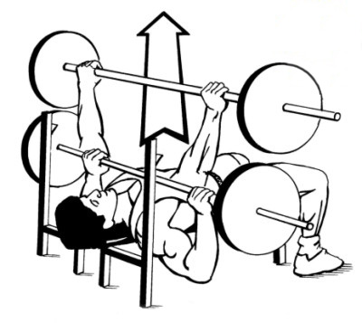
Steps:
Lie flat on a bench with legs bent and feet touching the floor.
Dismount barbell from rack, always using a spotter to aid if weights are particularly heavy.
Lower the weight to mid chest.
Press bar upwards until arms are extended. Make sure never to hyperextend the arms as this could result in serious injury.

When performing the bench press I will make sure to lower the bar with control and with less speed than when I raise the bar. My range of motion will be compromised if my grip is too wide however I will find it alot harder if my grip is too narrow, therefore I will position my grip so that my hands are just past my shoulders when extending and lowering.

Squats - This exercise primarily works on the quadriceps but also strengthens the gluteal's, abdominals, latissamus dorsi and hamstrings. Making it an extremely useful exercise.

Steps:
Position feet just over shoulder width apart, pointing forward but also slightly outwards.
Bend below the bar, position the bar at top of shoulders almost touching the neck and grasp the bar with your hands.
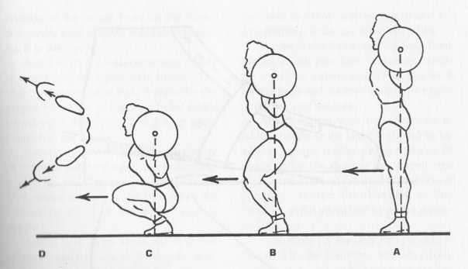
Bend knees downwards always making sure that they are directly above your feet and pointing in the same direction. Bend hips back and always keep a straight back. Keep descending until thighs are just past parallel to the floor and then extend until your knees are straight. Always keep looking ahead and never bend your head downwards to look at the floor, this will result in your back arching and potential injury.

Similar to the bench press I will always lower myself with controlled speed and then push upwards with maximum force. My heels should never leave the floor with equal weight distribution throughout forefoot and heel.

Deadlifts - This exercise works the trapezius, gluteals, hamstrings, gastrocnemius, abdominals, quadriceps and the latissamus dorsi making it one of the most effective exercises for working a range of muscles. The main muscles that are worked are exercised isometrically.

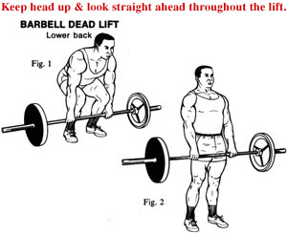
Steps:
Position feet under the bar with around three inches of feet in front of the bar.
Squat down and grasp bar with hands shoulder width or slightly wider.
Lift bar by extending hips and knees. Keep the bar as close to your body as possible to increase mechanical leverage and avoid a back injury.

When executing this exercise I will always make sure to keep my arms and back straight to avoid injury. I will also always look forward and not down so that my back does not bend. My knees must also always point in the same direction as my feet.

By regularly using these exercises as well as others I will be able to build my strength and eliminate or at least slow down the onset of arm pump and muscular fatigue which would hinder my performance when cornering. By increasing my strength I will improve my performance on all downhill tracks, and be able to maintain almost the same level of strength throughout the duration of the whole track, instead of seeing a marked decrease in my ability to corner well due to my muscles cramping or becoming tired. By regularly undertaking weight training, I will strengthen my myosin filaments. They will become thicker and the muscle fibres will be larger, resulting in them being more numerous. This will help improve my performance by increasing the strength of muscular contractions and the length of time that they can work before becoming fatigued.

Judo - Kamishio Gatame
C1 Kamishio Gatame– Muscular strength:
Muscular strength is the ability to overcome resistance or the amount of force that a muscle can exert against resistance. Muscular strength in the upper body specifically at the shoulder joint would be beneficial in this hold down as I do struggle to keep the opponent tightly pinned onto the floor as I lack the strength in my arms and the stability at the joint to perform repeated isometric contractions, this means that I do not have full control of my opponent and my grip on their belt is not strong enough to hold them down.
As well as this muscular Strength would be beneficial in the lower body when trying to escape from the opponents Kamishiho Gatame to hold them down with the same technique. Although my weakness is that I do not have enough strength in my legs to push of the floor and complete the bridging technique, therefore I need to work on my lower body strength to aid escaping this hold down in order to apply the same hold down. I also find it difficult to produce this action quickly applying the right amount of speed in order to turn my opponent over as a result of lacking lower body power and strength. To improve muscular strength I firstly need to know what my current strength is therefore I could use a dynamometer to measure grip and leg strength in order to asses my current state and improve upon this score.
There are many different types of strength, firstly maximum strength can be defined as the maximum force that can be developed in a muscle or group of muscles during a single maximal contraction. Men tend to be able to exert a greater maximum strength than women as a result of having a larger muscle mass. However the type of muscle fibre can also affect strength, fast glycotic twitch fibres are able to produce more force than slow oxidative fibres as they are designed more for maximum strength, therefore when undergoing training I would need to focus on increasing the number of fast twitch fibres in order to increase maximum strength. The easiest way to assess my maximum strength would to see how much I can lift in one single contraction or to use free weights to test more than one muscle group. Additionally, most team sports you work against your own body weight although you are not using your maximum strength you do need to work for long periods of time, whereas individual sports such as Judo mean that maximum strength is important to ensure that I can contract my muscles maximally so that I can hold my opponent down and grip tightly on their belt whilst pulling the grip in to stop the opponent from escaping the hold down.
Other types of strength include: explosive, static and dynamic. Explosive strength can be defined as the rapid contraction of muscle fibre units in order to achieve maximum force generation, and this is very similar to power as it involves a high speed contractions usually a eccentric contraction followed by a concentric contraction which is a key feature of this throw. This type of strength is also essential for any activates involving sprinting, throwing, jumping or hitting. As well as this a performer with high amount of explosive strength should also possess a high proportion of fast glycotic muscles fibres since these have a thicker myelin sheath than those stimulating slow twitch oxidative fibres which helps to speed up the rate of conduction and therefore speed of contraction to enhance performance. Static strength is the holding of a body part in a static position and this is usually used when trying to move an object, where there is no movement of that object therefore the muscles do not change in length, contracting isometrically. This is achieved by maintaining a state of contraction or tension often supported by a paired antagonistic muscle, and this is the type of strength that I would need to improve in order to hold the opponent down and prevent escape. Dynamic strength is the repeated contraction and relaxation of a single muscle or group of muscles repeating a movement over time and this is therefore similar to muscular endurance.
Strength is also linked with health, and is important not just in the sporting environment but for the completion of everyday activities such as lifting heavy bags or using our legs to stand up from a chair. Having a good level of core body strength in the abdominals and back is also important in avoiding injury, maintaining a good posture and preventing back pain that comes with ageing.
C2 Corrective Measure for muscular strength – Weight/strength Training
Weight training can be used by everybody and when paired with regular aerobic exercise, weight training can increase both strength and muscle endurance as well as overall fitness. This method of training involves the use of additional weights to provide resistance rather than using my own body weight. The additional weights can be in the form of free weights or a multi gym, and would require me to complete a number of repetitions and sets using a combination of lifting heavy weights with a low number of repetitions. However the number of repetitions as well as the weight chosen to lift would be completely dependent on which type of strength is being improved, but because I want to focus on improving my general strength in the upper body at the shoulder joint and lower body I would not need a heavy weight but would opt for a smaller weight with more repetitions in order to increase upper and lower body strength.
During a weight training programme there are key elements that I need to control in order to see an improvement in strength. Exercising larger muscle groups before smaller ones will enable both upper and lower body improvements in strength, also the exercises must use the same energy system that the activity requires so that I specifically train for my chosen activity to improve my health related fitness. As well as allowing appropriate recovery time between individual exercises and training sessions will aid the repair of muscles after being exercises both maximally and sub maximally.
Improving muscular strength is not just about working against resistance, but making the training programme as specific as possible. This can be achieved by considering a number of factors such as the type of strength that I want to develop. In this case undergoing general strength training would be beneficial to this hold down before specialising and specifically training to improve the different types of strength such as static and maximum strength. When specialising to improve maximum strength in the lower body, a weight session should include low repetitions with heavy weights therefore I would perform about 6 repetitions per set of a heavy weight. But firstly I would have to determine the weight I would lift by the maximum weight that I can successfully lift 6 times as this is a maximal exercise and therefore I would fatigue very quickly when using a weight that is too heavy and does not progressively improve strength. Fatiguing quickly acts as a result of the number of fast twitch fibres that would be recruited in lifting the weight meaning that I would be relying on the anaerobic energy system which fatigues quickly. Improving maximum strength particularly in the lower body would enable me utilise the improved strength in my legs in order to push off the floor to complete the bridging technique to escape this hold down to re-apply the same hold down.
Developing static strength would be beneficial so that I can improve my strength at the shoulder joint enabling me to pin the opponent down using my chest and shoulders to keep the opponents upper body pinned to the floor. Static strength is important in hold downs as they require holding a part of the body particularly the upper body during Kamishio Gatame in a static position meaning that the muscle length does not change, as the muscles act a fixators therefore contracting isometrically, which increases the muscle tension. Improving static strength means using a static resistance method but this can only improve strength at the specific joint angle used in training, as the isometric contraction strengthens the muscle near the joint which is being used during the exercise. However the position of the shoulders is hard to replicate in weight training therefore training at multiple joints rather than one will help in increase overall strength. As well as this static strength training is used to increase strength throughout the entire range of motion meaning that isometric exercises should be performed at every 10 to 30 degree increments as this leads to an increase in strength.
Examples of isometric upper and lower body exercises I could complete include: Isometric push ups which involve starting in the push up position with arms fully extended, then lower yourself to about half way to the floor, this is the point where you hold the position to isometrically contract the biceps and triceps. This will help to build up more muscle mass in the pectorals, deltoids, biceps and triceps. Isometric shoulder raises would also be beneficial in improving upper body strength, as you have to stand with your feet a shoulder with apart and then raise a weights to the side of your body so that your arms are parallel, to the floor, this would be beneficial as I want to improve my strength at the shoulder joint in order to hold the opponent down for the full twenty seconds. Lower body isometric exercises include squats as this requires you to place you back against a wall then lower yourself down until the upper legs are parallel to the floor and your knees are at a 90 degree angle, then by holding this position the muscles will contract isometrically improving both strength and power of contraction in the legs. For all of these exercises they should be held in position for around ten to thirty seconds, and repeated at least two to three times in order to work on muscular strength.
A weight training programme should last for at least 10 weeks, and requires completing set exercises at least two to three times a week in order to increase strength progressively as it is important to progressively increase resistance with strength adaptations. A typical weights session would includes a warm up of five to ten minutes followed by an exercise routine that leaves the muscles thoroughly exhausted. Examples of weight exercises for the upper body specifically the shoulders would include completing the shoulder press as this works on the deltoids. This exercise is completed by lowering a weight that is raised above the shoulders and then raising it upwards again, this works the deltoids, trapezius and the triceps so that muscular strength can become improved allowing me to successfully hold down my opponent just using my upper body. Also the lateral raise which involves holding weights and then lifting them out to the side so that they are just below the shoulder then lowering the weights again. Variations of this can also work the deltoids more and involve turning the hands downwards whilst raising the weight to the sides in order to further work the deltoids. Lower body weight exercises would include leg extensions and squats. Leg extensions are performed while seated by raising a weight out in front of the body with the feet therefore working the quadriceps, as well as this squats work the same muscle groups by squatting down with a weight held across the upper back and then standing up straight again. However this exercise also works other muscles such as the gluteals, hamstrings, and the gastrocnemius in order to improve lower body strength.
By performing these exercises benefits of the weight training are that it requires little space and time, can be used by everybody, it increases strength and muscular endurance as well as contributing to my overall fitness and that it is very easy to make sports specific which will be beneficial to my overall performance of this skill.
The effects of strength training include increasing the oxidative capacity of the muscle which means that the more oxygen can be stored within the muscle for it to be used as energy in contraction, whereas there is a decrease in oxidative enzyme activity. When performing weight training regularly the repetition of lifting weights can cause an increase in the rate of contraction, as the central nervous system response becomes quicker. Also strength training can cause an increase in ATP stores and the number of myofibrils and increase muscle mass in both the upper and lower body and therefore improve the amount of fast twitch fibres and motor units that are recruited when trying to exert a higher level of force.

Athletics – High lump take off
C1 High Jump Take-off
Leg and Arm Strength
Strength is defined as the amount of force that can be generated and exerted by the muscles. A lack of strength is a major weakness during my high jump take-off, which limits the force I can apply to reach greater heights. This means that greater strength must be achieved. It is important that to achieve greater strength there are greater motor units to which I can call on if a greater force is needed. This is a weakness of mine as due to a lack of motor units, I cannot call upon them during higher heights, causing me to knock off the bar as I do not have to motor units to reach the greater height.
During take-off my body requires high levels of strength in my legs to accelerate my ascension to clear the bar of which I lack, making it harder to transfer technique into height as well as well as limiting the height I am able to achieve due to lack of fast twitch motor units in the given areas to contract quickly and powerfully, moving my body upwards and over the bar. Fast twitch muscle fibres in which I lack are important for short, intense burst of energy that is required during the take off to optimise my take off. They also produce more force due to increased myosin filaments, which are also thicker than the equivalent in slow twitch fibres. The further developed sarcoplasmic reticulum means that calcium ions can be released at a much quicker rate allowing faster contractions to occur, creating greater force.
The muscles include the gluteals maximus, which is responsible for straightening the hips during take off, and is responsible for the majority of the jumping force. Hamstrings are serve two main purposes during the jump that are bending the knee to allow my hips to drop before take off as well as straightening the hips. They are mainly responsible for hip extensions and generate a powerful hip extension needed for take off. The quadriceps also plays an important rule in straightening the knee and a strong knee extension is required for assisting the hips in lifting you off the ground. Gastrocnemius is my last main muscle in my legs required for an effective take off. This is the muscle responsible for plantar flexion and this is required to transfer force from the hip and knee down into the ground to accelerate my ascension.
The time it takes for the muscle to contract eccentrically on the plant and then concentrically to lift myself off the ground, my body is unable to exert much force into the jump due to the short time in contact with the ground to maintain momentum, which leads to a lacklustre jump. This results in poor heights being achieved and seeing very little improvement.
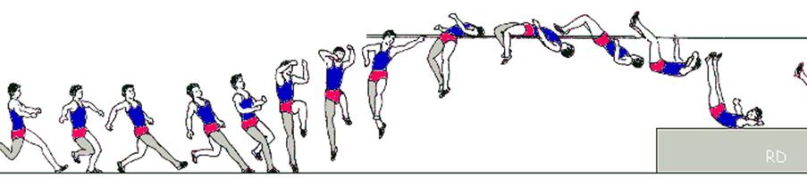
Strength is also required for my drive knee, aiding my take-off foot. The knee drive from under my body is lifted to slightly above 90 degrees, to stabalise my jump and to achieve a greater height. A large amount of strength is required to drive the knee fast and forcefully to make it an effective manoeuvre and this also results in me not being able to rotate my body during the flight leading to a poor flight and probably a no jump. This will reduce the height I can achieve leading to loss of motivation.
My arms are very important to maintain balance and to increase my height achieved and can contribute to around 5% increase in height making it essential to reaching a greater level in the event. This also helps to encourage the rotation of my body to become parallel to the bar, maintain a correct technique. Without my arms it would result in me knocking the bar off on the way up with my shoulder or landing awkwardly, possibly causing injury. This could cause me to lose dramatic amounts of height.
When I plant my foot during take-off, a lack of strength in my arms results in my not being able to swing forcefully enough to create momentum to achieve maximum height possible. A lack of strength means that the same height cannot be achieved and I will possibly knock the bar off on the way down due to momentum not available to carry my body over the bar and onto the mat. This also increases the chance of injury occurring.

C2 High Jump Take-off
Weight Training (Upper and Lower body)
To improve my high jump height and technique I need to increase my strength and I can achieve this by using weight training. This increases my muscle mass in the given muscle groups increasing the amount of motor units I can recruit to exert a higher level of force, increasing the potential height I could achieve.
This can be achieved through a series of strength building exercises, which include squats, lunges, seated calf raises, push-ups and bicep curls.
Squats
Squats build muscle tissue in the quadriceps, hamstrings, gluteal, hip flexors and gastrocnemius.
Preparation:
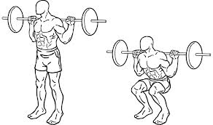
I would perform this by squatting down to lower myself under the bar. I would place 1 foot in front of my body and one behind to lift the bar off the squat rack. Once the bars been removed I will position my feet shoulder width apart. Abdominals should be slightly contracted to assist in keeping the back straight. I will then extend my knees and hips causing my legs to become straight.
Execution:
I will bend my knee while maintaining a straight back by allowing my hips to bend back behind me. I continue to sink towards the ground until my thighs are parallel to the ground. I lift the bar by extending my knee joint and hip flexors to maintain a straight back and to straighten my legs. This causes my quadriceps, hamstrings, hip flexors and calf muscles to contract, meaning that actin filaments will slide across myosin filaments in order to hold the weight of the body or the additional weights. This not only increases muscle mass and the motor units available for contraction but also helps to prevent injury as they improve both flexibility and balance, both important for a more efficient high jump take off and technique. I would perform these twice a week.
Lunge
Lunges work similar muscle groups to squats that include quadriceps, hamstrings, gluteals, hip flexors and calf muscles.
Preparation:
I’d begin with my feet shoulder width apart and my body erect facing forwards.
Execution:
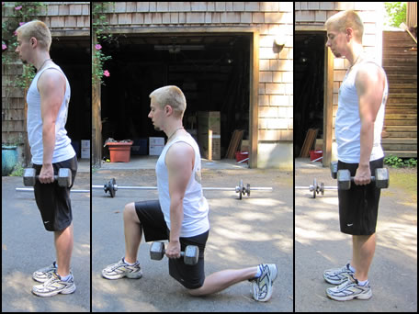
With my right foot I’d take a large step forward keeping the left foot in place. This step should be far enough to prevent my knee from passing over the front of the foot during this exercise. Once the right foot is on the floor I will lower my upper body by flexing my knee causing my thigh to be parallel to the floor. This causes my quadriceps to contracts and my hamstring to relax as well as my gluteals and my hip flexors will contract. The left foot remains in place by shifting my weight to the left toes.
I will then extend my knee causing an upwards and backwards movement to return the body to an erect position. Contracting my gluteals and hamstring as well as my calf muscle. I then repeat with the other leg.
To increase the difficulty and allow progression and overload I could perform this while holding weights to improve my strength further. This encourages my body to create more motor units in order to cope with the greater demand for strength, creates by the lunge. I will start to see benefits in my performance fairly quickly but improvement further is limited if you do not have equipment to work with. I would perform these 2 to 3 times a week.
Seated Calf Raises
This primarily increases muscle mass in the gastrocnemius and soleus.
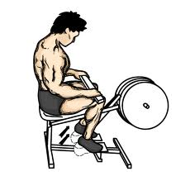
Preparation:
I will sit down in the seat and place the balls of my feet on the platform making sure to allow for full movements of the foot. I extend my knee, straightening my legs. I then place my toes and balls of my feet on the lower section of the platform with heels and arches extending off.

Execution:
I lower my weight by dropping the heels as low as possible and keeping the ball of the foot in constant contact with the platform. I flex my knee to allow my body to be lowered. I do this by bending my ankles until calves are stretched.
I push with the ball of the foot into the platform and lift the heels as high as possible. I extend my ankles as far as possible and straightening my leg by extending my knees without locking them. I would do this 2 times a week as this helps improve flexibility and strength in the lower leg, which is essential for transferring the power from the hip and knee joints. This will allow more motor units to be developed in my gastrocnemius but not of a certain type. Fast, anaerobic exercise will transfer it to fast glycotic of which I require for a more efficient jump.
Upper Body Strength
Push Up
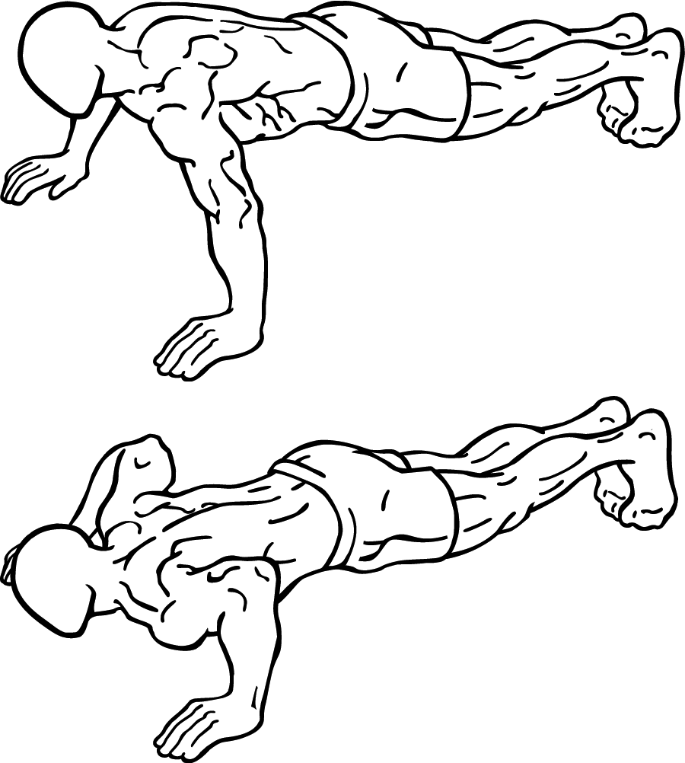
A push up builds muscle mass in the pectoralis major, anterior deltoids and deltoid. Deltoids are important when it comes to extending my arms upwards quickly for additional momentum.
Preparation:
I would begin facedown on the floor with my elbow extended and shoulder width apart. My back is flat and feet together. I lower my body towards the floor by flexing my elbows until my chest touches the floor, maintaining a straight back, which is parallel to the floor.
Execution:
I extend my elbow joints until my arms are straight. I do this with control while maintaining a straight back to prevent myself from injury. I would do this 3 to 4 times a week and would not see much improvement in performance but it would allow me to be more balance causing more consistent jumps. Would see improvements of up to 5%.

