B2 Javelin – Run up
Keshorn Walcott is a Trinidadian javelin thrower. He is currently the best javelin thrower in the world, which has recently been shown by winning a gold medal at the summer Olympics in London, making him the youngest ever javelin champion at just 19 years of age. He also won the world championships in Barcelona also in 2012. Even though Keshorn isn’t the biggest or strongest javelin thrower his technique allows him to be the best in the world.
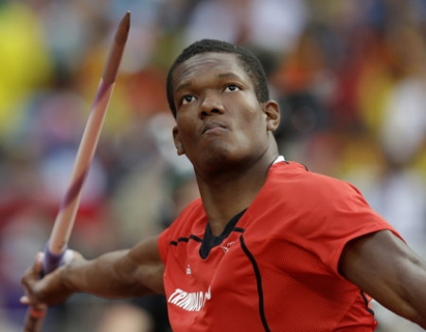

The aim of the javelin throw run up is to reach maximal speed in a controlled and balanced way to reach the athletes potential throw through three components which are speed, technique and strength. All of these have to be balanced otherwise you can lose huge amounts of distance. Keshorn Walcott does this effectively and shines in certain aspects of his technique.

Run up

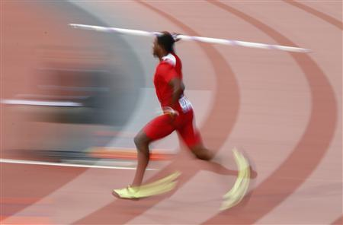
Keshorn uses a 15 step run up prior to withdrawal of the javelin. He uses this effectively as he gathers momentum well and manages to control it to have an efficient plant for the throw. To gather speed he doesn’t accelerate like a sprinter, he instead stays upright with his hips high and runs on the ball of his feet. This slowly increases speed and as huge amounts of speed aren’t necessarily needed he does not reach great speeds and therefore controls the technique perfectly. This speed sets him up for optimal conditions at plant to reach maximal distance. This running style allows his other arm to be free and swing more across the body. This relaxes other movements and makes him more balanced.

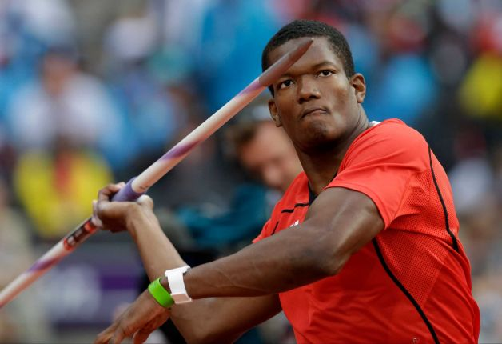
When Keshorn carries the javelin throughout the run up he relaxes the muscles of his right shoulder, arm and wrist, allowing an easy running action. He carries the javelin above the shoulders and the head with his right elbow pointing forwards. The palm of his right hand points toward the sky to provide and area for the javelin to sit in and the javelin points slightly toward the ground to allow the upper shoulder, arm and wrist to relax. All of these things allow the throw to be more successful as it decreases the amount of momentum lost. Keshorn gains control by not allowing his arm to bounce too much during the run up.

Keshorn has a very good withdrawal of the javelin meaning that hardly any momentum is lost, increasing the potential distance of the javelin. He does this well by accelerating ahead of the javelin instead of pushing the shoulders and head back. The head and hips continue to face in the direction of running increasing momentum and creating the optimal angle to throw. His aim at the withdrawal is to not affect the momentum that he has already built and to set him up for optimal conditions at the plant to reach maximal distances.

B1 Javelin

Run up
Keshorn uses a 15 step run up plus 4 steps prior to the throw; I on the other hand use only 11 strides and 8 steps prior to the throw. This causes me to not gather as much momentum as Keshorn does, but it does mean I can control the plant more easily. Due to lack of muscle development in comparison to Keshorn I do not need as much momentum as Keshorn otherwise it could just lead to me not being able to control the plant. I do not accelerate in the same way that Keshorn does. I tend to lean into the first few steps instead of staying upright which often results in me losing control of my javelin and wasting energy. Due to my fast acceleration at the start of my run up I do not accelerate much more during the rest of the run up. My run up is too fast for my ability so I find it very hard to control my final few steps and definitely do not set myself up for optimal conditions at plant. My left arm is very free and does swing more across my body causing my body to relax more which is good as if allows me to use less energy. However, over arousal may cause me to tense up using more energy and creating a poor, unrehearsed technique.

During my run up my javelin does tend to bounce a large amount due to my shoulder, arm and wrist being over relaxed and this does lead to my technique becoming uncontrolled, which means I will not be able to throw as far. I hold the javelin above my shoulder and head during my run up like Keshorn. Sometimes my javelin can be held too high making it harder to withdraw further down the runway. My elbow points forwards, the palm of my right hand points towards the sky and my arms are very relaxed because of this. I do not lose very much momentum because I do this well but still not as strongly as Keshorn.

My withdrawal of the javelin is fairly poor and often results in a large loss of momentum, due to lack of control, decreasing the potential distance I could throw, whereas Keshorn has a strong withdrawal and loses minimal momentum, resulting in him having much more speed to convert to power at the end of the run up. I tend to lean back instead of accelerating in front of the javelin, which does mean a lot of my throws are angled too high. Keshorn, almost always has a perfect angle as he has tailored his final steps to create the ideal lean for him to throw at the 33-degree angle. As well as this my shoulders and head do not get pushed back enough decreasing the lever size reducing the power I can produce from my arm. However, my head and shoulders do continue to face forwards, maintaining momentum.
B2 Javelin

Transition, Delivery and Throw

The final few steps of the javelin run up consist of several different steps such as the transition, the pre delivery stride and the delivery. In order to maintain momentum Keshorn has a very smooth, flowing transition (Cross-over’s). He does this by accelerating past his centre of gravity. This means that he has to stretch out his left leg past his centre of gravity to start the cross-over, which causes his body to lean backwards naturally without having to force his body to lean back controlling his run up more. He still has to continue his cross over by bringing his right leg over his left to prevent him from leaning too far backwards. Keshorn does 4 crossovers. After the 4 crossovers’ he stretches out his right foot in a pre delivery stride. He does this to get his shoulders and hips facing in the direction of the throw and his throwing hand is lifted above the shoulder. If this is not done correctly then the plant will not be as effective or as easy to achieve which will cause to huge distances being lost, as you will have to adjust your final few steps losing a lot of momentum.

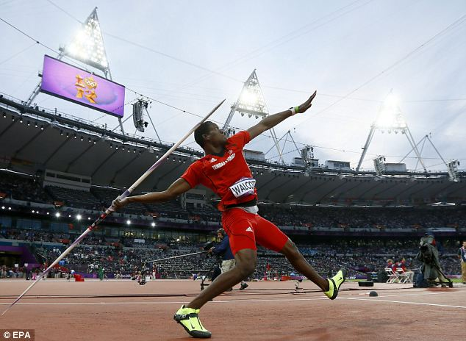
When planting his left leg drives forward further than either of the previous 2 steps, with the aim to stop his body from moving forwards any more and creating a more powerful lever by transferring momentum into power. He plants his left leg with the toes pointing in the direction of the throw as it’s easier to transfer the momentum that way and it puts his body in the correct position to throw straight. Keshorn also sinks into the plant as this means he can use his powerful leg muscles to stop himself more quickly and effectively. Meanwhile his hips thrust to cause the body to face in the direction of the throw. The throwing arm then travels over the right leg and the right leg lifts off the ground slightly thereby pulling the arm through powerfully with the elbow high. The grip of the javelin passes eye level so the elbow is at around 90 degrees to produce large amounts of power from his arm. Keshorn usually releases the javelin at around 33 degrees, as this is the optimum angle for the javelin to travel at.

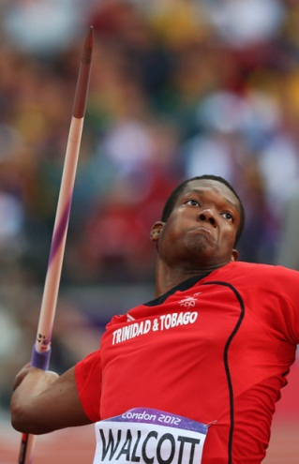
The recovery phase is basically from the release of the javelin until stopping. Keshorn brings his right foot past his left foot and then brings his left foot forward to stop. This usually takes him around 1.5 to 2 metres. He will throw further away from the line than this so he doesn’t get his throw discounted. The recovery phase is quite important in this event as the smaller the recovery phase the closer to the line he can throw, giving him precious centimetres. However, he still needs a full follow through to maximize power but needs to combine this with a quick brake to decelerate rapidly. The arm follows through to full extension before the javelin is released as this creates greater power due to the larger lever. Once the javelin has been released he will use his arms to balance himself and prevent himself from falling over the line, avoiding a discounted throw. This is all done to reduce forward momentum rapidly, maximizing power.
B1 Javelin

Transition, Delivery and Throw

My run up has 6 transition steps or crossovers, which does mean I lose more momentum than Keshorn. I also lose momentum through the change from normal run to crossovers. It is not that smooth a change as I put my left foot in front of my centre of gravity however not by enough, meaning I have to correct it by using 6 crossovers compared to Keshorn’s 4 transition steps. I also do not lean back and create good crossovers however in comparison to Keshorn, who has exceptional crossovers, I do not. His cross over’s lose minimal momentum unlike mine, which does result in decreased momentum. I do not accelerate past my centre of gravity; therefore I do not need to continue with the cross over as fast, losing speed. My pre delivery stride and delivery is a very poor part of my run up. I don’t stretch out far enough on my pre delivery stride which means I can’t plant very effectively at all. This mean I very rarely plant well, therefore decreasing my potential throw hugely. To improve this I need to stretch out further on my pre delivery stride like Keshorn to prepare me for the plant and throw. Due to the poor steps I often find that I do not have my shoulders and hip facing in the correct direction prior to throw, which also means that I do not plant as effectively and I find my body is unbalanced. This makes it much harder to stop during the recovery phase, leading to no throws. This is something in which Keshorn has perfected due to a superb pre delivery stride and powerful leg muscles to stop himself.

When I plant my left leg it does not drive forward far enough and doesn’t stop my body as effectively meaning my lever to throw is a lot weaker than Keshorn’s transferring less momentum into power. I do however plant my left leg with my toes pointing in the direction of the throw so not all power has been lost but I still will not generate anywhere near the same kind of power that I could potentially achieve. As my left leg does not drive forwards far enough I do not sink into the delivery step well, which is another reason why I can’t transfer momentum into power very effectively.
When I throw, my arm does travel over my right leg like Keshorn but I have to release earlier. If I don’t release earlier I will lose my balance because of my altered run up. This affects my throw as my legs are closer together, reducing the power I can produce from the momentum I have gathered. This also decreases the lever size meaning I will not gain the same distance. Keshorn has a larger lever because of wider legs improving balance resulting in more power being transferred into the throw. My right leg also comes off the ground slightly and the javelin grip passes at eye level but usually at an angle greater than 90 degrees often causing my javelin to not travel straight and go off to the right, whereas Keshorn’s javelin travels down the middle generating more power than me. My arm is brought through hard as it has to counter the poor plant and small lever otherwise I would not be able to achieve the same distances that I do. I often find I release my javelin at a greater angle than 33 degrees because of the amount I lean back. However, this angle could vary depending upon environmental conditions such as wind.

My recovery phase also takes around 1.5 to 2 metres but that is not because I stop as quick but just that I am not travelling as fast as Keshorn. He can stop quicker from higher speeds due to stronger and more developed muscles. I stop in the same way as Keshorn by bringing my right foot forward past my left foot and then my left stops me fully. I tend to throw further away from the line, resulting in loss of distance, as I am less experienced and my technique can sometimes be unreliable meaning it sometimes takes different distances to stop. I often have to release the javelin much earlier than full extension to regain balance meaning that the power I could potentially achieve is not achieved as the lever to produce the power is much smaller. I also use my arms to balance me but not as effectively meaning I take a longer distance to stop in comparison with the speed I was travelling at.

B2 Javelin – Pressurising Opponents
Keshorn has to perform consistently to maintain such a high standard of javelin throw and to retain his position of first in the world. This requires him having to pressurise his opponents during each competition. He attempts to achieve this by going for a long throw in the first round, which means that the other competitors have to throw longer to beat him later in the competition. This would be harder due to fatiguing of the body due to reduced phosphocreatine stores or build up of lactic acid, and as the competition goes on there is likely to be an increased arousal resulting in poor throws being achieved which would increase as the competition goes on further.

Keshorn would achieve this by aiming to travel at a faster speed up to the transition, delivery and throw stages so that more speed can be transferred into power, resulting in an increased distance achieved or a ‘longer throw’. The increase speed however makes it more difficult to maintain a good technique and more muscle is needed to stop the body. Leading to a poor first throw. This therefore leads to increased anxiety levels for Keshorn.

He would need to generate a greater speed firstly, so would achieve this my increasing ground contact time creating a larger opportunity to accelerate at a faster rate. Once he achieves his chosen speed he will control this well, not allowing his upper body to tense up to allow it to still be free improving the balance he has setting himself up for optimal conditions for the final stages as usual. He will naturally have to work harder to maintain a speed but it should still be a fairly easy running action. He will aim for all skills during the run up to be the same as a usual run up using his motor programmes steadying anxiety and stress levels. Causing a successful first throw decreasing pressure on Keshorn.

The transition, delivery and throw stage is the most strenuous stage at a faster pace and requires much greater power in his legs. The transition period and crossovers will still be smooth and flowing but there will be greater ground contact time to maintain speed, which makes the skill more difficult to perfect and perform. After the crossovers when his right foot stretched out he will travel further than usual as the increased speed means he travels further. Then the left foot gets driven forward for the plant. The increased speed may result in the plant not being very effective and a good throw not being achieved. This may also mean that Keshorn could step over the line, as he hasn’t effectively stopped himself, resulting in a no throw.

He usually counters himself from stepping over the line by modifying his run up and moving it backwards meaning that he would still be behind the line if he did not effectively stop himself. This would also be moved back as the increased speed will mean he will travel a greater distance, as each step will cause him to travel a greater distance.
Succeeding in his first throw will give Keshorn an advantage over his opponents and by increasing their arousal levels he is decreasing the level at which his opponents compete at. This results in Keshorn winning competitions more regularly.

B1 Javelin – Pressuring Opponents

It is important for me to pressurise my opponents during a competition as well as it is for Keshorn. I would do this to put pressure on main competitors to beat me causing the arousal levels to rise and errors will be created, therefore poor throws. This will also decrease the stimuli for the stress and anxiety meaning that I am more likely to reach my zone of optimal functioning; performing best throws to beat my competitors.

During my first throw I would travel faster to gain a more powerful throw however; I would not be able to travel at a much faster rate. This puts pressure on my opponents causing them to suffer from raised anxiety levels. Due to weak power in my legs, in comparison with Keshorn, which will not be efficient enough to transfer the speed into power resulting in a no throw and a poor technique. This could also be affected by loss of control due to the increased speed and muscle tension. The purpose of this is to put pressure on your opponents by achieving a long first throw and due to being fresh and having increase somatic and cognitive anxiety this is more likely to succeed on the first throw.

I would generate speed in the same way as Keshorn does, by increasing ground contact time. However, this will be less controlled as my upper body would tense up more than Keshorn’s, as he has developed relaxation techniques and used motor programmes to achieve this speed. Using relaxation techniques like Keshorn will decrease tension. Without this I will have to work harder to maintain speed, which will make it more difficult to achieve the skills in my usual run up meaning I won’t be able to use my motor programmes the potential throw achieved. This results in a short first throw.

I will lose a lot more momentum during the withdrawal phase in comparison to Keshorn, which limits the distance I can throw massively. This means that a large amount of energy has been used when it could have been saved for the throw itself that is due to less experience and development of motor programmes unlike Keshorn who has already developed motor programmes. If I do not succeed in achieving a long first throw then my anxiety levels will increase meaning that there is chances for further mistakes in the following throws. This also means that there is decreased pressure on opponents meaning they are more likely to perform successfully.

My transition phase into the crossovers is not as smooth and flowing as Keshorn, meaning I lose more momentum. However, I will have a greater ground contact time as I’m travelling at a greater speed making it harder to maintain balance and perfect the skill to perform. As Keshorn is travelling at a greater speed he will have more ground contact time than me. My right foot will travel further like Keshorn’s, but being able to step into the plant to set me up for optimal conditions is harder. I will need much greater power in my legs to physically stop myself and transfer the momentum into power. This will result in me having an ineffective plant and performing a poor throw, as well as stepping over the line to create a no throw. This will increase stress levels on me as a have a smaller amount of throws to perform a good throw, decreasing arousal levels of opponents. However, I will also modify my run up like Keshorn to prevent myself from stepping over the line.

Going into a competition with a ‘Game Plan’ can give you a great advantage over your opponents. Even more so if my opponents suffer from high state or trait anxiety, leading to over arousal. I also find that this decreases my arousal levels due to increased confidence in my performance. Succeeding on your first throw means that you can also afford to risk your throws later in the competition due to a competent throw being achieved.

