B2 High Jump Run Up
Elite/model performance.
Stefan Holm pictured on the left was the best high jumper in the world for a period of years between 2004 and 2008. He won gold in the Athens Olympics in 2004. He also won 4 gold’s in the world indoor championships in 2001, 2003, 2004 and 2008 as well as 2 gold’s in the European indoor champions in 2005 and 2007. He also respectively gained silver in the world championships, as well as silver and a bronze in separate European championships.

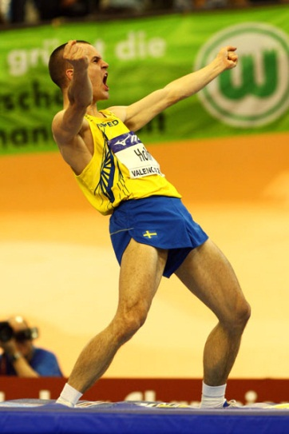

Run up
The run up or preparation phase is just as important as the high jump itself. The run up allows Stefan to build up velocity and body momentum to be converted upwards. Stefan has a fast preparation phase as he has leg power and a good conversion technique to be able to use the technique effectively and efficiently. Stefan also has a long run up which gives time for a gradual and smooth acceleration to reach his desired speed for the take-off. He will make sure he can convert the speed into height by using a natural fast rhythm that gives him control over his jump allowing him to reach his maximal potential jump. Also power training the related muscles as well as a good technique will mean Stefan will be able to jump close to his real potential.
The Drive Phase
The objective of the drive phase is to accelerate up to a speed, which means Stefan can accelerate to a higher speed later in the run up. This also gives him a controlled speed to exploit during the attack phase of the run up. Stefan leans into several quick short steps to gather momentum quickly and smoothly due to more contact with the ground increasing the opportunity to increase power that sets him up for a controlled run up. Stefan tends to not over work his arms during this phase to maintain his centre of gravity improving his balance. This is a highly effective way of building up a controlled speed in a short period of time. Stefan runs from the right side and takes off of his left foot as this is his more natural take off foot. Due to this being his more natural take off foot, it is naturally the more powerful leg.
The Transition Phase
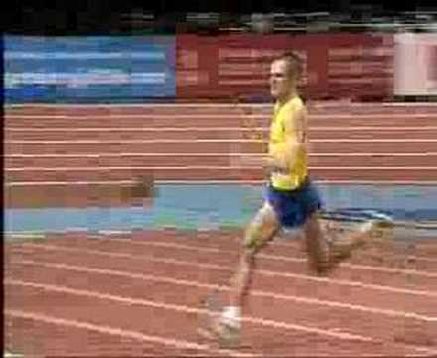
He then follows this by using, what is called a ‘bounding’ step. He drives his knee forwards and high creating a long, looping, ‘bounding’ stride, which is used to gather speed, open his stride and to lower his centre of gravity to maximise his optimal jumping position. He usually uses ‘bounding’ steps for approximately between 1 third to 1 half of his run up. Stefan runs upright without leaning forwards or backward as if he leans forwards too much he will not gain as much height and end up jumping into the bar and if he leans backward he would lose momentum and tend to not accelerate throughout the curved section of the run.

The Attack Phase
Every run up has a “J” shape where he uses the long, ‘bounding’ strides during the straight part of the “J” followed by much quicker, “snappier” steps which have increased ground contact and less flight time, accelerating to the optimal jumping conditions. Stefan uses 4 smaller strides to get to the high jump mat after the long ‘bounding to gather momentum and speed for the optimal take-off conditions. Each step prior to take off will get shorter during these 4 steps, the last step being the smallest to allowing him to sink into the last stride, gaining height by using the muscles in his upper leg. Stefan always starts his curve prior to take off on the outside foot, which in his case is his right foot and then he can maintain his rhythm therefore maintaining momentum that prepares him well for take-off. During this period of the run he still maintains his upright position and leans away from the bar by dipping his left shoulder lower than his right one. This stops him from jumping into the bar and instead causes him to jump upwards reaching his potential height. It also lowers his chances of knocking the bar off with his right shoulder. On the last stride his toe always points toward the far backside of the high jump mat which creates an angle that is optimal for his body to naturally in the air during flight.
B1 High Jump Run Up
My run up also builds up velocity and body momentum to be converted upward, however I have less power in my legs due to less developed muscles therefore my potential height is much lower than that of Stefan’s. My technique is much weaker than Stefan’s so that will also decrease the height I could achieve. My run up is shorter than Stefan’s due to not needing as much momentum, as I am not physically able to convert it into height, therefore I do not need as much speed as Stefan. My run up is also not as smooth as I have had less time to perfect it, as I am less experienced. I will have a less controlled technique compared to Stefan due to many different factors such as having less developed muscles, which are key to controlling every single movement. I also have less time to develop my technique further due to limited training time and coaches that may not have picked up my weaknesses compared to a professional coach.

The Drive Phase
I also use the same drive phase but tend to over accelerate resulting in not being able to control my plant effectively at the end of the run. I also lean into several short strides possibly too much as too much speed is generated from the steps. Stefan does this better than me, as he creates the correct amount of speed to match his ability meaning optimal heights are achieved. I could counter my over lean by not driving my arms as much. This causes my legs to move slower, making my body have to regain a more upright position otherwise I will be unbalanced and I will end up doing an uncontrolled jump, taking off possibly in the wrong position. I also create a fast speed highly effectively however; it is not controlled as I do not have enough ability or power in my legs to maintain a successful jump and technique.

The Transition Phase
I also follow the drive phase with ‘Bounding’ steps. My knee is driven high and does create a long ‘bounding’ stride but I tend to not gather much, if any speed during this period of the “J” run up. This also lowers my centre of gravity but not as much as Stefan so I am not in as good a take-off position as Stefan is at his take-off point. My ‘bounding’ strides take around half of my run up meaning that my curve is not controlled because of the fast nature of my run up. I tend to lean further forward than Stefan resulting in me jumping into the bar and often knocking it off with my left shoulder on the way up. This is also due to not being strong enough to transfer the speed to height.

The Attack Phase
I also use 4 fast, ‘snappier’ steps prior to take off. My steps would not be as quick as his meaning I have more flight time and less contact with the ground. This is due to less momentum built up from the run up and faults within my technique which wouldn’t prepare me for take-off to the same extent that Stefan would be ready for take-off. During my last step I often find myself stretching instead of shortening meaning I cannot produce as much power as it’s much harder to sink into the last step. I turn off my outside foot, which in my case is my left foot, but often at too great an angle meaning I will lose momentum and lose my ‘natural’ rhythm resulting in large amounts of height lost. During the actual curve I dip my right shoulder as I come from the opposite side to Stefan. I do not dip this shoulder as well as Stefan and this is why I will regularly knock the bar off on the way up. My toe does not point far enough to the back corner of the mat and is usually too parallel to the mat resulting in over rotation during the jump.
B2 High Jump Take off and flight
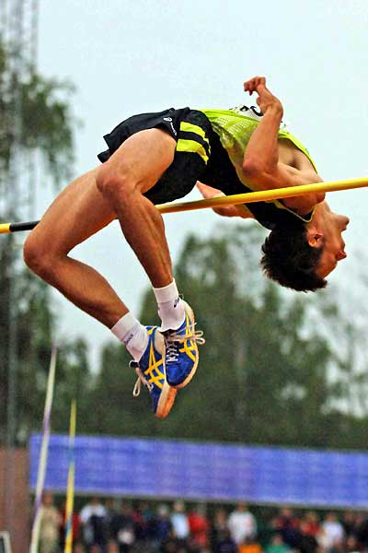
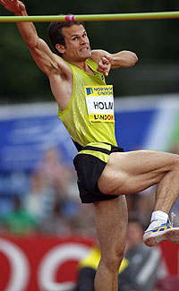
The take-off starts from the beginning of the run up, as it sets him up for optimal conditions at take-off. Stefan has built a great deal of speed up by the curve of the run, which sets him up well for take-off. On the penultimate step he starts to sink his hips towards the ground to prepare him for a powerful take off. Stefan does this naturally and smoothly to allow his final step to attack the ground with vigour and aggression. He does this with the middle of his foot rolling off the ball to create the most natural and powerful plant. He also leans away from the bar on the way up to prevent him from knocking the bar off with his right shoulder and jumping into the bar.
After the plant Stefan has a very strong knee drive. This helps him to gain maximum height. He does this by driving his right knee (trailing knee) powerfully upwards to just above 90 degrees to stop his knee from falling further into the jump. His arms accompany his knee as they are thrown upwards to accelerate his ascension.
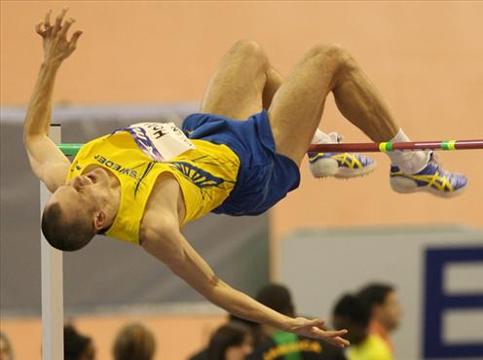
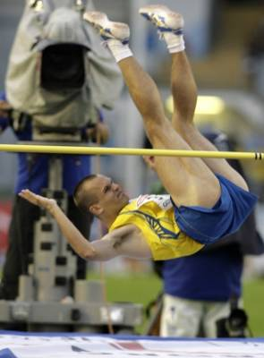
Due to Stefan’s take-off foot being positioned at the correct angle his body will naturally twist away from the bar and when assisted with a knee drive it is a lot more prominent. His knee drive is held until he is at his peak height as if he performs the next movement too early he will knock off the bar on the way up. If he performs the movement too late then he will knock the bar off on the way down. Therefore timing is essential and through experience Stefan knows when his peak height is to start the next movement. At the peak of his jump his back is facing the bar and he pushes his lower back upwards while tensing his gluteal muscles and throwing his head back to create an ‘arch’. This allows most of his body to go over the bar, however if no further movement was done then his legs would knock off the bar due to them still dangling lower than his hips. So to stop this from happening he places his chin on his chest and contracts his abdominal muscles to bring himself out of the ‘arch’ and create a “V” shape in the air instead in which his legs are lifted above his hips to prevent the bar from being knocked off with either his legs or feet. His buttocks are also dropped hugely causing him to land on the mat with his upper back and shoulders.

B1 Take off and Flight
By the time I reach the curve I have gathered momentum which also sets me up well for take-off. However on the penultimate step I do not sink my hips as effectively as Stefan and this does not prepare me for a good take-off as I cannot use all of my leg muscles effectively and I will be unable to produce the same kind of power I could potentially achieve. This also means I cannot attack the ground with the same vigour and aggression that Stefan does and also reduces the height I could achieve. Due to a poor penultimate step, I struggle to plant with the middle of the foot and roll off the ball making it less natural and less powerful than Stefan is able to.
My knee drive is not as powerful as Stefan’s or as effective. This is due to me not being as muscularly developed as him and therefore meaning I can’t reach the same kind of standard as him. However, I do drive my knee up as powerfully as I can but usually only to 90 degrees which often results in my knee falling slightly higher in the jump causing my body to not travel as far upwards and making it more difficult to produce a good arch. I do not use my arms effectively and it is a real weakness of my technique. They do not aid me in achieving higher heights as I only drive them up till my arm is at a 100-degree angle not giving me the drive I am capable of reaching.
My body also naturally twists away from the bar and sometimes I over rotate in the air resulting in the bar being knocked off on the way up, with my shoulder. This occurs on many occasions and when accompanied by a poor knee drive it often is uncontrolled. My knee is also held until peak height but as I don’t lean away from the bar during the curve as well as Stefan I still sometimes knock the bar off on the way up. I very rarely knock the bar off on the way down as I have reasonable timing. Near the peak of my jump I will create an ‘arch’ also by pushing my lower back upwards and tensing my gluteals but due to much poorer flexibility I do not manage to produce the same kind of arch as Stefan does. This causes my upper body to travel over the bar and due to okay timing I generally place my chin on my chest by contracting my abdominals and creating a “V” shape in the air. This is less effective than Stefan as he will always get his timing precise allowing him to reach constant height whereas my okay timing can result in the bar being knocked off by my legs and feet on many more occasions. If I do create a “V” shape too early then my gluteals will knock off the bar, as I would not have fully made it over the bar. If I go into the “V” shape too late then my legs and feet are left hanging lower than the rest of my body therefore not clearing the height of the bar resulting in it being knocked off. Sometimes I do not contract my abdominals enough and knock the bar off with the back of my feet. This very rarely occurs with Stefan due to stronger abdominals making is much easier to contract it to raise his feet, avoiding the bar.
B2 High Jump – Recovering from an Injury
Stephan will spend a lot of his training time to allow himself to compete at elite levels. In order for him to reach these levels he has had to prevent himself from suffering from injury. If he is injured then he may suffer from becoming unmotivated and frustrated as well as the possibility of suffering an injury of which you cannot recover from. There are steps he has taken to help prevent him from suffering from an injury but some injuries are unavoidable and it’s important that if he suffers from an injury he can ‘bounce’ back and get back to training as soon as possible to prevent decline in performance. This also will give him advantages over his opponents if they become injured due to his quick recovery time in comparison.
In order to prevent injury Stephan can reduce the probability of injuries in many ways. These can include using the correct equipment during training. For example high jump spikes should be worn while performing or training as they support your foot and ankle as well as adding grip to prevent slipping which could result in serious injury. If he has just recovered from an injury he could use taping or bracing to support the joint or ligament, reducing the chance of re-injuring himself. This could also help prevent injury in the first place due to the extra stability to the joint.
Another way of preventing himself from getting injured is through strength training and conditioning or the muscles and joints that are under the most strain from the strenuous training sessions and constant pressure they are under. This will also help to improve performance (due to increased muscle mass) as well as reducing the chance of injury. Strength training generally consists of resistance work and can involve body-weight exercises although sometimes the use of weights and resistance devices (rubber bands) can be used. Stefan will benefit from training and conditioning of his gastrocnemius, hamstring, hip flexors, gluteals and quadriceps. This will help to support the ankle, knee and hip joints allowing him to train more often and at higher vigour without suffering from injury. This also helps to stabilise the body helping to increase balance which is important for Stefan’s jump and technique.
Stefan also makes sure that he does not over train as overtraining is the cause of most injuries within elite performers. The causes can be due to putting too much strain on the body during training sessions or by training too often which doesn’t allow enough time for recovery, especially after intense training such as a plyometric session. This results in long-lasting fatigue, worsening of performance under competitive scenarios and chronic fatigue. The fatiguing of the muscles means that they are unable to support tendons, ligaments and bones meaning that there’s an increase in strains, sprains and stress fractures, all of which would lead to Stefan being unable to perform. This makes it important that Stefan should try and avoid injury by allowing a sufficient time for the body to recover and to make sure he never trains while ill (Results in weakening of immune system (Immuno-suppression) making him unable to recover from the illness, preventing him from training properly). He should therefore steadily build up training after an illness to make sure he doesn’t become ill once again.
As Stefan has performed at the elite level he has had access to many things that would speed up recovery from an injury in comparison to someone who is only performing at an amateur level, such as myself. These could include sports massages of therapeutic massage for muscle pains and joints as well, working my increasing range of movement and flexibility of joints and muscles as well as removing muscle soreness. Access to private sports specialist to develop recovery programs especially for him will also allow his body to recover much quicker with specialist stretching and training including water-based training (To avoid so much pressure on the injury parts of the body) and proprioceptive retraining to increase coordination of balance creating smoother coordinated movements to be performed decreasing the probability of injury again.
B1 High Jump – Recovering and Preventing Injury
In comparison to Stefan I have just recovered from a series of injuries and have only just returned to training. This was probably due to overtraining running up to a national competition. Overtraining in my case was not allowing my body to recover after intense training sessions. This resulted in a strained hamstring as well as a sprained ankle. Due to over training my body, my ankle joint was unable to support my body due to fatigued muscles and weakened joints.
When I return to training it will take much longer than it would for Stefan to recover due to lack of sports specialists but it is important that I follow certain steps to allow myself to recover fully. I should build up training slowly to allow my ‘weakened’ muscles to recover as well as to prevent them from becoming reinjured. Like Stefan I should ensure that my muscles and joints become conditioned once again my using strength training for my leg muscles (especially hamstring) and joints to allow my body to cope with the demands of my training. This would involve body-weight exercises (squats) and isometric work (lunges), weights and resistance could be added once I develop strength. This will allow me to not only become stronger but like Stefan, to develop balance and stability which will help me to control movements and transfer energy during take-off.
When it comes to preparation for my event there is a possibility that I could use taping and bracing to support my ankle joint (that will be weaker) during training and competition. Like Stefan this will allow me to train at a higher intensity than I would without as it provides extra stability on the joint and can prevent ligament injuries from occurring in my weakened ankle. This will reduce the chance of it not being able to support my body during take-off, decreasing the chance of injury.
It would be hard for me to recover at the same rate as Stefan as I do not have the same experience or technology to assist me in improving. Although a proper recovery after injury is still vital for me as it is for Stefan as due to the joint imbalances or poor biomechanical ‘form’ then it will almost always return if not dealt with sufficiently. This will mean that I will require sufficient things to allow my recovery to be quick and effective. This could include taking ice baths to speed up recovery as well as stretching. Stretching is important for me as it is for Stefan as it will increase flexibility and allow more movement around a joint meaning there is a decreased range or movement, which could cause injury. It also increases ‘elasticity’ or the muscle reducing the chances of damaging the muscles (overstretch or strain). However unlike Stefan I do not have access to therapeutic massage without paying large amounts of money, and as this is a main part to Stefan’s recovery, it will slow mine significantly. Light aerobic exercise will speed up recovery, as it will develop proprioceptors as well as putting gentle and continuous movement on the joint and muscles, strengthening it.
Like Stefan I also will train and perform in high jump spikes as they support my foot and well as supplying extra grip (preventing me from slipping or from my ankle ‘collapsing’ on me) obviously being a benefit of specialist equipment. However I do not have access to specialists and specialist equipment like Stefan, limiting how far I can progress.
I would naturally recover slower than Stefan as I do not have access to the same facilities as him and do not have much experience with recovering from injury. However I am still able to recover but I may find that when I return to training and competitions I cannot perform at the same standard as I did before my injury.
C1 High Jump Take-off
Leg and Arm Strength
Strength is defined as the amount of force that can be generated and exerted by the muscles. A lack of strength is a major weakness during my high jump take-off, which limits the force I can apply to reach greater heights. This means that greater strength must be achieved. It is important that to achieve greater strength there are greater motor units to which I can call on if a greater force is needed. This is a weakness of mine as due to a lack of motor units, I cannot call upon them during higher heights, causing me to knock off the bar as I do not have the motor units to reach the greater height.
During take-off my body requires high levels of strength in my legs to accelerate my ascension, to clear the bar of which I lack, making it harder to transfer technique into height as well as well as limiting the height I am able to achieve. This is due to lack of fast twitch motor units in the given areas to contract quickly and powerfully, moving my body upwards and over the bar. Fast twitch muscle fibres (which I lack) are important for short, intense burst of energy that is required during the take-off to optimise my take off. They also produce more force due to increased myosin filaments, which are also thicker than the equivalent in slow twitch fibres. The further developed sarcoplasmic reticulum means that calcium ions can be released at a much quicker rate allowing faster contractions to occur, creating greater force.
The muscles include the gluteals maximus, which is responsible for straightening the hips during take-off, and is responsible for the majority of the jumping force. Hamstrings are serving two main purposes during the jump that are; bending the knee to allow my hips to drop before take-off as well as straightening the hips. They are mainly responsible for hip extensions and to generate a powerful hip extension required for take-off. The quadriceps also plays an important role in straightening the knee and a strong knee extension is required for assisting the hips in lifting you off the ground. Gastrocnemius is my last main muscle in my legs required for an effective take off. This is the muscle responsible for plantar flexion and this is required to transfer force from the hip and knee down into the ground to accelerate my ascension.
The time it takes for the muscles to contract eccentrically on the plant and then concentrically to lift myself off the ground limits my body ability to exert much force into the jump, due to the short time in contact with the ground to maintain momentum. This could leads to a lacklustre jump, resulting in poor heights being achieved and seeing very little improvement.
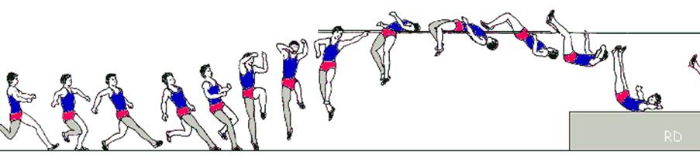
Strength is also required for my drive knee, aiding my take-off foot. The knee drive from under my body is lifted to slightly above 90 degrees, to stabalise my jump and to achieve a greater height. A large amount of strength is required to drive the knee fast and forcefully upwards to make it an effective manoeuvre. This could also results in me not being able to rotate my body during the flight, leading to a poor flight and an increased probability of a no jump. This will reduce the height I can achieve leading to loss of motivation.
My arms are very important to maintain balance and to increase the height achieved as well as contributing to around a 5% increase in height, making it essential to reaching a greater standard in the event. This also helps to encourage the rotation of my body to become parallel to the bar, maintaining a correct technique. Without my arms it would result in me knocking the bar off on the way up with my shoulder or landing awkwardly, possibly causing injury. This could cause me to lose dramatic amounts of height.
When I plant my foot during take-off, a lack of strength in my arms results in my not being able to swing forcefully enough to create momentum to achieve maximum height possible. A lack of strength means that the same height cannot be achieved and I will possibly knock the bar off on the way down due to momentum not available to carry my body over the bar and onto the mat. This also increases the chance of injury occurring.

C2 High Jump Take-off
Weight Training (Upper and Lower body)
To improve my height achieved during the jump and technique I need to increase my strength. This can achieve this by using weight training. This increases my muscle mass in the given muscle groups increasing the amount of motor units I can recruit to exert a higher level of force, increasing the potential height I could achieve. This also increased the size of the myosin filaments in the motor units meaning they can contract more powerfully and stronger.
This can be achieved through a series of strength building exercises, which includes squats, lunges, seated calf raises, push-ups and bicep curls.

Squats
Squats build muscle tissue in the quadriceps, hamstrings, gluteals, hip flexors and gastrocnemius.
Preparation:
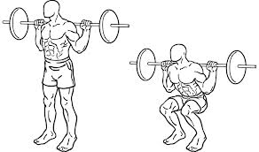
I would perform this by squatting down to lower myself under the bar. I would place 1 foot in front of my body and one behind to lift the bar off the squat rack. Once the bars been removed I will position my feet shoulder width apart. Abdominals should be slightly contracted to assist in keeping the back straight. I will then extend my knees and hips causing my legs to become straight.
Execution:
I will bend my knee while maintaining a straight back by allowing my hips to bend back behind me. I continue to sink towards the ground until my thighs are parallel to the ground. I lift the bar by extending my knee joint and hip flexors to maintain a straight back and to straighten my legs. This causes my quadriceps, hamstrings, hip flexors and calf muscles to contract, meaning that actin filaments will slide across myosin filaments in order to hold the weight of the body or the additional weights. This will increase the size of the myosin filaments by first damaging them but once repaired will increase in thickness, size and strength. Squat do not only increases muscle mass and the motor units available for contraction but also helps to prevent injury as they improve both flexibility and balance, both important for a more efficient high jump take off and technique. I would perform these twice a week.
Lunge
Lunges work similar muscle groups to squats that include quadriceps, hamstrings, gluteals, hip flexors and calf muscles.
Preparation:
I’d begin with my feet shoulder width apart and my body standing tall and facing forwards.
Execution:
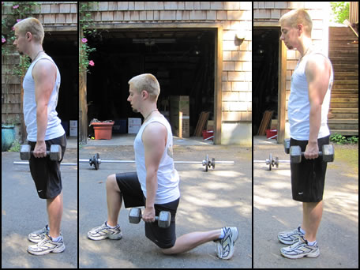
With my right foot I’d take a large step forward keeping the left foot in place. This step should be far enough to prevent my knee from passing over the front of the foot during this exercise. Once the right foot is on the floor I will lower my upper body by flexing my knee causing my thigh to be parallel to the floor. This causes my quadriceps to contract and my hamstrings to relax as well as my gluteals and my hip flexors will contract. The left foot remains in place by shifting my weight to the left toes.
I will then extend my knee causing an upwards and backwards movement to return the body to an erect position. This contracts my gluteals and hamstring as well as my calf muscle. I then repeat this process with the other leg.
To increase the difficulty and allow progression and overload I could perform this while holding weights to improve my strength further. This encourages my body to create more motor units and thicker myosin filaments in order to cope with the increased demand for strength, created by the lunge. I will start to see benefits in my performance fairly quickly but improvement further is limited as I do not have equipment to work with and increase the difficulty. I would perform these 2 to 3 times a week.
Seated Calf Raises
This primarily increases muscle mass in the gastrocnemius and soleus.
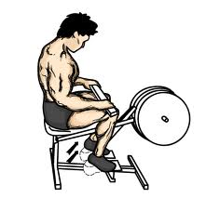
Preparation:
I will sit down in the seat and place the balls of my feet on the platform making sure to allow for full movements of the foot. I extend my knee, straightening my legs. I then place my toes and balls of my feet on the lower section of the platform with heels and arches extending off.
Execution:
I lower my weight by dropping the heels as low as possible and keeping the ball of the foot in constant contact with the platform. I flex my knee to allow my body to be lowered. I do this by bending my ankles until my calves are stretched.
I push with the ball of the foot into the platform and lift the heels as high as possible. I extend my ankles as far as possible and straightening my leg by extending my knees, without locking them. I would do this 2 times a week as this helps improve flexibility and strength in the lower leg, which is essential for transferring the power from the hip and knee joints into the jump. This also allows more motor units to be developed in my gastrocnemius but not of a certain type. Fast, anaerobic exercise will transfer it to fast glycotic of which I require for a more efficient jump. Thicker myosin filaments will be developed also.
Upper Body Strength
Push Up
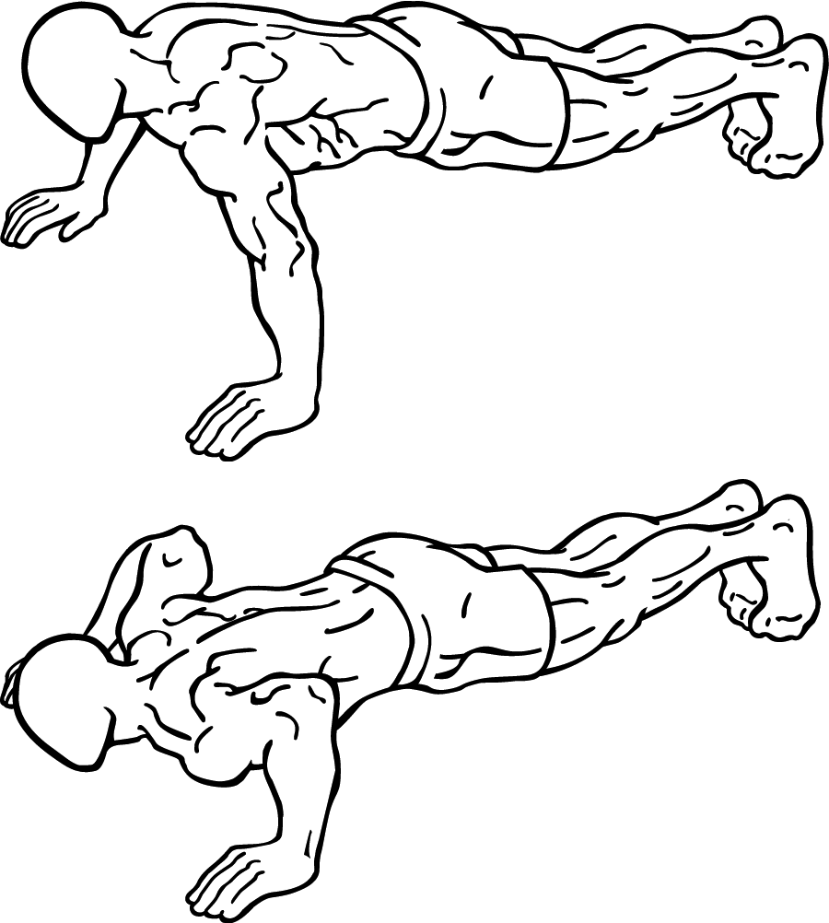
A push up builds muscle mass in the pectorals major, anterior deltoids and deltoid. Deltoids are important when it comes to extending my arms upwards quickly for additional momentum.
Preparation:
I would begin face down on the floor with my elbow extended and shoulder width apart. My back is flat and feet together. I lower my body towards the floor by flexing my elbows until my chest touches the floor, maintaining a straight back, which is parallel to the floor.
Execution:
I extend my elbow joints until my arms are straight. I do this with control while maintaining a straight back to prevent myself from injury. I would do this 3 to 4 times a week and would not see much improvement in performance but it would allow me to be more balance causing more consistent jumps. I could see improvements of up to 5%.
C1 High Jump – Power (Legs Muscles)
Power is defined as the maximum exertion of strength within a short burst movement. High jump requires large amounts of power (predominantly during the take-off phase) to be able to perform at a high standard. This requires large amounts of fast twitch fibres in the specific muscle groups in the legs that are required to contract rapidly to create a powerful jump upwards, achieving ultimate height. This will require fast twitch motor units to contract rapidly achieving a much greater height. The benefits of fast twitch fibres include that they have a developed sarcoplasmic reticulum meaning it can release calcium ions rapidly, speeding up contraction time. They also have a high motor unit strength meaning that greater force can be achieved much more quickly, creating a powerful leap. This is a weakness within my performance as without power in my legs I am unable to achieve the same height as an elite performer would even if I had developed a perfect technique. My performance is very reliant upon power.
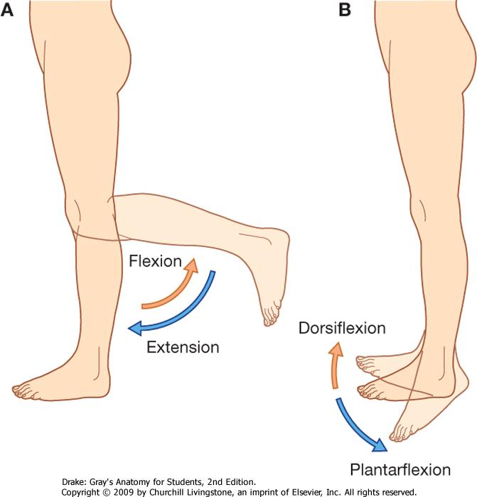
Power is created during take-off through a high knee drive, a powerful plantar flexion and flexion followed by extension around the knee joint. My quadriceps, gluteals, gastrocnemius, hamstring and hip flexors all accompany each other to drive my body off the ground. This will require large amounts of power to achieve maximum height and drive from the ground.
During take-off my hips should drop during the penultimate step causing flexion around the knee joint, contracting eccentrically first to create optimal conditions to contact concentrically during the drive upwards. A muscle that is eccentrically stretched before a concentric contraction will contract more forcefully. Without dropping my hips I would not be able to generate the same amount of power as I would by just contracting concentrically and without power my technique suffers. This could also be due to me being unable to recruit as many fast twitch motor units meaning that my maximum power could not be achieved.
A powerful plantar flexion is very important, as this is the last part of my body to leave to track meaning that this can generate the largest amount of power. This is predominantly powered by the gastrocnemius and will probably use all of the motor units available in this area (Spatial summation) meaning that I will find it hard to improve without the development of more fast twitch motor units or by changing my slow twitch fibres into fast twitch fibres, creating a more powerful jump. This is aided by all other movement to drive upwards such as the knee drive, movement around the knee joint and power arm drive. This also requires great amount of flexibility.
Power is requires achieving a successful knee drive, which help achieve maximum height. This achieved by contracting my quadriceps and hip flexors to perform this. To accelerate my ascension a powerful arm drive is essential. As this not only assists in achieving greater height but also determines the speed and strength at which the legs move. Both speed and strength are required to perform a highly powerful jump.
Power is vital for improving my personal best and is a major weakness within my technique. This must therefore, be improved through training and predominantly in the form of Plyometrics.
C2 Power Training - Plyometrics
To increase my power during high jump I will use Plyometric training. This is a form of power training and usually is done through bounding, jumping and hopping exercises. All of these involve contracting eccentrically before contracting concentrically and this is completed in 3 stages. Firstly an eccentric contraction during the downward movement followed by a short phase in which the contraction changes from eccentric to concentric, then finally the concentric contraction that is the actual training of the muscle. This creates an explosive muscular contraction, which engages the stretch reflex to prevent overstretching of the muscle.
Lower Body Plyometrics
Box Jumps
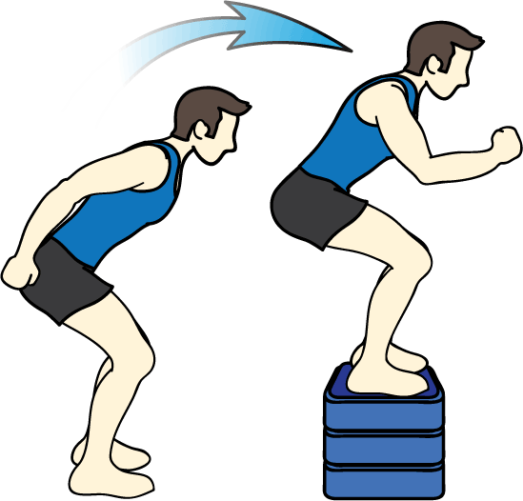
Box jumps involve jumping on and off a plyobox. It teaches your body how to quickly produce and reduce force. This will develop the muscle fibre into becoming a fast twitch muscle fibre and will allow more motor units to contract at a rapid rate. This will also develop more motor units, allowing me to recruit more when needed, under the law of spatial summation. The idea is to jump up and down as quickly as I can while maintaining my posture and avoiding injuries.
This involves explosive movements at a fairly high intensity. It maintains your posture and balance as you move and improves reflexes, reaction as well as muscular endurance, stamina and power.
You stand with your legs about shoulder width-apart with a plyobox around 60 to 90 centimetres high in front of you. Bend your legs (eccentrically) and jump onto the box (Concentrically), landing gently on the balls of your feet with your legs bent. You then immediately jump back to the ground and land in the same leg position you started. You would repeat this 10 to 15 times with 3 to 4 sets. I am already accustomed to this kind of training and if continued will increase my explosive strength required to achieve optimal height.
I have chosen this exercise as it is simple to do and does not require any specialist equipment. This is also directly transferable to high jump, making it and effective way of developing a greater jump. I would tend to see benefits within a few weeks as well if I perform this 2 to 3 times a week, as it will be required to withstand the added force from falling. It also damages myosin filaments allowing them to repair themselves. This increases thickness and therefore allows them to attach to actin filament much powerfully, increasing power.
Bounding and Hurdling
This is important for the run up phase of my jump and it involves building power to be used in a forward motion meaning that this is an excellent exercise for me to do as it will training the exact muscles I will need during performance. This is a Plyometrics training which involves oversized strides that are used to increase the time spent in the air. Two-legged bounds reduce the impact to be endured, but due to being conditioned to this kind of training I can increase the intensity by using one-legged bounding, or hopping. This works by the muscles contracting eccentrically to cushion the ‘bound’ on the downwards movement, followed by contracting concentrically to force my body back off the ground and into the oversized stride. This will allow me to increase the force of which I have available to be during my run up and jump, as it will develop more motor units creating a greater power, increasing height achieved. Bounding up stairs is a useful way to work on both the vertical and horizontal aspects of the running action. Multiple jumps over a series of obstacles like hurdles are valuable drills for athletes training for jumping events.
Many other lower body Plyometric exercises with intensity level includes standing based jumps (tuck jumps), jumps from standing (Standing long jump), eccentric drops (Drop jumping).
Upper Body Plyometrics
I require upper body power to maximise the height I can achieve by driving my arm upwards while maintain powerful leg contractions and a good technique. However this is not required to the same state as it is with my legs due to it being mainly used for support.
Medicine Ball
This is a high intensity exercise, which involves my basic conditioning to allow this to be used by me. I would lie on the ground and a partner will drop the medicine ball down towards my chest and I’ll catch the ball (Pre-stretch and contracts eccentrically) and then immediately throws it back (The actual training of the muscles and contracting concentrically). To allow progression and overload, the weight of the medicine ball can be increased, as can the frequency of the drops.
Benefits of Plyometrics include:
-Improved height achieved from jump
-Development of fast twitch fibres
-Greater motor units being produced
-Development of sarcoplasmic reticulum allowing calcium ions to be released quicker, speeding up contraction times
-Improved technique
-More powerful contractions, generating greater forces
-Myosin filaments will get thicker increasing power and strength of muscle contractions
C1 High Jump – Flexibility (Legs and back)
Flexibility is defined as “the range of movement around a joint.” It is an important aspect for performing an effective skill and technique or action as well as a contributory factor for speed and power. This range of movement depends upon many factors, which include muscle bulk, the surrounding tissue, and the structure of the joint, skin and muscle length. Muscle length however is the only one we can modify as humans (Stretching). If the lengths of the muscles in my legs are short then I will have poor flexibility meaning that I cannot stretch as far as an elite performer, meaning the lever I have to achieve higher heights is not long enough to accelerate my ascension further. A lack of flexibility in my back and abdominals prevents me from arching back further leading to me losing several centimeters.
Flexibility will also help for everyday mobility as well as decreasing my chances or injury. This all therefore means that it is an important aspect for me to maintain and improve to increase the heights I can currently achieve. As it stands, this is probably my worst weakness and is limiting my performance the most.
Flexibility is important during the flight and the arch of the back to clear the bar. Without flexibility I will have the inability to arch my back effectively during flight. This leads to my gluteals dropping, resulting in the high jump bar being knocked off and achieving a no jump. This also leads to me landing in an incorrect and awkward position that can result in an increased probability of injury.
After I have taken off after plant I require flexibility to drive my knee upwards to assist the leap. If I lack flexibility then I am unable to drive that knee above 90 degrees. This is due to my gluteals not being able to stretch any further (Due to short muscle length), limiting how high I can drive my knee. This results in the knee dropping further into the jump, which can lead to the development of a poor technique that makes it more difficult to rotate my body as well as achieving maximum height.
Poor ankle flexibility is a huge weakness for me as with a small plantar flexion I am unable to maintain contact with the ground for a large period of time. This means that I am unable to build an upward momentum due to the small ground contact time, which limits that height I can achieve. This also means that I have to become more reliant upon my drive knee to maintain the small amount will drastically decrease my trajectory in comparison to what I could achieve. This will therefore have a knock on effect on my technique as it limits the short period of time in which I have to drive my knee, rotate my body and arch my back ready for landing.
I also require flexibility in my arms to achieve a full circle around my shoulder. If I am unable to do this then I may become unbalance during the curved part of my run up, causing me to drop my shoulder away from the bar. This will result in a poor take off, possibly causing injury and a loss of momentum that could lead to me landing on the bar and achieving a no jump. This could lead to me losing a large amount of height, which could cause me to consistently perform poorly in competitions that could lead me to becoming unmotivated.
All these factors lead to me performing poorly so therefore it is important for me to improve my flexibility otherwise my performance may hit a plateau resulting in this being one of my largest weaknesses.

C2 High Jump – Improving flexibility
Proprioceptive Neuromuscular Facilitation (PNF)
Increasing the elasticity of the muscles is how I can improve my flexibility, therefore increasing the range of movement around the joints. I can achieve this through Proprioceptive Neuromuscular Facilitation (PNF).
Proprioceptive Neuromuscular Facilitation involves using alternating contraction and relaxation movements to increase flexibility. Firstly an isometric contraction is performed and this is followed immediately by a passive stretch until muscle spindles cause the muscle to prevent overstretching (This is the stretch reflex). This then stimulates the Golgi tendon organ, which causes the muscle to relax. The muscle is then actively isometrically contracted and the process repeats but the muscle will be stretched slightly further after the relaxation of the muscle. This is easiest to perform with a partner even though I would be able to perform this alone.
Isometric contractions followed by a passive stretch help to facilitate the body’s muscles inhibition causing them to gradually relax. This therefore increases the elasticity of the muscles increasing flexibility. This will help to achieve greater heights during my performance due to a larger amount of movement available to me, causing a much large amount of force to be generated and at my disposal. This will cause a greater knee drive, a much more powerful take-off leg as I will be able to extend my knee joints concentrically much faster, creating greater height. I will have a better ankle flexibility allowing me to stay in contact with the ground for a longer period of time, giving me an opportunity to generate much more force than if I was already airborne. This is related to ‘Newton’s 2nd Law’ suggesting that if I apply a greater force then I will accelerate faster meaning I would achieve a greater height. Impulse suggests that if I have a longer time in contact with the ground to gather momentum, then I will have a greater positive impulse resulting in a much quicker acceleration, creating a more powerful leap.
PNF stretching requires a long aerobic warm up to reduce the chances of injury during PNF. This is because PNF is a training session within itself and also requires around 48 hours of recovery time after the ‘set’. This should never be done on the morning of a competition, as it will lead to fatiguing and possibly injury.
Drills
I can improve all my flexibility through performing a series of drills. A drill is defined as a “Disciplined, repetitious exercise as a means of teaching and perfecting a skill or procedure”. This will be important for the arch of my back, as this is much harder to improve through PNF due to the increased probability of injury.

Bridge Drill:
To increase the arch of my jump, it is important to improve and maintain my flexibility. Yoga is not only effective for back flexibility, but it also is a cross-training exercise. I’d lie face down on the ground and with my chest up off the ground, straightening your arms. While lifting my upper body off the ground I’d concentrate on pushing my hips into the ground.
On a mat I would lie on my back and place my hands behind my head, close to my ears. I would have my palms lying flat with my fingers pointing toward my feet. I’d push up to create a bridge in my spine. As I get stronger at maintaining a bridge up, I will practice pushing my body off the ground in the bridge position. As I attempt to push myself off the ground I’d press my back into a deeper arch by quickly reaching for my ankles and releasing. Performing this drill in the pit will increase safety.

I chose this drill as it is easy to do and doesn’t require any other equipment making it much cheaper as well as being very effective in improving my arch and overall technique. This could add several centimetres onto my personal best as well as me starting to see improvements within a couple of months if I complete this exercise a few times a week.

Hurdle Step Over’s
This drill is done to improve flexibility in my hamstrings allowing me to lift my legs higher during the recovery phase (on the way down to the mat), decreasing the chances of me knocking the bar off with my feet.

This drill consists of setting up 5 to 6 hurdles all in a line, leaving a gap of around 50cm between each hurdle. They should stand at a height just below hip level. I will stand side on to the first hurdle flexing the leg closest to the hurdle up directly in front of me (stretching the hamstring) up to just above 90 degrees. Then this leg will then travel over the hurdle and flex to allow plant on the opposite side of the hurdle at which I begun. This allows me to extend my outside leg around the edge of the hurdle, while rotating my body 180 degrees, (Facing opposite direction) meaning my leg to being hyperextended behind me. Then bringing that leg (without planting) up in front of me (Extended) to a 90 degree angle and planting on the opposite side of the hurdle (Repeating the first action). I will then progress down the hurdle like this.

This is a good drill to use as it not only stretches my hamstring leading to a greater flexibility during take-off and during the drive knee, but also during rotation of the body and swinging my leg up to 90 degrees helps to improve take off technique ultimately helping with my technique during the jump. I should do this at the beginning of every training session to start to see improvement within my jump.

All these exercises will allow me to develop miniscule skills to help develop my technique overall and achieve a much greater jump. The improved flexibility will give me a greater range of movements meaning that I can reach greater heights as well as perform a better arch to allow extra centimetres to be added.

