B2 Javelin – Run up
Keshorn Walcott is a Trinidadian javelin thrower. He is currently the best javelin thrower in the world, which has recently been shown by winning a gold medal at the summer Olympics in London, making him the youngest ever javelin champion at just 19 years of age. He also won the world championships in Barcelona also in 2012. Even though Keshorn isn’t the biggest or strongest javelin thrower his technique allows him to be the best in the world.
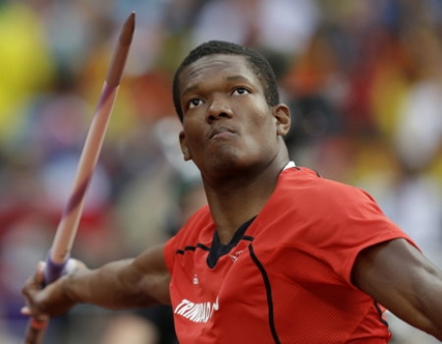

The aim of the javelin throw run up is to reach maximal speed in a controlled and balanced way to reach the athletes potential throw through three components which are speed, technique and strength. All of these have to be balanced otherwise you can lose huge amounts of distance. Keshorn Walcott does this effectively and shines in certain aspects of his technique.

Run up

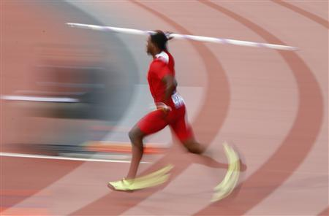
Keshorn uses a 15 step run up prior to withdrawal of the javelin. He uses this effectively as he gathers momentum well and manages to control it to have an efficient plant for the throw. To gather speed he doesn’t accelerate like a sprinter, he instead stays upright with his hips high and runs on the ball of his feet. This slowly increases speed and as huge amounts of speed aren’t necessarily needed he does not reach great speeds and therefore controls the technique perfectly. This speed sets him up for optimal conditions at plant to reach maximal distance. This running style allows his other arm to be free and swing more across the body. This relaxes other movements and makes him more balanced.

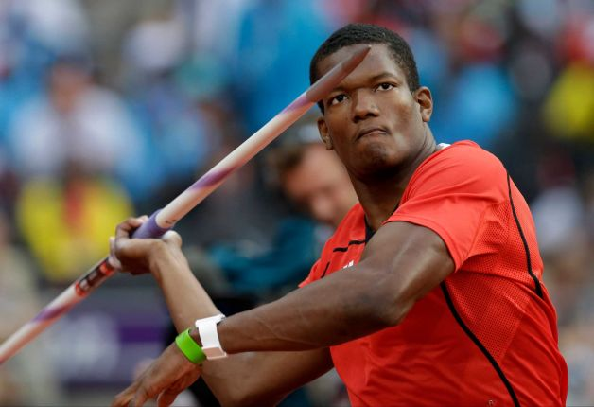
When Keshorn carries the javelin throughout the run up he relaxes the muscles of his right shoulder, arm and wrist, allowing an easy running action. He carries the javelin above the shoulders and the head with his right elbow pointing forwards. The palm of his right hand points toward the sky to provide and area for the javelin to sit in and the javelin points slightly toward the ground to allow the upper shoulder, arm and wrist to relax. All of these things allow the throw to be more successful as it decreases the amount of momentum lost. Keshorn gains control by not allowing his arm to bounce too much during the run up.

Keshorn has a very good withdrawal of the javelin meaning that hardly any momentum is lost, increasing the potential distance of the javelin. He does this well by accelerating ahead of the javelin instead of pushing the shoulders and head back. The head and hips continue to face in the direction of running increasing momentum and creating the optimal angle to throw. His aim at the withdrawal is to not affect the momentum that he has already built and to set him up for optimal conditions at the plant to reach maximal distances.

B1 Javelin

Run up
Keshorn uses a 15 step run up plus 4 steps prior to the throw; I on the other hand use only 11 strides and 8 steps prior to the throw. This causes me to not gather as much momentum as Keshorn does, but it does mean I can control the plant more easily. Due to lack of muscle development in comparison to Keshorn I do not need as much momentum as Keshorn otherwise it could just lead to me not being able to control the plant. I do not accelerate in the same way that Keshorn does. I tend to lean into the first few steps instead of staying upright which often results in me losing control of my javelin and wasting energy. Due to my fast acceleration at the start of my run up I do not accelerate much more during the rest of the run up. My run up is too fast for my ability so I find it very hard to control my final few steps and definitely do not set myself up for optimal conditions at plant. My left arm is very free and does swing more across my body causing my body to relax more which is good as if allows me to use less energy. However, over arousal may cause me to tense up using more energy and creating a poor, unrehearsed technique.

During my run up my javelin does tend to bounce a large amount due to my shoulder, arm and wrist being over relaxed and this does lead to my technique becoming uncontrolled, which means I will not be able to throw as far. I hold the javelin above my shoulder and head during my run up like Keshorn. Sometimes my javelin can be held too high making it harder to withdraw further down the runway. My elbow points forwards, the palm of my right hand points towards the sky and my arms are very relaxed because of this. I do not lose very much momentum because I do this well but still not as strongly as Keshorn.

My withdrawal of the javelin is fairly poor and often results in a large loss of momentum, due to lack of control, decreasing the potential distance I could throw, whereas Keshorn has a strong withdrawal and loses minimal momentum, resulting in him having much more speed to convert to power at the end of the run up. I tend to lean back instead of accelerating in front of the javelin, which does mean a lot of my throws are angled too high. Keshorn, almost always has a perfect angle as he has tailored his final steps to create the ideal lean for him to throw at the 33-degree angle. As well as this my shoulders and head do not get pushed back enough decreasing the lever size reducing the power I can produce from my arm. However, my head and shoulders do continue to face forwards, maintaining momentum.
B2 Javelin

Transition, Delivery and Throw

The final few steps of the javelin run up consist of several different steps such as the transition, the pre delivery stride and the delivery. In order to maintain momentum Keshorn has a very smooth, flowing transition (Cross-over’s). He does this by accelerating past his centre of gravity. This means that he has to stretch out his left leg past his centre of gravity to start the cross-over, which causes his body to lean backwards naturally without having to force his body to lean back controlling his run up more. He still has to continue his cross over by bringing his right leg over his left to prevent him from leaning too far backwards. Keshorn does 4 crossovers. After the 4 crossovers’ he stretches out his right foot in a pre delivery stride. He does this to get his shoulders and hips facing in the direction of the throw and his throwing hand is lifted above the shoulder. If this is not done correctly then the plant will not be as effective or as easy to achieve which will cause to huge distances being lost, as you will have to adjust your final few steps losing a lot of momentum.

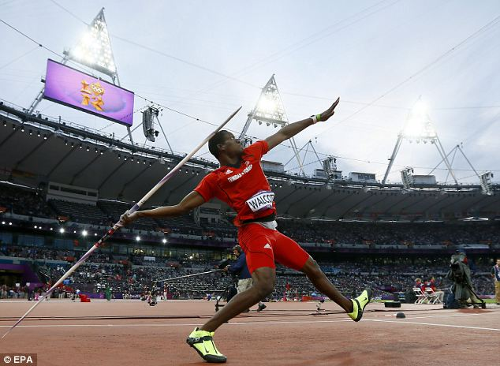
When planting his left leg drives forward further than either of the previous 2 steps, with the aim to stop his body from moving forwards any more and creating a more powerful lever by transferring momentum into power. He plants his left leg with the toes pointing in the direction of the throw as it’s easier to transfer the momentum that way and it puts his body in the correct position to throw straight. Keshorn also sinks into the plant as this means he can use his powerful leg muscles to stop himself more quickly and effectively. Meanwhile his hips thrust to cause the body to face in the direction of the throw. The throwing arm then travels over the right leg and the right leg lifts off the ground slightly thereby pulling the arm through powerfully with the elbow high. The grip of the javelin passes eye level so the elbow is at around 90 degrees to produce large amounts of power from his arm. Keshorn usually releases the javelin at around 33 degrees, as this is the optimum angle for the javelin to travel at.

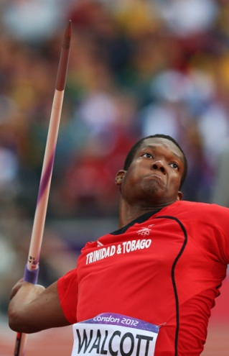
The recovery phase is basically from the release of the javelin until stopping. Keshorn brings his right foot past his left foot and then brings his left foot forward to stop. This usually takes him around 1.5 to 2 metres. He will throw further away from the line than this so he doesn’t get his throw discounted. The recovery phase is quite important in this event as the smaller the recovery phase the closer to the line he can throw, giving him precious centimetres. However, he still needs a full follow through to maximize power but needs to combine this with a quick brake to decelerate rapidly. The arm follows through to full extension before the javelin is released as this creates greater power due to the larger lever. Once the javelin has been released he will use his arms to balance himself and prevent himself from falling over the line, avoiding a discounted throw. This is all done to reduce forward momentum rapidly, maximizing power.
B1 Javelin

Transition, Delivery and Throw

My run up has 6 transition steps or crossovers, which does mean I lose more momentum than Keshorn. I also lose momentum through the change from normal run to crossovers. It is not that smooth a change as I put my left foot in front of my centre of gravity however not by enough, meaning I have to correct it by using 6 crossovers compared to Keshorn’s 4 transition steps. I also do not lean back and create good crossovers however in comparison to Keshorn, who has exceptional crossovers, I do not. His cross over’s lose minimal momentum unlike mine, which does result in decreased momentum. I do not accelerate past my centre of gravity; therefore I do not need to continue with the cross over as fast, losing speed. My pre delivery stride and delivery is a very poor part of my run up. I don’t stretch out far enough on my pre delivery stride which means I can’t plant very effectively at all. This mean I very rarely plant well, therefore decreasing my potential throw hugely. To improve this I need to stretch out further on my pre delivery stride like Keshorn to prepare me for the plant and throw. Due to the poor steps I often find that I do not have my shoulders and hip facing in the correct direction prior to throw, which also means that I do not plant as effectively and I find my body is unbalanced. This makes it much harder to stop during the recovery phase, leading to no throws. This is something in which Keshorn has perfected due to a superb pre delivery stride and powerful leg muscles to stop himself.

When I plant my left leg it does not drive forward far enough and doesn’t stop my body as effectively meaning my lever to throw is a lot weaker than Keshorn’s transferring less momentum into power. I do however plant my left leg with my toes pointing in the direction of the throw so not all power has been lost but I still will not generate anywhere near the same kind of power that I could potentially achieve. As my left leg does not drive forwards far enough I do not sink into the delivery step well, which is another reason why I can’t transfer momentum into power very effectively.
When I throw, my arm does travel over my right leg like Keshorn but I have to release earlier. If I don’t release earlier I will lose my balance because of my altered run up. This affects my throw as my legs are closer together, reducing the power I can produce from the momentum I have gathered. This also decreases the lever size meaning I will not gain the same distance. Keshorn has a larger lever because of wider legs improving balance resulting in more power being transferred into the throw. My right leg also comes off the ground slightly and the javelin grip passes at eye level but usually at an angle greater than 90 degrees often causing my javelin to not travel straight and go off to the right, whereas Keshorn’s javelin travels down the middle generating more power than me. My arm is brought through hard as it has to counter the poor plant and small lever otherwise I would not be able to achieve the same distances that I do. I often find I release my javelin at a greater angle than 33 degrees because of the amount I lean back. However, this angle could vary depending upon environmental conditions such as wind.

My recovery phase also takes around 1.5 to 2 metres but that is not because I stop as quick but just that I am not travelling as fast as Keshorn. He can stop quicker from higher speeds due to stronger and more developed muscles. I stop in the same way as Keshorn by bringing my right foot forward past my left foot and then my left stops me fully. I tend to throw further away from the line, resulting in loss of distance, as I am less experienced and my technique can sometimes be unreliable meaning it sometimes takes different distances to stop. I often have to release the javelin much earlier than full extension to regain balance meaning that the power I could potentially achieve is not achieved as the lever to produce the power is much smaller. I also use my arms to balance me but not as effectively meaning I take a longer distance to stop in comparison with the speed I was travelling at.

B2 Javelin – Pressurising Opponents
Keshorn has to perform consistently to maintain such a high standard of javelin throw and to retain his position of first in the world. This requires him having to pressurise his opponents during each competition. He attempts to achieve this by going for a long throw in the first round, which means that the other competitors have to throw longer to beat him later in the competition. This would be harder due to fatiguing of the body due to reduced phosphocreatine stores or build up of lactic acid, and as the competition goes on there is likely to be an increased arousal resulting in poor throws being achieved which would increase as the competition goes on further.

Keshorn would achieve this by aiming to travel at a faster speed up to the transition, delivery and throw stages so that more speed can be transferred into power, resulting in an increased distance achieved or a ‘longer throw’. The increase speed however makes it more difficult to maintain a good technique and more muscle is needed to stop the body. Leading to a poor first throw. This therefore leads to increased anxiety levels for Keshorn.

He would need to generate a greater speed firstly, so would achieve this my increasing ground contact time creating a larger opportunity to accelerate at a faster rate. Once he achieves his chosen speed he will control this well, not allowing his upper body to tense up to allow it to still be free improving the balance he has setting himself up for optimal conditions for the final stages as usual. He will naturally have to work harder to maintain a speed but it should still be a fairly easy running action. He will aim for all skills during the run up to be the same as a usual run up using his motor programmes steadying anxiety and stress levels. Causing a successful first throw decreasing pressure on Keshorn.

The transition, delivery and throw stage is the most strenuous stage at a faster pace and requires much greater power in his legs. The transition period and crossovers will still be smooth and flowing but there will be greater ground contact time to maintain speed, which makes the skill more difficult to perfect and perform. After the crossovers when his right foot stretched out he will travel further than usual as the increased speed means he travels further. Then the left foot gets driven forward for the plant. The increased speed may result in the plant not being very effective and a good throw not being achieved. This may also mean that Keshorn could step over the line, as he hasn’t effectively stopped himself, resulting in a no throw.

He usually counters himself from stepping over the line by modifying his run up and moving it backwards meaning that he would still be behind the line if he did not effectively stop himself. This would also be moved back as the increased speed will mean he will travel a greater distance, as each step will cause him to travel a greater distance.
Succeeding in his first throw will give Keshorn an advantage over his opponents and by increasing their arousal levels he is decreasing the level at which his opponents compete at. This results in Keshorn winning competitions more regularly.

B1 Javelin – Pressuring Opponents

It is important for me to pressurise my opponents during a competition as well as it is for Keshorn. I would do this to put pressure on main competitors to beat me causing the arousal levels to rise and errors will be created, therefore poor throws. This will also decrease the stimuli for the stress and anxiety meaning that I am more likely to reach my zone of optimal functioning; performing best throws to beat my competitors.

During my first throw I would travel faster to gain a more powerful throw however; I would not be able to travel at a much faster rate. This puts pressure on my opponents causing them to suffer from raised anxiety levels. Due to weak power in my legs, in comparison with Keshorn, which will not be efficient enough to transfer the speed into power resulting in a no throw and a poor technique. This could also be affected by loss of control due to the increased speed and muscle tension. The purpose of this is to put pressure on your opponents by achieving a long first throw and due to being fresh and having increase somatic and cognitive anxiety this is more likely to succeed on the first throw.

I would generate speed in the same way as Keshorn does, by increasing ground contact time. However, this will be less controlled as my upper body would tense up more than Keshorn’s, as he has developed relaxation techniques and used motor programmes to achieve this speed. Using relaxation techniques like Keshorn will decrease tension. Without this I will have to work harder to maintain speed, which will make it more difficult to achieve the skills in my usual run up meaning I won’t be able to use my motor programmes the potential throw achieved. This results in a short first throw.

I will lose a lot more momentum during the withdrawal phase in comparison to Keshorn, which limits the distance I can throw massively. This means that a large amount of energy has been used when it could have been saved for the throw itself that is due to less experience and development of motor programmes unlike Keshorn who has already developed motor programmes. If I do not succeed in achieving a long first throw then my anxiety levels will increase meaning that there is chances for further mistakes in the following throws. This also means that there is decreased pressure on opponents meaning they are more likely to perform successfully.

My transition phase into the crossovers is not as smooth and flowing as Keshorn, meaning I lose more momentum. However, I will have a greater ground contact time as I’m travelling at a greater speed making it harder to maintain balance and perfect the skill to perform. As Keshorn is travelling at a greater speed he will have more ground contact time than me. My right foot will travel further like Keshorn’s, but being able to step into the plant to set me up for optimal conditions is harder. I will need much greater power in my legs to physically stop myself and transfer the momentum into power. This will result in me having an ineffective plant and performing a poor throw, as well as stepping over the line to create a no throw. This will increase stress levels on me as a have a smaller amount of throws to perform a good throw, decreasing arousal levels of opponents. However, I will also modify my run up like Keshorn to prevent myself from stepping over the line.

Going into a competition with a ‘Game Plan’ can give you a great advantage over your opponents. Even more so if my opponents suffer from high state or trait anxiety, leading to over arousal. I also find that this decreases my arousal levels due to increased confidence in my performance. Succeeding on your first throw means that you can also afford to risk your throws later in the competition due to a competent throw being achieved.
C1 Javelin – Over Arousal

Arousal is defined as the state of general preparedness of the body for action, involving physiological and psychological factors. When I am at the beginning of my javelin run up I often suffer from high arousal levels, which can cause my performance to decrease or increase depending upon how I interpret arousal. If I perceive the arousal as a negative feeling then I will often perform far worse and feel flat and not motivated for the throw. If I perceive the anxiety as positive then I will feel ‘pumped’ and ready for the performance. I however suffer from over arousal, which can leave me over excited and unable to perform to my potential. This over arousal can cause me to travel at too great a speed meaning I may step over the line or be unable to plant properly over the final steps. It will also increase muscles tension preventing me from moving as easily and increasing the energy I use.

This can be explained by the ‘inverted U hypothesis’.

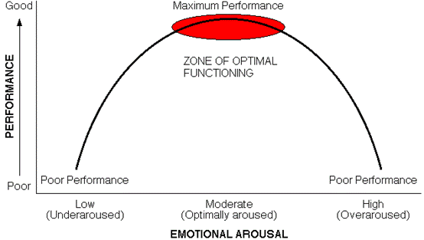

The ‘inverted U hypothesis’ suggests that your performance will steadily increase with arousal, up to a certain point and then will steadily decrease after this point. The zone of optimal arousal varies among people. An elite performers zone of optimal functioning is likely to be higher than my personal zone of optimal functioning, due to less experience and rehearsal of these skills. An autonomous performer is likely to have a higher optimal arousal point than a performer in the cognitive stage. This means that I will have a fairly high optimal arousal however I would still exceed it faster than an elite performer, resulting in a poor throw or inefficient run up.

Performance
Arousal
Cognitive
Associative
Autonomous

At optimal arousal irrelevant information is more easily filtered away without suffering from attentional narrowing. This will allow me to focus fully on my throw and not suffering from distractions from a crowd for example.

An elite performer is more likely to be able to perform better at over arousal. This is because a dominant response occurs at over arousal, as there is often an inability to concentrate and increased tension. This will be different for autonomous, associative and cognitive performers. Zajonc suggested that the dominant response occurs during over arousal. For experienced players this was known as social facilitation and the dominant response is the correct response due to motor programmes having been developed. This will reinforce this response and performance will improve allowing them to reach the elite level they are at. For performers in the associative and cognitive stage then it is known as social inhibition, which is where a less experienced performer will perform is incorrectly as the dominant response is not the correct response due to no motor programmes having been developed. This will result in the incorrect response being reinforced and their performance will deteriorate. However when I am over aroused my dominant response is often incorrectly causing me to perform the skill incorrectly and this response is reinforced. This could lead to a throw that is not reaching my potential at the end of the run up due to technique being poor. This is due to increased tension meaning that I cannot fully extend my legs during the run up, which results in larger amount of energy used during the run up to achieve the same speed. This leaves me at a disadvantage in comparison to my competitors.

The catastrophe theory is a development of the ‘inverted U hypothesis’ and is also relevant to me. This suggests that arousal increases up to an optimal point and then there is a dramatic decline in my performance, both somatically and cognitively. This will result in huge distances being lost due to the sudden collapse in technique.

An elite performer or someone in the autonomous stage is far more likely to experience ‘Peak flow experience’ as they are more likely to use evaluation apprehension to feel their arousal level increase and then take steps themselves to lower their arousal levels to reach their optimal arousal. This will result in huge improvements as they are ‘In the zone’ and performing to the best of their capability. They can ignore other pressures and let their body deliver what it knows best and all that matters is the performance. This varies for me as due to me not being in the autonomous stage in all aspects of the skill I do not have a feel for the perfect technique limiting me the opportunities to experience ‘Peak flow experience’ meaning that I will not see huge improvements until I have improved my technique.

C2 Javelin – Somatic and Cognitive Anxiety Controlling Techniques

I have recently taken part in the State-Trait Anxiety Inventory self-report questionnaire and discovered that I have high anxiety levels in both state and trait anxiety. State anxiety is the emotional reaction to a specific situation that someone may experience as threatening even though it may not be (Stage fright). Trait anxiety is personality trait that means you will generally act in an anxious way in every situation. This means that being able to lower my anxiety levels will be extremely beneficial to me and could improve my run up and throw potentially much further. This will allow me to focus on the run up in the competition to prepare myself perfectly for the throw ahead.

During a javelin throw competition there are constant changes within the environment; these can include officials, the crowd and the distance I am trying to beat (Competitors distance, qualifying distance or just personal best). Zajonc proposed that when the presence of something increases, in this case the audience, then so does arousal. This can result in me becoming very over aroused and unable to compete at a high standard.
To control arousal levels, anxiety and stress I will use ‘Breathing Control’ as this will allow me to lower my arousal levels to reach my zone of optimal functioning. This gives me an advantage over other competitors, as I am able to bring my arousal levels down to my zone of optimal functioning allowing me to perform at, or near my best, whereas my competitors are more likely to be over aroused. Arousal levels can be brought down by several somatic and cognitive techniques.

Benefits of decreasing cognitive arousal to ‘optimal arousal’ include an increased focus and concentration, heightened awareness of cues in environment and narrowing of attention. This will allow me to focus more on technique and the throw allowing me to develop minute skills that could result in a much better throw.

Imagery

The first cognitive technique for controlling anxiety and stress is imagery. Imagery involves manipulating the environment that is causing stress, by taking me away from the stressful stimuli and recreating a situation that is very relaxing, where I feel safe and no anxiety or stress has occurred. I would imagine an area that is often associated with positive emotions and feelings that will allow me to interpret the arousal as a positive thing making me feel ready for the throw (Training track). However this does take practice to think of your ‘happy place’ and to be able to use the technique to it’s full potential. My attention will also narrow to a point where all that matters is the event and I will be able to filter away irrelevant information such as the changing situations (Audience). This would occur before the throw to make sure that optimal arousal is likely to be reached. This technique is used by elite performers to mentally practice (Train) their event when they are unable to train prior to a competition. It is very good for javelin proven by Steve Backley who suffered from a series of injuries running up to the world championships, restricting him from training. Through imagery and mentally practicing, he was able to gain a silver medal. This has helped me due to just overcoming a 6 month long injury I had been unable to train. So the opportunity to maintain a feel for the event through imagery has allowed me to get back to training at a much quicker rate.

Visualisation

Visualisation also involves mental rehearsal but instead you imagine the perfect performance and use this to control the performance. This diverts attention away from the cause of anxiety and blocks out anxious thoughts. I could use this by watching a perfect model of a javelin run up so then I could ‘copy’ the perfect performance as I would have it in my mind from there perspective. This perfect performance would be rehearsed in my head eventually being stored in my long term memory and can be recalled during a competition. This will train my body and mind ready for the actual performance of the run up. Being able to visualise the run up will give me confidence in my performance meaning the anxiety and stress will be minimised.

Having high level of cognitive anxiety can be beneficial if accompanied by a low somatic anxiety as this can result in a successfully performed run up.

Biofeedback

Biofeedback is a somatic technique for controlling anxiety and stress. I would be attached to a monitoring machine for a time, which measures my heart rate, muscles tension, sweat, blood pressure and breathing rate. This data would come up on a monitor. This is predominantly used to decrease heart rate as this has been increased by anxiety. I would watch the monitor and attempt to slow down my heart rate by calming my body down. If I repeat this over and over, I will be able to sub consciously lower my heart rate during a javelin competition, decreasing anxiety.

Breathing Control

Breathing control is using breathing as a way to control my arousal levels. It involves focusing on breathing to distract you from the anxiety inducing situation or stimulus.
It is performed in several steps:
The first step would involve me learning how to perform ‘Deep breathing’
This would include making sure air comes through my nose and that my lower belly will rise. Although this may seem unnatural when first practiced, it will help to reduce anxiety levels. Breathing through my nose will encourage full exchange of oxygen meaning that there will be a beneficial trade of incoming oxygen for outgoing carbon dioxide within my body, which will result in slowing heart rate and stabalising blood pressure.
The actual process once practice goes through 5 stages:
1) I should sit or lie down (To allow me to be comfortable and relaxed)
2) I would breathe in slowly through my nose
3) Making sure that my chest and lower belly rise during inhale
4) I should let my abdomen expand
5) Breathing out slowly through my nose (Possibly mouth if it feels more natural)

These techniques all create a state of mind in which I am not over aroused and anxious. They allow me to be relaxed and aroused meaning that I will have the ability to concentrate on my run up, perfecting it to increase the potential throw after the final steps.

C1 Javelin – Motivation

A major issue within my performance is that I often become unmotivated during competitions and training leading to me hitting plateaus and not training properly leading to a decline in performance, further demotivating me. This is more training specific as if I become unmotivated during training then I will not compete at a high standard anyway. However becoming demotivated is also due to me getting no throws and failing to win competitions.

When it comes to motivation there are two types of achievement motivation which are ‘Need to achieve’, defined as, ‘The motivation to succeed or attain particular goals; people with need to achieve type personalities show approach behavior. ‘Need to avoid failure’ is defined as ‘the motivation to avoid failure; people with Need to avoid failure (Naf) personalities show avoidance behavior’. Somebody with a ‘Need to achieve’ (Nach) motivation is likely to seek out challenges and enjoys being evaluated. They do not fear failure, attributes their performance to internal factors and also values feedback from others. Somebody with a ‘Need to avoid failure’ avoids challenge and instead prefers very easy or very hard tasks. They do not like being evaluated and in turn perform worse and are often preoccupied with failure so avoid situations where success is unknown and could be evaluated.

I am in the ‘Need to avoid failure’ category when it comes to motivation meaning that whenever I don’t do well in training or in a competition I can become demotivated and this also causes me to become pre occupied with failure for the next competitions and in training, leading me to struggling to achieve peak arousal levels to perform at a high standard. Me having a ‘Need to avoid failure’ type personality means that I am going to shy away from challenge while throwing javelin meaning that I will never push myself to beat my personal best as well as being unlikely to perform in any high level competitions in the fear of being beaten. I also attribute my poor performances to external factors meaning that I am unlikely to force myself to improve; as I always believe other factors have caused me to throw poorly.

When I interpret success I am ego orientated meaning I only deem myself to be successful if I have beaten someone else, so often shy away from competition to avoid failure even though I will become more motivated if I win. This also means that I am unlikely to compete in any high level competitions and if I do I am unlikely to perform well as I will anticipate that I will have poor throws. I also will lack task persistence meaning that if I have a bad competition or throw then I am unlikely to ‘bounce back’ and will continue to throw poorly.

A lot of this is due to me being extrinsically motivated meaning that if anything goes wrong then I will blame other factors such as the weather or the crowd. This also means that I am not motivated by personal achievement (Task orientated) so I have to have extrinsic motivation to encourage me which relies upon me having good support from family and coaches. It also means then I rely upon the praise, applause and medals to motivate me but it does mean that it works to my disadvantage as when I have a poor day then I can become demotivated and it makes me scared to compete.

It is important that if I want to improve then I will have to become intrinsically motivated and change my personality to ‘Need to achieve’, allowing myself to challenge myself. This also means I can become more task orientated resulting in me being able to challenge myself and motivate myself through beating personal bests and improving technique. This could be achieved through many techniques such as goal setting and role models.

C2 – Motivation
Motivation is thought to be a combination of the drive within us to achieve our aims and the outside factors that affect it. To improve my motivation all of the time I need to change my type of personality from ‘Need to avoid failure’ to ‘Need to achieve’ so that I can challenge myself and have the ‘drive’ within me to improve. This also requires me to change my motivation type to intrinsic motivation from extrinsic motivation so that I no longer require outside input to feel like I have succeeded. This is achieved through goals and general knowledge of performance. This also will result in me changing the way I interpret success from ‘ego orientated’ to ‘task orientated’ meaning that I wouldn’t mind losing as long as I have done my best as it is due to my own effort and abilities, causing me to become demotivated less.

A coach is an important person that could be required to help this transaction to a more intrinsically motivated person. They can help by using extrinsic motivation to increase intrinsic motivation such as scholarships. The benefits of this include a better task-relevant focus meaning an increase in performance due to more focus on the javelin throw. Fewer changes in motivation meaning I would be happy to train more often and would become disheartened if I throw poorly in a competition. Less distraction meaning that I could reach optimal arousal more often resulting in a higher probability of a good throw. Less stress when mistakes are made means that I could become motivated for the following throw during a competition as well as having an increased confidence and self-efficacy. This means that I do not limit myself to a certain distance as much, although it is good to make goals. It will also lead to an all round greater satisfaction in performance, which could lead to improvements.

This could be achieved through goal setting. Goal setting is when a performer sets goals (Usually by coach) to improve performance by giving the performer an aim or a challenge (Linked with task orientated people by challenging themselves). These can be achieved in many different ways such as long term goals (Outcome goals) that can be worked towards using a series of process goals, for example my outcome goal could be to compete internationally for javelin and this would be achieved through a series of process goals which could include reaching county standard, regional standard and then national standard to keep me motivated for the period of time it take to reach international standard. These shouldn’t just be concerned with results as main improvements come from the performance itself, as this is more valuable. This is also linked to task orientated people as in athletics there is only 1 winner so those who aren’t just ego orientated and are strongly task orientated are more likely to reach that international standard.

Smarter goal setting is an effective way of achieving intrinsic motivation as it gives the performer a sense of ownership. Smarter goals contain 7 aspects, which are all important in order for it to work and each begin with a letter to spell out ‘Smarter’.
Specific – Making the goals less general (Throw further) make an aim such as 5 metres further than my personal best.
Measured – Measure each distance I throw to show the progress more clearly
Agreed – Making sure it’s agreed between my coach and I instead of my coach just telling me what to do
Realistic – Making sure my targets are challenging but also achievable, preventing loss of motivation
Time-scaled – Limiting the time I have to achieve saves me from feeling like I have a large amount of time to reach the goal as well as setting a clear different between my long term and short-term goals
Exciting – My coach should make sure that I am engaged and motivated
Recorded – This makes sure progress can be evaluated

There are many other ways to maintain and improve my motivation such as varying training to prevent boredom and adjusting the training environment meaning that I would compete against people of a similar ability. My coach could also use role models of people that I could possibly be as good as making it achievable. Reward specific behaviour could be used, which puts an emphasis on a better performance being a direct result of improvement. All these methods will help me to become more intrinsically motivated to prevent me becoming demotivated as much and to consistently compete at a high standard.

C1 Javelin – Progression to Elite

In order to reach a high standard then I have to progress through the sports development continuum and in order to reach the elite few in the excellence stage in the sports development continuum then I require necessary financial, technical and psychological support. The four stage of this continuum are foundation, participation, performance and excellence. Foundation stage involves early development of physical competence and recreational play of which I have already passed. The participation stage involves commitment of time to an activity and my event being done primarily as a recreational activity. Performance stage (My current level) is where there is a significant move towards organized sport, club or county level, regular training and coaching as well as me having a desire to win. The excellence stage is the elite standard at national or international levels.

When progression to a higher level begins there are many financial issue as without financial support while developing through the first 2 stages, then I would not have been able to get to the standard I am currently achieving. I also need more financial support now to create proper training schedules to enhance the potential as well as a high level coach to maintain motivation levels as well as high standard training. Due to javelin being an expensive sporting event due to equipment and athletics track costs, I am required to afford this as well as being in close proximity to a track and if not I must have affordable and reliable transport to get to each training session (Without training I am unlikely to see improvements).
In order to progress further then it is likely that I will require more training than I have been participating in up to this point. Lack of leisure time is the main cause of my limited training along with lack of available time on the athletics track and which I have access to a javelin throwing area. This may require me having to give up other activities in order to create more leisure time for training. This is more difficult as many of my companions do not take part in sport so me choosing to train over other social events of which my companions are participating could lead to me becoming isolated leading to possible depression and demotivation, which could also limit my progression hugely.

Racial discrimination could also limit my progression as javelin is a powerful event so is more likely to be aimed towards people of a Caribbean and African origin. Due to stereotyping it could be perceived that they will be better at the event or have a better potential due to there being a need for speed and strength which require fast twitch muscle fibres and a higher muscle ratio, more associated with these races. This could cause my coach to think I do not have the potential to achieve international standard and attempt to change the event of which I compete in. This could also pressurise me into believing I cannot compete at the same standard as I do not have a ‘natural’ advantage, causing me to no longer improve.

Due to me attending a state school there is less opportunity in comparison to if I attended a private school. This is due to lack of proper facilities within the school as we only have a temporary grass athletics track limiting when I could train as well as the level I could train at. There are also limited amounts of athletics competition as athletics is not a main focus with the curriculum or the school in comparison to the sports mainly focused on, including football and rugby. There are no specialist athletics coaches either meaning that I could not receive ‘proper’ training sessions or develop my technique beyond a basic level.

In order to progress I will need a development structure which enables me to move through the stages. This requires me to be able to have higher level opportunities in the form of structured layers of competitions such as athletics leagues or competitions allowing me to compete against elite performers. I also need to be recognised at higher standards such as at a regional level allowing me to get more structured competitions and training. As I have not gone through a talent identification programme I have no chance to train with elite performers limiting my ability to achieve my potential.

This is all-important to improve so it must be addressed otherwise my improvement will be halted and potential wasted.

C2 Javelin – Allowing Progression

In order to improve my javelin throw I will be in need of further training and increased dedication to the event. Otherwise it could result in my performance plateauing and I could become unmotivated, so dedication and training could prevent this. However this may require me to give up other leisure activities in order to allow greater training time, which could include any other activities such as swimming or a night out with your friends. This relates to the ‘Long Term Athlete Development Model’ that suggests that many different sports become more specialised at different stage of a life. For example gymnastics is becomes specialised at a very young age meaning that it is the only sport you would participate in and a lot more time goes into perfecting it. Athletics is a late specialisation so to reach the elite there is more time required to progress further through the 6 stages of the late specialisation model (FUNdamentals stage, learning to train, training to train, training to compete, training to win and retirement/Retainment).

I could plan my training programme with a coach in the form of periodisation. It is a way of setting goals. They are broken down into 3 stages, which are microcycles, mesocycles and macrocycles. A microcycle usually lasts between 3 to 7 days and is usually a plan of training sessions such as weight training on Mondays, power training on Tuesday, arms on Wednesday and technique on Thursdays and so on throughout the week. This will allow me to improve by focusing on certain aspects of each skill instead of developing everything all at once, which is near impossible (No way you can build muscle mass and cardiovascular fitness all at once). A mesocycle usually lasts between 4 and 12 weeks, and is a block of training with a certain goal such as improving my plant foot, which could include the technique of the plant, the position of the plant, increasing muscle mass of the leg to make the transfer of speed into power much more efficient as well as visualisation of the event. A macrocycle is an aim over a longer period of time (Usually 10 to 12 months) and it’s made of several mesocycles. This could be an aim to reach a national standard or a certain distance such as 60 metres. There is further macrocycles which could be made of several smaller macrocycles such as reaching an international standard could be made of reaching regional standard and national standards before.

My coach could use role models to motivate me into performing. These role models shouldn’t be out of my ability and should be achievable to avoid me becoming demotivated. Lack of facilities is a large disadvantage of mine living in a rural area with very few facilities and coaches limiting my performance. Achieving high academically could assist me within my javelin career as being given the opportunity to go further in education have allowed me to go to a large city with much better facilities and training, allowing me to progress further. This will allow me both training and training programmes to excel my ability beyond what I have currently achieved and help to achieve my overall potential. Having a more experienced coach could also act as a role model motivating me to achieve to reach the standards they have and to experience the things they have done within their life.

To prevent racial discrimination it is important that I believe in my own ability so I can express this. This could be achieved through self-talk. While performing self-talk it is vital that it remains positive and focuses on self-motivational content. Positive self-talk will make me more aware of my thoughts during training and competition. This over time will condition my brain to notice more positive things to do with my technique and throw and will also become a habit increasing my self-esteem and belief in my performance.

To achieve a greater standard within athletics I need to achieve certain standards in order to compete in higher leveled competitions. This starts with reaching a level to compete at a county standard and then following this, regional standard. This filters out the poorer standard athletes allowing the more successful to continue. This also will increase my opportunity to gain a coach or increased experience to allow me to develop further. The next stage up is to be able to compete nationally, meaning that I could compete at the top level within England before having to achieve a certain standard to compete at international competitions. If I compete at an international standard then I am likely to develop contacts and coaches of which will develop training programmes developed to improve my performance and tailored to my specific needs, allowing me to progress further and probably quicker.

