**B2 High Jump Run Up**

**Elite/model performance.**

Stefan Holm pictured on the left was the best high jumper in the world for a period of years between 2004 and 2008. He won gold in the Athens Olympics in 2004. He also won 4 gold’s in the world indoor championships in 2001, 2003, 2004 and 2008 as well as 2 gold’s in the European indoor champions in 2005 and 2007. He also respectively gained silver in the world championships, as well as silver and a bronze in separate European championships.

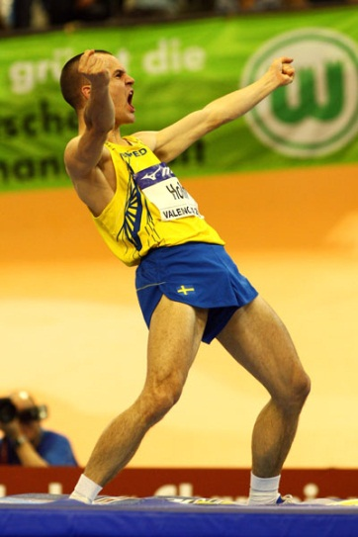

**Run up**

The run up or preparation phase is just as important as the high jump itself. The run up allows Stefan to build up velocity and body momentum to be converted upwards. Stefan has a fast preparation phase as he has leg power and a good conversion technique to be able to use the technique effectively and efficiently. Stefan also has a long run up which gives time for a gradual and smooth acceleration to reach his desired speed for the take-off. He will make sure he can convert the speed into height by using a natural fast rhythm that gives him control over his jump allowing him to reach his maximal potential jump. Also power training the related muscles as well as a good technique will mean Stefan will be able to jump close to his real potential.

**The Drive Phase**

The objective of the drive phase is to accelerate up to a speed, which means Stefan can accelerate to a higher speed later in the run up. This also gives him a controlled speed to exploit during the attack phase of the run up. Stefan leans into several quick short steps to gather momentum quickly and smoothly due to more contact with the ground increasing the opportunity to increase power that sets him up for a controlled run up. Stefan tends to not over work his arms during this phase to maintain his centre of gravity improving his balance. This is a highly effective way of building up a controlled speed in a short period of time. Stefan runs from the right side and takes off of his left foot as this is his more natural take off foot. Due to this being his more natural take off foot, it is naturally the more powerful leg.

**The Transition Phase**

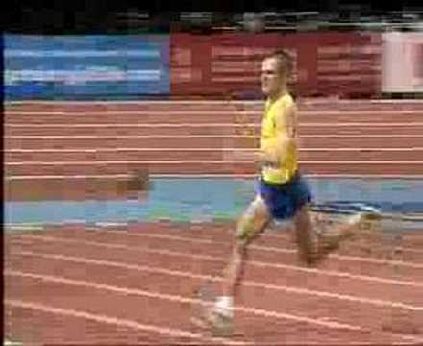 He then follows this by using, what is called a ‘bounding’ step. He drives his knee forwards and high creating a long, looping, ‘bounding’ stride, which is used to gather speed, open his stride and to lower his centre of gravity to maximise his optimal jumping position. He usually uses ‘bounding’ steps for approximately between 1 third to 1 half of his run up. Stefan runs upright without leaning forwards or backward as if he leans forwards too much he will not gain as much height and end up jumping into the bar and if he leans backward he would lose momentum and tend to not accelerate throughout the curved section of the run.

**The Attack Phase**

Every run up has a “J” shape where he uses the long, ‘bounding’ strides during the straight part of the “J” followed by much quicker, “snappier” steps which have increased ground contact and less flight time, accelerating to the optimal jumping conditions. Stefan uses 4 smaller strides to get to the high jump mat after the long ‘bounding to gather momentum and speed for the optimal take-off conditions. Each step prior to take off will get shorter during these 4 steps, the last step being the smallest to allowing him to sink into the last stride, gaining height by using the muscles in his upper leg. Stefan always starts his curve prior to take off on the outside foot, which in his case is his right foot and then he can maintain his rhythm therefore maintaining momentum that prepares him well for take-off. During this period of the run he still maintains his upright position and leans away from the bar by dipping his left shoulder lower than his right one. This stops him from jumping into the bar and instead causes him to jump upwards reaching his potential height. It also lowers his chances of knocking the bar off with his right shoulder. On the last stride his toe always points toward the far backside of the high jump mat which creates an angle that is optimal for his body to naturally in the air during flight.

**B1 High Jump Run Up**

My run up also builds up velocity and body momentum to be converted upward, however I have less power in my legs due to less developed muscles therefore my potential height is much lower than that of Stefan’s. My technique is much weaker than Stefan’s so that will also decrease the height I could achieve. My run up is shorter than Stefan’s due to not needing as much momentum, as I am not physically able to convert it into height, therefore I do not need as much speed as Stefan. My run up is also not as smooth as I have had less time to perfect it, as I am less experienced. I will have a less controlled technique compared to Stefan due to many different factors such as having less developed muscles, which are key to controlling every single movement. I also have less time to develop my technique further due to limited training time and coaches that may not have picked up my weaknesses compared to a professional coach.

**The Drive Phase**

I also use the same drive phase but tend to over accelerate resulting in not being able to control my plant effectively at the end of the run. I also lean into several short strides possibly too much as too much speed is generated from the steps. Stefan does this better than me, as he creates the correct amount of speed to match his ability meaning optimal heights are achieved. I could counter my over lean by not driving my arms as much. This causes my legs to move slower, making my body have to regain a more upright position otherwise I will be unbalanced and I will end up doing an uncontrolled jump, taking off possibly in the wrong position. I also create a fast speed highly effectively however; it is not controlled as I do not have enough ability or power in my legs to maintain a successful jump and technique.

**The Transition Phase**

I also follow the drive phase with ‘Bounding’ steps. My knee is driven high and does create a long ‘bounding’ stride but I tend to not gather much, if any speed during this period of the “J” run up. This also lowers my centre of gravity but not as much as Stefan so I am not in as good a take-off position as Stefan is at his take-off point. My ‘bounding’ strides take around half of my run up meaning that my curve is not controlled because of the fast nature of my run up. I tend to lean further forward than Stefan resulting in me jumping into the bar and often knocking it off with my left shoulder on the way up. This is also due to not being strong enough to transfer the speed to height.

**The Attack Phase**

I also use 4 fast, ‘snappier’ steps prior to take off. My steps would not be as quick as his meaning I have more flight time and less contact with the ground. This is due to less momentum built up from the run up and faults within my technique which wouldn’t prepare me for take-off to the same extent that Stefan would be ready for take-off. During my last step I often find myself stretching instead of shortening meaning I cannot produce as much power as it’s much harder to sink into the last step. I turn off my outside foot, which in my case is my left foot, but often at too great an angle meaning I will lose momentum and lose my ‘natural’ rhythm resulting in large amounts of height lost. During the actual curve I dip my right shoulder as I come from the opposite side to Stefan. I do not dip this shoulder as well as Stefan and this is why I will regularly knock the bar off on the way up. My toe does not point far enough to the back corner of the mat and is usually too parallel to the mat resulting in over rotation during the jump.

**B2 High Jump Take off and flight**

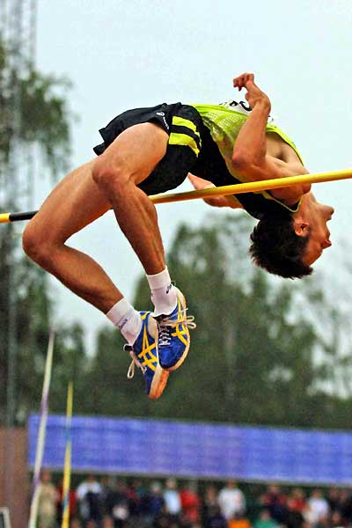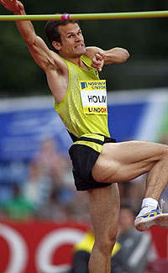The take-off starts from the beginning of the run up, as it sets him up for optimal conditions at take-off. Stefan has built a great deal of speed up by the curve of the run, which sets him up well for take-off. On the penultimate step he starts to sink his hips towards the ground to prepare him for a powerful take off. Stefan does this naturally and smoothly to allow his final step to attack the ground with vigour and aggression. He does this with the middle of his foot rolling off the ball to create the most natural and powerful plant. He also leans away from the bar on the way up to prevent him from knocking the bar off with his right shoulder and jumping into the bar.

After the plant Stefan has a very strong knee drive. This helps him to gain maximum height. He does this by driving his right knee (trailing knee) powerfully upwards to just above 90 degrees to stop his knee from falling further into the jump. His arms accompany his knee as they are thrown upwards to accelerate his ascension.

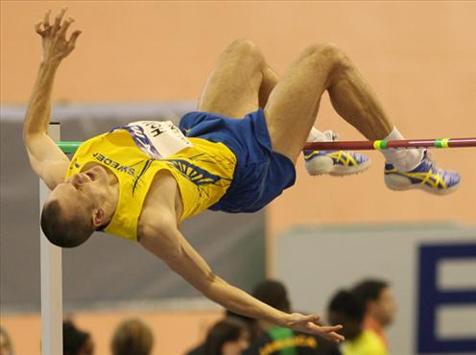

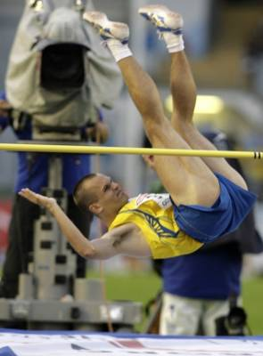Due to Stefan’s take-off foot being positioned at the correct angle his body will naturally twist away from the bar and when assisted with a knee drive it is a lot more prominent. His knee drive is held until he is at his peak height as if he performs the next movement too early he will knock off the bar on the way up. If he performs the movement too late then he will knock the bar off on the way down. Therefore timing is essential and through experience Stefan knows when his peak height is to start the next movement. At the peak of his jump his back is facing the bar and he pushes his lower back upwards while tensing his gluteal muscles and throwing his head back to create an ‘arch’. This allows most of his body to go over the bar, however if no further movement was done then his legs would knock off the bar due to them still dangling lower than his hips. So to stop this from happening he places his chin on his chest and contracts his abdominal muscles to bring himself out of the ‘arch’ and create a “V” shape in the air instead in which his legs are lifted above his hips to prevent the bar from being knocked off with either his legs or feet. His buttocks are also dropped hugely causing him to land on the mat with his upper back and shoulders.

**B1 Take off and Flight**

By the time I reach the curve I have gathered momentum which also sets me up well for take-off. However on the penultimate step I do not sink my hips as effectively as Stefan and this does not prepare me for a good take-off as I cannot use all of my leg muscles effectively and I will be unable to produce the same kind of power I could potentially achieve. This also means I cannot attack the ground with the same vigour and aggression that Stefan does and also reduces the height I could achieve. Due to a poor penultimate step, I struggle to plant with the middle of the foot and roll off the ball making it less natural and less powerful than Stefan is able to.

My knee drive is not as powerful as Stefan’s or as effective. This is due to me not being as muscularly developed as him and therefore meaning I can’t reach the same kind of standard as him. However, I do drive my knee up as powerfully as I can but usually only to 90 degrees which often results in my knee falling slightly higher in the jump causing my body to not travel as far upwards and making it more difficult to produce a good arch. I do not use my arms effectively and it is a real weakness of my technique. They do not aid me in achieving higher heights as I only drive them up till my arm is at a 100-degree angle not giving me the drive I am capable of reaching.

My body also naturally twists away from the bar and sometimes I over rotate in the air resulting in the bar being knocked off on the way up, with my shoulder. This occurs on many occasions and when accompanied by a poor knee drive it often is uncontrolled. My knee is also held until peak height but as I don’t lean away from the bar during the curve as well as Stefan I still sometimes knock the bar off on the way up. I very rarely knock the bar off on the way down as I have reasonable timing. Near the peak of my jump I will create an ‘arch’ also by pushing my lower back upwards and tensing my gluteals but due to much poorer flexibility I do not manage to produce the same kind of arch as Stefan does. This causes my upper body to travel over the bar and due to okay timing I generally place my chin on my chest by contracting my abdominals and creating a “V” shape in the air. This is less effective than Stefan as he will always get his timing precise allowing him to reach constant height whereas my okay timing can result in the bar being knocked off by my legs and feet on many more occasions. If I do create a “V” shape too early then my gluteals will knock off the bar, as I would not have fully made it over the bar. If I go into the “V” shape too late then my legs and feet are left hanging lower than the rest of my body therefore not clearing the height of the bar resulting in it being knocked off. Sometimes I do not contract my abdominals enough and knock the bar off with the back of my feet. This very rarely occurs with Stefan due to stronger abdominals making is much easier to contract it to raise his feet, avoiding the bar.

**B2 High Jump – Recovering from an Injury**

Stephan will spend a lot of his training time to allow himself to compete at elite levels. In order for him to reach these levels he has had to prevent himself from suffering from injury. If he is injured then he may suffer from becoming unmotivated and frustrated as well as the possibility of suffering an injury of which you cannot recover from. There are steps he has taken to help prevent him from suffering from an injury but some injuries are unavoidable and it’s important that if he suffers from an injury he can ‘bounce’ back and get back to training as soon as possible to prevent decline in performance. This also will give him advantages over his opponents if they become injured due to his quick recovery time in comparison.

In order to prevent injury Stephan can reduce the probability of injuries in many ways. These can include using the correct equipment during training. For example high jump spikes should be worn while performing or training as they support your foot and ankle as well as adding grip to prevent slipping which could result in serious injury. If he has just recovered from an injury he could use taping or bracing to support the joint or ligament, reducing the chance of re-injuring himself. This could also help prevent injury in the first place due to the extra stability to the joint.

Another way of preventing himself from getting injured is through strength training and conditioning or the muscles and joints that are under the most strain from the strenuous training sessions and constant pressure they are under. This will also help to improve performance (due to increased muscle mass) as well as reducing the chance of injury. Strength training generally consists of resistance work and can involve body-weight exercises although sometimes the use of weights and resistance devices (rubber bands) can be used. Stefan will benefit from training and conditioning of his gastrocnemius, hamstring, hip flexors, gluteals and quadriceps. This will help to support the ankle, knee and hip joints allowing him to train more often and at higher vigour without suffering from injury. This also helps to stabilise the body helping to increase balance which is important for Stefan’s jump and technique.

Stefan also makes sure that he does not over train as overtraining is the cause of most injuries within elite performers. The causes can be due to putting too much strain on the body during training sessions or by training too often which doesn’t allow enough time for recovery, especially after intense training such as a plyometric session. This results in long-lasting fatigue, worsening of performance under competitive scenarios and chronic fatigue. The fatiguing of the muscles means that they are unable to support tendons, ligaments and bones meaning that there’s an increase in strains, sprains and stress fractures, all of which would lead to Stefan being unable to perform. This makes it important that Stefan should try and avoid injury by allowing a sufficient time for the body to recover and to make sure he never trains while ill (Results in weakening of immune system (Immuno-suppression) making him unable to recover from the illness, preventing him from training properly). He should therefore steadily build up training after an illness to make sure he doesn’t become ill once again.

As Stefan has performed at the elite level he has had access to many things that would speed up recovery from an injury in comparison to someone who is only performing at an amateur level, such as myself. These could include sports massages of therapeutic massage for muscle pains and joints as well, working my increasing range of movement and flexibility of joints and muscles as well as removing muscle soreness. Access to private sports specialist to develop recovery programs especially for him will also allow his body to recover much quicker with specialist stretching and training including water-based training (To avoid so much pressure on the injury parts of the body) and proprioceptive retraining to increase coordination of balance creating smoother coordinated movements to be performed decreasing the probability of injury again.

**B1 High Jump – Recovering and Preventing Injury**

In comparison to Stefan I have just recovered from a series of injuries and have only just returned to training. This was probably due to overtraining running up to a national competition. Overtraining in my case was not allowing my body to recover after intense training sessions. This resulted in a strained hamstring as well as a sprained ankle. Due to over training my body, my ankle joint was unable to support my body due to fatigued muscles and weakened joints.

When I return to training it will take much longer than it would for Stefan to recover due to lack of sports specialists but it is important that I follow certain steps to allow myself to recover fully. I should build up training slowly to allow my ‘weakened’ muscles to recover as well as to prevent them from becoming reinjured. Like Stefan I should ensure that my muscles and joints become conditioned once again my using strength training for my leg muscles (especially hamstring) and joints to allow my body to cope with the demands of my training. This would involve body-weight exercises (squats) and isometric work (lunges), weights and resistance could be added once I develop strength. This will allow me to not only become stronger but like Stefan, to develop balance and stability which will help me to control movements and transfer energy during take-off.

When it comes to preparation for my event there is a possibility that I could use taping and bracing to support my ankle joint (that will be weaker) during training and competition. Like Stefan this will allow me to train at a higher intensity than I would without as it provides extra stability on the joint and can prevent ligament injuries from occurring in my weakened ankle. This will reduce the chance of it not being able to support my body during take-off, decreasing the chance of injury.

It would be hard for me to recover at the same rate as Stefan as I do not have the same experience or technology to assist me in improving. Although a proper recovery after injury is still vital for me as it is for Stefan as due to the joint imbalances or poor biomechanical ‘form’ then it will almost always return if not dealt with sufficiently. This will mean that I will require sufficient things to allow my recovery to be quick and effective. This could include taking ice baths to speed up recovery as well as stretching. Stretching is important for me as it is for Stefan as it will increase flexibility and allow more movement around a joint meaning there is a decreased range or movement, which could cause injury. It also increases ‘elasticity’ or the muscle reducing the chances of damaging the muscles (overstretch or strain). However unlike Stefan I do not have access to therapeutic massage without paying large amounts of money, and as this is a main part to Stefan’s recovery, it will slow mine significantly. Light aerobic exercise will speed up recovery, as it will develop proprioceptors as well as putting gentle and continuous movement on the joint and muscles, strengthening it.

Like Stefan I also will train and perform in high jump spikes as they support my foot and well as supplying extra grip (preventing me from slipping or from my ankle ‘collapsing’ on me) obviously being a benefit of specialist equipment. However I do not have access to specialists and specialist equipment like Stefan, limiting how far I can progress.

I would naturally recover slower than Stefan as I do not have access to the same facilities as him and do not have much experience with recovering from injury. However I am still able to recover but I may find that when I return to training and competitions I cannot perform at the same standard as I did before my injury.