# Ride 1 – without jumping

The elite performer that I have chosen to analyse for ride 1 – without jumping, in both B2’s is Carl Hester, an international dressage rider. He has won 51 British Championships which include 6 National titles and has ridden for Great Britain at most major championships. He was picked to represent Great Britain in the 2012 London Olympics, where he won a team gold in dressage. As of August 2012 the [Federation Equestrian International](http://en.wikipedia.org/wiki/F%C3%A9d%C3%A9ration_Equestre_Internationale) (FEI) ranked him 12th in the world riding [Uthopia](http://en.wikipedia.org/wiki/Uthopia).

## B2: Extended Trot

Extended trot is the outcome of added impulsion in the collection of working trot. The horse sends its front legs forward, the extension starting at the shoulder and finishing at the tip of the horses hoof whilst the back is staying flexible. The hind legs are engaged powerfully under the weight of the horse and leave the ground very clearly. The size of the strides, the agility, the balance and the rhythm express an extension in the working trot.

### Preparation:

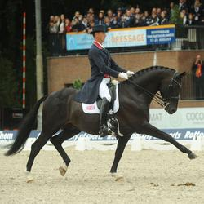**In preparation for extended trot Carl begins with a normal working trot to get a regular rhythm and balance. He fixes his hands in order to keep his horse working on the bit and riding into the bridle, so that his horse is engaging behind and remaining free and light on its forehand. He starts to ask for more collection and a more vibrant trot to get extra impulsion without increasing the speed. He does this by using his legs to ask his horse for an increase in power, whilst he uses half halts to keep the impulsion which creates more energy rather than just increasing his horses speed. He looks up and ahead so that he can see his markers and so he can ride a straight line from one marker to another. The extended trot normally happens along a diagonal. He only asks for the extended trot when he is riding straight, so that he doesn’t confuse his horse or cause his horse to become unbalanced. He carries the contact with the horse’s mouth forward and down in order to let the horse extend. He pushes with his belt, buttocks and his back, whilst keeping his legs soft on the girth line.**

### Execution:

**When on the correct marker for the extended trot movement and straight on the diagonal, Carl asks for the extended trot by going into sitting trot and collecting up his horse. This engages his horses hind legs well underneath its body which generates the forward energy needed to extend its legs to the fullest. Carl sits softly in the saddle with his two seat bones staying in contact with the saddle, without moving, to stay in balance with his horse. His seat goes with his horse’s motion, and he does not try to push his horse with pelvic movements. This means he remains still in the saddle which stops him interfering with his horse’s movement. His belly button is pushed forwards and his lower back stays a little arched, keeping his body supple and loose, preventing his body from stiffening up. This is to keep the movement flowing and to keep it smooth, it also means that he is sat correctly in the saddle with the right position. The right position allows Carl to carry out the extended trot correctly and to the best that he can. He lets his legs fall naturally underneath him, the angle of his thigh and upper body stays very open. He keeps his legs loose. By him keeping his legs down and underneath he is able to push his weight down into his heals so that he can maintain balance in the saddle. Carl’s chest stays close to the vertical position and relaxed with no stiffness in his lower back and with his shoulders low. He will get more marks for his position if he stays supple and this means that he will not be being harsh with his hands on his horse’s mouth. It also keeps his horse relaxed. He adds pressure with both of his lower legs on the girth to encourage his horse to extend its strides. He does not grip with his knees and maintains a straight line from head to hip to ankle. This allows his legs to hang free and means he can use his weight to sit deeply into the saddle. He sits deep into the saddle pushing his weight down and through into his heals to maintain balance. He keeps his heels down, toes in and legs long and down underneath him, as he will get marked on his position in the dressage test. Carl’s hands move slightly forwards so that he can ask his horse to start to open its frame and stretch through its back, which encourages the forward and lengthening motion. He keeps a contact with his horse’s mouth so that he can keep balance and rhythm with his horse and because he is trying to create extension with his horse’s legs and not to speed up the trot, if his horse speeds up he will half halt in order to slow the trot back down. He keeps his hands up and off of his horses shoulder and has a 90 degree angle at his elbow to give him maximum control, leverage and steering. When Carl moves his hands the movement is motionless, moving them the least amount as possible in the space between the withers of his horse and Carl’s belly button so that he is not over giving with his hands. His posture styles his balance, the size of the strides, the rhythm and the relaxation of his horse’s trot. With each stride Carl sits deep into the saddle and pushes each stride out, he sits up straight whilst remaining relaxed in his back and shoulders. He pushes each stride out to allow his horse to give maximum extension with its legs. He looks ahead and forward into the direction that he wants the extended trot to go. This allows him to look where he’s going and to keep the line that he is riding completely straight which will give him maximum marks. Carl maintains a smooth rhythm throughout the whole movement, making the extended trot look effortless, to give him maximum marks.**

### http://www.eurodressage.com/equestrian/sites/default/files/data/images/11_edc_hester_uthopia_7483.jpgRecovery:

**Once at the correct marker to come back into a normal working trot, Carl brings his horse back by sitting up and deep into the saddle whilst half halting. He continues to keep his legs on and around his horse in order to maintain a forward trot and not to slow the trot completely down. He allows his arms to follow the movement of his horse’s head and neck. This tiny block of the forward movement is what shortens his horse’s extension in front and what brings the horse back into a collected working trot. As soon as Carl’s horse returns back to the collected gait he softens his hands as much as his horse will allow so that his horse is able to move forwards in the new gait. He maintains a smooth rhythm and continues to look up and ahead for the next marker.**

## B1: Extended Trot

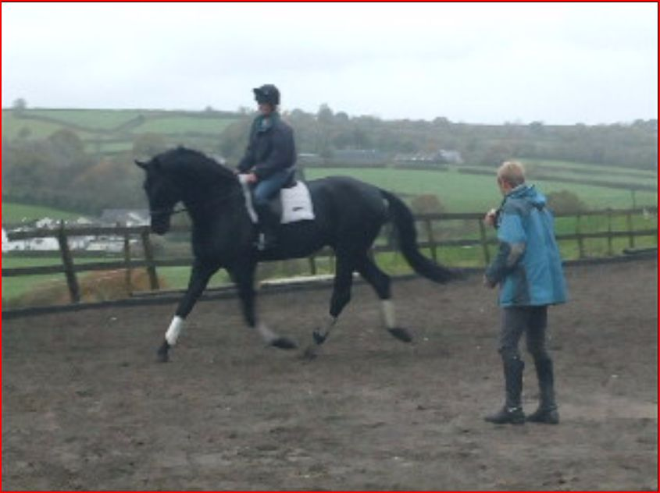**Preparation:**

*When I prepare for extended trot, I start with a normal working trot. This allows me to get a regular rhythm and balance. I try to get my horse working on the bit so that my horse is engaging behind and remaining free and light on its forehand. I keep my horse on the bit and riding into the bridle as I look for the turn onto the diagonal, as this gives me a better chance of keeping my horse straight across the line that I have chosen to ride. Carl’s horse stays on the bit throughout the whole test however I find that towards the end of the movement my horse starts to lift its head. This is because Carl is a much more experienced and able rider and his horse has constant training and schooling unlike my horse which means my horse does not have the same amount of built up muscle as Carl’s does. I push my horse forwards with my legs, however I do not always use light and quiet aids and so it can cause my horse to start rushing. Therefore I use half halts to try and contain the speed of the gait so that the effect of me using my legs is creating impulsion and not just an increase in speed. I try to keep my contact light like Carl however I find it difficult too as my horse has a tendency to pull down on me and lower its outline. This can also lead to my horse not trotting forwards enough for the transition to extended trot to happen as soon as I ask. I look up and straight ahead towards the marker so that I can ride a straight line from one marker to another. I push with my seat to encourage my horse to move forwards and try to keep my legs as quiet as possible. Again, this can be hard if I am trying to pick my horse up off of the forehand, as this leads to me using my legs more actively, which encourages my horse to speed up in the trot instead of lengthening its strides. This also causes my horse to rush as it tenses up and hurries. Unlike Carl who keeps his horse engaged behind so that more length of stride and frame can be achieved. This is because Carl rides his horse from his leg into a light hand contact whereas I just ride with my leg so therefore when I ask my horse to open its frame I drop the contact and the connection with my horse’s hind quarters.*

**Execution:**

*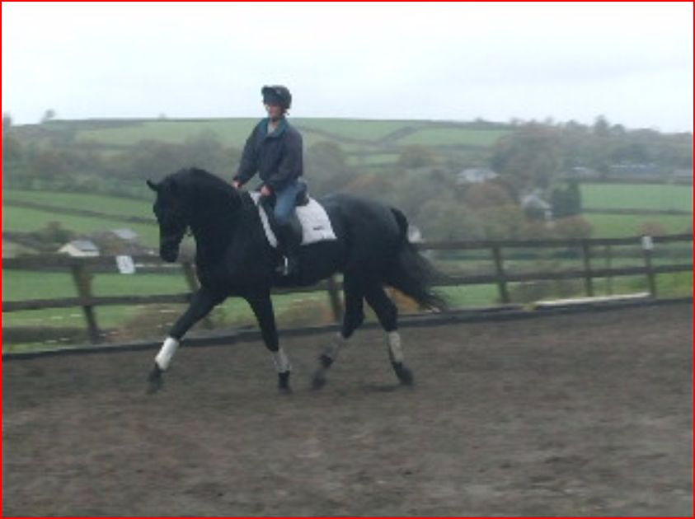When I am on the correct marker for the extended trot movement and straight on the diagonal, I will ask for the extended trot by going into sitting trot which helps me to maintain balance and push my horse forward with my seat. However, unlike Carl, I struggle to maintain an upright balanced position which also affects my lower leg position, as I unable to maintain the contraction in my gastrocnemius due to muscular fatigue. I also ask for extended trot by collecting up my horse, which engages my horse’s hind legs well underneath its body which generates the forward energy needed to extend its legs to the fullest. However, unlike Carl, I find that I can sometimes put my leg on too much which causes my horse to rush and just speed up in the trot. This means that my horse tenses up and hurries and tries to avoid doing the steps altogether. I find that my horse needs to stay more engaged behind so that more length of stride and frame can be achieved like Carl’s. This is because I need to ride more from my leg into a light hand contact and when I ask my horse to open its frame, I tend to drop the contact and find it hard to maintain the connection with the hindquarters. My horse can lean against my hand and on its forehand this happens when I do not keep my leg on. Carl’s horse does not do this as he has trained his horse for years to carry out this movement by riding a few extended strides at a time to help maintain control and balance and as his horse has progressed so had the number of strides that Carl rides. I do not grip with my knees and I maintain a straight line from my head to my hip to my ankle. I keep my legs on the girth, keeping my legs long and underneath me, pushing my weight down into my heals. My legs do remain along the girth line, however occasionally they are too active as I try and ‘force’ the gait, instead of letting it occur naturally. This causes my horse to rush in the trot and speed up in pace, rather than lengthening its strides. I keep my heals down and toes in. When I give with my hands I tend to throw them too far forwards unlike Carl who slightly moves his hands forwards when he gives with his hands. This means that I drop all contact with my horse which again can cause my horse to rush in the trot as I do not have a contact to half halt to control the speed of the trot. Also, this means that my horse loses its impulsion as I have no contact to half halt and bring my horse back onto its hocks and working on the bit. By me over giving with my hands it results in me tipping forwards in my position. Like Carl, I should be sat fully in the saddle and sat up straight as this is the correct position. By me tipping forward it also means that I lose balance because my horse does not remain engaged behind and light and flexible in its front. This happens because I have asked for too many strides which causes my horse to struggle to maintain its rhythm and balance. Loss of balance also happens when my aids are too strong or too weak causing my horse to tense up and to lose balance and rhythm. This is why Carl will have higher marks in a dressage test for his position because he sits up straight and correctly in the saddle. Leaning forwards encourages my horse to speed up in the trot again meaning that my horse does not lengthen its strides. By me not being sat completely in the saddle I cannot use my seat like Carl to control my horse’s speed and to bring my horse back onto its hocks giving my horse impulsion and a bouncy trot. I keep a contact with my horse’s mouth which allows me to keep balance and rhythm. I can sometimes add too much leg which speeds up my horse’s trot and means that my horse is not lengthening its strides like Carl’s horse. I keep my hands up and off of my horse’s shoulder and I have a 90 degree angle at my elbow to give me maximum control, leverage and steering. With each stride I sit deep into the saddle and push each stride out. I sit up straight and remain relaxed in my back and 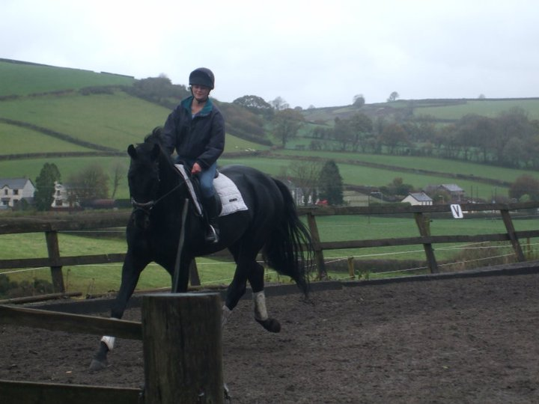shoulders. I keep my head up and I look straight ahead through my horse’s ears into the direction that I want the extended trot to go. Unlike Carl I do not always maintain a smooth rhythm throughout the movement, instead my extended trot can be too quick in places and the extended strides are not always equal.*

**Recovery:**

*Once at the correct marker to come back into normal working trot, I bring my horse back by sitting up and deep into the saddle whilst half halting and I actively use my legs to continue to encourage the horse forwards through the transition. However, as my horse is not as responsive as Carl’s grand prix dressage horse, I have to continue to block the forward movement of my horse with my hands until my horse goes back into a collected working trot. My horse can also become very heavy through the transition and pull down on the forehand which can cause me to tip forwards in my seat and to become marginally unbalanced which makes it harder for my horse to get its hocks engaged and tracking up in the working trot. Unlike Carl my transition is not always smooth, I keep my leg on in order to maintain a forward working trot but I need to keep my leg on more, so that when I half halt to slow down my horse does not collapse into a walk*. *I continue to look up and ahead for the next marker.*

## B2: Trot to Canter Transition

Upward transitions, like walk to trot, or trot to canter, must show an enthusiasm to go forward. For example, the transition to canter must show a clear uphill jump into canter. This can be achieved by balancing of the horse through a half-halt, alerting the horse that something is coming up.

**Depending on which rein Carl is on will control what aids he uses for the transition. If he is on the left rein his aids are as follows:**

### Preparation:

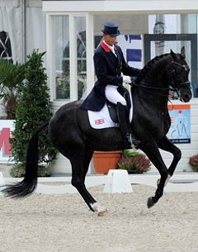**Firstly, in preparation for the upwards transition Carl gets his position correct by sitting up straight, driving his horse for an active trot. He uses a half halt to balance his horse and to create impulsion from its hocks so that his horse has enough power to create an uphill transition to working canter. He makes sure that his horse is mostly straight through its body but that his horse has a slight bend to the inside so that he is able to produce a transition into the correct canter lead. Carl maintains a light contact through his reins, with a straight line from his elbow to wrist to his horse’s mouth, which therefore ensures that his horse is remaining soft and doesn’t become resistant in the transition. He then looks up, forward and for the correct marker where the canter transition should take place and a few strides before the marker goes into sitting trot ready to apply the right aids to go into canter when his shoulder is in line with the marker.**

### Execution:

**At the marker Carl looks straight ahead to ask his horse to move off into canter. He goes into sitting trot by sitting on his seat bones and down into the saddle, so that he remains in balance with his horse as the gait changes. He then places his inside leg onto the girth and gently applies pressure to provide energy for the transition. Carl’s outside leg is put just behind the girth where he gently adds pressure to trigger his horse to strike off with the off hind first, to get left working canter and to stop his horse from drifting when the transition takes place and to control his horses speed. Whilst moving his legs slightly his weight is pushed through the back of his calves into the heel of each of his legs. He does this to ensure that the horse strikes off on the right canter lead. Carl keeps his knees soft and thighs open so that he doesn’t ‘bounce’ around in the saddle and so that he is able to sit smoothly to the rhythm of the canter. If his horse shortens its neck in the canter, then Carl will adjust his contact by shortening the contact during this period. As his horse moves into the canter, Carl remains light in his seat. His pelvis ‘rocks’ with the motion of canter, whilst maintaining an open posture and straight back, so that he stays in balance with his horse.** **Carl slightly moves his inside rein to the inside to ask his horse for a little bend to the inside which helps to tell his horse that he wants the left canter lead. He half halts with his outside rein to set his horse’s outside hind leg as the first beat in the canter. He gives with his inside rein while keeping contact with his outside rein. Carl increases his weight on his inside seat bone to again encourage the left canter lead whilst remaining tall in the saddle but still relaxed through his back and shoulders throughout the transition and working canter. When applying his aids and asking for the transition Carl is able to do it with the slightest of movements maintaining a smooth rhythm from the working trot to working canter.**

### Recovery:

**Once on the correct marker to come back down into working trot Carl brings his horse back by sitting up and deep into the saddle whilst half halting to balance his horse further and to help Carl reassure himself that his horse will react to his aids. He keeps his weight down into the saddle so that he can use his seat as a brake to help slow the gait down. This also helps to prepare his horse for the transition by allowing his horse time to get its weight back onto its hocks so that it is able to support its weight during the transition. He keeps his legs on and around his horse in order to maintain a forward canter. He maintains a smooth rhythm and continues to look up and ahead for the next marker. He keeps his hands up and off of his horse’s shoulder and has a 90 degree angle at his elbow to give him maximum control, leverage and steering. He pulls back slightly with both reins applying pressure on the horse’s mouth to ask the horse to return to trot. As his horse returns to trot he remains sitting up for a couple of strides and then returns to rising trot on the right diagonal so that he is in balance with his horse for the next movement.**

## B1: Trot to Canter Transition

*Depending on which rein I am on will control what aids I use for the transition. If I am on the left rein my aids are as follows:*

### Preparation:

*Firstly in preparation for the upwards transition, like Carl I try to get my position correct however I do not sit up completely straight. Instead I tip forward which prevents me from driving my horse forward for an active working trot using my seat. I need to use a half halt like Carl to balance my horse and to create impulsion however I do not and this allows my horse to get away from me. I make sure that my horse has the right inside bend so that the transition gives the correct canter lead however my horse does not have a good inside bend, instead when I ask for a bend it will lift its head higher and try to rush into the canter. This means that I am too harsh with my hands causing my horse to lift its head and means that I do not always get the correct canter lead first time round making the transition untidy and out of balance. This also can result in me tipping to the left to compensate for the lack of bend in my horse to try and get the right canter lead. My horse does this as it has not had as much and intense flatwork training as Carl’s horses will have. I look up and forward and for the correct marker where the canter transition should take place and a few strides before the marker I go into sitting trot ready to apply the right aids to go into a working canter when my shoulder is in line with the marker.*

### Execution:

*At the marker I look straight ahead and I place my inside leg onto the girth and gently add pressure to provide energy for the transition. I put my outside leg just behind the girth where I gently add pressure to tell my horse to strike off with the off hind first to get a left canter lead. I move my inside rein to the inside to ask my horse for a little bend to the inside which helps to tell my horse that I want the left canter lead. I can sometimes over hold through my rein contact which prevents my horse from riding up into the canter transition. This also means that I have tense shoulders and arms which prevent me from having a soft and elastic rein contact unlike Carl who says relaxed and supple. I go into sitting trot by pushing my weight down into my seat. I keep an even contact so that I am not pulling on my horse’s mouth and not creating confusion between asking my horse to move forwards and pulling back asking my horse to slow down as this will frustrate my horse and result in the transition not taking place. I allow my pelvis to follow the motion of my horse and I remain soft in my lower back so that I can absorb the movement of the canter. By remaining open through my shoulders, I am able to stay in balance with my horse. To stop my horse from rushing and taking off I half halt with my outside rein to set my horse’s outside hind leg as the first beat in the canter. I give with my inside rein whilst keeping contact with my outside rein. Sometimes when half halting I can be too harsh with my hands, I need to put my weight into my seat more and use my seat as well as my hand to slow down. As I am being too heavy with my hands it causes me to stiffen and tense up in my arms and position, unlike Carl who remains supple throughout and soft with his hands. This will mean that I will get marked down for my position in a dressage test as I am not soft and supple in my position, unlike Carl; this is because he will ride past mirrors so that he can see his position and correct it when training. Also, as I am too harsh on my horse’s mouth it causes my horse to lift its head up to compensate from me pulling on its mouth and to try to stop the pull on its mouth, this means that my horse stops working on the bit, which again will lose me marks as my horse is not using itself properly and working properly. I put my weight onto my inside seat bone to again encourage the left canter lead. I remain sitting up tall through the whole transition pushing the weight down into my heals keeping my legs long and underneath me.*

### http://a8.sphotos.ak.fbcdn.net/hphotos-ak-snc6/270639_2159057693332_6173626_n.jpgRecovery:

*Once on the correct marker to come back down into working trot I bring my horse back by sitting up and deep into my saddle whilst half halting. Unlike Carl I do not sit deep enough into the saddle. This means that I cannot slow the gait down using my seat and instead I just use my hands, which is very harsh on my horse’s mouth, which causes my horse to come off of the bit and lift its head up. Carl does not do this as he uses his seat as well as his hands to slow his horse down, which makes his downwards transition very smooth. This also means that I cannot prepare my horse with a half halt to help my horse stay in balance. Sometimes the use of a half halt can cause my horse to drop behind the vertical therefore I have to shorten my contact up slightly so that I still can remain in control of my horse’s overall outline, which gives me enough leverage to increase the pressure through my horse’s mouth in order to return to working trot. Carl’s horse does not do this because as he half halts he also keeps his leg on sending his horse forwards. I remain sitting in my saddle as my horse begins to trot so that I can adjust my position and get the correct diagonal before rising again. Carl never has to alter his diagonal as he can feel the horse’s leg movement due to intensive training. This means that he never has to go out of rhythm to change his diagonal. Once the required speed of my horse has been reached, I return to a rising trot on the correct diagonal so that I am in balance with my horse. Again unlike Carl, I do not always get the right diagonal first time so I often have to sit to two beats of the trot to then get on the right diagonal. I keep my legs on and around my horse in order to maintain a forward working canter and not to slow the trot completely down. Unlike Carl, I do not maintain a smooth rhythm as I often have to change my diagonal. However like Carl, I continue to look up and ahead for the next marker and so that I can ride a straight line. I keep my hands up and off my horses shoulder and I have a 90 degree angle at my elbow to give me maximum control, leverage and steering.*

# Ride 2- with jumping

The elite performer that I have chosen to analyse in both ride 2- with jumping B2’S is Ben Maher, an international and Olympic show jumper who is ranked number two in the UK. He represented Britain at the 2008 Beijing Olympics and 2009 European Championships, Windsor, and won team bronze at the 2011 Europeans Championships in Madrid. He was selected to represent Great Britain in the London 2012 Olympics and won a team GB gold. By the age of 26, he had overtaken regular British team members to become ranked number one in the country and number five in the World. He is also one of just two riders to have won both the Hickstead Derby and Speed Derby in the same year.

## B2: Jumping an upright

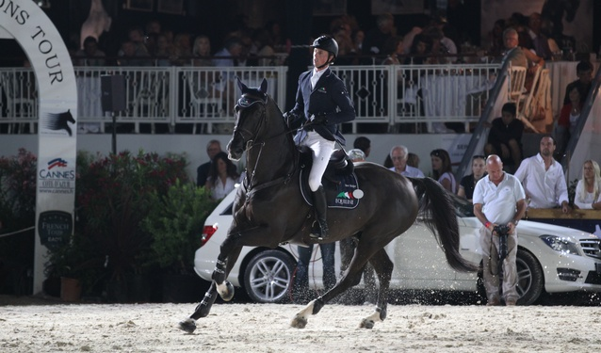**An upright fence** is made by a pole that goes straight across and is the same height on both of the jump wings. Upright fences should always have a second pole that either hangs under the upright pole or is lying on the floor directly under the jump. This helps the horse to judge the height of the fence and makes it more appealing to jump.

### Approach (preparation):

**On approach to an upright fence Ben Maher rides a straight line directly to the centre of the fence which ensures that there is no danger of him knocking a pole from touching the wings of the jump. This creates the smallest margin for error. To maintain a straight line to the jump Ben rides between his legs and his hands which allows him to keep a straight line with the horse continuing forwards with the impulsion and balance that is required to give his horse maximum power. He sits up by extending up through his upper body so that he is sat on his seat bones. He does this in order to stay in balance with his horse. He drops his weight down into his saddle so that he can stay in rhythm with his horse on the approach. He also does this to keep his horse balanced and to make sure that the horses hocks are engaged in order to create enough impulsion for take-off. Ben looks up and ahead at the fence which helps him to see his line and channel his horse forward so that he can look for the right stride and makes adjustments in stride length by half halting to lengthen or shorten each stride. It also brings his horse back onto its hocks, which gives his horse impulsion and power so that it can take off and clear the fence. His legs remain on the girth and his heals are down as he pushes his weight down through his heels which allows him to quickly absorb the flight, if his ankles were stiff he may be left behind when the horse jumps. He rides with a 90 degree angle at his elbow which gives him leverage for half halting to correct wrong strides so the horse doesn’t take a stride out or bury under the fence, increasing the chance of knocking the fence. It also helps to bring up his horse’s head so that it can look at the fence. Half halting slows the horse down and helps the horse to look at the fence so it can see where it’s going. He keeps his hands up and off of his horse’s shoulder and he does not drop his hands a stride before the fence which would make the horse bury under the fence, making the take-off harder.**

### http://i.ytimg.com/vi/vVLu08raZ7o/0.jpgTake off (execution):

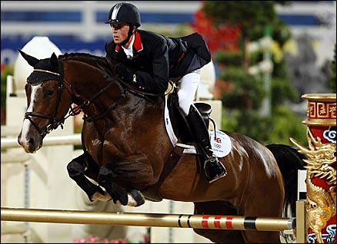**Ben Maher approaches in an upright position but upon take-off he follows his horse’s motion into the jumping position. He is quick to compact his body to absorb the charge of the take-off. To go into his jumping position Ben lowers his upper body and his seat retreats to the back of the saddle to absorb the horse’s motion. He does this by flexing at his waist whilst keeping his upper body low to his horse’s neck in order to stay balanced. He lifts his seat slightly out of the saddle in order to enable his horse to make enough height over the upright. While in the jumping position Ben keeps his back parallel to his horse’s back and does not allow his back to dip. He folds straight so that he can look through his horse’s ears and onto the next fence. He doesn’t lean to one side or twist in his position when in the air as this would unbalance his horse and himself as well. Whilst in the air Ben always looks forwards over the fence in order to help keep his horse straight and to help him position his horse on landing as he chooses his line to the next fence which he couldn’t do if he was looking down. When in the jumping position he extends forwards at the elbow, following the movement of his horse’s head and neck however, he continues to uphold a light contact through the rein to the bit which means that Ben will not be dropping his horse a stride out of the jump which would cause the horse to bury under the jump. Also, by Ben giving with his hands he allows his horse to stretch through its neck, back and body which gives his horse the freedom of movement it needs, while Ben still maintains a light contact through the rein. Whilst giving with his hands he keeps them up and off his horse’s shoulder and mouth which again enables his horse to reach with its neck in order to make the width of the fence. Ben keeps his lower leg securely wrapped around his horse, to uphold the horse’s energy and forward momentum. He also keeps his leg on the girth and does not let it swing back when in the jumping position which helps him to maintain balance. By keeping his heals down it again helps him to absorb his horse’s motion. He grips with his knees when in the jumping position but keeps his leg down and underneath him on the girth; this prevents his legs from swinging out of position which could result in a loss of balance upon landing. He keeps his heals down, toes in and legs long and down underneath him. Occasionally his toes face outwards when jumping bigger jumps for extra grip to re-gain balance.**

### Landing (recovery):

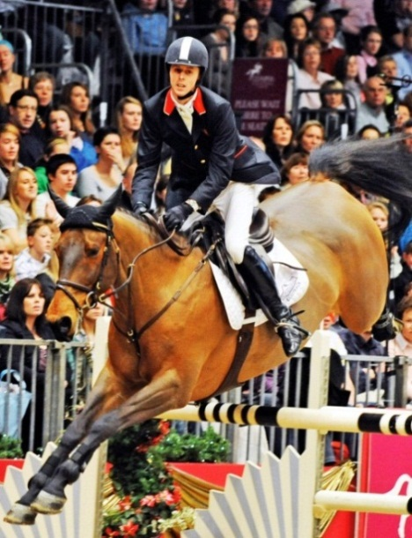**As the horse is near to clearing the upright Ben starts to sit up to stop the horse from ‘getting away’ from him on landing. He firstly brings his upper body back up into an upright position and his seat back down into the saddle so that he will not lose balance and this will mean he can easily regain control to set his horse up for the next fence. This also helps Ben to get his horse balanced and engaging in its hocks, to create impulsion. He achieves this by regaining the contact because this enables Ben to half halt which can control the speed of his horse. He does this in order to adjust the horse’s stride length or speed if necessary. Whilst keeping a contact, he still continues to allow with his hands so he keeps a contact through the rein to the bit in his horse’s mouth without interfering with his horse’s movement and balance. This is very important as his horse will be using its neck for most of its balance. By Ben regaining contact it allows him to control his horse’s speed and adjust strides. He opens his hands to allow freedom in his horse’s neck to land. Ben’s lower leg still remains on the girth and doesn’t swing back behind the girth enabling him to pick his horse up on landing and adjust his horse’s stride to the next fence as quickly as possible, which he will have chosen to ride to when he walked the course before riding it. He closes his leg around the horse to obtain control because if his knees were loose he would be at risk of losing control after the landing which could have a negative effect on the next jump or result in Ben falling off. Although your toes should be turned in, Ben sometimes when jumping bigger fences turns his toes out to grip with his calves. He continues to look ahead and up, to the next fence. When landed Ben re-balances his horse and gathers his horse back onto its hocks to give plenty of energy and impulsion and so that his horse is on the correct canter lead so it can turn in balance to the next fence.**

## B1: Jumping an Upright

### Approach (preparation):

*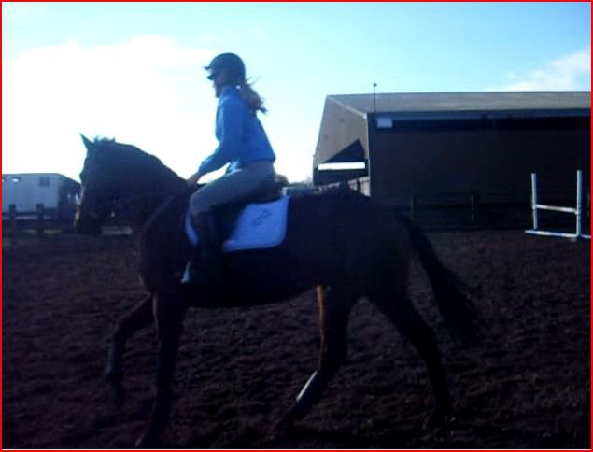On approach to an upright fence I do not do it like Ben who always rides a straight line directly to the centre of the fence this means that I put myself in danger of catching my leg on a wing. This is because I do not look ahead at the fence, which means that I cannot see a straight line. Ben looks ahead at a fence which helps him to channel his horse forward so that he can look for the right stride and make adjustments which stops his horse from taking a stride out or putting in an extra stride which increases the chance of knocking a pole. However, I often get the wrong stride into a fence as I don’t have the time to alter my horse’s stride, causing my horse to put in an extra stride and burying under the fence or taking a stride increasing the chance of knocking a pole with its front feet. Unlike Ben, I do not sit on my seat bones enough as I tip forward. This means that I do not fully bring my horse back onto its hocks and do not keep a contact with my horse allowing it to get away from me. Ben does this by sitting up and driving his horse forward whilst remaining the contact in his hands, which gives his horse impulsion and power so it can take off and clear the fence. To maintain a straight line to the jump I ride between my legs and hands which allows me to keep a straight line, with my horse continuing forwards with impulsion and balance that is required. I sit up straight like Ben however I have the tendency to tip forwards slightly in the canter upon approach which means I’m not sat on my seat bones which means that my seat is not well engaged driving my horse forward and as I’m in a more forward seat it can make my horse speed up and rush to the fence. Also this means that my weight is not down in the saddle which would help me to bring my horse onto its hocks and means that I find it hard to stay in balance with the horse. I keep my legs forward and push my weight down into my heals which allows me to quickly absorb the flight and to maintain a secure lower leg position. If my ankles were stiff then I may get left behind when my horse jumps. I ride with a 90 degree angle at my elbow, like Ben, which gives me leverage for half halting to slow down or to correct wrong strides so the horse doesn’t take a stride out or bury, increasing the chance of knocking the fence. This slows down my horse and helps the horse to look at the fence so it can see where it’s going. I keep my hands up and off of my horse’s shoulder, however I sometimes drop my hand a stride out from the fence which causes my horse to 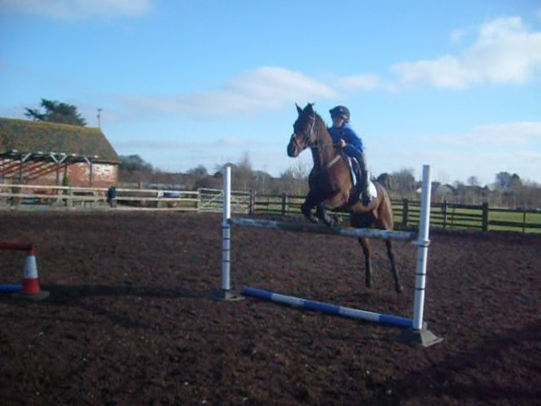bury under the fence increasing the chance of knocking a pole and makes the jumping movement untidy and leaves me getting left behind. Ben does not do this as he keeps a contact throughout the whole approach to a fence and applies a half halt to correct his horse’s stride into a jump. He never gets left behind as he gets the right stride into every fence and does not drop his horse a stride out from a fence. This is because he practices counting strides so that he is able to correct any stride if it is off. It is easy to bury under an upright fence as there can sometimes be no floor pole, which means the horse cannot see where to take off, so this is why I would need to ride more with my hands maintaining a contact to prevent my horse from burying and me getting the right stride.*

### Take Off (execution):

*At the take-off I keep my lower leg securely wrapped around my horse, to uphold the horse’s energy and forward momentum. I also keep my leg on the girth however, unlike Ben, when jumping bigger upright fences, I have the tendency to swing my leg back when in the jumping position which means that I cannot maintain balance. This is because Ben has much more experience than I do with jumping bigger fences. I approach the fence in an upright position and I quickly compact my body to absorb the charge of the take-off. To go into my jumping position I flex at my waist keeping my upper body parallel to my horse in order for us both to stay in balance. I lift up out of my seat taking my weight off of my horse’s back allowing it to get height over the fence. On the point* of *take-off, like Ben, I follow my horse’s motion into the jumping position. My upper body is lowered and my seat retreats to the back of the saddle to absorb the horse’s motion. While in the jumping position I keep my back parallel to my horse’s back, however unlike Ben I sometimes over arch my back which causes me to become stiff. By having a rounded back it makes my position look bad and affects my balance. Ben maintains good balance as he keeps his flat back. He continues to uphold a light contact through the rein to the bit; I sometimes drop this contact a stride before the jump which means that I will be dropping my horse which causes my horse to bury under the jump. I do not give with my hands 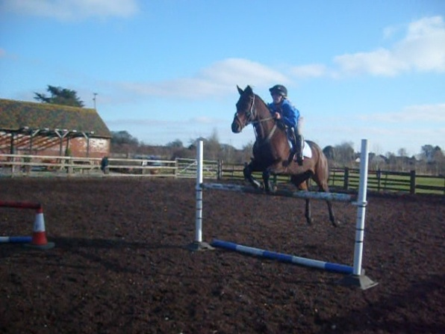enough which restricts my horse from stretching through its neck, back and body which would give my horse the freedom of movement it needs. My hands follow the movement of my horse’s head and neck and I continue to look up. Whilst in the air I still continue to look ahead and over the jump which helps to keep my horse straight over the fence and allows me to look for the next jump. However, I sometimes have the tendency to look down which restricts my vision and means I cannot always see where I am going. I do not lean to one side or twist in my position as this would unbalance my horse and myself. I keep my knees tight into the saddle however my lower leg may swing a little during the take-off. Ben’s lower leg remains on the girth because he does not grip with his knees which means that he pushes his weight down into his heals keeping his leg in the correct position. This means that it is harder for me to pick up my horse upon landing as I have to readjust my leg position, which means there is a greater chance of the horse riding a difficult stride to the next fence.*

### Landing (recovery):

*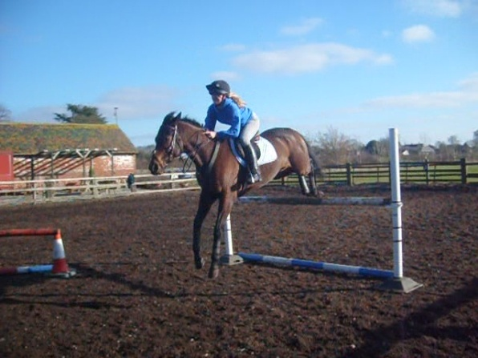On landing I do not sit up quickly enough as my horse prepares to land. This allows my horse to get away from me upon landing. Unlike Ben, it also means that I get left behind which cause me to change my position into an incorrect one, to compensate for my loss of balance. However, Ben sits up quickly by firstly bringing his upper body back up into an upright position so that he does not lose balance like I do. This is why he can easily gain control upon landing. I also do not fully control my horse’s speed as I am too slow in sitting up. This means that my horse takes off after the fence and means I have less time to adjust my horse’s stride by half halting for the oncoming jumps. As my horse lands, I am too far back in my position which means that unlike Ben, I cannot push my seat back into my saddle to give me a better chance of setting my horse up correctly for the next fence. As I am leaning back I have to slip my reins in order to not pull on my horse’s mouth and so that my horse can stretch upon landing. This means that I have to gather up my reins once landing which again means that my horse gets away from me and I do not have contact. This does not happen to Ben as he always upholds a contact. I lose all flexion in my arms causing them to become stiff meaning that I cannot half halt to bring my horse back onto its hocks to create impulsion. Unlike Ben, I am sometimes a bit slow at this which means that I don’t give myself as long to prepare for the next fence. Once I have regained control upon landing, I open my hands to allow freedom in my horse’s neck to land. I retake the contact by flexing at the elbow, as this again allows me to apply a half halt if necessary to get my horse back onto its hocks and to create impulsion. However sometimes I am a bit slow at this as I do not always pick up contact as quick as Ben, meaning that I don’t allow myself as long to prepare for the next fence. My lower leg still remains on the girth however I sometimes push my lower leg too far forward in compensation to retain balance over bigger up-right fences, this causes me to become unbalanced and leaning too far back in my position. This means that I can’t sit up quickly on landing to regain control and also means that I get left behind in the movement. Ben does not do this as he has more experience in jumping bigger fences and has adapted his seat and the way he rides to overcome this. If needed, I reposition my leg back onto the girth which then allows me to apply my leg if necessary to send my horse forwards to the next fence. I close my leg around my horse to obtain control because if my knees were loose I would be at risk of losing control after the landing which could have a negative effect on the next jump. I keep my toes turned in.* *I continue to look ahead and up focussing on the next fence whilst in the air, so that I can then position my horse appropriately on landing for the line that I am going to ride into the next fence. When landed I re-balance my horse and gather up my reins bringing my horse back onto its hocks to give plenty of energy and impulsion and so that my horse is on the correct canter lead so it can turn in balance to the next fence. I am very tired by the end of a show jumping cause due to my lack of aerobic fitness; this is why I do not maintain riding upright efficiently. Unlike Ben, who maintains the same level and standard of riding throughout a show jumping course, especially over uprights.*

**B2: Jumping a two stride Double Combination**

A double is two separate fences positioned with a recommended amount of strides in between them. The term "two stride double" refers to the fact that you can fit two non-jumping canter strides in between each fence.

**Approach (and take off over the first element):**

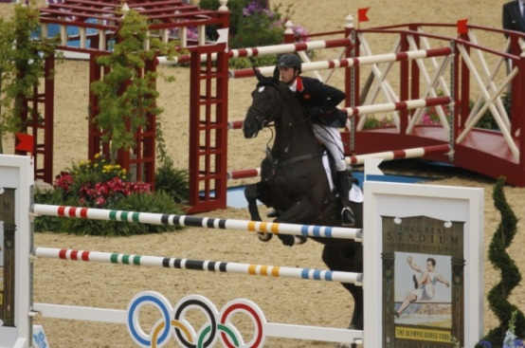**On approach to a two stride double, Ben makes sure that his horse is well balanced with a rhythmical, bouncy canter. He achieves this by maintaining a secure contact and having his legs strongly placed on the horse. He does this to allow him to adjust the horses stride to the first element of the double, and ensure enough impulsion is being created. It also helps to get the horse looking at the fence. As he comes around the corner on the approach he makes sure that he is looking at the first fence, so that he can set his horse up whilst keeping it between his hand and leg and to keep his approach straight. Ben makes sure that he stays in balance, keeping a contact throughout. When one or more fences are linked together, they require athleticism and power from the horse. This is why Ben presents his horse correctly at the first element so that he is able to jump the second fence with no problems. It is very important that Ben makes sure that his horse jumps well over the first part of the double because this determines how his horse will jump over the second element. The more impulsion that Ben gives his horse on the approach, the more chance Ben will have at meeting the first fence on a good stride. Ben sits upright deep into his saddle, half halting to keep his horse on its hocks so that the horse has power to jump the fences and so that Ben can lengthen or shorten his horse’s stride length according to his situation. Ben approaches in an upright position but upon take-off he follows his horse’s motion into the jumping position. He is quick to compact his body to absorb the charge of the take-off. To go into his jumping position Ben lowers his upper body and his seat retreats to the back of the saddle to absorb the horse’s motion. He does this by flexing at his waist whilst keeping his upper body low to his horse’s neck in order to stay balanced. He lifts his seat slightly out of the saddle in order to enable his horse to make enough height over the upright. While in the jumping position Ben keeps his back parallel to his horse’s back and does not allow his back to round. This stops him from becoming stiff and means that he can maintain balance. He folds straight so that he can look through his horse’s ears and onto the next fence. He doesn’t lean to one side or twist in his position when in the air as this would unbalance his horse and himself as well. Whilst in the air, Ben always looks forwards over the fence in order to help keep his horse straight and to help him position his horse on landing for the second element of the double. When in the jumping position he extends forwards at the elbow, following the movement of his horses head and neck, however he continues to uphold a light contact through the rein to the bit which means that Ben will not be dropping his horse a stride out of the jump which would cause the horse to bury under the jump. Also, by Ben giving with his hands it allows his horse to stretch through its neck, back and body which gives his horse the freedom of movement it needs, while Ben still maintains a light contact through the rein. Whilst giving with his hands he keeps them up and off his horse’s shoulder and mouth which again enables his horse to reach with its neck in order to make the width of the fence. Ben keeps his lower leg securely wrapped around his horse, to uphold the horse’s energy and forward momentum; he also keeps his leg on the girth and does not let it swing back when in the jumping position which helps him to maintain balance when in the jumping position. By keeping his heals down it again helps him to absorb his horse’s motion. He grips with his knees when in the jumping position but keeps his legs down and underneath him on the girth. He keeps his heels down, toes in and legs long and down underneath him, so that his weight is in his heels which will prevent him from gripping with his knees and his legs from swinging behind the girth out of position. It also means that he sits up straight with his legs in the correct position and will stop him from becoming unbalanced in the saddle. Occasionally his toes face outwards when jumping bigger jumps for extra grip to re-gain balance. He rides to the center of the fence so that he will ride to the second fence at the center. As the horse takes off Maher flexes at the waist in order to stay in balance with the horse as it moves over the fence. However, he avoids flexing too low to the horse’s neck as this means he would have less time to prepare the horse for the second element on landing.**

**Execution (the ride in between the double):**

**Once Ben has landed after the first element of the double, he is very quick in sitting up to stop his horse getting away from him on landing. It also stops his horse from tipping onto its forehand reducing the chance of the horse having the pole from the second element down in front. He sits up and deep into his seat for the two strides in-between the fences. He does not tip forward as this would encourage his horse to rush and gives Ben less control. Whilst riding the two strides he looks up and ahead at the second fence so that his horse keeps in a straight line and does not move to one side as this would increase his chance of knocking a pole. He applies his legs on the girth so that he is able to push his horse forwards to continue moving through the double and onto the next fence, but still maintains a contact so that he remains at his usual canter speed with his horse on it hocks so that it has the power to clear the second jump. He regains his contact through flexion at the elbow at 90 degrees, to help pick his horse up in front, making it easier for his horse to lift in the forehand to make enough height over the second element of the fence. Ben picks up his rhythm and balance again as soon as he can by half halting to recover the impulsion and to get his horse back and concentrating on second fence on the double. Ben is careful to not over-ride the strides in-between so that he does not interfere with his horse’s rhythm or balance; this is why he sits as still as possible. He makes sure that he does not drop his hands a stride before the second fence as this would cause his horse to bury under the fence. He then goes into jumping position when his horse takes off over the second element.**

**Recovery (landing over the second element and the ride away):**

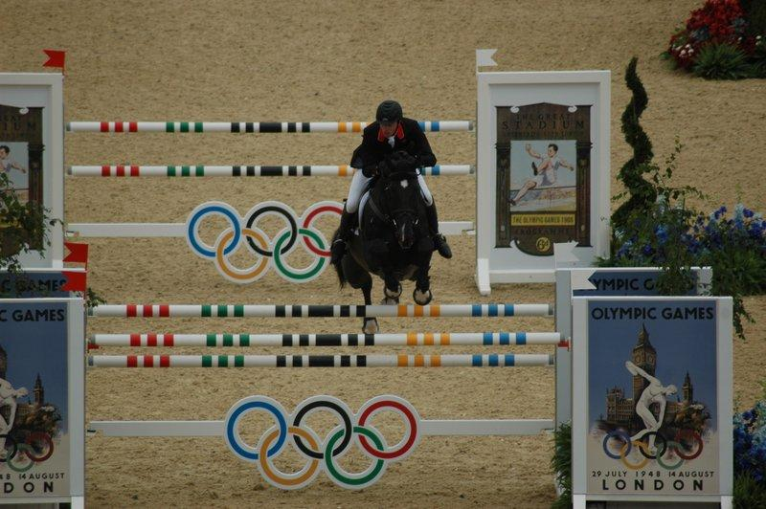**As Ben’s horse is near to clearing the second element of the double, he starts to sit up, to stop the horse from ‘getting away’ from him on landing. He firstly brings his upper body back up into an upright position and his seat back down into the saddle so he will not lose balance and he can easily regain control to set his horse up for the next fence. This also helps Ben to get his horse balanced and engaging in its hocks, to create impulsion. He achieves this as well by regaining the contact because this enables Ben to half halt which can control the speed of his horse. He does this in order to adjust the horse’s stride length or speed if necessary. Whilst keeping a contact he still continues to allow with his hands so he keeps a contact through the rein to the bit in his horse’s mouth without interfering with his horse’s movement and balance which is very important as his horse will be using its neck for most of its balance. By Ben regaining contact it allows him to control his horses speed and adjust strides. He opens his hands to allow freedom in his horse’s neck to land. Ben’s lower leg still remains on the girth and doesn’t swing back behind the girth, this means that he is able to pick his horse up on landing and adjust his horses stride to the next fence as quickly as possible, which he will have chosen to ride to when he walked the course before riding it. He closes his leg around the horse to obtain control because if his knees were loose he would be at risk of losing control after the landing which could have a negative effect on the next jump or result in Ben falling off. Although your toes should be turned in, Ben sometimes when jumping bigger fences turns his toes out to grip with his calves. He continues to look ahead and up, to the next fence. When landed Ben re-balances his horse and gathers his horse back onto its hocks to give plenty of energy and impulsion and so that his horse is on the correct canter lead so it can turn in balance to the next fence.**

**B1: Jumping a two stride Double Combination**

### Approach (and take off over the first element)

*On approach* *to a two stride double, like Ben, I try and make sure that my horse is well balanced with a rhythmical, bouncy canter. However, I do not always achieve this as I do not maintain a secure contact and do not have my legs strongly placed on my horse, like Ben does. Ben does this to allow himself to adjust his horse’s stride to the first element of the double, and to ensure enough impulsion is being created – I cannot do this I do not have my horse on its hocks. As I come around the corner on the approach I do not always look at the first fence but the second, this means that I cannot set my horse up whilst keeping it between my hand and leg. This means that my approach is not straight as I’m not looking for a straight correct line into a fence. It also means that I do not get my horse looking at the correct fence like Ben does. This increases his horse’s confidence and likelihood of keeping the first fence up. When one or more fences are linked together, they require athleticism and power from the horse. This is why Ben presents his horse correctly at the first element so that he is able to jump the second fence with no problems. However, again* I do *not do this as I do not ride straight to the first fence resulting in a short or long stride as the fence which messes up the next stride to the second part of the fence. This is why I need to improve on my approach to the first fence as it is very important that I make sure that my horse jumps well over the first part of the double because this determines how my horse will jump over the second element. The more impulsion that I give my horse on the approach, the more chance I will have at meeting the first fence on a good stride. I sit upright and deep into my saddle, half halting keeping my horse on its hocks so that my horse has power to jump the fences and so that I can lengthen or shorten my horse’s stride length according to the situation.**At the take-off over the first element I keep my lower leg securely wrapped around my horse, to uphold the horse’s energy and forward momentum, I also keep my leg on the girth, however, unlike Ben when jumping bigger upright fences I have the tendency to swing my leg back when in the jumping position which means that I cannot maintain balance when in the jumping position. This is because Ben has much more experience than I do with jumping bigger fences. I approach the fence in an upright position and I quickly compact my body to absorb the charge of the take-off. To go into my jumping position I flex at my waist keeping my upper body parallel to my horse in order for us both to stay in balance. I lift up out of my seat taking my weight off of my horses back allowing it to get height over the fence. On the point of take-off, like Ben, I follow my horse’s motion into the jumping position. My upper body is lowered and my seat retreats to the back of the saddle to absorb the horse’s motion. While in the jumping position I keep my back parallel to my horses back, however, unlike Ben, I sometimes over arch my back which causes my body to become stiff. This makes my position look bad and affects my balance. Unlike Ben who continues to uphold a light contact through the rein to the bit I sometimes drop this contact a stride before the jump which means that I will be dropping my horse which causes my horse to bury under the jump. I do not give with my hands enough which restricts my horse from stretching through its neck, back and body which would give my horse the freedom of movement it needs. My hands follow the movement of my horses head and neck and I continue to look up. Whilst in the air I still continue to look ahead and over the jump which helps to keep my horse straight over the fence and allows me to look for the next jump. However I sometimes have the tendency to look down which restricts my vision and means I cannot always see where I am going, unlike Ben, who keeps his head up looking ahead which allows him to see exactly where he is going to keep himself riding the correct line preventing him from any errors. I do not lean to one side or twist in my position as this would unbalance my horse and me. I keep my knees tight into the saddle however my lower leg may swing a little during the take-off. This means that it is harder for me to pick up my horse upon landing as I have to re-adjust my leg position, which means there is a greater chance of the horse riding a difficult stride to the next fence.I ride to the center of the fence so that I will ride to the second fence at the center. As my horse takes off I flex at the waist in order to stay in balance with my horse as it moves over the fence. However I can sometimes flex too low to my horses neck and this means that I have less time to prepare the horse for the second element on landing, unlike Ben, who slightly folds so that he has plenty of time to sit up and ride the strides perfectly to the second element of the double.*

### Execution (the ride in between the double):

*Once I have landed after the first element of the double, I am not always quick enough in sitting up; this then allows my horse to get away from me on landing. Ben never allows his horse to get away from him as he always stays in control. He does not over fold and is very quick to sit up on landing to regain control as his horse is much more powerful and stronger than mine, so he needs to always remain in control. When I am sat up this stops my horse from tipping onto its forehand reducing the chance of my horse having the pole from the second element down in front. I sit up and deep into my seat for the two strides in-between the fences. Again because I can sometimes be too slow in sitting up it means that I can tip forwards and this encourages my horse to rush and gives me less control. Whilst riding the two strides I look up and ahead at the second fence so that I can try and keep my horse on a straight line, however because I do not sit up quick enough it means that I cannot pick up my contact as soon as Ben does and this can mean that my horse drifts to one side in the middle, increasing my chance of knocking the second pole. However, I do not allow my horse to drift as I keep my legs on keeping my horse straight and I am quick to readjust my body. Ben does not do this as he is much more experienced and more muscular than I am so he does not get thrown around in the saddle when in the air and as he is stronger that I am he can control his horse better. I apply my legs on the girth so that I am able to push my horse forwards to continue moving through the double and onto the next fence. I regain contact through flexion at my elbow at 90 degrees, to help me to pick my horse up in front, making it easier for my horse to lift in the forehand to make enough height over the second element of the fence. I pick my rhythm and balance up again, as soon as I can by half halting to recover the impulsion and to get my horse back and concentrating on the second fence of the double. I can sometimes over-ride the strides in between which causes me to interfere with my horse’s rhythm and balance; this is why Ben sits as still as possible. I then go into jumping position when my horse takes off over the second element.*

### Recovery (landing over the second element and the ride away):

*On landing over the second element of the double, I do not sit up quickly enough as my horse prepares to land. This allows my horse to get away from me upon landing. Unlike Ben, it also means that I get left behind which cause me to change my position into an incorrect one, to compensate for my loss of balance. However, Ben sits up quickly by firstly bringing his upper body back up into an upright position so that he does not lose balance like I do. This is why he can easily gain control upon landing. I also do not fully control my horses speed as I am too slow in sitting up. This means that my horse takes off after the fence and means I have less time to adjust my horses stride by half halting for the oncoming jumps. As my horse lands, I am too far back in my position which means that unlike Ben, I cannot push my seat back into my saddle to give me a better chance of setting my horse up correctly for the next fence. As I am leaning back I have to slip my reins in order to not pull on my horse’s mouth and so that my horse can stretch upon landing. This means that I have to gather up my reins once landing which again means that my horse gets away from me and I do not have contact. This does not happen to Ben as he always upholds a contact. I lose all flexion in my arms causing them to become stiff meaning that I cannot half halt to bring my horse back onto its hocks to create impulsion. Unlike Ben, I am sometimes a bit slow at this which means that I don’t give myself as long to prepare for the next fence. Once I have regained control upon landing, I open my hands to allow freedom in my horse’s neck to land. I retake the contact by flexing at the elbow, as this again allows me to apply a half halt if necessary to get my horse back onto its hocks and to create impulsion. However sometimes I am a bit slow at this as I do not always pick up contact as quick as Ben, meaning that I don’t allow myself as long to prepare for the next fence. My lower leg still remains on the girth however I sometimes push my lower leg too far forward in compensation to retain balance over bigger up-right fence. Ben does not do this as he has more experience in jumping bigger fences and has adapted his seat and the way he rides to overcome this. If needed, I reposition my leg back onto the girth which then allows me to apply my leg if necessary to send my horse forwards to the next fence. I close my leg around my horse to obtain control because if my knees were loose I would be at risk of losing control after the landing which could have a negative effect on the next jump. I keep my toes turned in.* *I continue to look ahead and up focussing on the next fence whilst in the air, so that I can then position my horse appropriately on landing for the line that I am going to ride into the next fence. When landed I re-balance my horse and gather up my reins bringing my horse back onto its hocks to give plenty of energy and impulsion and so that my horse is on the correct canter lead so it can turn in balance to the next fence.*

**Ride 3 – Application of strategy/tactics**

The elite performer that I have chosen to analyse for both ride 3 - application of strategy/tactics B2’s is Ellen Whitaker.She is a [British](http://en.wikipedia.org/wiki/United_Kingdom) female [show jumper](http://en.wikipedia.org/wiki/Show_jumping) ranked 16th by the [British Show jumping Association](http://en.wikipedia.org/wiki/British_Showjumping_Association) for September 2011. She is renowned for cutting corners and her fast jump-off times against the clock.

**B2: Turning in the Air**

Ellen will turn in the air over jumps so that her horse lands on the correct lead for the approach to the next fence. This saves Ellen valuable time in the jump off and she does not have to do a flying change on the approach of a jump which would cause her horse to become unbalanced, increasing the risk of her knocking a pole.

**Depending on which canter lead Ellen wants it will control what aids she uses for the turn in the air. If she wanted the right canter lead her aids are as follows:**

### Preparation

**In order for Ellen to turn in the air successfully she has to take into consideration her approach and her time of her horse’s leg change over the fence. It also means that she has the option to take a slightly wider turn to the harder fence. On the approach to the fence Ellen has to look to ride a successful line to leave the fence standing but also look at her landing position to make the quickest distance to the next fence. This is why Ellen will ride at an angle to the fence as this will also help make her turn in the air easier. In order for her to do this she will have walked the course before so that she can map out her route. She will have counted distances and strides between each fence, so that she can choose the quickest route to get the fastest time but also ride lines which have the best chance of leaving fences up. She keeps her turns into the fences sharp but on an even stride to maintain balance. Ellen has good balance and a bold attitude to turn short into a fence. She encourages her horse to produce an athletic, rhythmic canter which is one gear up from the speed that she would normally ride, again without allowing her horse to become flat. She does this so that she can ride the fastest jump-off possible without her horse galloping around knocking each fence, as her horse has become flat. She approaches the fence on a smooth curve still allowing time for her horse to see the jump.**

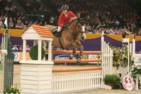**She does not attempt to alter the shape of her curve as she approaches as this would make her lose her balance. Once Ellen had started to turn into a fence she does not take her eyes off the fence that she is about to jump. If she did, she would either over shoot or under shoot it. It is only when she has reached the jump that she then looks ahead to where she is going next. She keeps a strong hold of her rein and gives her horse plenty of leg to let her horse know that she is confident and in control. In order to jump a fence off one canter lead, then land on the opposite lead to change direction to the next fence, Ellen firstly sets her horse up for the first fence. She maintains a rhythmical, uphill canter with plenty of impulsion so that she has control of her horse but also leaves her horse with power to make it over the fence. She gets this through half halting to shorten or lengthen her horses stride accordingly and to balance her horse, which is key, whilst maintaining a secure contact between her legs and her horse’s stomach to push him forwards. Although Ellen is pushing her horse on in the jump-off she does not let her horse rush into the fences and keeps her horse on its hocks so that it still has impulsion for power over the jumps and is not jumping flat. At the gallop, a bigger show jump is very difficult to clear, due to the long, flat stride of the gallop. Therefore Ellen does not gallop at the fence but increases her horse’s stride after the jump. Then, three or four strides before the next fence she shortens the stride by half halting remaining balanced for the next take-off, getting her horse’s hocks underneath it, to create energy for power and to avoid knocking a pole.**

### Execution:

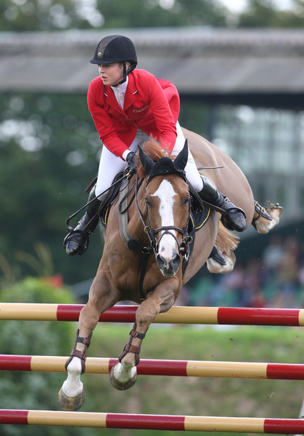**As Ellen has approached the fence with the intention of turning right on landing she will have ridden into the fence at an angle from the left. She will still aim for the centre of the jump to avoid knocking the pole from the wings. Just like jumping a normal fence Ellen will be in the upright position, with her seat deep into the saddle with her legs on the girth driving forwards and hanging long and underneath her. She will keep her weight down into her heals and her toes in, so that she can maintain control and prevent her legs from becoming out of the correct position. She keeps her hands up and off of her horse’s shoulder, with her elbows flexed at a 90 degree angle so that she has maximum leverage, steering, control and so that she doesn’t drop her horse a stride out from the fence, causing her horse to bury. As her horse takes off (for example from a left canter lead) Ellen moves forwards with her horse into the jumping position so that they stay in balance. Her seat retreats to the back of the saddle to absorb her horse’s motion. She does this by flexing at her waist whilst keeping her upper body low to her horse’s neck in order to stay balanced. She lifts her seat slightly out of the saddle in order to enable her horse to make enough height over the fence. While in the jumping position Ellen keeps her back parallel to her horse’s back and does not allow her back to dip. But differently from just jumping a normal fence, when her horse is about parallel to the ground, Ellen will give the aids to her horse to land on the right lead. She opens her right indirect rein to encourage her horse to bend right. Also, as she’s opening her hand she places her left leg behind the girth, furthering the command for canter right. This means that her horse will land with the right foreleg first and on the right canter lead. This means that she doesn’t waste any time on landing, balancing her horse to perform a flying change, before being able to successfully change direction. Additional aids she uses whilst in the air to make her horse turn in the air are by shifting both of her hands slightly towards the direction of the right lead so that her outside hand acts as a mild neck rein and the inside hand acts as a mild leading rein. All the time whilst Ellen is in the air she looks to the right and on to the next fence encouraging her horse to shift its weight onto its right side and to change lead from the left to the right. She also twists her upper body slightly when she is the air towards the right to again encourage her horse for the right lead. Therefore upon landing she is able to direct her horse immediately onto her pre prepared line, reducing even more time. The most important element to a successful turn in the air is balance. Ellen ensures that she is in perfect harmony with her horse by allowing her weight to go with her horse. So when she’s turning right, her weight will be down in her right stirrup and in her right seat bone. However, she still bears some weight to the left, so that she doesn’t unbalance her horse. Her aides are subtle, with most of the work being done by her lower leg, rather than her upper body or hands.**

### Recovery:

**As her horse is near to clearing the fence Ellen starts to sit up, to stop her horse from ‘getting away’ from her on landing. She firstly brings her upper body back up into an upright position and her seat back down into the saddle so she will not lose balance on the turn and she can easily regain control to set her horse up for the next fence or to push on. This also helps Ellen to get her horse balanced and engaging in its hocks, to create impulsion. She achieves this as well by regaining the contact because this enables her to half halt which can control the speed of her horse. She does this in order to adjust her horse’s stride length or speed if necessary. Whilst keeping a contact she still continues to allow with her hands so that she keeps a contact through the rein to the bit in her horse’s mouth without interfering with her horse’s movement and balance which is very important as her horse will be using its neck for most of its balance. She opens her hands to allow freedom in her horse’s neck to land so that she doesn’t take its teeth out if she is leaning too far back on landing. Ellen’s lower leg still remains on the girth and doesn’t swing back behind the girth which means that she is able to pick her horse up on landing and adjust her horse’s stride to the next fence as quickly as possible, which she will have chosen to ride to when she walked the course before riding it. She closes her leg around her horse to obtain control because if her knees were loose she would be at risk of losing control after the landing which could have a negative effect on the next jump or result in Ellen falling off when turning in the air. Although your toes should be turned in, Ellen sometimes when jumping bigger fences and turning in the air turns her toes out to grip with her calves. She continues to look ahead and up, to the next fence. When landed Ellen re-balances her horse and gathers her horse back onto its hocks to give plenty of energy and impulsion so that with the added speed in the jump-off, her horse isn’t jumping flat. By Ellen landing on the correct lead, she avoids having to make a flying change to change the lead altogether after the fence when approaching another, which makes her round smoother and gives Ellen more time to think about the upcoming fence. Once she has landed on the new rein, she is very quick to establish a balanced canter again with her horse on its hocks. To ride well against the clock, Ellen uses firm hand and leg aids to instil the idea of instant obedience and quick changes.**

**B1: Turning in the Air**

*When I see an opportunity to turn in the air, I will use this option, as it will speed up my jump-off time.*

*Depending on which canter lead I want, it will control what aids I use for the turn in the air. If I want the right canter lead my aides are as follows:*

### Preparation:

*On the approach to the fence, I have to look to ride a successful line to leave the fence standing but also to look at my landing position to make the quickest distance to the next fence, this is why I will ride at an angle to the fence and this will also help to make my turn in the air easier. My initial flaw with turns in the air comes with my course walking. I will not study the course as much as Ellen will have done, as she has time to study the course in depth and she jumps at a much higher level than I would do. This means that I have to make a lot of the decisions to turn in the air when I am actually in the jump-off on the spur of the moment. I keep my turns into the fences sharp but on an even stride to maintain balance. I encourage my horse to produce an athletic, rhythmic canter which is one gear up from the speed that I would normally ride however unlike Ellen who keeps her horse on its hocks I have a tendency to let my horse get away from me which causes my horse to rush into fences and jump flat increasing the risk of me knocking a pole. At the gallop, a bigger show jump is very difficult to clear, due to the long, flat stride of the gallop. I try to approach fences on a smooth curve like Ellen however my curves can become zig zagged as I try to rebalance and come at an angle to a jump. This is because I am not as experienced at riding curved lines like Ellen is. Once I have turned into a fence I do not always keeps my eyes on the fence as I tend to be looking for the right stride, this means that I either over shoot or under shoot the fence. It is only when I am jumping the jump that I tend to look ahead to where I am going next. I keep a strong hold of my rein and give my horse plenty of leg to let my horse know that I am confident and in control. In order to jump a fence off one canter lead, then land on the opposite lead to change direction to the next fence, I firstly like Ellen, set my horse up for the first fence. I try to maintain a rhythmical, uphill canter with plenty of impulsion however I can let my horse get away from me which takes the power from my horse away making it harder to make it over the fence.*

### Execution:

*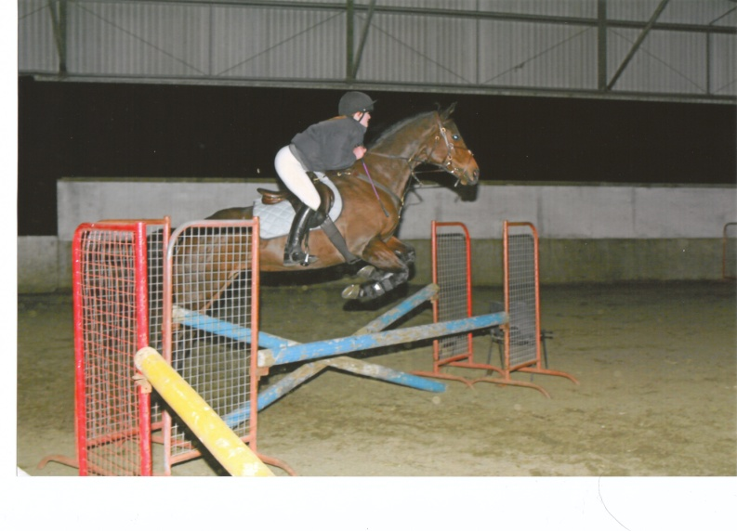As I approach the fence with the intention of turning right on landing, I ride into the fence at an angle from the left, like I said in the preparation phase, I do not always ride a straight line to the centre of the fence. Ellen does not do this as she rides to the centre of the fence to avoid knocking the pole from the wings. Just like when jumping a normal fence I approach the fence in an upright position however I do not fully sit on my seat bones as I tip forwards. This means that unlike Ellen, I do not drive my horse forwards with my seat with my horse on its hocks. To go into my jumping position I flex at my waist keeping my upper body parallel to my horse in order for us both to stay in balance. However, unlike Ellen, I tend to over arch my back; this makes my position look untidy and also means I lose balance. I lift up out of the saddle taking my weight off of my horse’s back allowing it to get height over the fence. On the point of take-off, like Ellen I follow my horse’s motion into the jumping position. My upper body is lowered and my seat retreats to the back of the saddle to absorb the horse’s motion. While in the jumping position I keep my back parallel to my horse’s back, however unlike Ellen, I sometimes over arch my back which causes me to become stiff. It makes my position look bad and affects my balance. Unlike Ellen, who continues to uphold a light contact through the rein to the bit I sometimes drop this contact a stride before the jump which means that I will be dropping my horse which causes my horse to bury under the jump. I do not give with my hands enough which restricts my horse from stretching through its neck, back and body which would give my horse the freedom of movement it needs. My hands follow the movement of my horse’s head and neck and I continue to look up. Whilst in the air I still continue to look ahead and over the jump which helps to keep my horse straight over the fence and allows me to look for the next jump. However, I sometimes have the tendency to look down which restricts my vision and means I cannot always see where I am going. Ellen does not do this. When riding a jump-off, Ellen is constantly looking where she is going so that she can look for shorter lines to a fence to save valuable time. It also means that she can see the correct strides into a fence. Ellen is much better at looking where she is going as in her training programme she will do specific exercises which make her look where she is going. I do not lean to one side or twist in my position as this would unbalance my horse and myself. I keep my knees tight into the saddle however my lower leg may swing a little during the take-off. This means that it is harder for me to pick up my horse upon landing as I have to readjust my leg position, which means there is a greater chance of my horse riding a difficult stride to the next fence. Ellen never has to readjust her position on landing as she keeps her body in the correct position. She knows how important it is to not waste time sorting out her position and how the slightest incorrect movement could mess up her horse's stride to the next fence. At the take-off I keep my lower leg 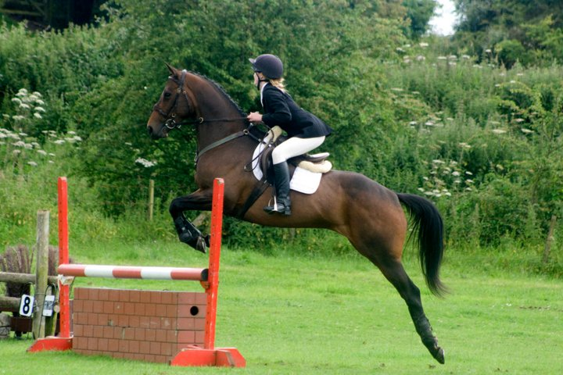securely wrapped around my horse, to uphold the horse’s energy and forward momentum. I also keep my leg on the girth, however unlike Ellen, when jumping bigger upright fences I have the tendency to swing my leg back when in the jumping position which means that I cannot maintain balance, this is because Ellen has much more experience than I do with jumping bigger fences. But different from just jumping a normal fence, when my horse is about parallel to the ground, I will give the aids to my horse to land on the right lead. I open my right indirect rein to encourage my horse to bend to the right. Also as I am opening my hand I place me left leg behind the girth, furthering the command for canter right. This means that my horse will land with the right foreleg first and on the right canter lead. This means that I don’t waste any time on landing, balancing my horse to perform a flying change, before being able to successfully change direction. Additional aids I use whilst in the air to make my horse turn in the air are shifting both of my hands slightly towards the direction of the right lead so that my outside hand acts as a mild neck rein and my inside hand acts as a mild leading rein. However, I can sometimes over exaggerate the opening of my right hand. Opening my right hand too much can cause my horse to fall out through its right shoulder and it also makes my position look untidy. Again, like Ellen, I also twist my upper body when in the air towards the right however I can over twist and end up leaning too far to the right which can have the opposite effect on my horse by it counteracting my movement to regain balance resulting in my horse moving to the left.**All the time whilst I am in the air I look to the right and on to the next fence which encourages my horse to shift its weight onto its right side and to change lead from the left to the right. The most important element to a successful turn in the air is balance. I try to ensure that I am in perfect harmony with my horse by allowing my weight to go with my horse. So when I’m turning right, my weight will be down in my right stirrup and more in my right seat bone. However, I do not bear enough weight into the left, so this results in me over leaning and unbalances my horse. Ellen does not do this as she trains on a daily basis whereas I train with a trainer once a week. Whilst in the air I relax my body and do not tense up.*

### Recovery:

*As my horse is near to clearing the fence I start to sit up to stop my horse from getting away from me upon landing .However, I can occasionally leave it too late to sit up which results in me pushing my legs forwards in front of the girth to counteract the downward movement and to keep my balance. Ellen is always quick to sit back; she doesn’t over fold like me. Instead she folds to the minimum amount that she needs to. This stops her from having to correct her position on landing and keeps her legs in the correct position. This also means that when I do not sit up quickly enough I cannot collect my horse up so my horse rushes and it reduces the amount of preparation time I have for the next jump. I sit up by firstly bringing my upper body back up into an upright position so that I will not lose balance. This means that I can easily regain control upon landing which allows me to control my horse’s speed which stops my horse taking off after the fence and allows me to adjust strides for the oncoming jumps. As my horse lands, I push my seat back into my saddle to give myself a better chance of setting my horse up correctly for the next fence. I continue to allow with my hands to allow my horse to stretch down over the up-right fence. I retake the contact by flexing at the elbow, as this also allows me to apply a half halt if needed to get my horse back onto its hocks and to create impulsion. However, unlike Ellen, I am sometimes a bit slow at this which means that I don’t give myself as long to prepare for the next fence. Once I have regained control upon landing, I open my hands to allow freedom in my horse’s neck to land. I retake the contact by flexing at the elbow, as this again allows me to apply a half halt if necessary to get my horse back onto its hocks and to create impulsion. However, sometimes I am a bit slow at this as I do not always pick up contact as quick as Ellen, meaning that I don’t allow myself as long to prepare for the next fence. My lower leg still remains on the girth however I sometimes push my lower leg too far forward in compensation to retain balance over bigger up-right fences. Ellen does not do this as he has more experience in jumping bigger fences and has adapted his seat and the way she rides to overcome this. If needed, I reposition my leg back onto the girth which then allows me to apply my leg if necessary to send my horse forwards to the next fence. I close my leg around my horse to obtain control because if my knees were loose I would be at risk of losing control after the landing which could have a negative effect on the next jump. I keep my toes turned in.* *I continue to look ahead and up focussing on the next fence whilst in the air, so that I can then position my horse appropriately on landing for the line that I am going to ride into the next fence. When landed I re-balance my horse and gather up my reins bringing my horse back onto its hocks to give plenty of energy and impulsion so that with the added speed in the jump off my horse isn’t jumping flat. By landing on the correct lead, I avoid having to make a flying change to change the lead altogether after the fence, approaching another, which makes my round smoother and gives me more time to think about the upcoming fence. Once I have landed and re-gathered on the new rein, unlike Ellen, I am not very quick to establish a balanced canter. Like Ellen, to ride well against the clock, I use firm hand and leg aids to instil the idea of instant obedience and quick changes however, unlike Ellen, my hand aides can be over exaggerated when pushing on or making a flying change over a fence. This causes my position to be incorrect which means that I am not using the correct aids. It also means that when over exaggerating for a change of direction my horse can fall out through its shoulder.*

**B2: Choosing your Line (Cutting In) to ride a successful jump off**

When in the jump-off, Ellen will look for the shortest lines to each fence that she can take. She considers how supple her horse is and how experienced she and her horse are as a pair. For example if she was riding a younger horse, she is likely to ride more simple, time consuming lines to give her horse a better chance of leaving the poles up and to gain experience.

### Preparation:

**Before even entering the jump-off she will have studied her course thoroughly so that she can plan ahead so that she can see where she can take her tight turns and where she can lengthen her horse’s stride between fences. Ellen begins and finishes her round by jumping as close to the start/ finish line as she possibly can. This means that she will plan to ride the appropriate line to achieve this, which may lead to her having to jump on an angle, or off of a bend. Ellen knows that shorter quicker lines and clear rounds can make her win. She will always look for something that no one else is likely to see, and take that risk. This is what gives her the competitive edge. On the approach to the fence Ellen has to look to ride a successful line to leave the fence standing but also look at her landing position to make the quickest distance to the next fence. This is why Ellen will ride at an angle to the fence. She will have walked the course before so that she can map out her route. She will have counted distances and strides between each fence so that she can choose the quickest route to get the fastest time but also ride lines which have the best chance of leaving fences up. She keeps her turns into the fences sharp but on an even stride to maintain balance. Ellen has good balance and a bold attitude to turn short into a fence. She encourages her horse to produce an athletic, rhythmic canter which is one gear up from the speed that she would normally ride again without allowing her horse to become flat. At the gallop, a bigger show jump is very difficult to clear, due to the long, flat stride. Therefore she does not gallop in-between fences but increases her horse’s strides after a jump. Then, three or four strides before the next fence she shortens the stride again to get her horse onto its hocks, remaining balanced for the next take-off. Getting her horse on its hocks underneath her creates energy for her horse to take off with. However she knows the risks of her horse lengthening its stride, consequently flattening into fences. A stronger stride into a fence also makes it more difficult to make a tight turn afterwards. Therefore instead of changing the speed throughout, she will still try and stay at the same rhythmical, impulsive canter round the entire jump off.**

### Execution:

**She approaches a fence on a smooth curve still allowing time for her horse to see the jump. She does not attempt to alter the shape of her curve as she approaches as this would make her lose her balance. Once Ellen has started to turn into a fence she does not take her eyes off the fence that she is about to jump. If she did, she would either over shoot or under shoot it. It is only until she has reached the jump that she then looks ahead to where she is going next. Her eyes are constantly fixed in the direction that she is riding and going to turn when she is moving over the jump, which helps her to land on the correct lead. But she also looks around her when cantering in-between fences to look for the next opportunity to make a tight turn into a fence or a cut through some fences to make the line to her desired fence shorter and quicker. She ensures that she is keeping her horse’s hocks underneath it and that she is riding her horse forward into her hands to enable her to make tight turns in between fences. This is especially important through her corners so that she is able to produce a balanced and accurate turn. A key aspect to Ellen’s style is that she remains as still as possible in her upper body over a fence as she knows that the slightest incorrect movement can throw her horse’s balance or stride off, increasing the chance of knocking a pole. She keeps a supple hip letting her horse determine the amount of forward bend that it requires over the fence in order to stay balanced. This will help her horse lift through the shoulder and lessen the chance of knocking it down. This also allows her a quicker recovery for a quick turn. The most important element to successfully turning tight into a fence or cutting between fences to make the line to the desired fence quicker and shorter is balance. Ellen ensures that she is in perfect harmony with her horse by allowing her weight to go with her horse. So if she’s turning right, her weight will be down in her right stirrup and more in her right seat bone. However, she still bears some weight to the left, so that she doesn’t unbalance her horse. When making a tight turn she remains sitting upright in the saddle, she never leans to one side as this will unbalance her horse around the turn, making the ride to the fence very hard. However, if Ellen has made a very tight turn with only a few strides into the fence she will lean forward to help encourage her horse to go forwards to the jump. Whenever Ellen makes a cut in or a tight turn she always keeps her leg on, to keep the forward movement and impulsion to clear the fences. Also by her keeping her leg on, it means that she is riding positively, increasing the confidence of her horse when turning in tight to a jump. If she did not keep her leg on and made a tight turn into a jump, her horse would most likely stop at the fence as Ellen would not be riding her horse forwards. She lets her legs hang long and underneath her, on the girth, with her weight down into her heals. She keeps a strong hold of her rein and gives her horse plenty of leg to let her horse know that she is confident and in control.** **Ellen always keeps her hands up and off her horse’s shoulder, with a 90 degree angle at her elbow, to give her maximum leverage and steering around the tight turns. If she wants to push her horse on for more speed she will apply more leg and give with her hands slightly, allowing her horse to stretch and cover more ground, this is also why she may tip forward slightly. She always keeps a contact of her horse so that it does not get away from her and so that she can easily half halt to make changes. If Ellen’s horse is on the wrong canter lead to turn or cut through into a jump she will make a quick flying change in order to rebalance her horse so that she can turn smoothly and successfully. To ride well against the clock Ellen ensures she gives her horse firm hand and leg aids to begin with to instil in her horse the idea of instant obedience and quick changes. Whilst riding her jump off she will occasionally have a quick glance to her time on the clock, this then allows her to see whether she needs to push on and make tighter turns or shorter lines or whether she has a quick time and doesn’t have to take many chances. Ellen has a high level of achievement motivation and she always wants to get the fastest time possible in her jump off. She is very confident when making really tight turns, giving her a short line into a fence.**

**B1: Choosing your Line (Cutting In) to ride a successful jump off**

*When in the jump off, I will look for the shortest lines to each fence that I can take. I consider how supple my horse is and how experienced I and my horse are as a pair. Ellen’s horse and Ellen are much more experienced than me and my horse, which means that I could not take some of the turns that Ellen might for example, this means that I am likely to ride more simple, time consuming lines to give my horse a better chance of leaving the poles up and to gain experience.*

### Preparation:

*Elle will have studied the jump off course before even entering the jump off, however I do not have the opportunity to do this at my level of competing. I have to virtually look for my lines as I am riding, which means that I can often miss opportunities to make cuts or means that a line I think looks good, may not be. When riding my route I ride the appropriate line to achieve the quickest time, which may lead to me having to jump on an angle, or off of a bend. I have learnt from people like Ellen that shorter quicker lines and clear rounds can make me win. On the approach to the fence I look to ride a successful line to leave the fence standing but I also look at my landing position to make the quickest distance to the next fence which is why I will ride at an angle to a fence. I keep my turns into fences sharp but on an even stride to maintain balance. I feel I have good balance however my balance is not as good as Ellen’s as she can control her body more than I can. I encourage my horse to produce an athletic, rhythmic canter which is one gear up from the speed that I would normally ride however, unlike Ellen, who keeps her horse on its hocks, I have a tendency to let my horse get away from me which causes my horse to rush into fences and jump flat increasing the risk of me knocking a pole. I try to approach fences on a smooth curve like Ellen, however my curves can become zig zagged as I try to rebalance and come at an angle to a jump. This is because I am not as experienced at riding curved lines like Ellen is. A stronger stride into a fence also makes it more difficult to make a tight turn afterwards. However, I tend to change the speed throughout unlike Ellen, which means that my ride around the jump-off has no rhythm as I’m constantly changing my horse’s speed. It makes my jump-off harder by changing speeds as I’m constantly shortening or lengthening strides to correct a wrong stride into a fence. This means that it is hard for me and my horse to get into a smooth rhythm together meaning mistakes are easily made. When in a jump off I tend to kick on in some parts and hold my horse back in others which means that my round becomes un-rhythmical and I lose an impulsive canter around the entire jump off.*

### Execution:

*Like Ellen, my round begins and ends with my horse moving over the start/finish line as quick as possible, however, I do not always consider getting as close to this as I can. Instead, when riding to the first and last fence, I will ride a straight and central line, which helps to increase the chances of the fence being untouched. I do not always keep the same rhythm round the course as I use my legs to push forwards and use my contact and seat to work as a break where I need it too. Whereas Ellen keeps a constant speed throughout a jump-off which means that Ellen and her horse are working in a smooth rhythm together which means that she is less likely to make an error. It also means that she does not have to waste time altering her position to change speeds. I often lengthen my horses stride to a fence and this almost always leads to my horse jumping flat and having a pole down. Therefore I maintain a strong contact so that I feel more in control of my horse, making it easier for me to place my horse on the line that I want to ride. Ellen always rides a perfect stride into a fence as she maintains a smooth rhythm throughout her jump-off which means that she can easily shorten or lengthen her horse’s stride to correct it, in time to jump the fence. I, however, do not collect my horse up to control its stride as I am too busy pushing my horse on or slowing my horse down which means my horse loses all of its impulsion to get height over a fence. Sometimes I can turn too tightly into a fence. This then just increases the chances of a refusal as my horse does not get time to look at the fence. This causes me too look down at the fence and tip forwards, unbalancing my horse and no longer riding positively towards the fence. Ellen does not do this as she has a lot more experience than I do competing on a regular basis whereas I just compete in my spare time at a much lower level. She also approaches her fences in good time giving her horse a few strides and a chance to see the fence. Once I have turned into a fence I do not always keeps my eyes on the fence as I tend to be looking for the right stride, this means that I either over shoot or under shoot the fence. I try to ensure that I am keeping my horse’s hocks underneath itself by half halting and sitting deep into my saddle however, like I have said before, I have a tendency to let my horse get too flat. This means that my horse is likely to knock the fence as it is coming into the fence with long flat strides as my horse does not have any impulsion to use its back end to get height over the fence. Ellen is very good at not letting her horse go flat. She is very quick to feel when her horse starts lengthening its stride so she quickly half halts to bring her horse back onto its hocks. Unlike me, she always upholds a contact with her horse which again stops her horse from becoming flat as she can easily half halt to bring her horse back onto its hocks. I make sure that I am riding my horse forward into my hands to enable me to make tight turns in between fences. This is especially important through my corners, so that I am able to produce a balanced and accurate turn. The most important element to successfully turning tight into a fence or cutting between fences to make the line to the desired fence quicker and shorter is balance. I ensure that I am in perfect harmony with my horse by allowing my weight to go with my horse. So, if I am turning right my weight will be down in my right stirrup and more in my right seat bone. I still bear some of my weight to my left, so that I do not unbalance my horse. However, I can sometimes put too much weight to my right causing me to tip to the right which then means that my horse will counteract my movement by moving to the left to regain balance. When making a tight turn I remain sitting upright in the saddle, however, unlike Ellen, I can sometimes lean too far to one side. This again will unbalance my horse around the turn, making my ride to the next fence very hard. When Ellen pushes on in her jump-off she slightly leans forward to help encourage her horse to speed up however I can get too excited when increasing in speed and lean too far forwards, collapsing on my horse’s shoulder. This means that my horse will be cantering extremely flat and it also means that I lose a large amount of control that I would have had if I was using my seat. Leaning too far forwards also causes me to give too much with my hands when cutting through fences and all these factors will increase my chance of making an error and knocking a pole. This again can make my horse flat and can mean that I drop my horse before a jump making it bury and it also means that my horse can back off from jumps as it does not feel the contact giving it confidence. Whenever I make a cut in or a tight turn I always keep my legs on to keep the forward momentum. I let my legs hang long and underneath me, on the girth. I always keep my hands up and off of my horse’s shoulder, with a 90 degree angle at my elbow, to give me maximum leverage and steering around the tight turns which I will need if I am leaning too far forwards, but this in turn can mean that I am being too harsh in my horse’s mouth. If my horse is on the wrong canter lead to turn or cut through into a jump because I may have been over leaning to one side, I will make a quick flying change in order to rebalance my horse so that I can turn smoothly and successfully. Like Ellen I will occasionally look at my time on the clock if the venue that I am riding at has one. However not every venue that I compete at has high quality timing equipment which means they don’t show my time on a clock. I therefore have no idea of my time which means that whilst riding my jump-off I have no idea how close I am to the quickest time and so I cannot tell whether I need to push on or whether I can take my time. This means I have to take a lot of chances as I have to go into a jump-off with the intention of cutting as many corners as I can to get the quickest time possible. This doesn’t always pay off as it increases the chances of me making an error and my horse knocking a pole. Ellen will always have a clock as she competes at a much higher level than I do and at more advanced venues. In addition I do not have much achievement motivation like Ellen as although I want to get the fastest time possible I am not confident like Ellen in making really tight turns, giving me a short line into a fence. I would rather jump a clear jump off in a slower time than increase the chance of making an error and having a pole down or a stop at a fence.*