Ride 1- Flatwork

A Downwards Transition from Canter to Trot
The elite performer that I am comparing and analyzing for this skill is Charlotte Dujardin.
A good transition from canter to trot should be smooth; it should follow on from one another and should not be abrupt. The transition should also be accurate, for example if in a dressage test the movement is to make a transition to working trot at the letter ‘F’ the transition should be made there, when the riders shoulder is in line with the marker. When the transition has been made the trot should be active, rhythmical and balanced.

Preparation B2
When preparing a transition from canter to working trot Charlotte will start to prepare her transition about 10 canter paces before she wants the transition to occur. This will also depend on what type of horse she is riding. If she is on a young or inexperienced horse she will prepare it more in advance, whereas if she is on an experienced horse she may not prepare it as in advance, especially if the horse is slightly backwards thinking and is not very forward. This is because if she prepares the transition too early it is likely that the horse will break from canter in to trot or the transition will be too early.
When preparing the canter to trot transition Charlotte will want to have a good canter with a three time beat to it. She will also want the canter to be rhythmical, with the correct bend and flexion to which rein she is on.
Charlotte’s preparation will start by slightly collecting the canter, this will help to warn the horse that a movement or transition is about to occur. She will do this by using a half halt with her hand aid and also by using her seat aid, she will use this by sitting slightly deeper into the horse but keeping an upright position through her body. Charlotte will also use her thighs to help collect the horse, she will use them by contracting them which encourage her lower leg aid to ease in the amount of pressure that it has against the horse’s side.

Preparation B1
When I am preparing a transition from canter to trot I try to use the same aids as Charlotte does, but some of my aids are not as clear and effective as Charlotte’s are. Due to Charlotte being in the autonomous phase of learning she does not have to think so much about what she is doing, and therefore can plan ahead. I am in the associative phase of learning and moving towards the autonomous phase so when the movements are complex or there is a lot of other factors affecting me for example the crowd, other noises, my horse being naughty I am then thinking about these factors which causes my preparation to be late or poorly prepared.
My horses canter may sometimes become a four time beat which then causes it to become backward and on the spot so the transition may be abrupt and not flowing. This will also cause the trot to be lacking impulsion and connectivity. My canter usually becomes four time due to me not using enough leg to keep it forward. This is due to my horse finding the balance of the canter hard so in a small dressage area we tend to lack forwardness and energy.
The canter that me and my horse has is not always rhythmical, this is due to it lacking balance, so going through the corners the canter strides become very short and choppy, and then once through the corner the canter strides become longer and flatter. I also find it hard to keep a rhythm due to my horse being tense so the rideability is lacking.
I will start to collect my canter, but unlike Charlotte who will be able to keep an active collected canter I find it hard to, this is due to my horse not understanding that my leg aid doesn’t only mean go forwards and therefore it tends to have a faster tempo or it resists the hand and leg aid when they are applied at the same time. When preparing a downwards transition from canter to trot I tend to collapse my core, due to a lack of core strength. This then causes my horse to become strong, and the movement not being as aesthetically pleasing as it could be.

Execution B2
When the canter is slightly collected and the horse is listening to Charlotte she will slowly close her thighs, sit deep into the horse and ask for trot.
If the horse does not trot when Charlotte has asked it to she may use a more severe half halt. In training at home if her horse is not responding to her aid and therefore not doing the transition Charlotte may use a small circle to help the transition happen more easily.
Execution B1
When my horse becomes more collected in its canter I will use the aid of squeezing my thighs. When I do this I tend to grip with my knees which can make me out of balance to my horse and therefore it results in a poor transition due to it either falling into trot or it not being aesthetically pleasing.

Recovery B2
Once Charlotte has completed the transition from canter to trot there will be several things she will be looking out for and doing. She will want the horse to be going forwards in the trot. To achieve this she will be using both legs at the same time by squeezing them. If the horse doesn’t respond to this and drops behind the leg she will use both legs and give the horse a kick.
Charlotte will also be making sure that her horse keeps a consistent contact down the reins throughout. This will also help the horse keep the same outline. If her horse drops behind the vertical Charlotte will either lift her hands slightly, push her hand forwards or flick her hand upwards to encourage her horse to bring its head and nose outwards.
Charlotte will want the horse to have the correct bend through its body and neck and flexion through its poll. She will have this in the canter and will encourage the horse to keep it throughout the transition and when in the trot.
Recovery B1
My transition from canter to trot tends to either be very sudden which then causes the trot to be lacking impulsion and energy, or in some cases my transition will not be well prepared and my horse can fall into the trot causing my trot paces to be very long flat and fast.
My horse usually comes behind the vertical during the transition due to it being quite a tense horse. I do not respond or anticipate quickly enough to this and therefore do not correct it quickly enough. This causes my horse to drop off the contact and then causes it to become hard to ride and maneuver around an arena.
My horse has good flexibility through its body so it is easy to gain the correct bend. If my aids are not clear though, for example a half halt with my outside rein, or a squeeze with my leg aid can cause confusion and make incorrect bend. This will occur if one of my legs squeezes harder than the other it will cause my horses quarters to swing or bend away from the stronger leg. If I use a half halt too severely and don’t have and contact with my inside hand it may cause my horse to think we are turning to the outside or that I want it to bend to the outside, also known as counter flexion.

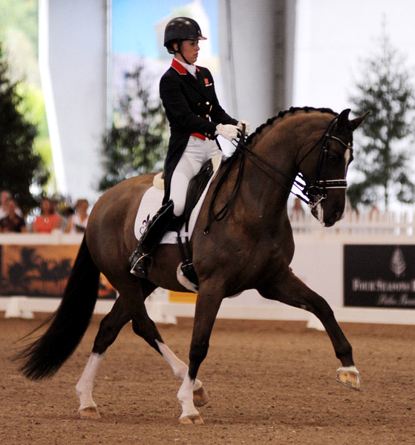
Half Pass in Working Trot
Half pass is when a horse will bend through their body and will cross their legs over to move sideways (laterally) the way at which the bend is. For example if the horse is bent left, they will travel left by moving their right legs underneath them to cross over and move sideways. I will be using Charlotte Dujardin as the elite performer to compare myself to.
Preparation B2
For the preparation of a half pass Charlotte will have a good balanced and active working trot. She will have an active trot to help the horse be able to provide power to push their legs underneath them and also to be able to move forwards and sideways at the same time. Without power the rhythm of the trot will be lost and the size of the trot steps with decrease which will cause her marks in a dressage test to decrease. She will also want to have a good contact with the horse’s mouth and she will be encouraging the horse to be active behind, she will do this by using her leg aid and by doing several half halts with her hand aid to keep the rhythm the same and not allowing it to get longer. If the horse is not active behind it will cause the cross over behind to not be so impressive and will also cause it to be a lot more difficult for the horse. If the trot stride becomes long and fast it will become hard for the horse to cross over and for Charlotte to be able to engage the horse and use the correct aid to get the horse to move sideways, which therefore means the sideways step will decrease dramatically. Charlotte will also use her seat to keep the rhythm and then activeness; she will do this with her core strength and her seat position. If Charlotte were to allow the horse to lose rhythm and activeness the dressage judge will decrease the mark that they are giving her for that movement and it will also make the movement less fluent and aesthetically pleasing. Charlotte will ride through the corner, she will ride fairly deep into the corner so that it gives her more space and time to be able to prepare. If charlotte doesn’t ride through the corner it may cause her not to smoothly and successfully get the correct bend, and therefore the half pass will be late to start and may not have the correct bend. Charlotte uses her leg aid through the corner to encourage the horse to bend through its body and about her leg. She will also use her hand aid to encourage the horse to bend to the inside.

Preparation B1
When I am preparing to do the movement of half pass my working trot is not as energetic and as powerful as Charlotte’s, this then causes the horses cross over to be less and also causes the paces to be less forward. This is due to my horse not being as established and also due to me lacking in core strength to be able to hold the horse together to prevent it getting long. Due to my lack of core strength it causes me to tilt forwards in my saddle making my lower leg insecure. The contact that I have with the horse’s mouth is less consistent than Charlottes, this is due to not having the horse’s hind leg underneath them as much as Charlotte’s horse, and also due to Charlotte’s horse being more established in the movement and its muscles would be more specifically trained and stronger to be able to do the movement. My leg aid is not as clear as Charlotte’s which can confuse the horse. This is due to me not having as much experience and my balance not being as good as Charlotte’s which causes my lower leg not to be as stable. Also I am not as good at anticipating when to do a half halt due to not being as experienced at the movement, this can cause my half pass to become too fast and lacking in sideways movements. I find the preparation hard, this is due to all the movement coming up quite quickly and I usually don’t prepare for it early enough which then means my transition into it is either late of not fluent and established.

Execution B2
When Charlotte is performing half pass she will have an active working trot. She will be using her seat and hand aid to keep the horse supple and with a slight inside bend. As Charlotte comes through the corner she will place her outside leg behind the girth and apply pressure against the horse’s side. This will cause the horses hind quarters to move away from her leg, and encourage bend through the body. She will keep her inside leg on the girth to control how much and how quickly the horse moves sideways. If she doesn’t have her inside leg on the horse’s side it will ‘fall in’ or lose its balance and the steps will not be consistent. This will then result in the dressage judge marking her down. Charlotte will then slightly turn her shoulders the way she is wanting to go, for example if she is going from the letter ‘F’ to the letter ‘H’ in a dressage arena she will position her shoulders towards the letter ‘H’. This will help aid the horse to move sideways, due to when she turns her shoulder it will cause her right leg to push against the horse’s side. She will place her inside leg on the girth to stop the horse bending too much and crossing over too quickly and to help control the balance and step. Charlotte’s hand aid will not change dramatically, she will use her outside hand, in this example it will be her right hand to support the horse’s balance and control the pace. Her outside hand will also prevent the horse from bending and flexing too much. Charlotte’s inside hand will be used to encourage the bend by using lots of little half halts and holding it slightly to the inside, in this case it will be held slightly to the left.

Execution B1
When I am performing a half pass my horse gets a little tense due to not accepting the leg aid very well, this causes the suppleness to decrease and it becomes hard to keep the inside bend.
When I am going through the corner like Charlotte I place my outside leg back, my horse sometimes resists this and fights against it by hollowing or rushing forwards. Due to my knowledge of this I tend to be slightly hesitant of putting my leg on and therefore when carrying out half pass my horse and I do not have enough cross over in the paces. It also causes my horse not to have enough bend through its body and can cause the quarters to trail behind and the shoulder to lead too much. This causes the judges marks that they award me for this movement to be low.
Due to not being able to put my leg on very much it means I cannot use my inside leg aid to stop the horse falling in and loosing balance as much as Charlotte does. Also due to my poor core stability it causes me to be out of balance with my horse which results in my leg not being stable and therefore is not in the correct position to ask for half pass.
When I am out the corner I try and turn my shoulders the way that I am going. Unlike Charlotte who does this and stays completely upright I tend drop my left shoulder down. This results in me collapsing my body down the left side meaning there is more weight on the left side of my horse. This will make it harder for my horse to cross over and move to the left. This occurs due to my poor core strength.
Unlike Charlotte when I am doing half pass I am not able to use as much leg to help keep my horse from having too much bend and flexion. This causes my horse to be very bent when doing half pass whereas Charlotte’s horse will have less bend so therefore move laterally more easily.

Recovery B2
When Charlotte reaches the marker ‘H’ she will turn her shoulders to the inside, in this case to the right. Her leg aid will change. Her new inside leg which was originally the leg behind the girth pushing the quarters over will now be placed on the girth and will apply pressure to the horse’s side to encourage the horse to bend through its body to the new inside which in this case will mean bending to the right. Charlotte’s new outside leg which was the leg helping balance the horse and stopping it moving over too much will now be placed just behind the girth to stop the horse from falling out and to help encourage it to bend around the inside leg. Charlotte’s hands will not change a huge amount, although if the horse is not very responsive to the leg aid she may use her hand aid to encourage bend. This may be done by several half halts, a gentle feel down the rein or even by widening her hands.

Recovery B1
When I am recovering from half pass my aids are similar to the aids that Charlotte will use but are not always clear enough and are sometimes not firm enough so the horse does not respond to them. Due to not turning my shoulders as much as Charlotte when I am doing half pass it therefore means I cannot change them as much after completing the movement. This causes my aids not to be as clear to my horse as they could be. On the right rein I find it especially hard to gain bend around my inside leg without my horse falling in due to my right leg being weaker than my left leg. Due to this I have to use more hand aid which is not correct and it has a big risk of my horse resisting the change in rein aid and contact.

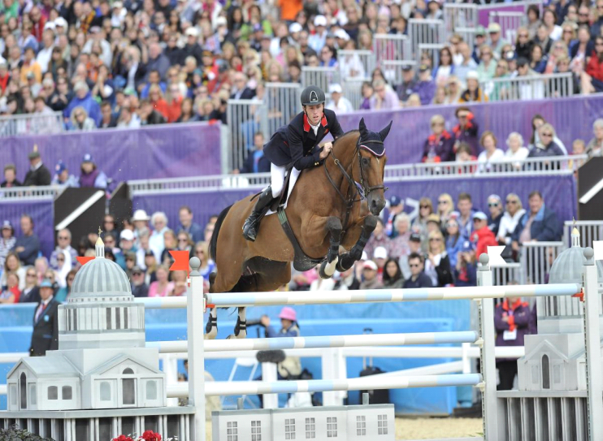
Ride 2- Jumping
The elite performer that I will be comparing myself to when jumping a single fence is Scott Brash. He is an international and Olympic show jumper and is ranked number one in the world.

Jumping a Single Fence
When jumping a single fence Scott will be trying to keep the same rhythm the whole way into the fence. He will make his approach effective, for example if he is riding a tight line to an upright he will have a more collected bouncy canter than if he is coming on a smooth curve to a spread fence where he will have a slightly more forward canter. Scott will make sure his position is good in the approach to the fence, in the air and landing of the fence. This is to ensure he doesn’t affect the horse in a negative way.
Preparation B2
Scott will prepare jumping a single fence in several different ways; he will do this by using different aids, which will be done by his body and sometimes his voice. Scott will normally approach the fence in a canter; this is because canter is the most natural pace for the horse to jump from. In some cases he may approach in trot if he is on a young horse, warming up a horse, or doing some grid work in training at home. Scott will have an active working canter, he will do this by using his seat aid and core strength to prevent the horse from getting long in its paces and so that he stays in balance with the horse. He will do this so that it is easier for the horse to jump the jump and also if the horse’s canter gets very long it will find it a lot harder to put in a short stride before the jump which may cause it to have a fence down or a refusal. He will sit lightly in the saddle so that he allows the horse to work over its back and be active behind without it being too strenuous. If Scott were to be sitting very heavily in the saddle the horse may become tight over its back and may find it hard to keep its canter active which will therefore mean that the actual jump is not easy and uncomfortable. It may also cause the horse to have a fence down. On the other hand if Scott were to sit too lightly in the saddle it may encourage the horse to want to gallop or have a much more forwards, free flowing and long canter. He will use his lower leg aid by applying pressure against the horse’s side. This will help encourage the horse to stay active but will also help aid the horse’s hind leg to become underneath it. If Scott feels the horse is not active behind and is not working over its hind quarters he will use a double kick with his leg aid, this is when he will do two close together little kicks with the lower part of his leg. If he does not use his lower leg the horse may lack energy to its canter and this will then cause the jumping effort to be difficult and if the jump is of a decent height it may cause the horse not to be able to jump it. Scott’s lower leg aid will also help him to stay in balance with the horse. In preparation of jumping a jump Scott will use several half halts with his hand aid to help keep the horses canter up in front and active. If Scott doesn’t use half halts the horse may begin to run and its canter will become flat which may cause the horses jump to be flat in the air, resulting in a knock down.
Preparation B1
When I am jumping a single fence I try to prepare it to make it easier for me and my horses. I do this by creating a good canter in approach to a fence. Sometimes my canter can lack impulsion, this is mainly due to having to make a turn and my horse lacking in balance so having to go slower for the turns. When doing this instead of keeping my leg aid strong like Scott would do I take my leg off slightly causing my horse to lose impulsion. This then causes the jump to be a lot harder for my horse. When I am preparing to jump a jump and I cannot see a good stride to the fence I tend to sit a little heavy in the saddle, this causes my horse to hollow and become very tight and tense over its back. Also instead of sitting still with a soft hand like Scott will I tend to tighten my arm and take a check, this sometimes causes my horse to resist and put its head up causing the jumping effort to be a lot more strenuous and sometimes it will put me into a bad take off spot, which is normally too close to the fence.
Unlike Scott I find it hard to feel when my horse is working over its back and is active behind. This then causes me not to be able to anticipate when to use a double kick which therefor means my horse tends to lack activeness behind and I also don’t correct it in training unless I have an instructor telling me that it is not active behind.
My lower leg is not as effective as Scott’s due to a bad habit of mine is gripping with my knees’. I tend to do this due to my poor aerobic fitness meaning I fatigue quickly and therefore find it hard to stay in balance with my horse. This then causes my lower leg to be very loose against the horse’s side. As a result of this it means I do not have a lot of pressure against the horse’s side which causes my horse to lack in activity and energy to move forwards. When riding a slightly tired or laid back horse I find it very hard to create energy and find that it is much harder to jump due to there not being as much impulsion to get over the fence. Due to Scott being a lot fitter and stronger than me he will be able to use his leg aid effectively for longer which will enable him to produce impulsion and energy to get over the fence. Also due to my leg being loose against the horse’s side I find staying in balance with the horse a lot harder. For example my chest usually becomes too close to the horse’s neck when I fold in the air and also my lower leg slips back.
When preparing to come to a fence I tend to use too many half halts which causes my horses canter to become very on the spot and sometimes it changes from a three beat canter to a four beat canter. This then causes the jump to be a lot more strenuous for my horse.

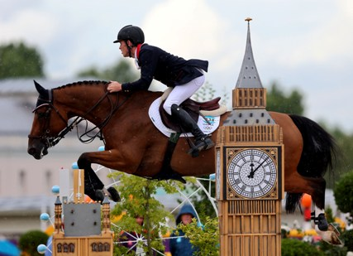
Execution B2
When Scott is jumping a fence he will try to make his body-weight affect the horse as little as possible. For example he will lift his bottom out of the saddle which will bring his weight off the horse’s back. This will allow his horse to work over its back and be able to use its back muscles. If Scott were to sit heavily on the horse’s back when going over a jump his horse would tighten through its back and slightly dip its back causing it to not be able to use its hind end over the jump. This will usually result in the horse having a pole down with its back legs, and if Scott were to continually sit heavy on the horse’s back in the air it may cause the horse to start refusing to jump the jump and it may cause the horse pain over its back. Scott will bend forwards at the hips when jumping, as you can see from the picture about. He will be conscious that his shoulders do not drop too low because this would then load the horse’s front and shoulders which then may cause the horse to knock a pole down with its front legs. Scott will push his hands forwards along the top third of the horse’s neck. This will allow the horse to stretch its neck down and encourage it to stretch over its back and bascule over the fence. When in the air Scott will begin to start looking at the next fence, this will help to encourage the horse to land on the correct leading leg which will help to save time due to not having to do a flying change or a change of leg through trot. Scott’s lower leg will hardly change due to his high fitness level and muscular strength and indurance. He will keep some pressure against the horse’s side from take-off right through to landing. He will use his leg position to help keep his balance, so for example when the jump that he is jumping is small his leg will not come back at all and will stay on the girth, but when the jump is big his leg may slide back a little, like in the photo to help keep his balance with the horse instead of bracing himself.
When the horse is starting to come down on landing Scott will alter his position in several minor ways to help allow the horse to find its balance and for him to be in a good position and ready to ride to the next fence on landing. Scott will bring his shoulders slightly up and back, he will do this so that he does not load the horses front and so that he is in balance. If he were not to do this it would be likely that he would fall on the front end of the horse, and the horse would have a higher risk of falling and stumbling on landing due to Scott’s weight being influential. When Scott brings his shoulder up he will also push his legs into a more forwards position. This will help Scotts balance. If he did not push his legs into a more forwards position he may fall off the front of the horse or will collapse his body onto the horses neck. Scott will keep his hands as forwards as he can so he doesn’t catch the horse’s mouth which will result the horse in chucking its head or hollowing which might cause it to have the fence down behind.
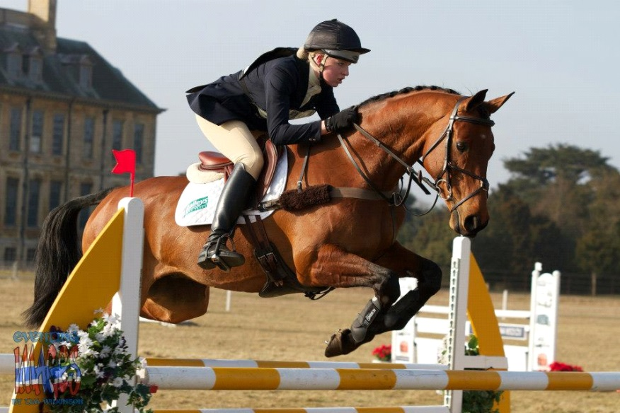
Execution B1
When I am jumping a fence like Scott I try and get my weight out of the saddle as much as possible but sometimes when I am not on a good stride pattern or my horse takes off in an unexpected place I tend to sit slightly heavy on my horse normally due to being slightly left behind. This then causes my horse to hollow and tighten over its back. This then results in my horse being unable to use its muscles correctly and therefore the jump is affected negatively and we then have a fence down. When jumping like Scott does I will bend at my hips, but when I do this I tend to collapse my upper body which causes me to be too close to my horse’s neck and shoulders. My body position causes my weight to load my horse’s front which can cause my horse to have a fence down with its front legs due to it being a lot more effort. Like Scott I will push my hands forwards to allow the horse to stretch its neck over the fence. Sometimes I do not give enough so my horse’s neck is still quite tight in the air over a jump. This will cause my horse’s frame to been quite tight and won’t allow it to lengthen. As a result of this my horse may have a fence down and in the long term it may start refusing to jump. Also due to my hands being a little tight it will cause my horses jump to be rigid and will not allow my horse to be able to bascule over the fence, this will cause my horse to have a bad jumping style and also it will not be as aesthetically pleasing to watch.
When I am in the air over the fence like Scott I start looking at the next jump. But unlike Scott when I do this I find that I change my weight distribution on top of the horse. This sudden change in weight distribution can shock my horse. This then causes my horse to tighten over its back, as a result of this it may cause my horse to have a pole down especially if jumping over a spread fence. My horse may also speed up due to my sudden change of weight. For example my horse might go very quickly through the air it may shoot off on landing.
When I am jumping due to my bad habit of gripping with my knee my lower leg position changes from take-off position and through the air and to landing, whereas Scotts leg position will hardly change throughout due to his muscular strength and endurance. When my horse takes off unlike Scott’s my legs tend to slide backwards. This is due to my body folding forwards, and my knees holding me in position so my lower leg is loose so goes back due to the horse being upright. This also becomes worse when I begin to fatigue due to my poor aerobic fitness.

When my horse is over the top of the fence my leg position is in a better position on the horse’s side. This is due to my balance position changing. I will be starting to bring my shoulders into a more upright position so my legs will move slightly more forwards towards my horse’s shoulders.
When my horse is beginning to land from jumping a fence I tend to do either of two things with my body. One of which is when I bring my upper body position up too quickly. This then puts extra weight on my horse’s back which can cause it to have a fence down, whereas Scott’s weight over the fence and on landing does not hinder his horse at all due to his weight being evenly distributed and in an effective place at the correct time. I usually bring my upper body up too quickly when my horse has got in deep to the fence or if I have to turn sharply on landing. When this occurs it also affects my position with my hand, when I bring my upper body up too quickly it also causes my hands to be lifted and drawn back which causes my horses neck to become shorter and tighter. This can cause a lack of balance for the horse on landing and may cause it to stumble.
Another fault of mine that occurs when I am beginning to fatigue or have seen a bad stride or a long flat stride to a fence is that my upper body collapses onto my horses neck and on landing I don’t bring it up quick enough so this loads my horses front end causing quite a lot of strain on my horses front legs due to being on its forehand and having my weight on its front end when it lands from a fence. When this happens it also effects the positioning of my hands and therefore affects the contact with the horse’s mouth. Scott will always have a contact with his horse’s mouth but due to my position being too far forwards it means that the distance from the horse’s mouth to my hand it a lot shorter and this will then cause my reins to be loose. Due to my reins being loose it means that I cannot support my horse and help it balance if it were to stumble or peck slightly on landing.

Recovery B2
When Scott has landed from a fence the first things that he will be wanting to do is to be starting his approach to the next fence with a good quality canter and a canter that is suited to the fence he is about to jump. This will mean his canter being balanced, energetic and in a consistent rhythm. Scott will use his shoulders and leg aid to turn the horse in the direction that he wants to go. For example if he wanted to make a right turn Scott would turn his shoulders to the right. He would then put his inside leg, the right one on the girth to encourage the horse to bend round his leg. His outside leg, in this case his left one will be fractionally behind the girth to stop the horse falling out. Also his outside hand would be against the horse’s neck to stop the horse falling through its shoulder on the turn.
If the jump that Scott is recovering from has not been successful or can improve Scott will want to do sometime about this as soon as he lands. For example if the horse has taken off on a very long stride and a long way off from the fence he will then want to get the horse back to him and sitting on its hocks as soon as it lands. He will do this by using his leg aid and doing a half halt. On the other hand if his horse has got a bit deep or has been a bit backwards and lethargic over the fence and on approach Scott would land and want to do something about it. For example he would move the canter on a bit. He would do this by squeezing with his leg aid.
Recovery B1
When I have landed from a fence I am a lot slower to react and organize my horse’s canter and my position than Scott is. This means that I have normally travelled a couple of strides before being back in a good quality canter and me being in a good position.
Due to Scott being in the autonomous phase of learning when he from a fence he is very quick to anticipate what needs to be done to improve whereas when I land I am not very good at anticipating what changes need to be made to my horse’s canter. This can cause me to have several bad jumps in row due to not changing the factors affecting me and my horse.
When I am turning to start my approach to the next fence, unlike Scott who uses his body mainly to turn his horse I tend to use my hand aid to steer and encourage the horse to go the way I want it to. This has several negative results, one of which is that it can cause the horse to fall out through its shoulder which will then mean then approaching the next fence the horse will not be straight so to take off in front of the fence will be a lot more strenuous due to not having as much power. Also it can cause the horse to dangle an individual leg which may cause the horse to have a pole down. Due to using my hand it may also make my horse start resisting my hand and becoming very strong which then makes it a lot harder for me as the rider to be able to give and soften my hand in front of the fence. Due to this being hard it causes my horse to be very tight in the air over a jump and can also make my horse jump very flat.

Jumping a Triple
For this skill the elite performer that I have used as my comparison is Scott Brash. He is a top class Show Jumper.
Jumping a triple is when there are three fences made up either of upright fences, spread fences, or a mixture of both. They will be placed either one horses canter stride or two horses canter strides apart from each other. They involve a lot of effort from the horse and for this reason are not used in lower level competition.
Preparation B2
When Scott is preparing to jump a triple he will want to ensure that he can do everything in preparation to make the ‘triple’ as easy as possible for the horse.
To approach a triple Scott will make sure he has a canter that is adjustable. He will do this by several things. One of which will be in his warm up, he will ensure that he can move his horse forward into a medium canter by using his leg aid and his seat to help push the horse forwards into a uphill medium canter. He will also ensure his horse is focused on his aids and that he is able to easily bring the horse back to him by minor alterations of his body position. For example he will bring his shoulder back and a little more upright when asking the horse to come back to him in to a steadier more collected canter.
Scott will also make sure that his horse is very supple over its back and through its neck. This is important because if the horse is stiff in its body or through its neck it will not be easy to adjust in the approach to the fence. Also if the horse is stiff it may cause pain when jumping through the combination which may result in a lack of confidence of the horse. In the long run this may cause the horse to start refusing at jumps. To prevent this happening Scott will work on doing suppleness exercises at home, but also on approach to a fence he will work on flexion of his horse. He will do this by gaining correct bend round his inside leg when doing a turn to a fence. If he were to over shoot his ideal line of approach to the fence he may use the dressage movement of leg yield to move the horse back onto the correct line, this will also help to encourage suppleness over the horses back and through its neck.
Scott will also make sure that his approach to the triple if very straight. This is very important because it allows time for the horse to read and understand what it is being asked to do. For example if Scott were not to approach the fence straight the horse may not see the third part and therefore may refuse or have to jump awkwardly.
Scott will make sure he has an effective body position. This is to ensure he is able to help the horse if there were to be a difficult situation, or the horse was not to do as expected. This may be something such as the horse backing off the fence. In this case Scott would have his body position a little behind the horse’s movement which would make him able to drive the horse a little more forwards in hope to get over the fence successfully.

Preparation B1
When I am preparing to jump a triple I try to make my canter adjustable like Scott does. But when I bring my canter back to a more collected canter I tend to use too much hand aid and this then causes my horse to fight against me and become hollow. It also means that my canter does not have a lot of impulsion to it due to me having to take my leg off to encourage to horse to go slower. Whereas Scott will use his body position to bring the horse back so he will be able to keep his leg aid on and this will help the horse’s canter have more impulsion and energy. When I am preparing to jump a triple I also like Scott try to move my horse’s canter forwards into a medium canter to make sure that it is on the leg aid. But when I do this my position usually becomes to forwards into a half seat position which causes my horse to become to free and therefor gets very long and flat in its paces. Scott will prevent this from happening by having a more upright position and by taking several half halts throughout the medium canter strides.
Usually when I jump a triple it will be mid-way in a course of jumps. Throughout the course my horse tends to get a little fixed and stiff throughout its body and neck. This is usually due to me not keeping the correct bend round the turns, whereas Scott will keep the correct bend depending on which way he is turning to which rein he is on. To do this Scott will use his inside leg (depending on which rein he is on) against the horse’s side to encourage the horse to bend through its body and he will use his inside rein to encourage the horse’s neck to bend to the inside. Scott will also use his outside rein by holding it close to the horse’s neck. This will help prevent the horse from falling out through its shoulder and will also prevent too much bend through the body. This skill is one of my bad habits as unlike Scott I tend to have a loose outside rein which then causes my horse to fall out through its shoulder. Also my horse gets stiff because I tend to keep the same canter pace and rhythm throughout the course so my horse does not have to listen to my aids and shorten and lengthen itself so as a result becomes stiff in its body.
When I am approaching a triple, I tend to turn too early. This then causes my approach not to be straight and therefore my horse cannot see the whole combination. This has several negative effects. For example Scott will approach the combination on a straight line so his horse can see the whole combination and understand what it is meant to do, whereas my horse will not have had a chance to see and understand the whole combination so will have to either guess what it has to do and make late decisions. Scott’s approach will also allow him more time to be able to alter his stride pattern if necessary, which will make the place at which the horse takes off more ideal. Whereas due to my poor approach to the triple it will not allow me as much time if any to be able to alter my stride pattern so if I were to have a bad spot to take off I wouldn’t be able to change it. This may cause my horse to refuse, or have fences down and it will make the distances throughout the combination a lot more difficult for my horse to make.
Like Scott I will try and make my body position as effective as possible so that I am able to use different aids easily depending on the situation. If my horse backs off a fence unlike Scott who will use his upper body by moving it backwards to drive the horse I tend to collapse my upper body forwards which will therefore mean I am not in an effective position to encourage my horse forwards.

Execution B2
When Scott is jumping a triple he will keep his body still and stay in balance with his horse throughout all three fences. He will not make any dramatic changes throughout the combination unless it is necessary. When he is jumping the first part of the triple he will go into a normal jumping position. He will give with his hands to allow the horse to stretch through its neck and over its back. He will do this by pushing his hand forwards along his horse’s upper neck. He will then fold forwards at the hip to lighten his weight of his horse’s back. This will allow the horse to be able to ‘bascule’ over the fence. This is the correct way a horse should jump. Scott’s lower leg will stay in a fairly forwards position. This will help his balance and will help keep his body in an effective position. If Scott’s lower leg were to swing too far back it may cause him to become in front of the horse’s movement and therefore out of balance. This may cause Scott to fall off or cause the horse to become lower in front resulting in the fence being knocked down.
Once over the first part of the combination Scott will bring his shoulder up and back into a half seat position. He will go into this position so that his weight doesn’t suddenly alter. For example if he were to suddenly sit onto the horse’s back with all his weight it would be likely to cause the horse to hollow and tighten over its back. If Scott were to do the opposite and keep his body in a jumping position it would encourage the horse to quicken and become flat.
If Scott is riding a horse that is quite quick through the air and or has a big stride it is important that he tries to prevent it making up too much ground in the combination. To slow the horse down in the air Scott will not fold his upper body forwards as quickly or as much as he would normally. This will help prevent the horse being too quick in the air. Once Scott has landed over the first part of the combination he will bring his shoulder up and back quickly and will use a half halt to slow the horse down and stop it taking too big a stride between each part of the combination.
If Scott were on a horse with a small stride or a horse that is slow in the air he will need to be able to make up the distance in the combination. This may be done by riding a lot more forwards in approach to the triple. But it may also be done throughout the triple. Scott will land in quite a forwards position and only bring his shoulders up fractionally throughout the combination. Once landed over the first part he will use his leg aid to encourage the horse forwards. He will use his leg by either doing a small kick with his lower leg or just by squeezing his leg against the horse’s side. When in the air over the fence Scott will keep his leg aid against the horse’s side to keep encouraging it forwards.
Scott will then jump the second part of the combination. He will change his position depending on the situation he is in.
If Scott’s horse were to make up too much ground in the combination and as a result it is taking off quite close to the second part of the combination Scott will do several things to try and resolve the issue. When folding forwards into the jumping position he will not fold as much as usual and will keep his shoulders a little more upright than usual. Also he will fold his body forwards in a slower motion to help prevent the horse from quickening and thinking that he wants to go more forwards. With his hand aid he will not give as much. This is quite a precise skill as if Scott were not to give enough it may catch the horse in the mouth and cause it to chuck its head, drop a back leg over a fence, become tight in its whole body and though its neck causing the jump to be uncomfortable and it may also cause the horse to be put off balance. Scott may also keep his lower leg in a more forwards position. This will help him to keep his position in balance and in a more upright position. Having his leg position further forwards will also put Scott in a position where he will be stronger due to being in better balance. This will enable him to steady the horse even if it is strong.
If Scott’s horse were to be a long way off the second element he would try and encourage the horse forwards to ensure that it is able to take off from further away from the fence. To do this he will land after the first element and use his leg aid to send the horse forwards. He will do this by either applying pressure against the horse’s side or by giving the horse a nudge with his lower leg.
Once over the middle part of the triple Scott will be able to anticipate what is needed to be done in-between this and the finial element. He will react to the situation in the same way at which he does when adjusting between the first and second element depending on the situation.
Scott will keep his eyes and head up to anticipate what is going to happen through the combination and be able to make any alterations when necessary. If Scott were to be looking down it may cause a change to his balance but will also cause him to be unable to predict what is going to happen within the stride pattern so he will not be able to make alterations as easily.

Execution B1
When I am jumping a triple unlike Scott I find it hard to stay completely in balance with my horse. As a result I tend to collapse my core and use too much hand aid to try and stay in balance with my horse. This causes my body weight to load my horse’s front end causing it to become on its forehand. Also due to me using too much hand aid it can cause my horse to be tight over its back and not able to stretch its neck in the air.
When Scott is in jumping position he pushes his hands forwards to allow the horse to stretch. When I am in jumping position I tend not to give with my hand enough. This then causes my horse to not be able to stretch as much and causes it to be rigid over its back and neck. This then results in my horse having fences down and not being as aesthetically pleasing to watch.
Like Scott I also bend forwards at the hip to allow my horse to bascule over the fence but when I do this I tend to bend forwards too quickly and too much whereas Scott will use his core strength to stop him collapsing onto his horse’s front and will be able to stabilize his upper body to allow him to fold slower. Due to my faults of collapsing my upper body and folding too far forwards it causes my weight to load my horse’s front making it a lot harder for it to jump and causing it to land on its forehand.
When I am jumping my lower leg is not very secure so moves a lot and ends up sliding quite far back, whereas Scotts lower leg will stay quite consistent and still. Due to my lower leg not being stable it means that for me to stay in balance with my horse are quite tricky and therefore I tend not to be in balance.
Once I have jumped the first part of the combination unlike Scott who will go into a half seat position I tend to stay in a too forwards position. This causes my horse to quicken through the non-jumping strides of the combination and it also usually causes my horse to become long and flat in its canter paces.
Due to my position in-between the fences it tends to mean that my horse makes up too much distance. Unlike Scott who will anticipate this and be able to alter his stride pattern fractionally by using his body position I tend to use my hand aid to steady my horse. This causes my horse to fight against my hand and become tight over its back and through its body.
Due to my reaction to my horse making up too much ground when I am jumping the second fence of the triple I tend to still be tight in my hand and my horse tends to be above the bridle and tight in its neck and back. This can cause it to not be able to see and judge where to take off at the fence, which may result in having the fence down or it refusing.

Recovery B2
When Scott has jumped the last part of the triple his horse is likely to have a flat canter and not a lot of impulsion. As a result of this Scott will land after the fence and the first thing he will want to do is get a good canter again. To do this he will bring his shoulders into an upright position. This will help to encourage his horse to not be on its forehand and to sit on its hocks. Scott will then use his leg aid to keep the horse’s hind legs active and he will also use his leg aid to keep his horse going forwards. At the same time as using his leg aid Scott will use several half halts to prevent the horse from running through the bridle. This will also prevent the horse’s canter stride from getting long, flat and too quick.
Once Scott has got a canter that he is satisfied with he will concentrate on his preparation and approach to the next fence.
Recovery B1
When I have completed jumping the triple my horse has normally become quite fast and become tense over its back.
Like Scott I the first thing I try to do is organize my canter. When I am trying to improve my canter I tend not to bring my shoulder up enough or as quick as Scott does. This causes me to take a lot longer to get a good quality canter which tends then to affect my approach to the next fence. Scott will use both his hand aid and to prevent the horse from dropping behind the bridle when he uses a half halt he backs it up with his leg aid. When I am trying to get my horse to wait I tend to use too much hand aid. This causes my horse to drop behind the bridle and lack impulsion in its canter paces.

Application of Strategy and Tactics
The elite performer that I am using to compare myself to is Scott Brash. He is a top class Show Jumper and has competed at European Championships and the 2012 Olympics.

Jumping a fence on an angle
When Scott jumps a fence on an angle he will usually be jumping against the clock. This is a very good tactic to have as it can save a lot of time so will make his round a lot more competitive. When I am preparing for a jump off I will look at the fences that I can jump on an angle to save some time as it will make the distance I have to cover a lot shorter so will save me time.

B2 Preparation
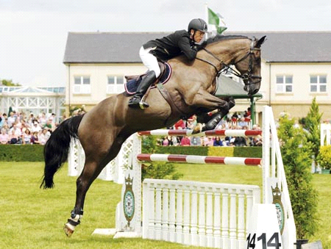
When Scott is preparing to jump a jump on an angle he will usually be approaching on a tight line from a fence before but he may also be jumping the jump on and angle to make his approach to the next fence a lot easier and smoother. Scott will approach the jump in a good quality canter like he would approach any other jump. He will be jumping across the jump but will want to make sure that his horse has seen the jump. When jumping a fence on an angle Scott will aim to take off a little further away from the fence than he would normally. This is to allow the horses front legs to be tucked up in a pair in time for the fence. Due to jumping the fence on an angle the side of the horse closest to the fence, in this photo the near fore side of the horse (the left), will have less time to get high enough to clear the fence. This is why Scott will aim to have the take-off point a little further away from the fence than normal. To be able to do this he will need a very active canter and be able to adjust it easily.

B1 Preparations
When I am preparing to jump a jump on an angle from either a tight line or to make my turn on landing a lot smoother I will, like Scott, aim to have an active good quality canter. Sometimes when I am jumping a fence on an angle I ride a bit backwards due to not always being able to see a stride as well. My canter will therefore lack in energy and forwardness. Due to the lack of energy and forwardness it means that my canter is not very adjustable, so it is hard to make alterations in approach to make sure that my horse doesn’t get too close to the fence. Due to not being able to alter my canter stride if I get close to a fence my horse is likely to knock it down due to not having enough time to get its feet out the way. When I am approaching a fence on an angle my turn is sometimes too shallow which causes my horse to have to jump the jump on less of an angle and turn more in the air which some horses like mine find harder than jumping on an angle.
Execution B2
When Scott is in the air jumping a fence on an angle he will keep his body very still. This is to ensure that he does not affect the way the horse jumps. He would go into a normal jumping position when over the fence. So he will push his hands forwards and bend at the hip. Scott will keep his shoulders a little more upright when jumping a fence on an angle to ensure that his horse doesn’t have as much weight to carry on its shoulders. Scott may use his leg aid to help prevent the horse from drifting in the air. For example if he is jumping the fence on an angle like he is in the picture he will use his right leg against the horses side to prevent it drifting right handed in the air. If the horse were to drift in the air it may cause the horse to have a fence down, hit the wing of the fence or land in a poor position for the approach to the next fence. When Scott is in the air over the jump he will turn his head and eyes to the next jump. This will help warn the horse of what direction it is going in and will help aid the horse to land on the correct leading leg which will save time due to not having to do a flying change or make a change of leg through trot. This will also help Scott keep a good and consistent canter rhythm throughout the course.
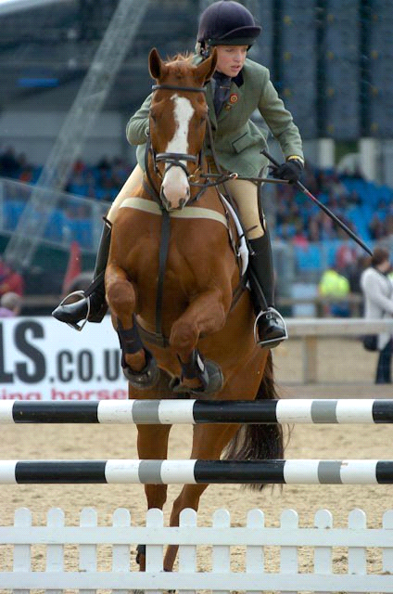
Execution B1
When I am jumping a fence on an angle and am in the air my body position is not as effective as Scott’s. This is due to my upper body collapsing in the air causing my horse to have more weight loading its shoulder and therefore making it more effort for it to be able to get its front legs high enough for the jump. Also in the air my body tends to twist when jumping a fence on an angle. This causes my horse to have a slight loss of balance in the air which may cause it to panic. Also it may cause my horse to land in an awkward position which may put strain on its muscles and tendons especially in its back and front legs. When I am in the air my lower leg tends to be quite loose against the horse’s side, this will therefore allow the horse to drift in the air due to my leg aid not being able to prevent it like Scott’s leg aid does. When my horse drifts in the air it normally means that my approach to the next fence is more difficult or will take longer than it would have if my horse were not to drift in the air. When I am in the air over a fence I tend to forget to look in the direction of the next fence which sometimes means that my horse lands on the wrong canter lead so I have to make a change of leg. This causes my canter not to be able to flow and it makes it harder to keep a good active canter rhythm.
Recovery B2
When Scott has landed from jumping a fence on an angle he will want to get a good quality canter and gain his horses concentrations as soon as possible. This is so he can prepare his approach to the next fence in plenty of time. Scott will bring his shoulder upright again like he would when jumping a normal fence, but when jumping a fence on an angle he may bring his shoulders up fractionally slower and later to allow the horse to be free over its back the whole way through the air. If he were to bring his shoulders up too soon it may cause the horse to tighten in its back and as a result of this it may cause the horse to drop a hind leg and have a fence down. Scott will also keep his eyes looking at the next fence because this will change his weight distribution on the horse which will help to aid the horse in which direction it is going. If Scott were not to do this, his turns would be abrupt and sudden causing the horse to lose its balance and rhythm. When landing from the fence Scott will make sure his lower leg is forward and against the horses side to help him stay in balance with the horse and to be able to support the horse if it were to stumble on landing.
Recovery B1
When I have landed from jumping a fence on an angle it normally takes me about two of my horse’s strides before I start to get a good canter rhythm and prepare my approach for the next fence. This causes my horse to lose its balance and also it makes my approach for the next fence not as effective due to not having as long to prepare and gather my horse up again. Sometimes on landing from jumping an angled fence I bring my shoulder up too quickly and due to my horse being very sensitive it causes it to tighten over its back. When my horse has tightened over its back it normally causes it to land too soon from the fence or lower a back leg causing the fence to come down. When I have landed I tend to look at the next fence like Scott does, but when I look at the fence I tend to collapse my core to the way at which I am looking. For example if the next fence is to the right I will look right but drop my right shoulder down and collapse my core. This then causes my horse to drift away from the right which as a result means that my approach and turn to the next fence is usually too tight and I have over shot it. My lower leg is usually in a good position on landing but it tends to be very loose against the horse’s side so if my horse were to stumble I would become out of balance with my horse and would be likely to fall off.

Choosing your line to a fence
The elite performer I have chosen to use as a comparison is Scott Brash. He is a top class show jumper who has competed at the 2012 Olympics.
Before Scott will jump a course he will prepare his route, how he is going to get there, for example by going around another fence or by taking a tighter line and coming inside a fence. Scott will also plan how many strides his horse will put in on route so that he is then able to know if the distance will cause Scott’s horse to be close to the fence when he takes off or if it will be a long way off the fence. This then allows Scott to change his choice of route or change his horses stride pattern by either lengthening or shortening the canter stride.
Preparation B2
When Scott is choosing his line to a fence he will take into account a few factors. For example what horse he is riding, if it is experienced or not. He will also take into account the technicality of the line and how risky it is. He will also have decided if he is going into the class planning on winning or is going in for experience.
For the preparation of choosing a line to a fence Scott will walk the course he is going to jump on his feet. When doing this he will walk the exact line that he is planning on taking. When doing this he will also walk the distance between the two fences. This will help him to predict how many strides his horse will put in. Scott will do this by standing on the landing side of the fence. He will then take two paces forwards, which should be between 1.5m and 2m. This is where the horse should land after the fence. He will then take four paces forwards, which will be about 3.5-4m. These four paces are the distance of an average horse’s one canter stride. He will then repeat this until he gets to the take-off side of the fence. Just before he gets to the fence he will take two paces until he is right in front of the fence. This is the area in which a normal horse will take off in.

Preparation B1
When I am choosing my line to a fence like Scott I will also walk the line that I am going to take. Scott will walk his distances at the same time as walking his line, when I am walking my distance my paces are not always even and accurate in distance. This causes me to not always ride a line that is on an accurate stride pattern for example when I am riding the line I may get to the fence on a half stride due to walking the distance as a long one so pushing my horse forwards when it was not necessary to do so. This usually results in have a knock down or a refusal.

Execution B2
When Scott is riding the line that he has chosen he will do several things to ensure that he is as accurate as possible. Once he has landed he will change his position quickly. He will move out of the jumping position and back into a light seat position. He will do this my bringing his shoulders more upright. This will cause his seat to be more in the saddle. He will also make sure that his lower leg is on the girth and against the horse’s side. His hands will also be brought back towards him a bit. Once Scott is in a good position, which will happen very quickly he will turn his head and shoulders to look ahead on the line he wants to take. He will use his leg aid to help turn the horse. For example if he is going to be turning right he will use his outside leg (left leg) slightly behind the girth to prevent the horse’s quarters from falling out and drifting. His inside leg (right leg) will be on the girth. This will prevent the horse from falling in through its body and its shoulders. Scott will also use his hand aid to help with turning the horse. His outside hand (left hand) will be used to stop the horse falling out through its shoulders. It will prevent this because it stops the horse having too much inside bend. Scott will move his inside hand (right hand) so that it is slightly wide and encourages the horse to turn and it will also prepare the horse for turning.

Execution B1
When I am riding the line that I have chosen I try to be as accurate as possible. Like Scott once I have landed from the fence I will change my position into a light seat. When Scott changes his position it is a lot quicker and more effective than when I change mine. For example I tend not to bring my shoulders up enough which means my core strength is weak and it makes it more difficult to be able to bring my horse back and slower so it tends to be on its forehand and running into canter. Due to the canter running it makes it a lot harder to alter the stride pattern which tends to result in my horse having a fence down. When changing my position like Scott I bring my lower leg more forwards on the girth. As I get further through the course my lower leg position becomes weaker and therefore is not against the horse’s side and therefore it can result in my horse not being as active in its canter or as forward. It also causes my balance to deteriorate. On landing like Scott I will bring my hands back towards me. This will help to engage my horse from behind into the contact. Once I am in an effective position I will start to look at the line I am taking by turning my head and shoulder to look ahead on my chosen line. I will guide my horse to keep on the line that I want to take using my leg and hand aid. I will use my legs pressed against my horse’s side and then will increase the pressure and change the position when I want to turn. For example, like Scott, if I am turning right my outside leg will be fractionally behind the girth to prevent my horse from falling out. My inside leg should be on the girth like Scotts to prevent the horse from falling in, but throughout my round my leg muscles get a little weak and therefore I cannot keep my horse as straight and engaged from behind. When wanting to turn I will also use my hand aid, unlike Scott who will rely more on his leg aid to turn the horse I use more hand aid than leg aid. This causes my horse to drop the behind the bridle due to not being connected from behind. It also causes the canter to lack impulsion and energy; this will then result in a fault at the fence. My left hand is also stronger than my right. Therefore when turning right my horses tends to fall in and load its inside shoulder this is due to having too much outside bend causing it not to be able to bend through its body and turn.

Recovery B2
Once Scott has ridden his line he will be focused on the jump. For example his position. He will make sure that his body is in time with his horse. This is because if he were to get in front of his horses movement it will load his horse’s forehand which may cause it to have a fence down. Also if he were to be behind the movement it may also cause his horse to have a fence due to his weight causing his horse to tighten behind resulting in the horse not being able to flick its hind legs and therefor dropping a hind leg on the fence. Scott will also make sure he is soft with his hands. This is to allow the horse to jump because if he is tight in his hand it will restrict the horse from jumping freely and cause it to become rigid through its body. In the air Scott will also look in the direction that the next fence is in. He may also change his body weight fractionally to help the horse land on the correct lead.
As soon as he has landed he will then begin his preparation for his line to the next fence. This will include adjusting the canter if necessary. It may also involve changing the horse’s leg.
Recovery B1
When I have ridden my line to the fence like Scott I will be concentrating on the jump and then my landing and preparation to the next fence. When I am jumping my upper body tends to be a little in front of the movement. This is due to bad core strength. If this happens and I am on a deep stride it will make it a lot harder for my horse to be able to get its front legs up and high enough for the fence causing it to be more likely to have a fence down in front. When I am riding I tend to be tighter in my left hand than I am in my right. This causes my horse to be bent unevenly. So when it takes off for the fence its body is not always parallel and straight to the fence. This can cause my horse to dangle a front leg in the air or not be able to get both legs up as a pair and therefore have the fence down with its near for. Also due to being tight with my left hand it may restrict my horses jump. It may also cause my horse to jump off center and drift in the air. Like Scott I try and change my body weight to help my horse land on the correct leading leg. On the right rein this is hard due to me being tight in my left hand. Also on the left rein due to my hand being tight it can cause my horse to land off balance and become disunited.
Once landed like Scott I will start preparing my line for the next fence.

