Perfect Model: Steve Fisher
Choosing the line:
B2:
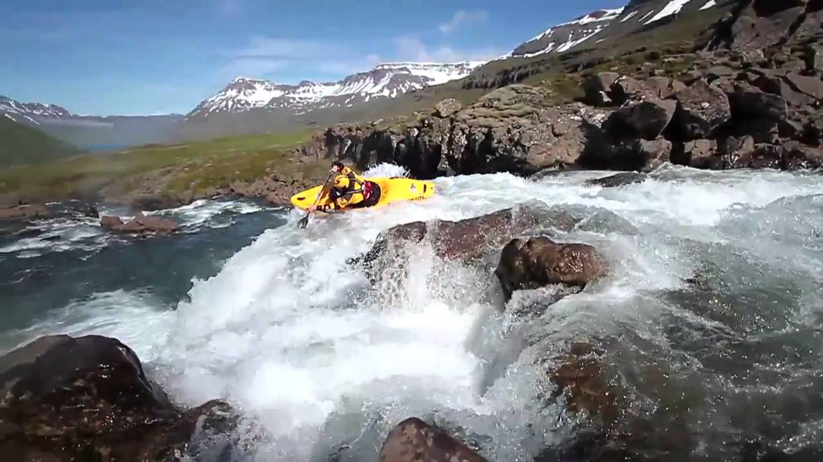
This is one of the most important skills to have when running big white water or complex and technical rapids. Grade classifications within white water are classified by the visibility of the line and how easy it is to see and execute. Sometimes when paddling white water there are also other obstacles in the way which could result in you changing your line as there is the potential to get stuck or hurt. These could be obstacles such as a fallen tree or a knick point on a river.
PREPERATION PHASE:
Normally, when Fisher intends to paddle a piece of water, he will look at it before paddling (potentially walking the whole route, but a majority of the time he would just look at the main features that’s he’s looking to run), making sure he is aware of any major obstacles. He also has to find out if there is a large change in the water levels and velocity when there has been rainfall as these are all contributing factors to the decision whether the stretch of river is safe enough to run. If he decides it isn’t safe, he would have to find the last few eddies in which he could eddie out and portage the feature. He would need a few just in case something unpredicted prevents them from edding out on the previous eddy. The scouting ahead also allows Fisher time to plan what kind of safety he would use and where it would come from. For example, where someone would stand on the bank with a throw line. He would again, assess the river on the intended day of paddling allowing him to see if there are any unexpected obstacles that were not previously there; for example a fallen tree, preventing him and his group accessing the feature just in case of causing a dangerous scenario. He would also have planned his line through the feature, choosing the safest way through the rapids. The best line would be determined through the direction of the ‘tongue’ and the safety of that route. The direction of the ‘tongue’ is where all the water flows down into one section creating the fastest flow and normally the safest route (most dead bury being washed out and the water would have eroded a clear path). When he begins to paddle his chosen route he will have mentally rehearsed it. Allowing him to perform the correct strokes at the correct time giving him a smooth trip down his chosen line.

EXECUTION PHASE:
Whilst Fisher is paddling down his chosen line, he makes sure he stays on his chosen route by using correctional strokes such as stern rudders and draw strokes. These are strokes that are used to move the boat and change its direction. This can be very slight or dramatic and through the use of them it allows Fisher to stay on course; however, they require a lot of power as the moving water applies resistance to the paddle. If anything unexpected was to occur, Fisher would be prepared as he would have gone through extensive safety checks and methods with his team and they would all be aware what to do when a situation arises. This allows the team to perform a fast efficient rescue, reducing the likelihood of injury or difficulty. However, Fisher also paddles with a very experienced group of people. This would help with the efficiency of the rescue.
Fisher is also required to have very strong core and upper body strength as well as Gluts and Quadriceps. This is to help Fisher stay on course as he needs to use his Gluts and Quads to help him grip the boat in his thigh braces and seat which allows him to have good contact points with the boat and therefore he is able to use his body weight to put the boat on edge, resulting in the boat moving rather than having to put in a correctional stroke which could potentially cause him to lose momentum. He needs his core and upper body strength to apply the correctional strokes when he begins to stray off course. This requires large amounts of aerobic efficiency as he needs to maintain a high standard throughout the paddling sequence. If Fisher fatigues, it causes his strokes to become sloppy and potentially putting him off his line, down a dangerous route.
RESULTS PHASE:
Fisher’s preparation and awareness of the water would allow him to paddle his chosen line successfully and it would be very unlikely to encounter something that was completely unexpected.
B1:
PREPERATION PHASE:
Normally I am unable to scout ahead days in advance. This prevents me from knowing the river or any changes in the river (if I have paddled the river before). I also mainly rely on being with people who have paddled the section of river before or my previous knowledge of the river or help from other paddlers reports of the river. This is due to money and time constraints. Fisher is able to look and assess the rivers he paddles in great detail before the intended time of paddling. This is made possible through funding he receives from companies such as Red Bull and that paddling is his main source of income, allowing him to paddle and take trips near enough when he wants to. Unlike Fisher, I am in full time education alongside possessing a weekend job; this prevents me from having the time to assess the river in advance. Therefore I am heavily reliant on others who are paddling the river with me to know the particular points of rescue. However, many of my occupants also have full time jobs or are in full time education, therefore on many rivers, we are unable to walk the route we would take. Therefore if we are unable to see the river in front of us, or can hear large volumes of water, we get out at that point and scout ahead. This is potentially really dangerous if none of the group manage to notice the lack of river ahead.
EXECUTION PHASE:
When I begin on my chosen line, I use markers and pointers such as trees and rocks to help me stay on the line, however, at some points I am unable to notice if I stray from my line. In many cases the rocks and trees look very similar and I am unable to distinguish between them, this makes it very difficult for me to continue on the safest line. This occurs more regularly when there is no ‘tongue’ to the waters movement. This makes it hard for me to pick the best line through the water, consequently causing me to pick an unsafe route that may place me in danger. When Fisher paddles, he too takes note of rocks and other markers helping him stay on course, but due to his previous scouting ahead, he has a much better knowledge of the river which helps him stay on track when paddling through the rapids. This organisation and preparation of Fisher and his team makes the running of the river much smoother and easier as every team member knows what they are doing, unlike the team I paddle with, we choose the safety precautions on the day after assessing the piece of water.
I also lack in the body strength and muscular endurance that Fisher has. This results in me having poor grip on the boat; it also causes me to put in poor correctional strokes as I have weaker muscles. This lack in strength results in me going off course and I am unable to correct it. This causes me to have to have fast reactions to find the second best line try to get on that course. However, due to high arousal and anxiety levels when paddling, I don’t focus on all my surroundings. This causes me to take a bad line consequently causing me to struggle when paddling and could result in me putting myself in danger as the quality of the line is so poor and I haven’t got the ability to correct it: this could become an end result of me becoming pinned or landing on a rock and causing injury because of the poor line.
I also become tired when paddling as the water is very turbulent and requires lots of energy to paddle. This contributes to my weaker correctional strokes and result in me fatiguing faster. This can be very dangerous as if I ended up swimming; I may not possess the energy to swim to the edge of the river to get out. I would also be more prone to the cold, giving me a higher risk of hyperthermia.
RESULTS PHASE:
Due to my lack of preparation and lack of knowledge of the river, my ability to choose a line is much less successful that Fisher’s.

Perfect Model: Heather Herbeck
Boofing:
B2:
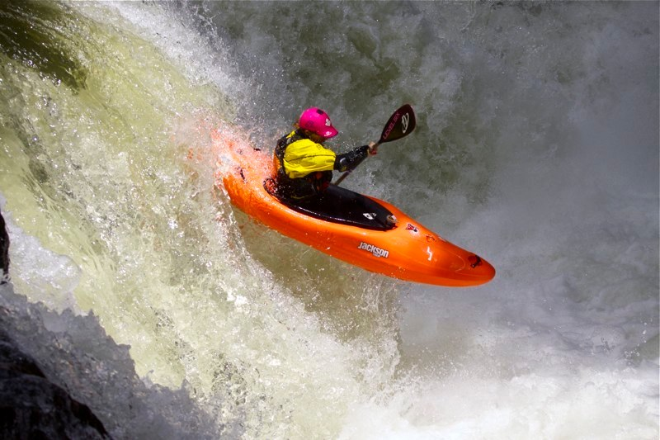
A boof is a series of movements which prevent the boat from either nose diving or tail ending when going over a small drop. It helps you land flatter than you normally would, help to prevent the performer becoming stuck in a stopper or a series of rescues however, not too flat as that may cause injury. Boofing is a skill which requires a certain degree of power and strength. It is a skill which prevents the paddler from getting stuck or sucked into a stopper by preventing the bow of the kayak from fully submerging. Boofing is one of the most important skills to learn when creeking as you are able to boof waterfalls and steep drops, but you can also boof holes, pourovers, reactionaries, and even eddy lines. Although boofing is a very important skill to obtain, it can become very dangerous and cause the paddler injury if it isn’t performed correctly.
PREPERATION PHASE (SET UP):
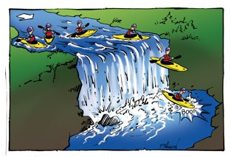
Before actually performing the boof, Heather would have already looked at and assessed the water from the other side of the feature she is about to paddle. Whilst doing so, she would have taken into account the highest point of the feature, whether there were any rocks or obstacles in the way and whether a boof was necessary due to the height and volume of water at the bottom of the rock face. She would also assess how safe her boof would be due to the obstacles in her path. When Heather begins her boof, she makes sure she obtains lots of forward momentum and positions her boat away from the centre of the drop but at the steepest part. If the water is not flat when she begins to carry this out, she uses features such as trees or clusters of rocks to make sure she maintains her line. This is because the stopper at the bottom is strongest at the centre and choosing the steepest part of the feature allows her goal to be achieved easier. As she moves closer to the drop, she will begin to lift her knees and feet up, preventing the nose of the boat from dipping down. She also moves her centre of gravity to the back of the boat to help prevent the boof becoming stuck in the stopper. She also has to enter the feature with maximum speed to propel her as far as she can. If she does not do this, she may again become caught in the stopper and it would result in her becoming back ended. This is where the boat is forced onto its stern end and normally ends in a roll or rescue, depending on how deep and forceful the stopper is.
EXECUTION PHASE (BOOF STROKE):
The “boof stroke” is the last stroke Heather takes before she drops over the lip of the feature. It requires a combination of timing and power. For timing, Heather plants her last stroke in on the lip of the falls; this is where she can retrieve the most power allowing her to boof clear of the stopper at the bottom. On shallower drops, this sometimes means that she would pull away off the face of the falls. Heather then uses a power stroke which is a vertical forward stroke which propels the kayak without turning it. Heather times her final power stroke just as she goes over the lip of the falls so that she can gain maximum force off the face of the falls and through her paddling power. The further she pulls her paddle stroke, the more lift she will gain, resulting in a better boof. She then thrusts her hips forwards until they are past the paddle blade to make sure her bow is kept up. This is to ensure the bow of her boat doesn’t become too submerged as it may result in Heather becoming off balance and could cause her to be pulled back into the stopper. This could result in several complex rescue scenarios.
RECOVERY PHASE (LANDING):
Heather always lands her boof in her “default paddling position” (also known as your “moderately aggressive position”). This is the performer’s normal paddling position with her stronger hand out in front ready to perform a power stroke. Landing like this helps to cushion the bow and reduce the risk of being back-ended and potentially causing injury. Landing in this position also helps Heather control the boat when she lands. Landing with her paddle planted in the water at her toes to act as a brace, giving her the ability to apply forwards momentum if she was being pulled back into the stopper. Heather is also careful to make sure she does not land the stopper too flat. If she did land the boof flatly, she would jar her back and potentially cause injury, this is why she has to angle her boat so the nose and paddle break the water before the landing rather than the boat landing flat, simulating a belly flop.
B1:
PREPERATION PHASE:
When I prepare to perform a boof, I make sure I have properly inspected the section of river I am about to paddle. This allows me to determine which is the highest and fastest flowing section of the river. I make sure I identify my markers correctly allowing me to perform my boof to the best of my ability, however, as I approach the drop, I begin to reduce the amount of power I put in my strokes rather than increasing it. This is because I struggle to get the timing right. It is also due to apprehension. This is because I become nervous and anxious about the drop ahead and try to make myself perform it correctly; however reducing my power and speed of my strokes reduces my ability to perform it correctly. When Heather is paddling, she makes sure she is putting her full force into her strokes as well as placing her paddle stokes in the water at the correct timing causing her to perform a perfect set up. As I am unable to do both, I reduce the power in my strokes so I am able to get the timing right. This is due to my attentional narrowing, causing me to only focus on one que at a time. This causes me to begin the boof badly.
EXECUTION PHASE:
The boof stroke would be the last forwards paddle stroke I perform before going over the drop. Unlike Heather, whose timing is immaculate, I struggle with my timing in the preparation phase, setting me up badly for the execution phase in which, again, I need timing. This causes me to perform several strokes before going over the feature rather than a few very powerful strokes. This causes me to have less propulsion when going over the drop, potentially resulting in me to get stuck in the stopper at the bottom which causes me to become back ended, subsequently bringing about complex rescue scenarios. I also have weak core and upper body muscles. This causes my power stroke to be poor and not very forceful. This combined with my poor timing leads to a very poor execution of the boof and despite lifting with my knees and feet, the nose of my boat drops down due to my weak and poorly timed power stroke.
RECOVERY PHASE:
Unlike Heather, I normally go over the feature badly due to my timing and therefore the amount of power I put into my strokes, I do not land in my default paddling position. When heather paddles, she is prepared to go over the feature as she has great timing and consequently powerful forwards paddle strokes. I do not land in my default paddling position because I am normally forced to place a high or low brace into my landing to prevent me from capsizing. This reduces my forward momentum which then causes me to be pulled back into the stopper because I am not paddling forward as heather would be; instead I am putting in a high brace sedentary position. If Heather is forced to place a high brace, she is able to quickly shift her weight into a brace position and she knows to do this through the way she feels her body position when going over the drop. In other scenarios, I prepare myself to perform sculling as I would have to skull whilst stuck in the stopper to keep my body above the water whilst waiting to be rescued. Therefore, my boof is not as effective or as well executed as Heather Herbeck’s.

Perfect Model: Sam Sutton
Forwards Paddle Movement:
B2:
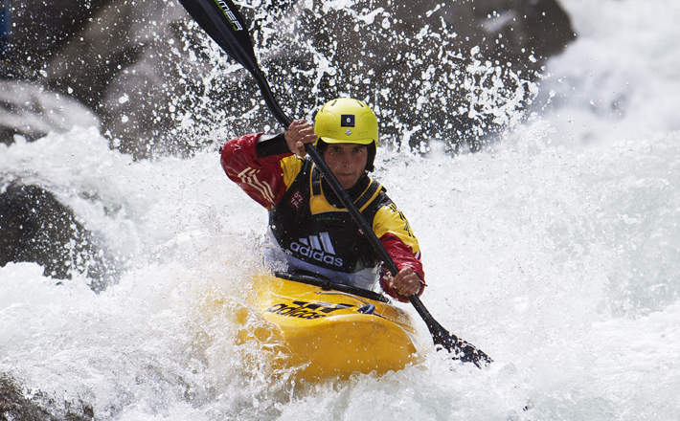
When Sam Sutton paddles, he grips in many places to help the boats forward momentum and minimize energy loss through turning or sideways movement. Gripping with his feet, knees, gluteals and hips also helps him to keep the boat stable, preventing him from going on edge unintentionally. Gripping is important when paddling as you want to try and prevent the loss of energy through the paddler moving inside the boat. This is why Sutton pushes down on his footrest, forcing his knees into the thigh braces, locking them into position and helping stabilise the boat. Pushing out from his thighs into the thigh braces prevents any sideways movement whilst gripping with his gluteals and hips giving him full control of the boat.
PREPERATION (CATCH PHASE):
When Sutton begins the paddle stroke, he plants the paddle into the water just in front of his toes at the tip of the boat. Planting the blade in the water at the bow of the boat will give Sutton longer forwards paddles stroke. This allows him to create a stronger stroke than he would have if he planted the paddle (for example) in the water at his knees. This is because it would be a much longer stroke allowing him to put more power and force into the longer stroke. The face of the blade must be perpendicular to the way he is pulling. This is because if it was parallel to the boat, he would slice the water. Meaning, he would not gain any pull as he would be using he edge of the blade rather than the face. Sutton plants the paddle so that it is fully submerged and predominantly upright giving him maximum propulsion across the water surface and efficiency to his stroke. He places this in the water with minimal disturbance of the water’s surface; this will reduce the amount of energy lost. This is known as the “Catch Phase”.
EXECUTION (POWER PHASE):
Once the blade is in the water, Sutton uses his core strength and trunk rotation to allow his body and boat to glide past the blade enhancing the forward motion and preventing backwards movement. He pushes forward with his top hand, setting the boat into the forwards driving motion. The key to the perfect paddle stroke is in torso rotation (trunk rotation) not the motion of the arms. This allows Sutton to use power from his whole body, rather than just his arms as just the use of his arms would cause him to fatigue quickly consequently reducing his speed and paddling time. However, the trapezius, triceps and deltoids also help this motion. This is known as the “Power Phase”.
RECOVERY PHASE:
Normally, you remove the paddle from the water between your hips and the back of your seat rest; however, it is dependent on the type of paddling you are participating in. Sutton would remove his paddle at the hip, as for white water paddler it is “tip to hip”. This is because he would lose forwards momentum after his hip.
After Sutton has completed the stroke, he lifts the blade out of the water at his hips. He removes his paddle at a perpendicular angle to the water to minimize the loss of energy through excess water being brought up with the blade. The motion is then repeated on the opposite side of the boat to continue the forwards motion of the boat.
B1:
CATCH PHASE:
When Sutton forward paddles, he plants the paddle in at his toes. This allows him to put in a forceful, strong stroke which would give him lots of momentum through the water. When I forwards paddle, I do not reach very far forwards, preventing me from planting the paddle into the water at my toes. This reduces the amount of power I am able to put into the stroke and results in me having weak strokes and forces me to put in more paddle strokes to make up for the shorter stroke. This consequently wastes energy and causes fatigue to set in sooner. As a result, fatigue can cause me a large problem as the challenge of the water can become physically and mentally taxing; particularly on upper sections of rivers, where there are V shaped valleys, it is very hard to get off the water and take a break. Unlike other sports, kayaking has no natural stoppages causing it to be hard to get off the water and there are rarely paths which the paddler is able to walk along with their boat.
POWER PHASE:
To propel the boat forwards, Sutton uses his trunk rotation and core strength to enhance power from the whole of his body. Unlike Sutton, I revert to using my upper body strength rather than my core muscles. This is because I have a small amount of core muscle and struggle to enhance its potential power. This causes me to have a weaker stroke than Sutton and forces me to use more energy to complete the stroke and tire faster than I would use my core muscles. I also struggle to use my core muscles as when I go to rotate my trunk, I move about in the boat due to my limited contact points. This again causes me to waste energy and makes it easier for me to rely on my stronger upper body strength.

REVCOVERY PHASE:
During the recovery phase, Sutton takes the blade out of the water when it reaches his hip and he removes it at a perpendicular angle. When I forwards paddle, I regularly fail to take my paddle out the water at my hips and at a perpendicular angle. Removing the blade from beyond my hips reduces the amount of power in the stroke because after your hips there is no forward momentum, therefore my blade just acts as a break, reducing my speed and wasting energy I put into the stroke. Also removing the paddle when it isn’t perpendicular to the boat also wastes energy as it results in me bringing up water with my paddle: creating splash. When Sutton removes his paddle it is at the perfect point in the stroke. It’s removed at his hips and with very little splash. This reduces his energy loss and keeps the boats forward momentum.

Perfect Model: Dane Jackson
Hanging draw:
B2:
The hanging draw is a stroke which is used to move around a rock or obstacle in the paddle’s line. It is a draw stroke which helps you move sideways across the river without disrupting your forwards momentum as it is a dynamic stroke, however, the paddle is static when the skill is performed. You perform this skill by bringing your upper hand to forehead height and putting your boat slightly on edge, using the turn provided by this and adjusting the angle of the blade to suit the turn, the boat moves across the water, maintaining its forward momentum that it previously had. This is a very particular skill which can only be used in certain situations. Therefore it isn’t a stroke that is used regularly although a very useful stroke when it does need to be used.
PREPARATION PHASE:
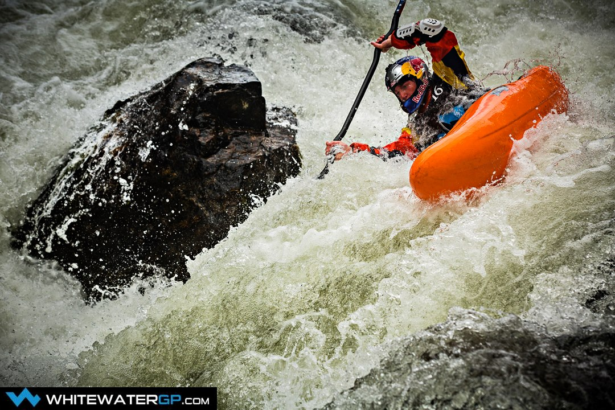
When Jackson performs a hanging draw, he reads the water in front of him and sees the obstacle ahead before needing to perform a skill to avoid the obstructing feature. This is done through scouting ahead and choosing his line. After seeing this, he would begin the hanging draw early on as it is a relatively slow movement. Before beginning the stroke, Jackson places a normal forwards paddle stroke on the side of his boat he doesn’t intend to apply the hanging draw to. This allows him to maintain his momentum when performing the stroke. When Jackson begins the stroke he makes sure that he maintains all his contact points in the boat. This will allow him to keep his boat stable when performing the skill. (Contact points: Feet, knees, bottom, hips. (explained in forwards paddle stroke)). It also depends on the speed he is traveling at and the angle of his blade when it is in the water. He begins the stroke (for example when he is going right) lifting his left arm so his forearm is in line with his forehead and holding the blade parallel to his boat and hips.
EXECUTION PHASE:
During the execution phase, Jackson puts his boat on edge by putting weight on one side of the boat. He does this by gipping with his knees, toes and bottom, lifting them slightly on one side to cause a rise. He also grips tightly to prevent the boat from capsizing because the more grip he has the easier his boat is to control, however putting it on edge. He also makes sure his body is upright in the boat (the default paddling position) and leaning towards the side of the paddle almost as if he is putting his weight on the paddle, this also helps keep him more stable preventing capsize and causes the boat to turn in the correct direction. The amount of edge he put on his boat is dependent on the amount he wants to turn; however, too much edge could result in him capsizing. (More edge, larger turn until the optimum point which after, causes the boat to capsize).
Within the execution phase, Jackson also adjusts his paddle angle to help with the turning. When this is done, it is only a very slight adjustment as too much adjustment would cause the paddle to become perpendicular to the boat, reducing stability and acting as a break. This would result in Jackson putting his weight on the paddle at a different angle, not stabilising him or his boat as it would perform a slicing movement toward his boat or deeper into the water. The paddle would be dragging underwater and pulling Jackson over as he has maintained his forwards momentum. This could also cause him to capsize, which would then result is a series of rescue scenarios.
RECOVERY PHASE:
During the recovery phase, Jackson reduces the amount of edge by flicking his hips and using the grip which he already has on the boat allowing the boat to return to its upright paddle position. As he does this with his boat, his body and paddle will follow. After correcting himself into the default paddling opposition, he would resume normal forwards paddling. This is done in one swift movement as doing so allows him more time to concentrate on the next feature or obstacle ahead of him.
B1:
PREPERARTION PHASE:
When I go to begin my hanging draw, I place the paddle stroke needed on the side of my boat which I don’t intend to place the stroke on. When Dane Jackson performs a hanging draw, he goes into it from his normal forward paddling. This means he is applying the same amount of power to both sides of the boat, not sending I off course through too much or too little power on one side. Sometimes, I apply too much power to my stroke causing me to swing to the opposite side. This counter acts the hanging draw I am about to put in and causes me to apply more forwards paddle strokes to make my boat regain its correct course before reapplying the stroke prior to the hanging draw. From this small mistake, I perform my stroke too late, not giving me enough time to execute the stroke to its full potential. When Jackson performs his hanging draw, he judges how much power to put into his stroke through the speed and turbidity of the water. If the water is traveling very fast, he wouldn’t need to place such a powerful stroke, however if it is very bumpy and there is a lot of turbidity, his boat may be forced from his line, resulting in him performing a powerful stroke before the skill. Although, if the water was both fast and turbid, he would need to moderate his power that is placed into the stroke, finding the perfect balance between speed and staying on course. This is where I fall.
EXECUTION PHASE:
When executing the hanging draw skill, Jackson makes sure he has a strong grip on his boat through his toes, knees, bottom and hips. Sometimes, when performing this skill, I am unable to full grip sometimes due to the size of the boat I am paddling. When I don’t have this grip, it gives me less control of the boat and from moving around inside the boat, I waste energy and reduce my forwards momentum which could knock me off my line or force me to perform correctional strokes when coming out of the feature or into the next feature, potentially resulting in me capsizing. I also struggle to judge the amount of edge that I am able to put on the boat, either not putting enough edge on or too much which results in me not turning at all or capsizing due to too much edge.
RECOVERY PHASE:
Due to my lack of grip on the boat, I am unable to flick my hips to let the boat down slowly. This causes me to have to move my whole body inside my boat. This results in the boat becoming more unstable and potentially capsizes. This could consequently place me and others I am paddling with in danger. When Dane Jackson performs a hanging draw, his hip flick is perfectly performed. He would have a great grip on his boat making sure all his contact points in the boat are tight. This would make his hip flick my easier, consequently holding the boat in place alongside his body inside the boat. The grip on his boat would reduce the energy loss and allow him to maintain his momentum when paddling.

Perfect Model: Toa Berman
B2:
High Brace:
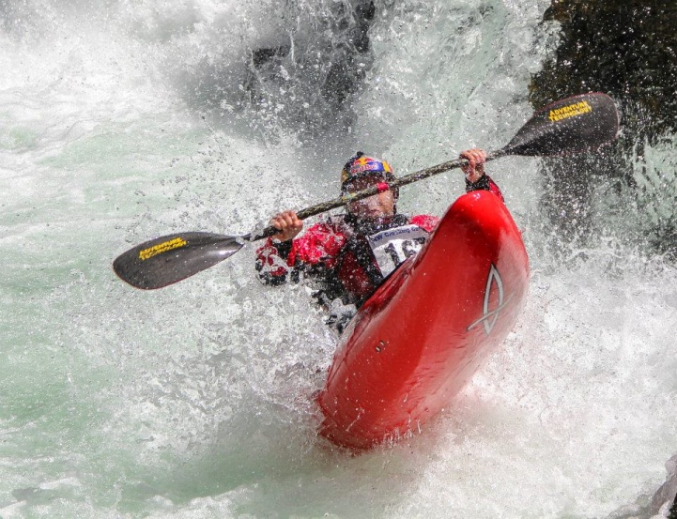
A high brace is one of the most basic skills needed when paddling. It is a self-rescue stokes which prevents the paddler from capsizing the kayak. A high brace is done by lifting both arms up to forehead height, creating a box with your paddles and elbows. You then reach the lower paddle out and leaning on the power side of the blade as the boat becomes unstable. You must make sure that your upper elbow is tucked in, allowing the performer to have maximum leverage against the water’s surface. The high brace is a very reliable stroke when it’s performed correctly and is one of the most important stokes used on large volumes of water or white water. However, if it not performed correctly, it may result in the performer capsizing therefore leading to a variation of rescue scenarios. Toa Berman is a great example of consistently perfectly executed high braces. This is because Berman has perfect timing allowing him to perform the skill with minimal effort as well as preventing injury or disturbing his line for following features.
PREPERATION:
A high brace’s preparation phase is performed very quickly as it is a manoeuvre which prevents an off-balance boat from capsizing. The performer has to predict which way the boat will go/is going off balance and change their paddling position from a normal stroke position to a brace position. To do this, Berman has to contract his biceps forcing the elbow to bend consequently rolling the shoulder back to get the paddle shaft in line with the paddler’s eyes. This has to be done leaving the power face of the blade facing the water so the follow through can happen smoothly and prevent a capsize. If Toa is able to predict what the cause of the brace would be and where it would happen, he would put the paddle into the brace position before reaching the obstacle. If a situation occurred in which Toa cannot predict when the high brace will occur, he swiftly moves from the forwards paddling position to the brace position when he feels the boat to begin to tip. He feels this through his knees, thighs and abdominal muscles. If Berman begins to feel this happening, he moves into the brace position making sure that the paddle shaft isn’t close to his nose (because it would hurt if he hit it!) preventing facial injury. He also makes sure his elbows are tucked in the “safety box”. If Toa is unable to do this, when the paddle reaches the water it could cause potential facial or shoulder injury.
Figure 1: Toa Berman.

EXECUTION:
When the execution phase occurs, Berman’s boat will already have begun to tip over. This will cause him to apply a degree of force to the water to correct his mistake. The majority of the power that helps Toa correct himself comes from his core muscles helping to prevent injury in the shoulder. Berman performs the skill by placing the power side of the blade face down in the water and rotating his hips, following with his core and then shoulder “winding up” his body. This prevents Berman from making the boat more unstable than it previously was as it stops the centre of gravity from being too high. This also reduces the amount of effort needed to perform the skill, consequently allowing less pressure to be placed on the paddle.
Occasionally, Berman may get himself caught in a stopper or a hole and he may need more than one high brace to completely correct himself. Normally, Berman can tell this when he is part of the way through the execution of the high brace. When this occurs Berman either holds the brace and allows the water to flush him and his boat out or he, at great speed, flicks his writs, rotating the blade 90 degrees pulling the paddle out of the water smoothly like a knife. This brings his paddle to the surface and then gives him the opportunity to place another high brace in. The second high brace is used as a last resort as it has to be performer within a couple of seconds. Performing a second high brace puts Toa at a higher risk of a capsize.
RECOVERY:
The recovery phase of the skill, Berman “unwinds” his upper body and pulls the paddle down against the water’s surface. With the aid of his hip flick (a flick of his hip (as they are gripped tightly in the boat, it aids the boats recovery.)), he corrects the position of his boat, making sure he has left his body in the water and corrects the boats position before his, removing his head from the water last. This is because in the water, your body feels lighter, therefore does not need as much force to hold it up. After turning his boat the correct way up with his hip flick and paddle force, Berman is able to push his weight against the paddle forcing him up into his original boat position. This all has to be performed very quickly as the boat will capsize if not.
Berman is normally very successful with his high braces, reducing or preventing his need to capsize out or roll the boat to correct himself. A high brace is also a smaller skill than a roll or capsize, reducing the amount of waste energy and doesn’t damage is line or the focus on the upcoming feature.

B1:
PREPERATION:
In the preparation phase of the skill, I struggle with foreseeing the need to perform a high brace. When Berman is forced to perform a high brace, he is able to read the water in front of him (for rocks and odd flows etc.) and can see features which would cause him to perform a high brace, this allows him to make the decision and choose at which point he needs to carry out the skill. This allows him to be fully prepared when he reaches this point. As I can’t foresee what is about to happen, I am unable to prepare myself for the brace. This forces me to shift my position in the boat at speed and perform the brace very quickly, causing unbalance in the boat and potential capsize.
Unlike Berman, sometimes whilst performing the high brace at speed, I do not lift my arms to the right height, causing me to have a smaller brace position. This reduces the amount of power that I am able to put into the brace, consequently forcing me to perform the brace faster than I normally would. I also wouldn’t be able to catch the water correctly, potentially forcing me over. This is then most likely to cause me to capsize therefore leading to several rescue scenarios and ruining my line that I originally intended to take. I also have the risk of performing my high brace too high; taking my arms out of the safety box this could cause me injury. When Berman performs his, his wide high brace position allows him to transfer more power from his core and allows him to perform the skill slower or hold the brace longer than I would be able to.
EXECUTION:
In the execution phase, Toa uses his core muscles to correct himself. As I have lower core muscle strength than Berman, I tend to use my shoulders and upper body muscles to perform the stroke. This puts me at a higher risk of injury and sometimes cause my paddles to slice the water as it results in me not putting the power face of the blade into the water, giving me very little and short amount of stability. This then results in me capsizing and rescues to occur.
RECOVERY:
Occasionally, my hip flick is not effective as it should be. This is because I am generally too small for the boats available to me, reducing the amount I am able to grip the boat and causing my body to move around within the boat. This then causes me to waste energy as I have to grip harder. The boat being too large results in me being unable to “flick” the boat to its correct position, forcing me to bring my head up first. This makes it much harder for me to complete the skill consequently causing a capsize. Toa Berman continuously has a stable amount of flick, forcing his boat to correct it before his body unwinds.

Perfect Model: Ben Brown
Stern Rudder:
B2:
The stern rudder is one of the most basic skills used in kayaking. It is normally used when surfing a wave, this could be tidal or standing. This is a quick powerful way to change direction and is particularly useful when there are strong winds, waves or current that takes dominant control. However it slows the momentum of the boat down and also breaks your paddle rhythm, this could be a problem if you are in a race or a particular situation in which the paddler needs their speed.
PREPARATION PHASE:
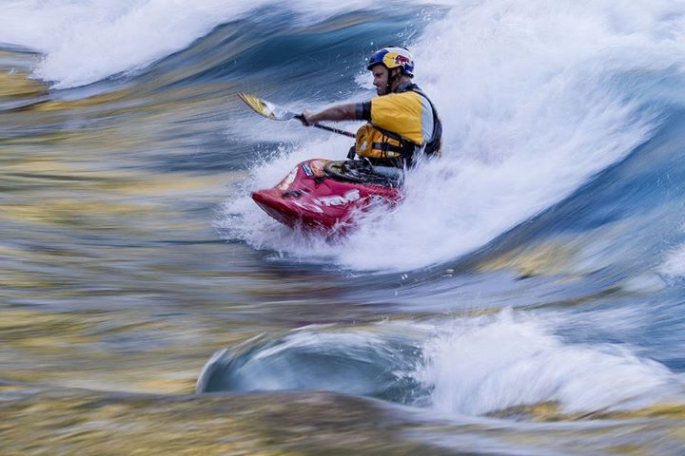
Brown only uses a stern rudder when he has a lot of speed and a good forwards momentum. This is because the stern rudder stroke acts as a break in the water and reduces your speed when it’s used due to the drag it creates. This stroke is sometimes prepared through a fast burst of strong forwards paddling, allowing Brown to have enough speed to continue to carry the boat forwards whilst performing the skill. The stern rudder can be performed in two ways. The first of which, Brown would continue a normal paddle stroke, however, leave the paddle in the water allowing it to travel past his hips (where you would normally remove the blade from the water) and allow it to settle at the stern of the boat. By doing it this way, the forwards paddle stroke flows smoothly into the stern rudder and causes the boat to turn in the opposite direction faster. When performing the skill, Brown twists his whole body to the side of the boat he is going to perform the stroke on and then turn his head to face forwards. Brown’s torso rotation allows him to control the blade in the water more accurately as it is at the back of the boat. Browns ability to face forwards when performing this stroke allows him to read the water in front of him and gives him the opportunity to choose which way to go and when to perform a trick or bail off the wave. If he did not turn his head and followed the paddle instead, he would most likely capsize due to his lack of knowledge of his way or as he may follow the paddle with his eyes, potentially causing himself to turn horizontally on the way resulting in a capsize. The second way would be performed simply without the forwards paddle stroke and Brown completely rotates his trunk to the side which he wants to put the stroke in and simply places the blade in the water. In both techniques, Brown makes sure the blade begins vertically in the water at the back of his boat (flat and just above the surface at the front (depending on the angle of the blade)) causing it to act like a rudder. He also makes sure the blade is fully submerged underwater, giving him maximum control of the boat.
EXECUTION PHASE:
During the stroke, Brown is able to change direction. This is done through changing the distance between the boat and paddle. When Brown decides to change the distance between the blade and the boat, he keeps his arms locked in the same position and rotates his trunk to adjust the blades position. This effectively, is moving the boat rather than the paddle. This is because; the movement of the boat changes the direction more efficiently than the movement of the paddle as the boat has the momentum forcing it forwards.
He is also able to change how much he wants the change in direction to take effect by changing his wrist position (i.e. wrist rotation) therefore changing the angle of the blade. This can be done easily and is fairly effective. It also reduces the ability to out the boat off balance as he does not move the paddle away from the boat. To help the turn of the boat, Brown edges his boat allowing him to gain more control of the boat and help the moment of his boat. This is done by Brown lifting his knee and hip of the opposing side (e.g. if you wanted to turn left, you would put the stroke in on the left side and lift the right knee) pushing the boat slightly on edge.
RESULTS PHASE:
As Brown continually, successfully and accurately executes the stern rudder to the highest standard, he is able to effortlessly move him and his boat along the wave in complete control. This allows him to place himself in the perfect position on the wave for his next trick or next line.
B1:
PREPARATION PHASE:
During the preparation phase, unlike Brown, I tend to not rotate my upper body to perform this stroke. This causes me great difficulty because without the trunk rotation I am forcing myself into the seatbelt position (a position where my arm crosses my body like a seatbelt with no torso rotation). If the paddle became caught, without my trunk rotation, it could cause me to dislocate my shoulder or cause other injury. This makes it very dangerous to perform this skill in this way. When Brown performs the skill, the rotation of his upper body allows the stroke to drive smoothly into the water and doesn’t cause him to put himself into the seatbelt position, reducing the risk of injury. Whereas when I perform the skill, I do not rotate my trunk enough, causing me to force my paddle into the water, putting me off balance and leading to a capsize. I also regularly pull muscles in my shoulders and my torso.
Occasionally when I go to perform a stern rudder, I apply too little power to my forwards paddling. In these circumstances, when I go to perform the stern rudder, my blade just acts as a brake rather than a rudder. It still allows me to change direction however; my reduced amount of forward momentum pulls me back off the wave. Whereas if I apply too much power, I end up bouncing past the wave itself and it leads to me missing the wave completely. When Brown paddles, he has had vast quantities of practice and applying the correct amount of power to the force of the wave has become a dominant response for him. This allows him to perform the stern rudder autonomously, with no thought put into the skill; only thinking about his next trick when this is performed.
Brown is thoroughly capable of performing the Stern Rudder in both ways. When I go to perform the stern rudder, I struggle with the first way (traveling from a forwards paddle movement into a stern rudder). This is again due to my paddling power and the force of the water. I find the second way (just placing the stern rudder into the water) easier as I apply the forwards paddle strokes and the completely stop to carry out the stern rudder. This allows me to find my ground a maintain my balance when doing so, whereas with the first technique (applying the stern rudder from the forwards paddle stroke) I struggle with a lot more. This is because I am unable to judge the correct quantity of power that I need to put into the stroke that leads to a stern rudder. Normally when I begin to perform the stroke, I put too much power into the stroke that will lead onto the stern rudder. This effectively acts as a sweep stroke and has too much turn on it for the stern rudder to correct. As an outcome, I spin around on the wave, losing control and inevitably ending in a capsize. Because Brown has had so much practice, he knows when he needs to apply more or less power thought the feel of the blade in the water. This allows him to judge correctly; applying less or more power in the correct situations. Unlike Brown, he had the opportunity to practice surfing on waves and using the stern rudder regularly. Whereas I, growing up inland with not much white water or rivers I was forced to learn all my skills on a canal from my older brother. This didn’t provide me with much opportunity to practice my kayaking skills on moving water, preventing me from getting the feel of the moving water.
EXECUTION PHASE:
When Brown decides to change direction, he performs a subtle, relaxed movement of his blades, slowly distancing them from the boat or changes the angle in which he holds the paddle. However, when I try to change direction, I move my paddle very violently without the subtleness Brown has. This is because the fast movement of the water causes me to feel I have to use a lot of force to change my direction and adapt my paddle angle. This causes my trunk rotation to take place very fast or sometimes not at all and the angle of my blade to change without intention. This then results in me going off balance when performing this skill. Consequently leaving me to capsize out or roll, but in both situations, I would need to be washed out by the wave. This could be due to poor learning as I have not been able to have the opportunity or experience that Brown has had because I am unable to get to an area which has a wave I am able to practice on. This has meant that I have to learn the skills on flat water and only once every so often use the skill on the wave. This could be why my paddle movement is so violent.

RESULTS PHASE:
Unlike Brown who executed this skill at the highest of standards, I am unable to perform a stern rudder to the highest of standards, this results in me to be unable to move the boat across the water with full control. This stands out particularly when paddling in competitions and it throws me for my next trick or restricts the execution of my next line resulting in a continuously bad result.

