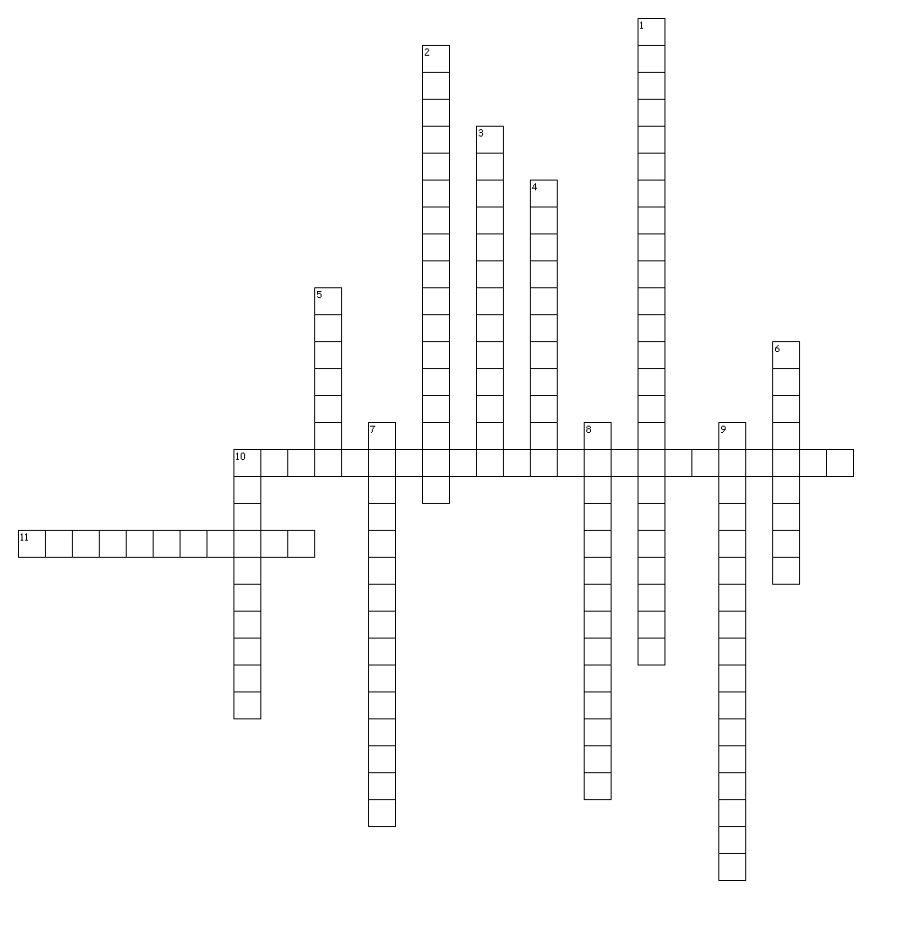
Lung Function Crossword

Clues

Across
10. maximal amount of air forcibly expired in addition to tidal volume
11. the act of breathing in

Down
1. maximal amount of air forcibly inspired in addition to tidal volume
2. the amount of air moved in and out of the lungs in one minute
3. maximal amount of air exhaled after a maximal inspiration
4. amount of air breathed in or out per breath
5. tiny thin-walled air sacs found in large numbers in the lungs
6. the movement of gas molecules from an area of high concentration to an area of low concentration
7. the pressure a gas exerts in a mixture of gases
8. amount of air left in the lungs after a maximal expiration
9. vital capacity plus residual volume
10. the act of breathing out

