Defensive Skill 1
Elite Performer- Richie McCaw (New Zealand All Blacks and Crusaders)
Tackle, (front on) - Tackling is an essential skill in the game of rugby. It is used to stop the opposition on the move whilst in defence and can put your team on to the front foot if done effectively. Tackling involves a wide range of muscle groups as it is a whole body movement and needs to be executed in an explosive manner to be effective.
B2-Preparation Phase
As Richie McCaw is standing in the defensive line, he will be communicating with his team mates, letting them know he is ready to make a tackle on his opposite man, possibly even pointing to him and making lots of noise trying to distract him from catching the ball and put him off his play. This gives his teammates confidence that they can cover their own man. McCaw would be particularly vocal as he is the captain of the All Blacks. As the ball carrier has decided to go into contact and approaches Richie McCaw he will be focusing on their hips, and not watching the ball or feet, which would distract him from the tackle if the opposition attempts to make any kind of dummy. Watching the hips informs him of which shoulder to use as they show the direction the opposition will go if they decide to sidestep or change direction. He will then bend at the knees and pull back his scapula’s and engage his core muscles. This would give him the perfect flat back, making the action efficient and prevent any injury, the flat back provides stability and minimises the chance of opponent breaking through if had an arched back. Having a strong flat back means all the power being transferred from the legs can go straight up the back and into the shoulders, making the movement fluent. Bending at the knees allows McCaw to get in the correct initial position and height to perform the tackle aligning his shoulder with the opponent’s hips and his head to one side. He prepares for an explosive leg drive still focused on the hips and steps forward with the opposite leg to the shoulder that he will use before preparing a powerful upwards leg drive.
B1- Preparation Phase
In the defensive line I also communicate with my team mates, making sure we go up as a line. As the captain of my team to I try to emulate McCaw’s vocal presence on the pitch but as I do not have the same level of fitness and stamina as McCaw, towards the end of the game as I begin to tire my vocal encouragement and commands start to fade I am using all my breathe to concentrate on my own performance. As the defender approaches me I focus on their hips as much as possible, however, I can sometimes be fooled by a dummy or a side step which doesn’t happen as frequently in McCaw’s game due to more experience of the tackle situation and being able to react very quickly to slight changes. When the attacker is coming towards me I am deciding which shoulder is appropriate to use, I adjust my body in to the correct position, lining up the suitable shoulder to one side of their torso. I get into a low body position by bending at the knees and keeping my weight on the front of my feet as much as possible, however I do not have equal balance and core strength in comparison to McCaw, causing occasional lack of stability and resulting in being flat footed when preparing to tackle. This sometimes means I fall backwards as making a tackle and give the opposition a few extra yards. Similarly to Richie I pull back my scaps and engage my core to make me as stable and strong as possible when performing the tackle. However, I occasionally don’t quite get the exact body position, as I am focusing on other aspects, ending up with too rounded shoulders due to a lack of flexibility in them. This differs from McCaw’s situation as he will have varied training techniques to improve flexibility. As a result of experience it becomes natural to him to get in the perfect body position without thinking about it.

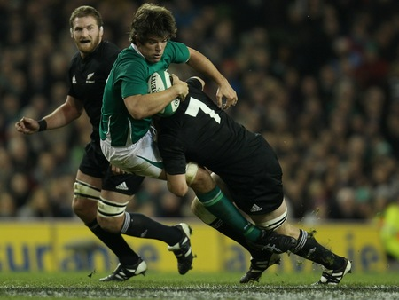
B2-Execution Phase
From the bending of the knees in the preparation phase, the leg drive will occur with an extension at the knee joint and contraction of the quadriceps. McCaw will make sure he puts his head to one side of the opponent’s body to avoid injury. McCaw will adjust his positioning in reaction to where his opponent goes. As he puts his head to one side the leg drive begins, the first point of contact will be with his shoulder onto the opponent’s hips/abdominals area. He will make contact half way through his leg drive because he will already be moving forwards and giving himself momentum. If he waited to make contact with the attacker and then begin the leg drive, McCaw would struggle to tackle the player and move him backwards. Once his shoulder makes contact he will explode up and forwards completing his leg extension and wrap his arms around the player, at the same time squeezing to stop leg movement. Although this seems like a static step by step movement, it is performed with fluidity and at great speed. Once the player has been stopped, he continues the leg drive and keeps hold of the player, in order to push him back a few yards and put his team on the front foot. The most effective tackle will slightly lift the opposition off the floor, as it completely prevents any further forward movement. Finally when he has driven the player back, he will proceed to take him to the floor by driving his shoulder downwards towards the floor, making sure that any point below the opponent’s shoulders hit the floor first, therefore preventing any injury or giving away a penalty. It is his responsibility to get the player down safely or he can be penalised against. The safest way to do this is to keep hold of player, not drop him, and make sure doesn’t land past 90 degrees. Once the opposing player is on the ground, the recovery stage begins as McCaw gets to his feet and attempts to regain possession.
B1- Execution Phase
I try to focus on the hips as I begin the leg drive; this informs me which way the attacker will go. In comparison to McCaw who is always fully focused and concentrating on where and when to accelerate through the motion as a result of experience, I can occasionally be slightly put off by some footwork, resulting in me putting my head in the wrong position. Following on, I extend my legs as I drive into the opponent, aiming for the middle of his body, I will put my head to the opposite side of the shoulder that I am tackling with to avoid injury to myself. The first point of contact I have with the opposition is with my shoulder. I then drive the player upwards, however I do not have the same level of strength or perfection with technique as McCaw resulting in a lack of power and sometimes being unable to lift the player off the ground and drive the opposition back. In this scenario I tackle them directly to the floor if unable to drive them back. This is not as effective as driving them back a few paces but still prevents them making ground. I make sure I have a strong grip on the attacker to stop his leg drive on the move; I also try and get him to the floor as quickly as possible to stop him from offloading. In addition to a lack of power, my anaerobic fitness is not at the same level as McCaw. He is able to complete short bursts of intensity in every tackle situation throughout a game. I am unable to produce the same level of effectiveness in a tackle as a cause of my less developed anaerobic energy system.
B2- Recovery Phase
Once the opposing man has been tackled to the floor, McCaw gets to his feet very quickly, using the man on the floor to help him get up and whips his lower body round to an onside position. He must completely release the player and enters from the back foot in an onside position. The releasing of the player is exaggerated, to show the referee that he is making a clear effort to let go of player before going for the ball. He proceeds to perform a bridge over the player and get his hands on the ball, supporting his own body weight at the same time on his feet. This is called jackling, where you compete/try and slow down the ball. If McCaw gets to his feet and gets his hands on the ball before the next attacking player comes in and McCaw can hold on to it, he will be rewarded with a penalty for his team.
B1- Recovery Phase
After I have got the attacking player to the ground, I get to my feet as quickly as possible in order to compete for the ball. I begin to jackle for the ball as I wait for support from the rest of my team mates. I attempt to get in to the low body position as quickly as possible, but in comparison to McCaw I sometimes get trapped on the floor as incoming players join the breakdown. His strength and speed of releasing the player is far greater than that of mine, allowing him to be more clinical. Furthermore when I get into the body position to compete, my leg stance is sometimes not wide enough, therefore is not as secure, I also occasionally let my shoulders drop below my hips when reaching for the ball, which weakens my position and is a penalising offence. McCaw manages to keep his back flat, making it hard for opposition to push him off and if they do he will already have hold of the ball which was his aim.

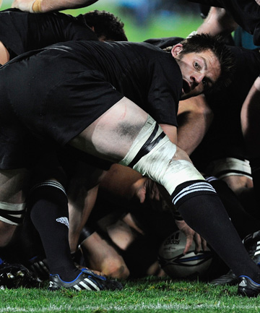
Defensive Skill 2
Elite performer- Richie McCaw
Rucking/Jackling- Rucking is used in attack and defence. When in attack it is used to secure possession, however in defence it provides a good opportunity to slow down the ball or get a turnover if you arrive first. I have chosen McCaw, as he is the top number 7 in the world. One of the main characteristics of an open side flanker is to be able to get to the breakdown quickly and be effective when you get there. He does both of these consistently and disruptively, therefore frustrating opposition when he slows down the ball, giving his own team time to re-align.
B2-Preparation Phase
As soon as McCaw sees a ruck beginning to form, he needs to decide very quickly whether he is required to join it or not. As a number 7 he should be the first to the breakdown from any set piece. Speed is key to winning a breakdown, if you aren’t there first then the opposition can get a good base and get the ball away quickly. He will accelerate to the break down, whilst at the same time beginning to lower his body in to the starting position to ruck and drive off the opposition. Meanwhile he will be communicating with his team mates, either encouraging them to support him or telling them where he is on the pitch.
B1-Preperation Phase
In the same way as McCaw approaches the situation, I too attempt to attack the breakdown maintaining speed and balance; however over the course of a match as I begin to fatigue I find it increasingly difficult to be as athletic as McCaw around the pitch. This add to me being unable to communicate as consistently with my team mates due to me using all me breathe to focus on providing oxygen for my muscles.
B2-Execution Phase
As the first man at the ruck McCaw will be allowed to compete for the ball and get his hands on it. Approaching the ruck he will get in to a low body position by bending his knees, and keeping his eyes on the ball. This will hopefully allow him to get lower than the opposition and be able to prevent him being driven off the ball. He will stop by the tackled player on the ground and get in a wide stance; his feet will be wider than shoulder width apart, giving himself a strong base to proceed from. He will reach over and put his hands on the ball, keeping his arms in tight and his head over the ball to protect it and make him as strong as possible. At the same time he will be supporting his own body weight to avoid giving away a penalty. By this stage it is likely that the opposition players will be joining the ruck too, therefore he remains strong by engaging his core, and rounding his shoulders to make his body as compact and solid as possible. At the same time he will be trying to bring the ball back on to his team’s side. He does this by pulling it towards him and putting it through his legs, but remains strong to protect the ball.

B1-Execution Phase
When I enter the ruck as the first man, I attempt to get into a matching body position as McCaw, however I do not have the same flexibility and strength in my shoulders or legs, therefore I sometimes struggle to support my own body weight and compete when the opposition come in to play. McCaw is able to generate far more power from his legs in comparison to myself. Therefore, he is more destructive and effective in a ruck. Furthermore, due to my lack of core strength in comparison to McCaw I can be pulled off my feet which can lead to giving away a penalty. This is often the case as I put the ball back through my legs and have to support my body weight even more.
B2-Recovery Phase
As mentioned, he will remain in the ruck still competing against opposition players trying to come through. Once the ruck is finished and the following phase is taking place McCaw will get to his feet as quickly as possible to make himself available, either as a runner or to go in to a ruck again and recycle the ball. In a similar fashion to the preparation phase McCaw will be communicating to his team mates as moving across the pitch to the next phase.
B1-Recovery Phase
When the ruck is completed, I try to get to my feet as quickly as possible, using opposition players bodies to help me get up. However in comparison to McCaw I do not have the same level of agility to get off the floor with speed, especially as the game comes to a close and fatiguing it can be challenging to get up quickly. Following on, at the next phase I sometimes go into the ruck when it may be more efficient to stay out and be an option in the back line.

Tactical Skill 1
Elite Performer- Danny Care (England and Harlequins)
Box kick from just outside own 22.
A box kick can be used in a variety of situations- to clear lines when under defensive pressure and the fly half may be involved in the contact area, used as an up and under for wingers to chase or as a tactical placement kick to try and put your team on the front foot when already inside opposition territory. Here I am going to talk about when it is being used as an up and under for wingers to chase. It is a great way to relieve pressure and can pin the opposition back in to their own territory. It is commonly used when just outside your own 22m line because if passed back to the fly half from outside it must bounce before going in to touch. Therefore it is far easier for the scrum half to put in a box kick with wingers chasing to clear his teams lines than to put the pressure on the fly half. The scrum half must make sure that the ball does not go out on the full as this would result in a line out for the opposition where the ball was kicked and put pressure back on to your own team to defend.

B2-Preparation Phase
In preparing for a box kick the scrum half would make sure he has got enough protection either side of the ruck, to allow him slightly more time to perform the kick so that he can focus more on where it has to go rather than worry about the oncoming pressure from the opposition. He would order loose forwards to stand either side, normally two either side of ruck. They act as a barrier and stop any players coming directly through, therefore make the path to their scrum half longer for the opposing forwards to reach. Danny Care will also be communicating with his blindside winger and letting him know he is about to do a box kick. Whilst preparing the forwards Care will keep looking up and looking where to place his kick, in relation to where the opponents are. Also he will check the positioning of the ball on the ground, adjusting it slightly with his boot so that it is exactly where he wants it and is ready to kick. Care will also ensure that the ball doesn’t all of a sudden get kicked out by a random boot which would lose the structure of the skill and put his team under pressure as loose opposing forwards bound towards him. With the kick he will be aiming to get it high enough over the players in front of him, with reasonable distance and make sure doesn’t land in to touch as this would give a line out to the opposition where he kicked it from. He is aiming to reach about half way and land it as close to the touch line as possible. The most likely outcome is that an opposing playing will catch the ball and it is the job of the chasing winger to put him under as much pressure as possible.
B1-Preparation Phase
As approaching the ruck I will look back to my fly half and having looked at the situation, suggest a box kick to him, this relieves the pressure of him kicking from outside the 22. Once I have decided that a box kick is the right option, I begin to go through similar process to Danny Care. I make sure the ball is securely won and there is no chance of any opposing forwards bashing through. I will communicate in similar fashion to Care ensuring that my forwards are on guards either side of the ruck blocking any players put pressure on the kick. In comparison to Care I do not get my forwards in position quickly enough, this can slow down the process of the kick and give time for the opposition full back or wingers to re position themselves to catch the kick.
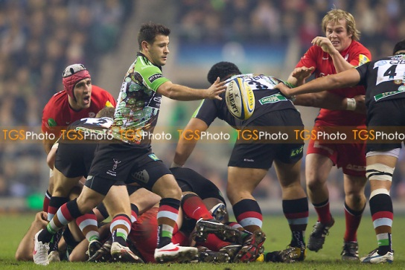
B2-Execution Phase
Once Danny Care has made all the checks of where to kick it and making sure all his other players are in the correct positions, he will begin to execute the skill. He will prepare his body in similar position as if he were about to pass. He will be parallel to the touch line, Care is right footed, therefore will be standing with his left foot just in front of the ball with his knee bent and the majority of his weight on that front leg. His right leg will be fully extended to his side and his hands will be hovering over the ball, he will only pick it up when ready because as soon as his hands touch the ball the opposition are allowed to go for him. Care then begins to transfer his body weight from his left leg, he will cross his left foot over his right and plant it slightly in front of him then, just as the left foot is planting he accelerates through the kicking motion. Danny Care strikes the ball kicking it at the bottom of the ball, tilted slightly backwards. His right hand stays on a little bit longer guiding the ball down to his leg. The leg drive needs to be short and sharp from the static position, his leg will have slight flexion at the knee joint before entering the kicking phase and the leg fully extending. He is aiming for his foot to be finishing near his head, swinging from right to left. In follow through, head and shoulders are over the ball and left hand should be up for balance.

B1-Execution Phase
I will pick the ball up from just inside of my left foot as kicking with right foot. I bend at my left leg to pick the ball up, then accelerate off my left leg moving the weight on to my right leg and place my left foot across my body. I attempt to replicate Cares actions, but I do not perform with such fluidity and speed. My kicking action is a lot slower as I am focusing on aim and where about on the ball I am kicking, therefore I need to allow myself more time in the kicking action. A further reason for performing the kick at a reduced speed is because I have a lack of self-confidence when performing a box kick. This is because it is not my regular position and I lack the practice. The reduced speed of execution and nervousness occasionally results in the kick being charged down. As I continue with the motion, my left foot touches the ground in front of my body; I rotate at the hips, and bring back my leg before beginning the kicking motion across my body. Likewise to Care, I hold the ball for slightly longer with my right hand as I guide it towards my foot. This is done to try and prevent the ball from rotating in the air and resulting in making contact with the ball at the wrong point. This occasionally occurs when I perform a box kick as have not yet perfected the technique.

B2-Recovery Phase
Once the kick has taken place, Care will have to chase his kick to put the rest of his team onside, a winger should be chasing from behind the ball to put everyone onside too. The chase is especially important as the ball is remaining in play, this means that a tackle will need to be made on the opposition catcher, and furthermore it is essential that a good line of defence is present to prevent a counter attack. This will most likely be led by the scrum half communicating with the rest of his tem as Care is most likely to be the second man to the breakdown.
B1-Recovery Phase
After I have kicked the ball, I will follow up fractionally behind the chasing winger, as he will have had a head start. Bringing up the rest of the defensive line with me, in comparison to Danny I do not have the same speed and acceleration as him; therefore he would be more effective at getting up quickly on the opposition as they begin their attack back. I allow them too much time to start a counter attack.

Tactical Skill 2
Elite Performer-Ronan O’Gara (Ireland, Munster)
Kicking in play
Kicking in play is a great way to put your team on the front foot and pin the opposition back in to their territory. It is a difficult skill to master as you are under a lot of pressure from the defending side when it is done compared to a penalty kick to touch where you can take your time and focus on a target. Furthermore it must bounce before going out, as the kick is used when outside of your own 22. Ronan O’Gara is my chosen elite performer. Over the years as Irelands fly half he has done an outstanding job of pushing back defences by driving the ball in to the corner, measuring it perfectly. He is also renowned for the banana kick, which is a spiral kick which is rarely used now by the top kickers as a new end to end kicking style has been adapted. It is a hard kick to perform as there is a large margin of error, therefore making it more impressive and showing the level of skill he has.

B2-Preparation Phase
As O’Gara prepares to kick he needs to make sure it is the correct time do to so. This is dependent on several factors; is the possibility of losing possession worth it in order to giant territory on the pitch? Is there a full back in play that may be able to cover his kick? He makes all of his checks before he receives the ball, these include; making sure his teammates know he is going to kick so that they can remain onside, and he also needs to decide where he is aiming to make the ball land. As he will be outside of his 22 it will have to bounce at least once before going in to touch. O’Gara will want to disguise his kick so it’s not obvious for the opposition to identify it and for a full back to drop back, therefore he will not be standing too deep. He will probably be standing in a similar position as if he were going to pass down the line. He needs to receive the pass from the scrum half safely before kicking it, once he has hold of the ball, he will have little time to perform the kick. This means his preparation is essential, after deciding to kick he needs to be committed to it. O’Gara will make a signal to the relevant winger, therefore he can chase the kick and gather the ball if it remains in play.
B1-Preperation Phase
In comparison to O’Gara I stand deeper when preparing to receive the ball; this gives me more time to make my decision. O’Gara has a greater ability to manoeuvre the ball in his hands faster than I can; this allows him to be holding it in the correct grip. Furthermore O’Gara has far more experience of being under pressure from opposing players and can deal with it in a controlled manner in comparison to myself. Sometimes I lose focus when under pressure, resulting in not getting the kick away in time and caught in possession or making a bad kick. This puts my own team under pressure as opposed to pressurising the opposition.
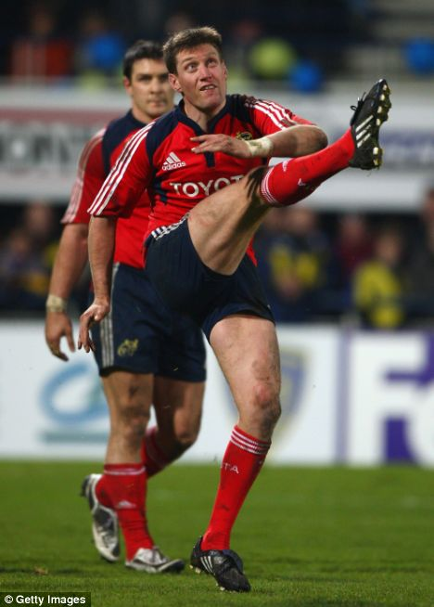
B2-Execution Phase
Following on from receiving the ball, he will begin the kicking motion. He will take a few steps forward to help with the momentum of the kick. He will face directly towards the direction he is going to kick in. He will plant his left foot firmly on the ground and he brings back his right leg as soon as his left foot hits the floor. O’Gara will hold the ball in both hands, (his right at the top of the ball and his left at the bottom) he drops it just in front of his body tilted slightly backwards, he kicks the ball with the laces of his boot aiming to make contact three quarters down the ball (the sweet spot) giving the ball a backwards rotation to increase the chances of it bouncing forwards in to touch after the bounce. He punches the ball with his right foot, not with a full follow through, the size of leg swing is dependent on how far the kick is. However in general it isn’t usually a massive kick where distance is key, he is focussing on accuracy. O’Gara will lean forwards keeping his head over the ball to maintain balance, keeping his shoulders square and everything in line to direct the kick. He will keep his head down until he has made contact with the ball where he will begin to raise his head to check it has gone where he wanted it to.
B1-Execution Phase
I hold the ball the same way as O’Gara, with my right hand higher on the ball to balance it and to help it stay level as I drop it towards my foot. I will take a few steps forward, before planting my left foot, and dropping the ball down. At this stage the slightest imperfection in the drop of the ball can affect the flight of the kick. After multiple practices O’Gara has become consistent at making sure the ball remains level when releasing it. However I sometimes let go with my left hand too early, resulting in it tilting off central and my kick going off target. Following on from releasing the ball I keep my head down and follow through with my right foot aiming to connect with the ball fractionally above the ground, as it is the most powerful part of the kicking motion. However I occasionally miss judge this and make contact with the ball too early or too late as I have not yet perfected the timing. In addition to the off central drop of the ball it amounts to the kick going wrong. Following connection I finish my follow through to complete the action. I cannot follow through to the same extent as O’Gara, (shown in the image above) due to a lack of flexibility in my hamstrings. As a result of this he can generate more power and be more accurate as the follow through plays a key part in directing the ball. The aim is for the ball to land as close to the touch line before going out of play. This prevents the opposition re-gathering the ball. O’Gara can target his kick to a much finer degree, whereas I need to be more preserving and less ambitious with my kick. Therefore I aim further in field to make sure I don’t kick it straight out on the full. This would give the opposition a line out from where I kicked the ball as I would be outside my own 22m line.
B2-Recovery Phase
After performing the kick, O’Gara has two options. He can either follow the kick in support for the winger or he can drop back to support the full back if a kick is returned after not reaching touch. Meanwhile the rest of the back line will go up together. Communication with the winger is key for the kick to work, the winger stops them taking a quick throw in and puts the rest of his team onside because he began his run from behind the ball. If for any reason the ball takes an unlucky bounce and the opposition re gather possession then they have a strong platform to attack from as O’Gara’s team are most likely to be staggered, creating gaps for them to run through. This means there is even further pressure on O’Gara to get the kick correct initially.
B1-Recovery Phase
Once the kick is completed, I will follow up making sure the opposition can’t take a quick line out. This means I have to rely on my full back to remain in position, in case there is a returning kick. Furthermore, in comparison to O’Gara my kicks are not as consistent and I cannot rely on them landing where I had aimed for, therefore I have to follow up in case I made a poor connection or if the ball has taken a bad bounce and I need to make a tackle. But this can leave my full back isolated whereas O’Gara would be back there in support. He has more confidence in his kick and can depend other players around him going up in a defensive line because they would have practiced what to do in this situation a countless number of times.

Attacking Skill 1
Elite performer- Johnny Wilkinson (Toulon and England)
Passing-Fly half receiving ball from a set play, (scrum) and distributing accordingly
Passing is one of many key and basic skills which need to be performed to perfection and autonomously to play at elite level. This is in order to focus on other decision making tasks, for example, set plays. It is the key skill to move the ball around the pitch. Generally the 2 best passers in a team are the scrum half and the fly half. Due to them being the distributors to the rest of the back line or players outside of them. However, scrum half’s pass mainly from the ground, whereas fly half’s receive the ball on the move and have to pass the ball across their body in one motion; I have chosen Johnny Wilkinson as my elite performer for this skill as I feel that he has a consistently accurate and flat pass which is required to hit targets on the move.

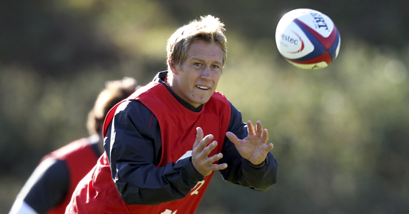
B2-Preparation Phase
In the fly half position Johnny Wilkinson will be organising the rest of the back line outside of him and calling any pre-drilled moves that he wants to use in attempt to break through the defensive line. He will be prepared so that he has organised the players before the ball comes out of the scrum so that he has time to prepare to receive the pass from the scrum half and make a pass himself. He will be standing with his outside foot forwards and his hands up in the direction of where he is going to receive the pass from. This gives the scrum half a clear target to aim for. His hands will be up nice and early as he is running on to the ball, using a lot of communication to inform the scrum half of where he will be, (short, deep, wide) He may also say to the scrum half exactly when he wants it, for example with a call, ‘NOW’.

B1-Preparation Phase
As I am preparing to receive a pass I ensure I have communicated to the player passing me the ball where I would like to receive the ball. However, I do not do this as consistently or early enough in comparison to Johnny, I sometimes have to call it late which gives very little time for the scrum half to adjust accordingly and can result in a wayward pass. I stand with my outside foot forwards in the same style as Johnny, this give me the most effective stance to receive the ball as I am towards the direction it is coming from. I also talk to the player directly outside me to make sure I know where to pass the ball after I have caught it. But as I have less experience to Wilkinson, and as I begin to fatigue throughout the game it takes me a fraction longer to look up and find a gap then correspond a move to exploit it. Johnny will have perfected this skill through experience and training; he will always play with his head up hence being far more prepared when receiving a pass. Furthermore, Johnny will have better awareness of what the other players further down the line are doing in the move, whereas I only focus on passing accurately to the man next to me.
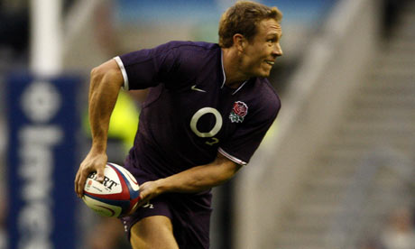
B2-Execution Phase
As he catches the ball his arms will be fully extended to the side of his body where he is receiving the ball. This gives the scrum half a clear target, allowing him to start in the perfect position to move the ball across his body in the passing motion. His shoulders are slightly turned towards the man passing to him in preparation for the rotating motion of the shoulders. He is aiming to catch the ball with 10 points of contact, (all of his fingers cushioning the impact of the ball). Wilkinson will receive the ball at pace to give himself momentum and initiate the attack. He will be watching it in to his hands, adjusting his hand position so that he is holding the ball with the correct grip to pass on to the next player. For Johnny to perform a short pass both of his hands will need to be more central for a ‘pop’ pass, however if a spin pass is required for a further pass then his hands will need to be slightly further apart, the hand of the side he is passing off would be towards the back of the ball and his other hand between the centre and front of the ball. Before passing on to the next player he will draw the defender with some footwork and running towards their inside shoulder, this prevents the defender drifting in defence and covering an extra man. After successfully drawing in the man, Johnny will pass the ball across his body keeping the elbow of the hand he is passing off high to ensure it is a flat pass, e.g. if passing to the right his left elbow will be high. Both of his elbow joints flex as he moves the ball comes across his body, as it reaches the far side of his body his elbows extend as he flicks his wrists in the direction of the pass creating power, his fingers are left pointing at the receiver to aid with aiming. On release of the ball his left leg should be forward to maintain balance and allow his shoulders to move with the motion of the pass and naturally finish facing the target. This movement comes naturally to him and the autonomous performance as an elite performer of the skill allows him to focus on other factors.
B1-Execution Phase
I try to receive the ball with the same approach as Johnny; with my arms full extended to the side I am receiving the ball. In contrast to Johnny’s continuous idealist preparation, my arms can become too bent as I fatigue. Resulting in once I have caught the ball, I have to re-extend my arms, leading to a delay in the movement. In the same way as Johnny does, I attempt to adjust my hands during the balls flight towards me, allowing me to catch it in the correct position. However, I am not always consistent in this stage of the skill. This leads to me having to quickly readjust my grip on the ball, therefore delaying the speed of distributing the ball on to the next player. Johnny manages to consistently perform the pass in one motion moving the ball swiftly across his body keeping his inside elbow high and resulting in a flat pass. In my case, although I do this, it is not as consistent as Johnny’s pass. Sometimes I bring the ball in to my body and then pass on, rather than keeping it in front of me and passing across myself. However in general my elbow is high giving a flat pass. The overall cause for my inconsistency and occasional fault in technique is due to my lack of aerobic fitness. I know how the pass should be performed, and I can do it at the start of a game but as a game draws to a close I begin to tire and technique fades, often leading to a stray pass or delayed motion. Wilkinson clearly has a higher level of aerobic fitness as a result of his elite training program and it is something I need to look to improve as I am keen to develop my passing to last the duration of a game.

B2-Recovery Phase
Once the pass is completed successfully, he will follow his pass to support the next carrier giving himself as an option for an inside pass. He also needs to be there if required for a breakdown. However in general as a fly half, when the ball is taken in to the next breakdown he will be communicating with the rest of his team and setting them up for the next play. Due to it not being a set play Johnny will have to play more ‘head up’ rugby and decide the correct pass from what is in front of him and utilise the different options he has set up, for example forwards inside ball or spread wide if they have more numbers than then defending side.
B1-Recovery Phase
After I have passed the ball, I also follow in the same direction, however if the ball goes wide I can find myself ‘ball following’, whereas Wilkinson uses his awareness and skills learnt over years of experience to react to the situation, if the ball goes past the man beside him then he does not need to directly support the play. This would be the job of the centre who has just made the pass. Johnny will still be attentive to any change in movement but he will be moving in to the correct position in order to set up for the proceeding phase. As a result of my inexperience leading to me ball following, I can find myself out of position on the pitch and give myself double the amount of work to do as I track back across into position, This leads to further fatigue and a lowering in my general performance.

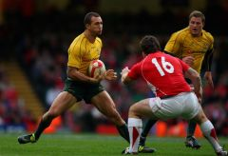
Attacking skill 2
Elite performer- Quade Cooper (Queensland Reds, Australia)
Sidestep
The aim of a sidestep is to draw the defender one way then go the other. The side step is a very useful skill when in attack. If used effectively it can beat an opponent one on one by catching them flat footed or off balance in the change of direction. It can also be used to draw a defender before passing, and is good for changing speed or the angle of attack. I have chosen Quade Cooper as the elite performer because he has quick and light feet which are essential to perform a side step. He has an immense ability to leave a defender static as he slides past them.
B2-Preparation Phase
When approaching a defender Cooper will be looking to see which side he has most of his weight on and aim for the opposite shoulder, trying to identify a weak spot and exploit it. He wants to avoid running straight in to a defender as it will be an easy tackle. He wants to try and run at a flaring forearm as opposed to a shoulder. When reaching the defender Cooper looks up choosing which way he will go, and makes the decision dependant on the players either side of the man he is attacking. If the player to one side is a prop then it is most likely Cooper will spot this and go that way as props are usually flat footed, lack pace and agility and are not used to defending in the line. He will quickly evaluate the situation then try to move the defenders focus away from his hips (which indicate the direction he will go). Deviation can be done by making eye contact, movement of the ball and the use of footwork.
B1-Preparation Phase
Before I get to the defending line/player I will have an idea of which way I am planning to go. In comparison to Quade’s ability to make a decision within a short time frame, I tend to decide which way I am going from a far greater distance away. This gives me the opportunity to focus on footwork and movement without having to worry about decision making directly before the contact area. However this can end up with me going the wrong side of the opposition, giving them an easy tackle to execute. Nevertheless I will begin to attack one side and then make my move about one pace in front of the player. I don’t have the level of experience that Cooper does, therefore sometimes I don’t identify the players either side of the defender, Therefore I usually base my decision on where he looks off balance, in order to give me the greatest chance to break through.

B2-Execution Phase
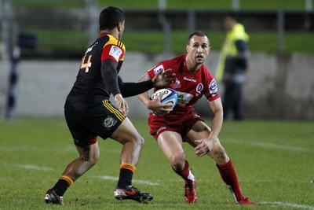
Quade will attack one shoulder running just off full pace, to allow for a change in speed. About two paces away from the defender, he will push off one foot, planting all of his foot on the ground to avoid twisting an ankle or any other injury. He will bend at the knee of the same leg, however not lowering fully, just a short distance to give him that burst of power essential to a side step. As he performs the side step he may try to distract the defender and make him think he is going a certain way by looking that way or with ball movement. Once his leg has the slight bend in it then he will accelerate up and push in the direction he wants to go (across the defender) aiming for the forearm, as it is weaker than the shoulder and is hard for the opposition to make a tackle from there. Within the sidestep movement Cooper will rotate his hips in the direction he is going, this helps to break the tackle if the player manages to get hold of him. As he is passing the side of the defender he will increase to full speed by pumping his legs to break through and at the same time move the ball to his arm furthest away from the tackler. He can use his free hand to fend off the defender and the ball is secured away from any attempt of it being ripped out. It also gives an option to off load if gets tackled as falling to ground.
B1-Execution Phase
I try to execute the side step as effectively as Quade, approaching the defender I aim for one shoulder, then just before him I will push off one foot. I sometimes do not give myself enough room to execute the side step, I perform it too close to the defender, this gives him the opportunity to tackle me as I am far closer to him and little movement is required. Cooper has a greater ability to hold a defender for that split second before the change in direction and pace; this is done by his greater movement in the direction he isn’t going before going the opposite way. This leaves a greater gap for Cooper to go through. He has developed this technique through experience and being able to detect the small changes in the display, compare them to previous experiences (which he has many of) and being able to react quickly with the correct response. Although I have some understanding of the cues I am looking for, I can sometimes have a delay in response. This is caused by several factors; the psychological refractory period-where there is a delay between registering two stimuli that overlap with one another (for example the movement of other opposition defenders). This can distract me form the skill itself as I am unable to filter out the irrelevant information. Continuing, I tend to push off too quickly, and I haven’t moved the player at all by this point, meaning that there is very little movement required to cover and tackle me. Furthermore Cooper’s leg drive whilst passing the defender is immense in comparison to mine, this makes it challenging for the defender to make a tackle as Quade is powering in the opposite direction. Sometimes as a result of my non-existent leg drive I perform a good step but can still get tackled as I do not complete the motion properly. If I have successfully broken passed the opposition I move the ball into the hand furthest away from the contact area, leaving my other hand free to fend the defender, and look to offload or pass as I move in to the recovery phase.
B2-Recovery Phase
If the side step was successful and broke through the line Cooper will be attacking the full back and in full sprint. At this stage Quade will have moved the ball back in to two hands after fending off the defender. This now means he can pass in either direction. He will be looking to beat the full back, and make the most of his hard work so far. Depending on the positioning of the full back Cooper will have to decide whether he can run around him if he is far away from the full back or if the full back is quite close, Cooper will have to analyse the situation very quickly and decide what is the best option. As he approaches the full back he will be slowing down to give himself more options of where, or who to pass to. He will be looking either side of himself and trying to hear for support from other team mates running on to the ball, he needs to make the correct decision, whether it be a pass to put someone in to score a try or the use of another side step and a dummy to continue himself.

B1-Recovery Phase
After I break through the defensive line, I immediately accelerate before looking up to see what options are available. In contrast to Cooper, who controls his speed and knows his pacing better than I know mine, as I am accelerating I don’t always give myself enough time or room to make a decision, resulting in me getting caught in a tackle by the full back as I am trying to do too many things at once; slow down, pick a pass or use footwork. In addition to my lack of ability to control speed and pacing in comparison to Quade I can be indecisive, whilst Cooper makes his decisions almost instantaneously and follows through with them. Cooper shows his skill and ability to beat the full back on a one on one situation; this has been worked over many years of being in this circumstance and having a range of options to choose from in order to be clinical.

